A
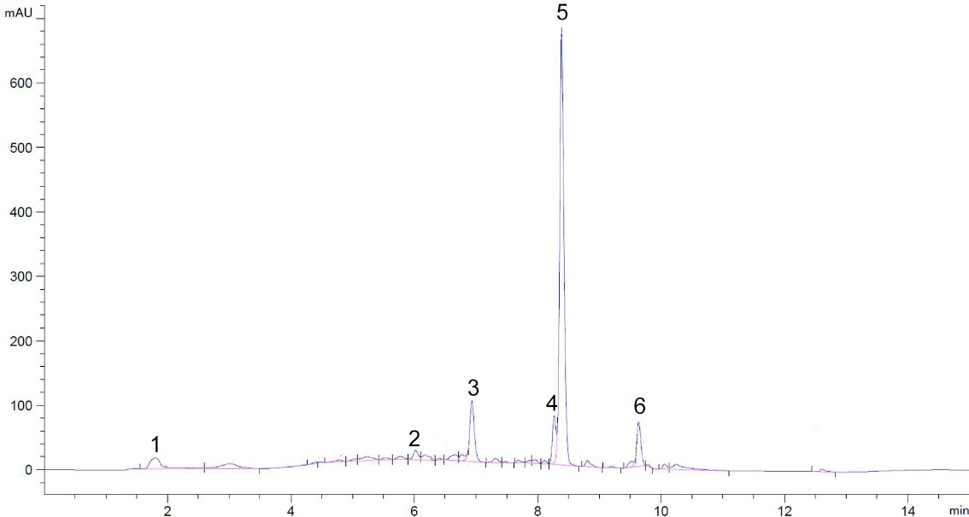
B
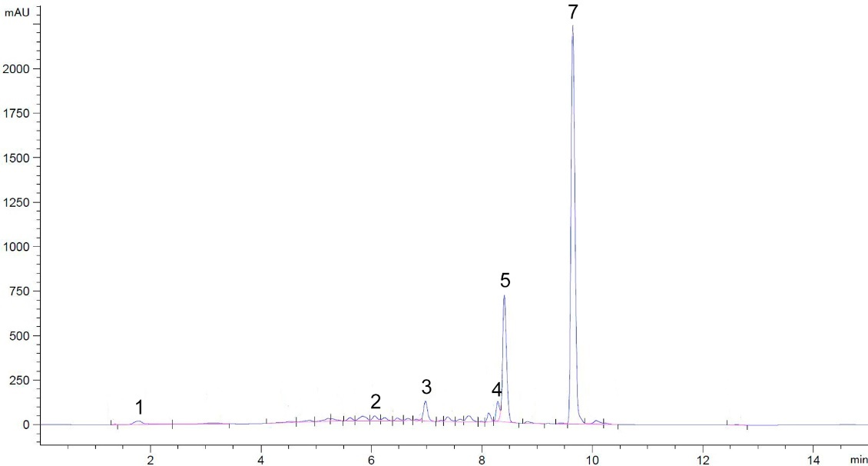

Fig. S1. HPLC chromatograms of the phenolic fraction of the alfalfa root exudates collected from uncontaminated and from phenanthrene contaminated sand. (A) Phenolic fraction of root exudates collected from uncontaminated sand. (B) Phenolic fraction of root exudates collected from phenanthrene-contaminated sand. Peaks 1–6 were associated with root exudates. The RT of component (2) coincided with that of the naringenin standard. The RT of component (7) coincided with that of the phenanthrene standard.

A
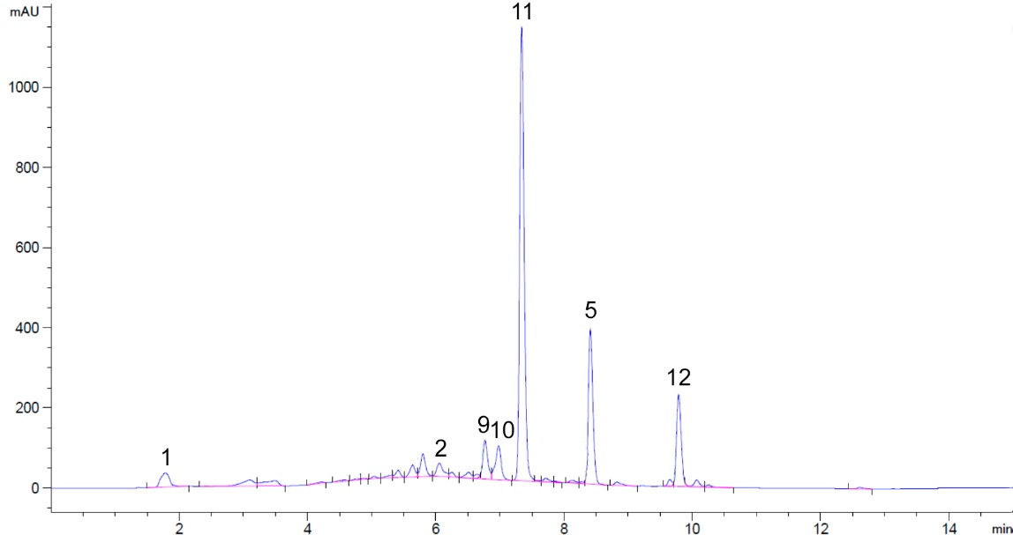
B
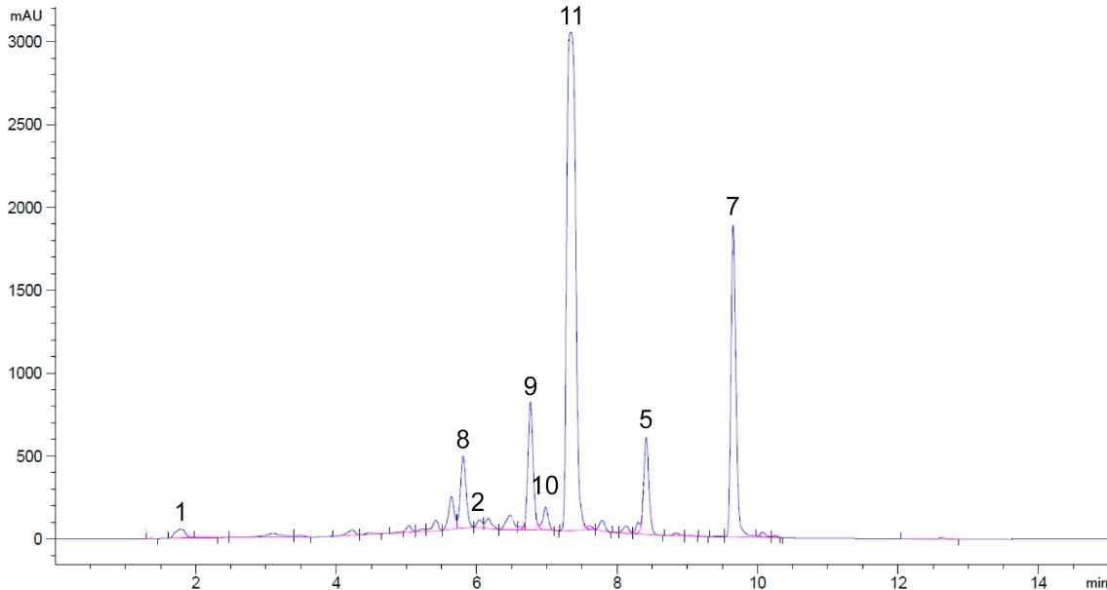
Fig. S2. HPLC chromatograms of the phenolic fraction of root exudates collected from alfalfa inoculated with E. meliloti P221 and grown in uncontaminated and in phenanthrene-contaminated sand. (A) Phenolic fraction of root exudates collected from uncontaminated sand. (B) Phenolic fraction of root exudates collected from phenanthrene-contaminated sand. Peaks 1, 2, and 5 were associated with root exudates, and peaks 9–11 were presumably associated with bacterial metabolites. The RT of component (2) coincided with that of the naringenin standard. The RT of component (7) coincided with that of the phenanthrene standard. The RT of component (8) coincided with that of the 1-hydroxy-2-naphthoic acid (oxidized derivative of phenanthrene) standard.

