I. Graphs of key kinetic parameters
- R_{max} vs. Concentration: This graph shows the maximum response (R_{max}) for OH-Cbl and NO-Cbl at different concentrations.
- k_{obs} vs. Concentration: This graph illustrates the observed rate constants for OH-Cbl and NO-Cbl across the tested concentration range.
Both graphs are plotted on a logarithmic scale for the x-axis to emphasize the trends across orders of magnitude in concentration.

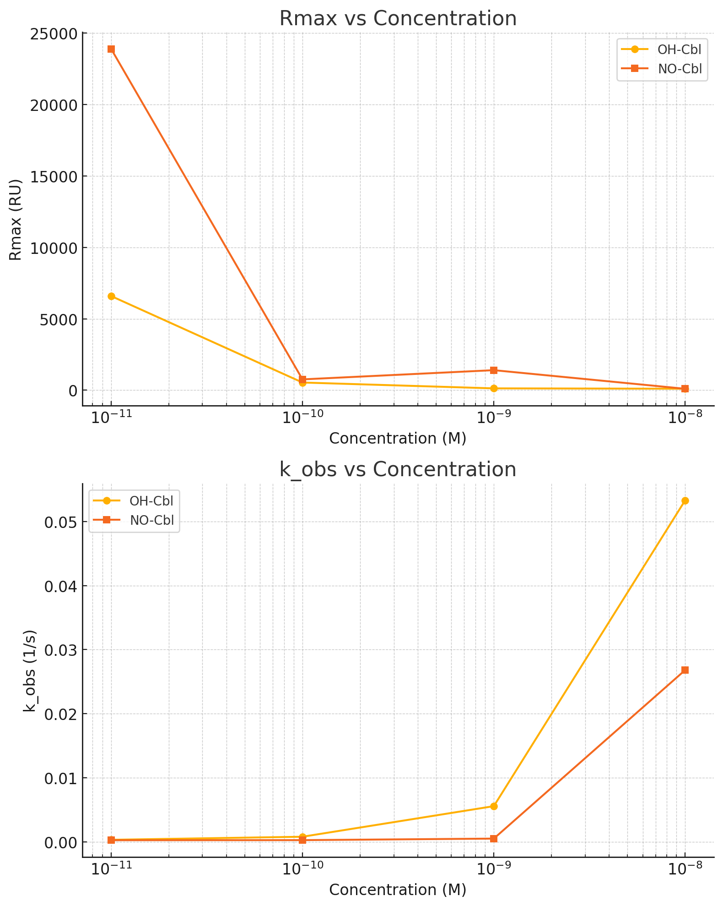

II. Summary of Kinetic Parameters
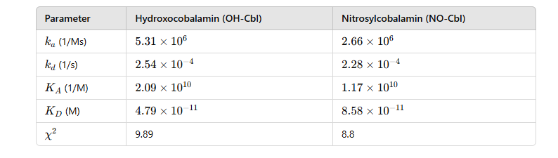
The Langmuir fit is a widely used mathematical model for analyzing binding interactions, particularly in surface plasmon resonance (SPR) studies. This model is based on the Langmuir adsorption isotherm and assumes a reversible 1:1 interaction between an analyte and a ligand, with uniform and independent binding sites. The fitting process involves using experimental data to calculate key parameters, including the association rate constant (ka​), dissociation rate constant (kd), and the equilibrium dissociation constant (KD​), which reflects binding affinity. The Langmuir equation predicts the response (R) as a function of analyte concentration (C) and the total binding capacity (Rmax​).
The equilibrium dissociation constant (KD​) is particularly important as it represents the analyte concentration at which half of the ligand sites are occupied, offering a direct measure of binding strength. Errors and uncertainties in the parameters are quantified using the chi-square goodness-of-fit metric which ensures the reliability of the derived kinetic values. By employing this robust analytical framework, our study elucidates the binding properties of NO-Cbl and OH-Cbl with intrinsic factor, linking these findings to their biological and therapeutic relevance.

III. Spearman Rank Correlation
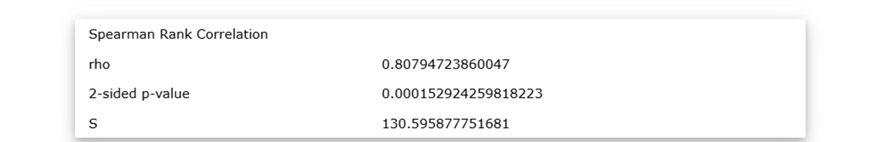
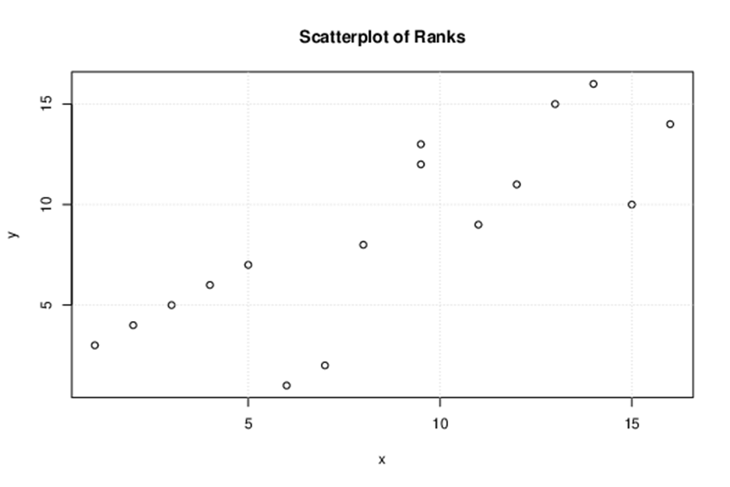

IV. Schematic Illustration of a Biacore™ Sensorgram (Cytiva Life Sciences)
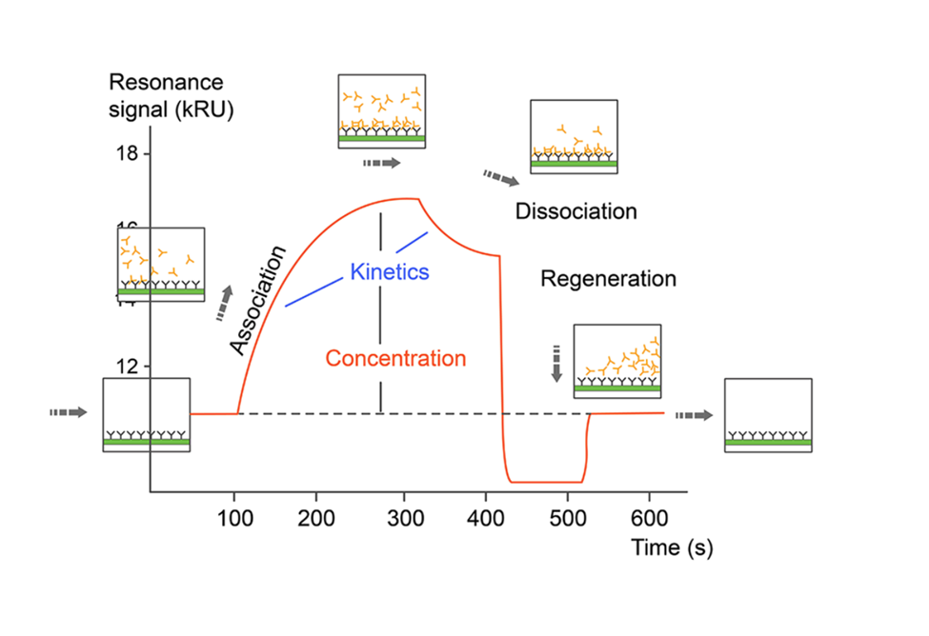
Dring sample injection, a positive response can be viewed in the sensorgram, as analyte (the interacting partner in solution in Biacore™ based assays) binds to the ligand (the interaction partner that is attached to the sensor surface in Biacore™ based assays). The response decreases during dissociation. After an analysis cycle is completed, regeneration solution is passed over the sensor chip, removing bound analyte, preparing for the next analysis cycle.

