Supplementary Table 1. Details for datasets from GEO.
GEO | Organism | Normal (N) | Tumor (N) | Submission
GSE14407 | Homo sapiens | Healthy ovarian surface epithelia samples (12) | Serous ovarian cancer epithelia samples (12) | Jan 13, 2009
GSE18520 | Homo sapiens | Normal ovarian surface epithelium (10) | Advanced stage primary ovarian tumor (53) | Oct 11, 2009
GSE27651 | Homo sapiens | Human ovarian surface epithelia samples (6) | Ovarian carcinomas (43) | Mar 02, 2011
GSE36668 | Homo sapiens | Superficial scraping from normal ovary (4) | Serous ovarian carcinoma (8) | Mar 21, 2012
GSE54388 | Homo sapiens | Ovarian surface epithelium samples (6) | High grade serous ovarian cancer (16) | Jan 24, 2014

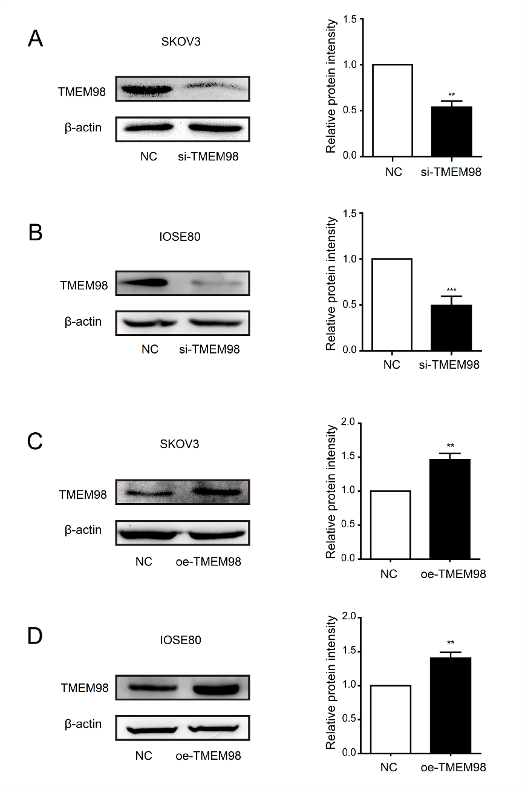
Supplementary Fig. 1. Cell model with Knockdown and overexpression of TMEM98. (A) siRNA-TMEM98 decreased the expression of TMEM98 protein in SKOV3 cells (n=3, **P<0.01). (B) siRNA-TMEM98 decreased the expression of TMEM98 in IOSE80 cells (n=3, ***P<0.001). (C) Overexpression of TMEM98 protein in SKOV3 cells was induced by TMEM98 overexpression plasmid (n=3, **P < 0.01). (D) Overexpression of TMEM98 protein in IOSE80 cells was induced by plasmid (n=3, **P<0.01).

