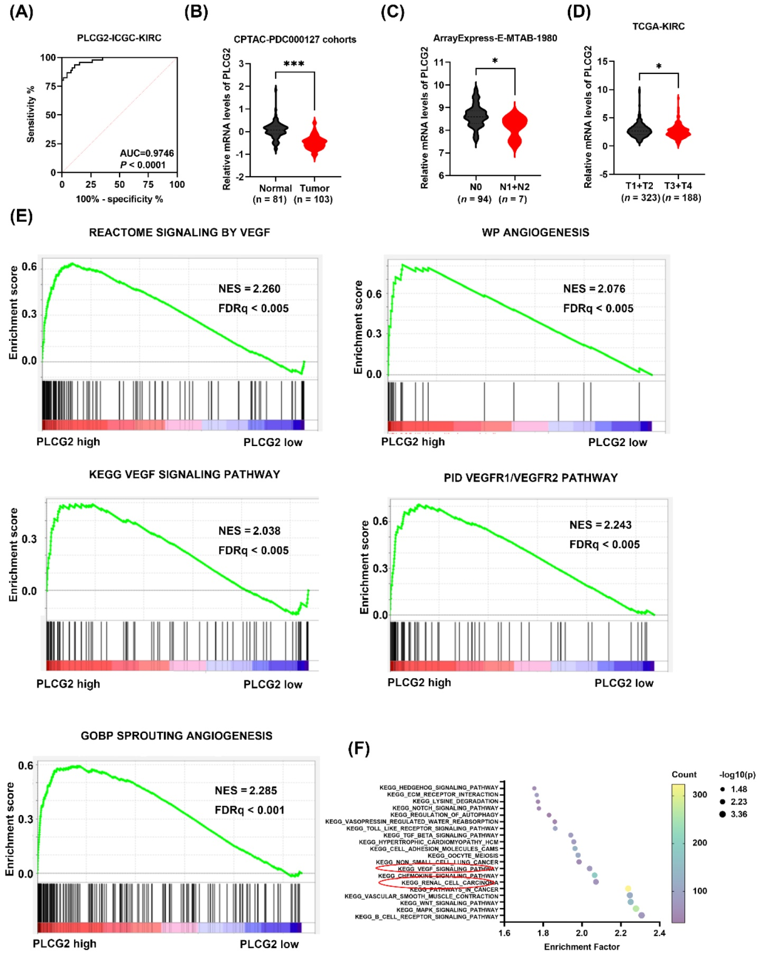
Supplementary Fig. 1. PLCG2 was downregulated and was a potential biomarker in ccRCC. (A) ROC curve of PLCG2 in ICGC-KIRC. (B) PLCG2-relative mRNA expression in normal and tumor on CPTAC-PDC000127 cohorts. (C) The differential expression of PLCG2 between different N stages on ArrayExpress (E-MTAB-1980). (D) The differential expression of PLCG2 between different T stages on TCGA-KIRC cohort. (E) The GSEA results of PLCG2 using TCGA-KIRC expression dataset. (F) The bubble diagram of KEGG according to the TCGA-KIRC revealed a correlation of the PLCG2 expression and VEGF signaling pathway.

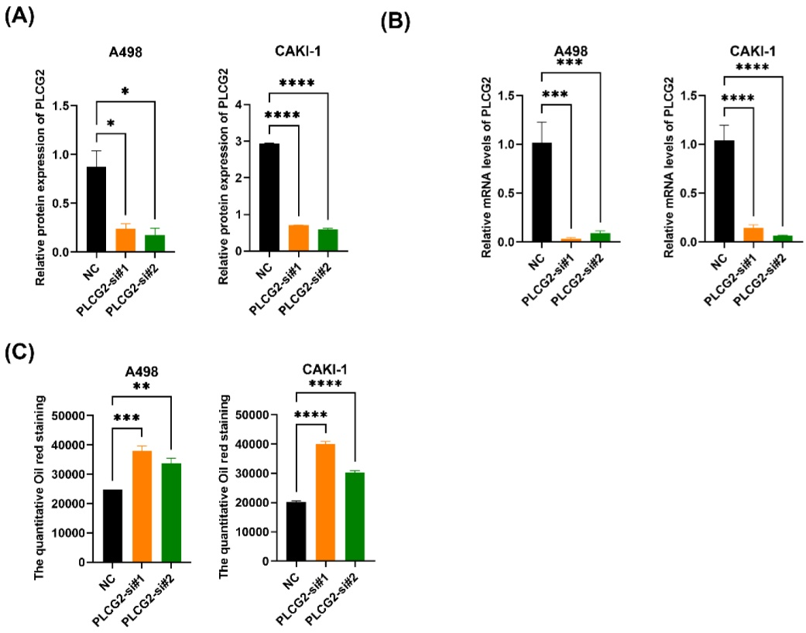
Supplementary Fig. 2. Knocking down PLCG2 promoted cell proliferation, migration, invasion, and lipid accumulation in ccRCC. (A) The statistical graph of the gray value of PLCG2 knockdown compared with the negative control (n = 3). (B) The mRNA levels of PLCG2 knockdown group were compared with the negative control (n = 3) by qRT-PCR. (C) The statistical graph of the quantitative oil red staining (n = 3).

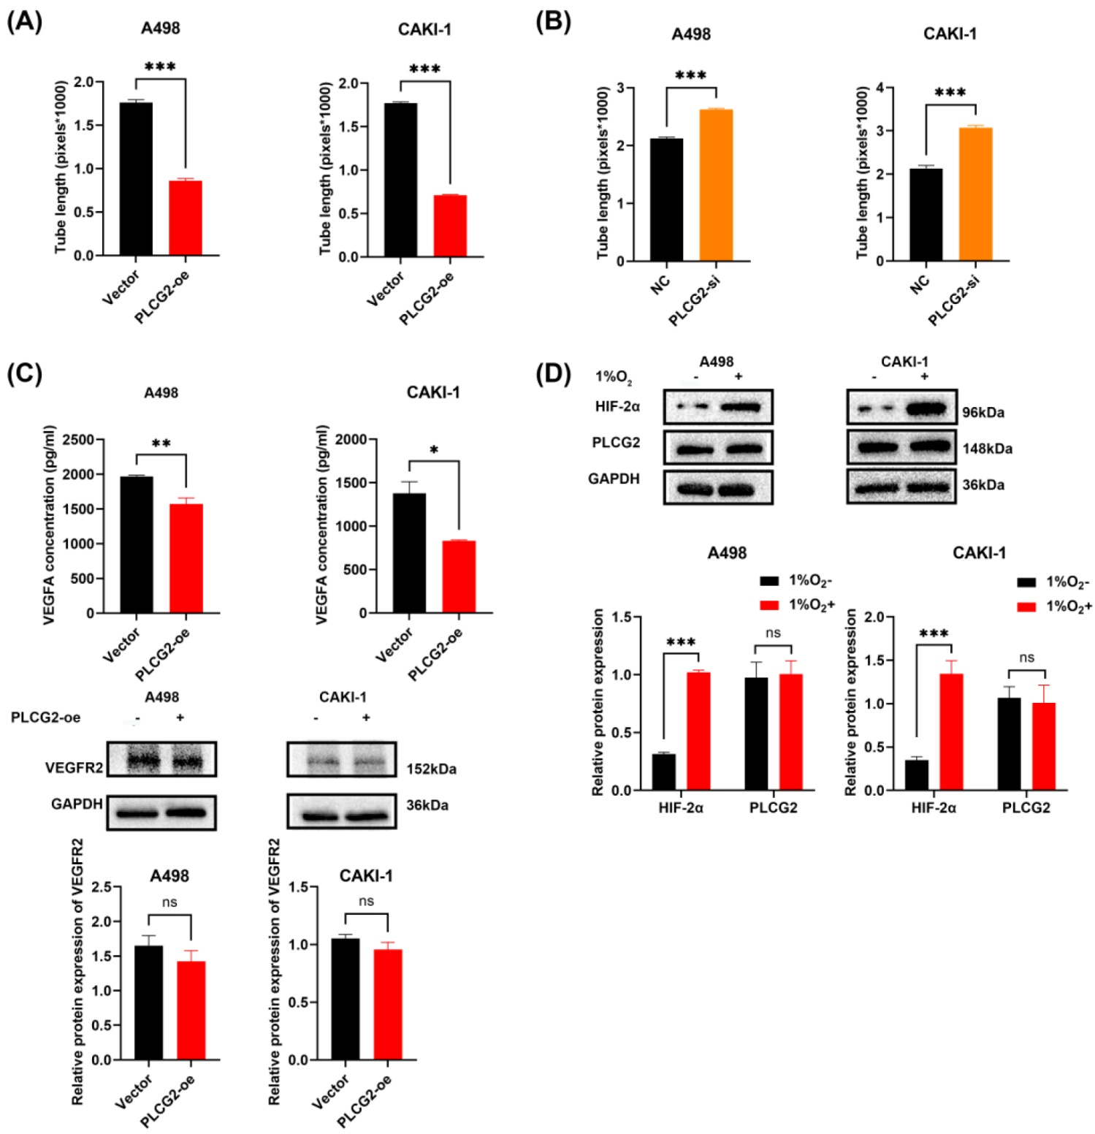
Supplementary Fig. 3. PLCG2 plays an important role in tumor angiogenesis. (A) The statistical graph of tube total length formed by HUVEC co-culturing with conditioned medium from the overexpression PLCG2 group and vector group (n = 3). (B) The statistical graph of tube total length formed by HUVEC co-culturing with conditioned medium from the PLCG2 knockdown group and control group (n = 3). (C) ELISA experiment for the VEGFA content in a conditioned medium with overexpression group compared to the control group (n = 3). And corresponding western blot and statistical graphs of VEGFR protein expression in the HUVEC (n = 3). (D) Comparison of protein expression in hypoxic renal cell carcinoma cell lines and control groups with corresponding statistical graphs (n = 3).

