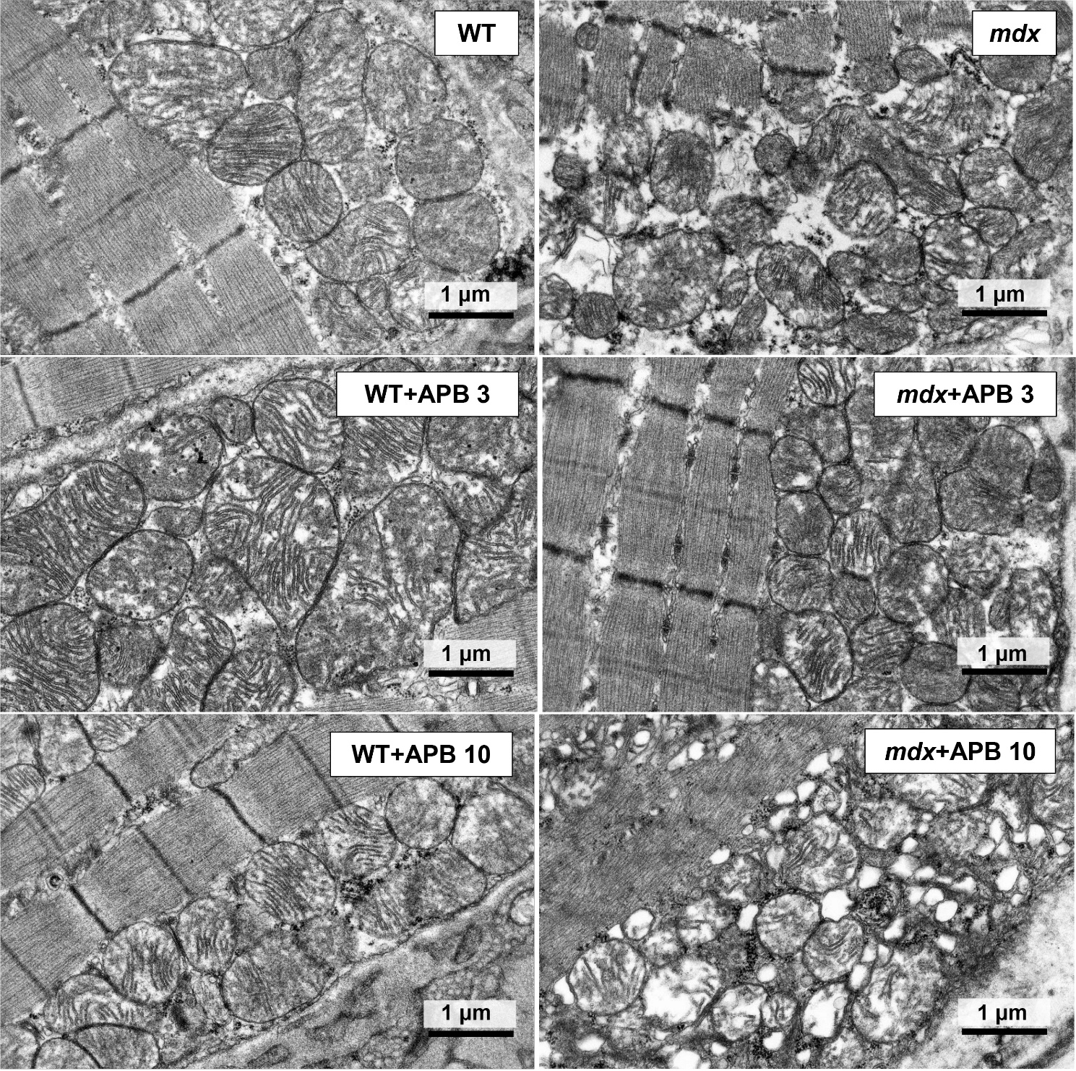
Supplementary Fig. 1. Representative transmission electron micrographs of mouse quadriceps sections showing the subsarcolemmal population of mitochondria. Scale bar is 1 μm.

