Fig1
A
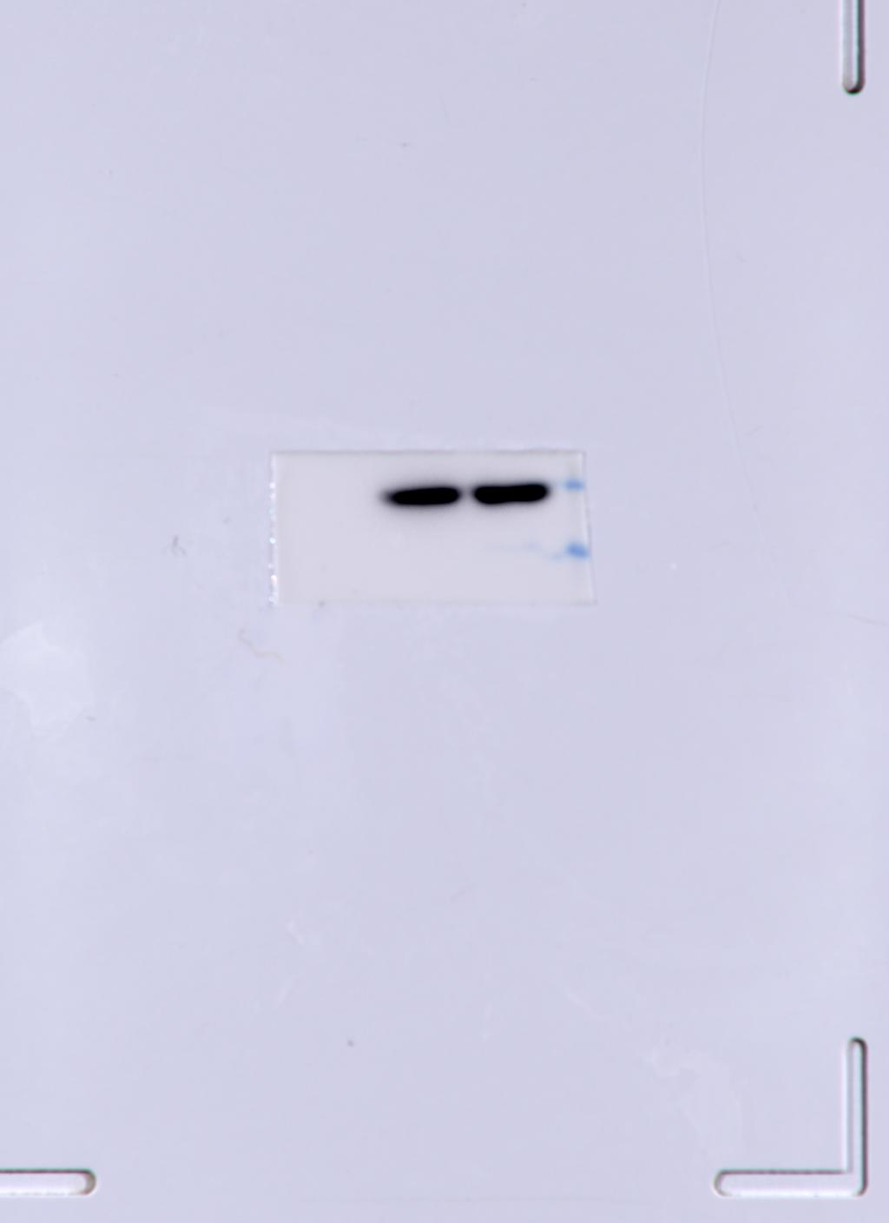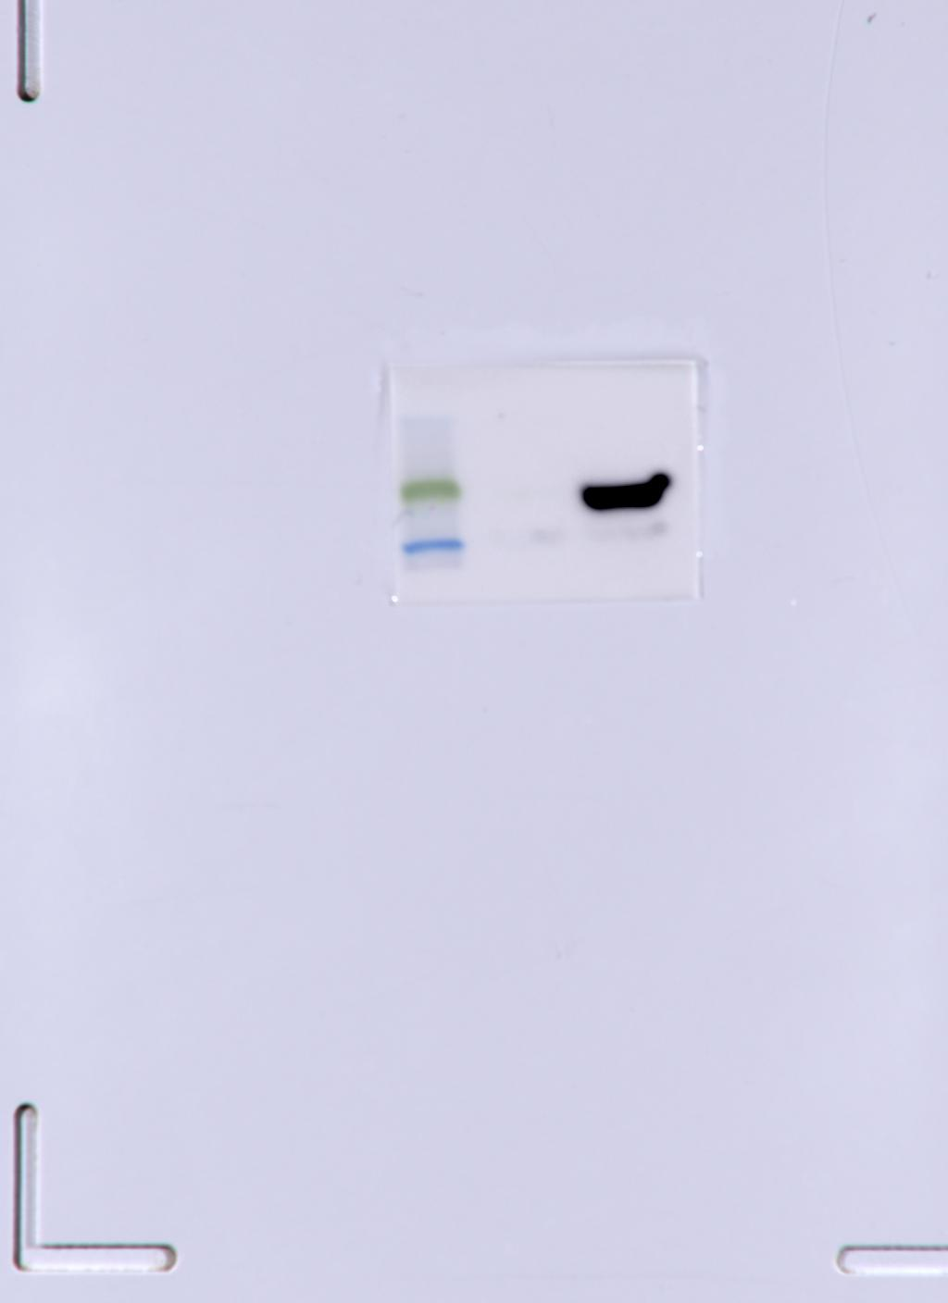
b-actin Myc-vp3
B
EV+EMCV
3.956239872e+009 | 4.331118592e+009 | 4.61009664e+009
VP3+EMCV
6.877366272e+009 | 6.016000512e+009 | 7.34539008e+009
C
EV+EMCV | VP3+EMCV
5.8 | 8.2
6.2 | 7.8
6 | 7.4

Fig2
A
Blank | EV+EMCV | VP3+EMCV
1 | 43.3205566 | 12.341064
0.7778814 | 46.8498535 | 13.1271973
1.285543 | 52.3284912 | 12.011963
B
Blank | EV+EMCV | VP3+EMCV
1 | 20.36305237 | 6.397211552
0.7778814 | 25.23198509 | 8.437630892
1.285543 | 25.52526855 | 10.78856087
C
Blank | EV+EMCV | VP3+EMCV
1 | 15.54278469 | 9.652389526
0.7778814 | 15.52590942 | 8.736194611
1.285543 | 17.95081139 | 10.66466808

Fig3
A
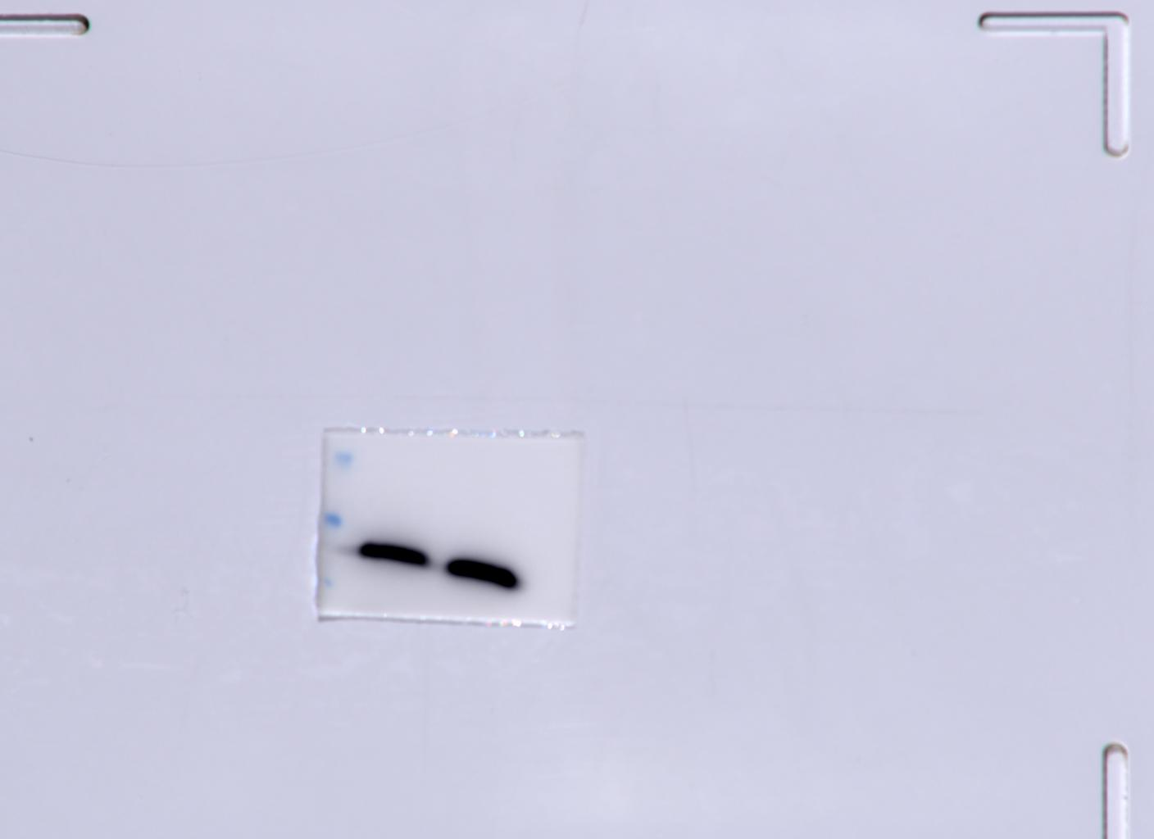
β-actin
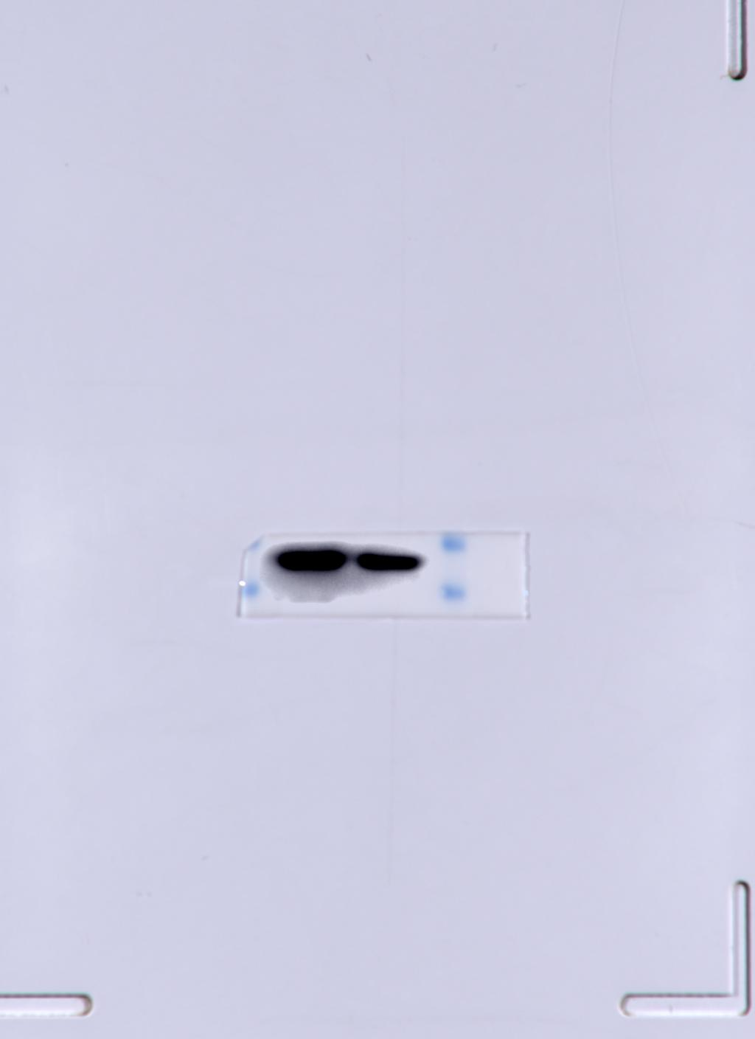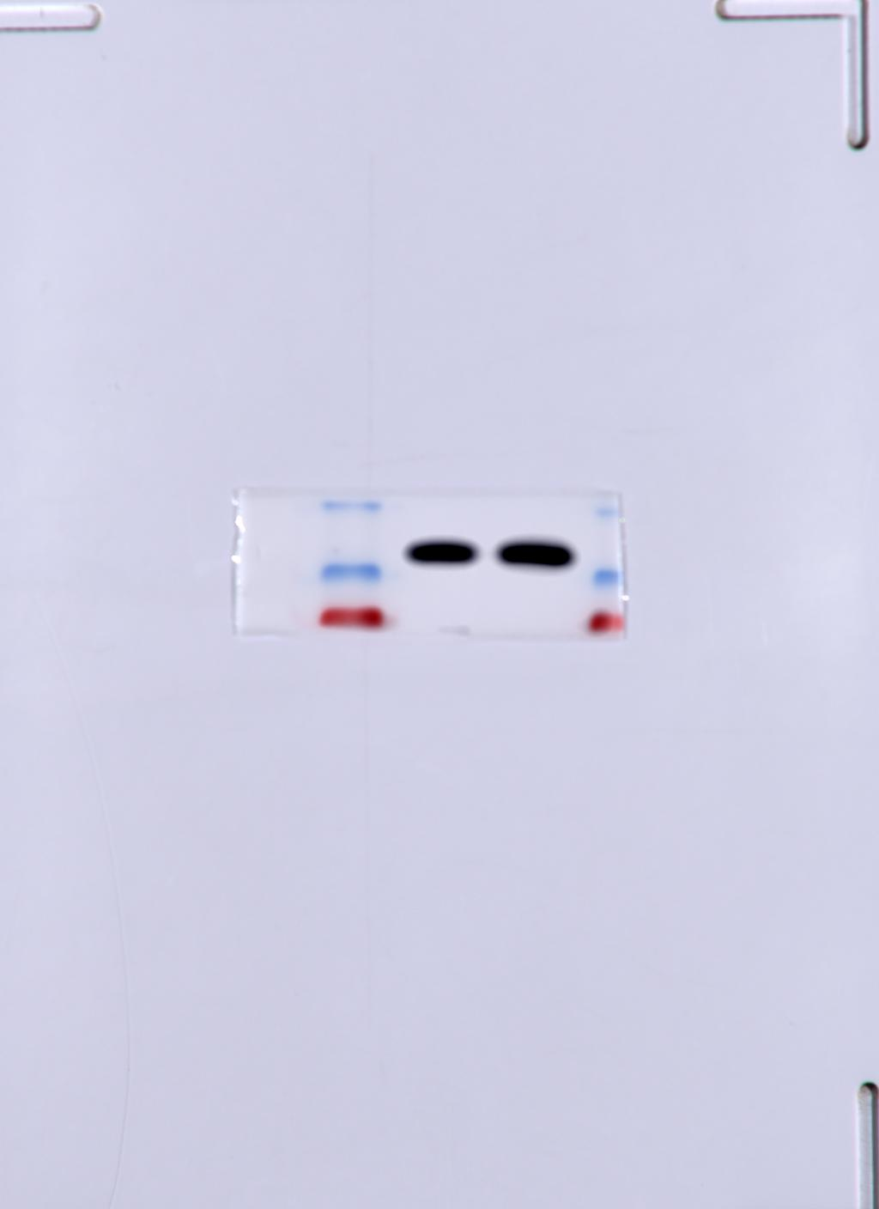
IκBα p50
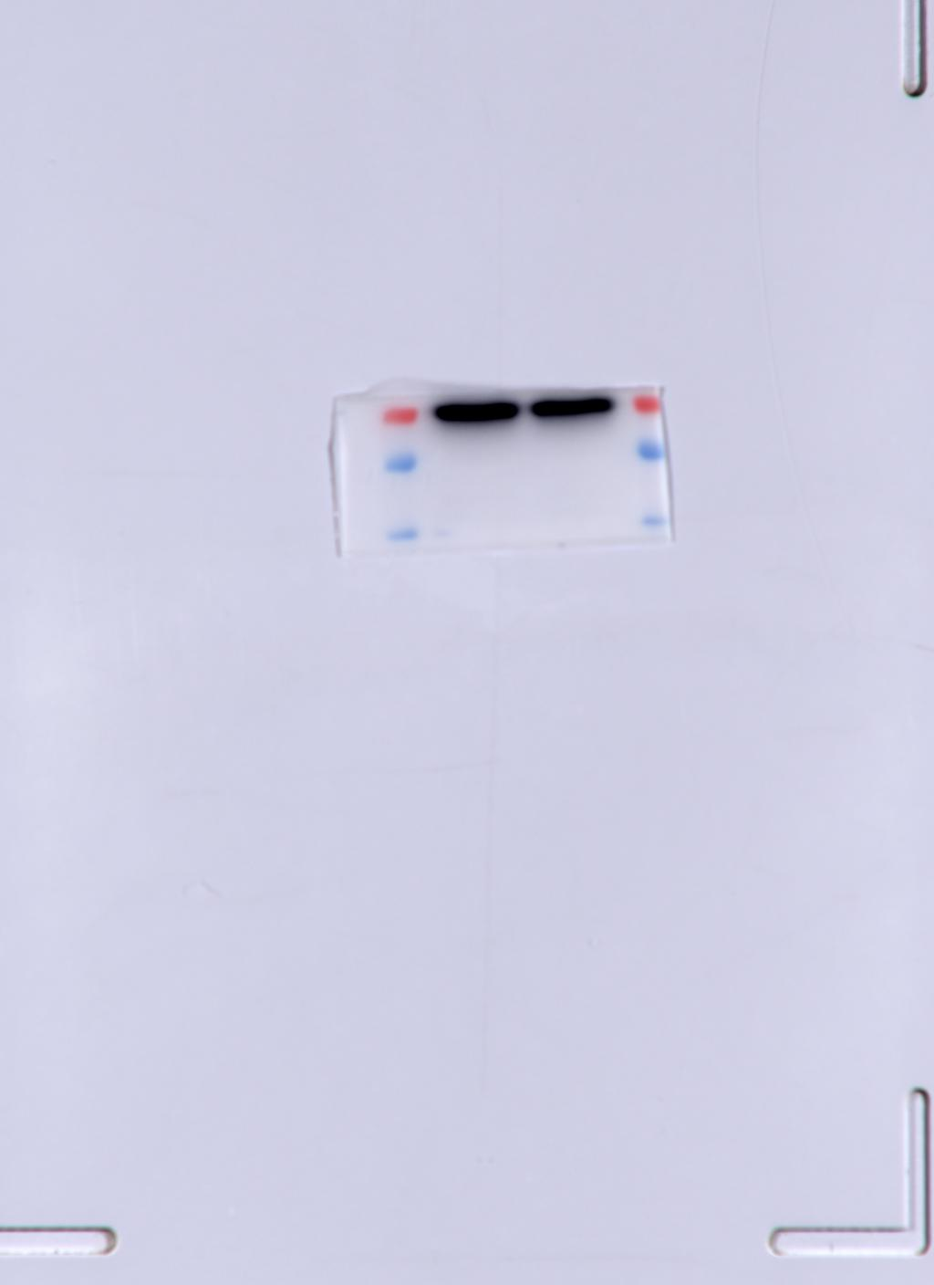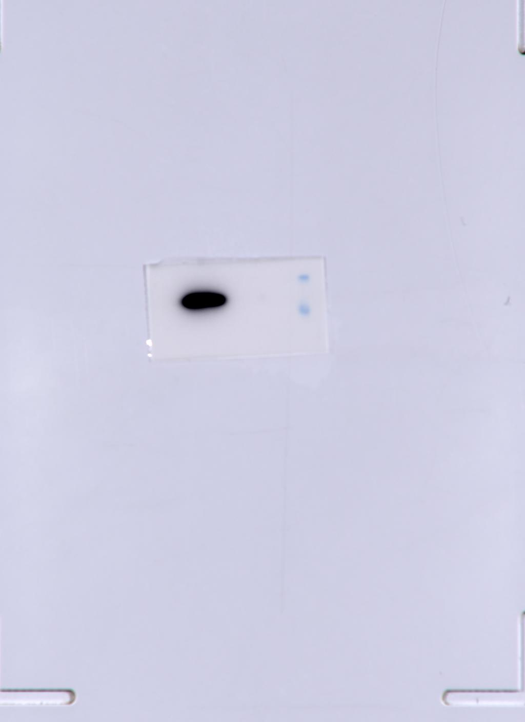
p65 Myc
 | pCMV-Myc |  | Myc-VP3
IkBα | 1 | 1 | 1 | 1.007121 | 1.005121 | 1.009121
p50 | 1 | 1 | 1 | 1.00345 | 1.03345 | 1.05345
p65 | 1 | 1 | 1 | 0.999887 | 0.999 | 1.099087

B
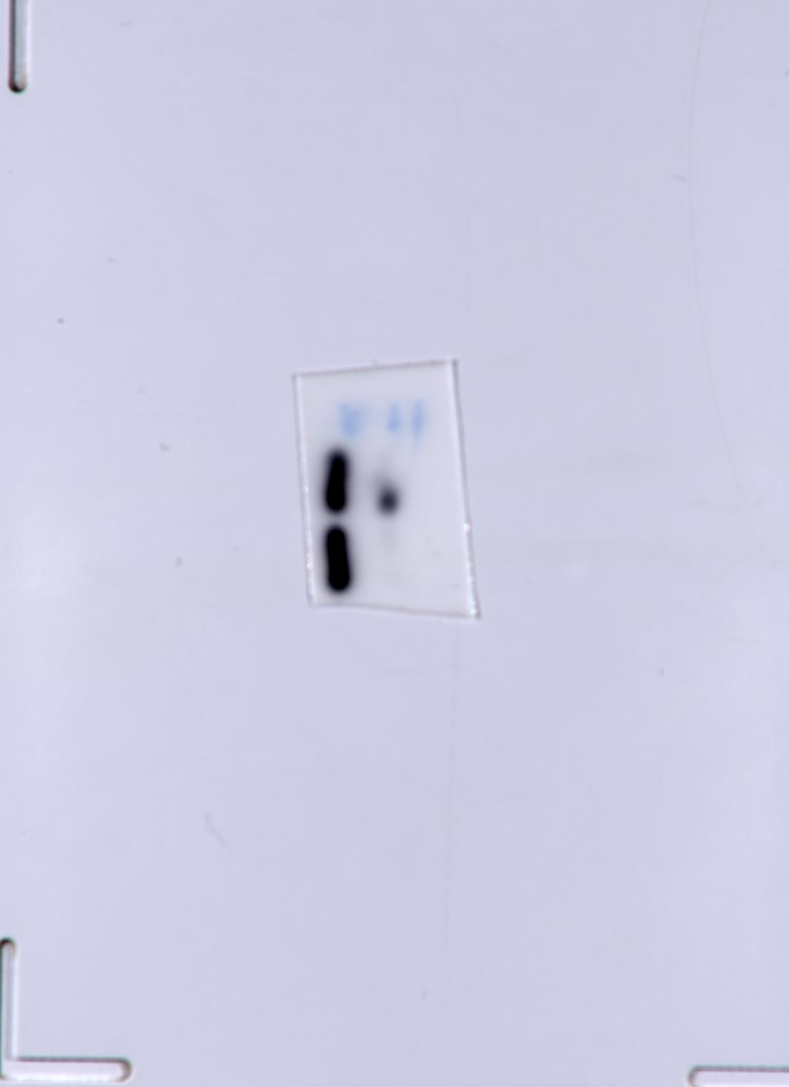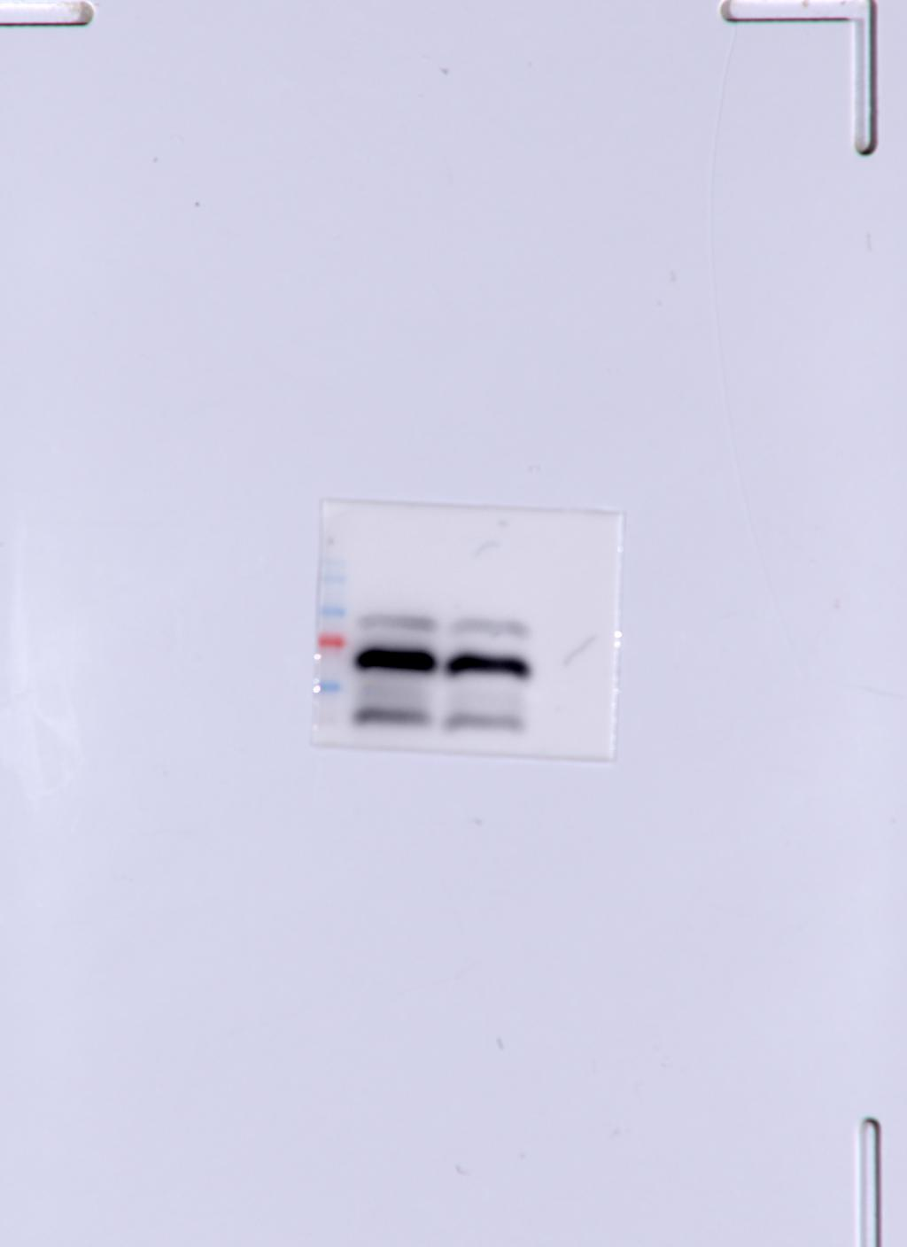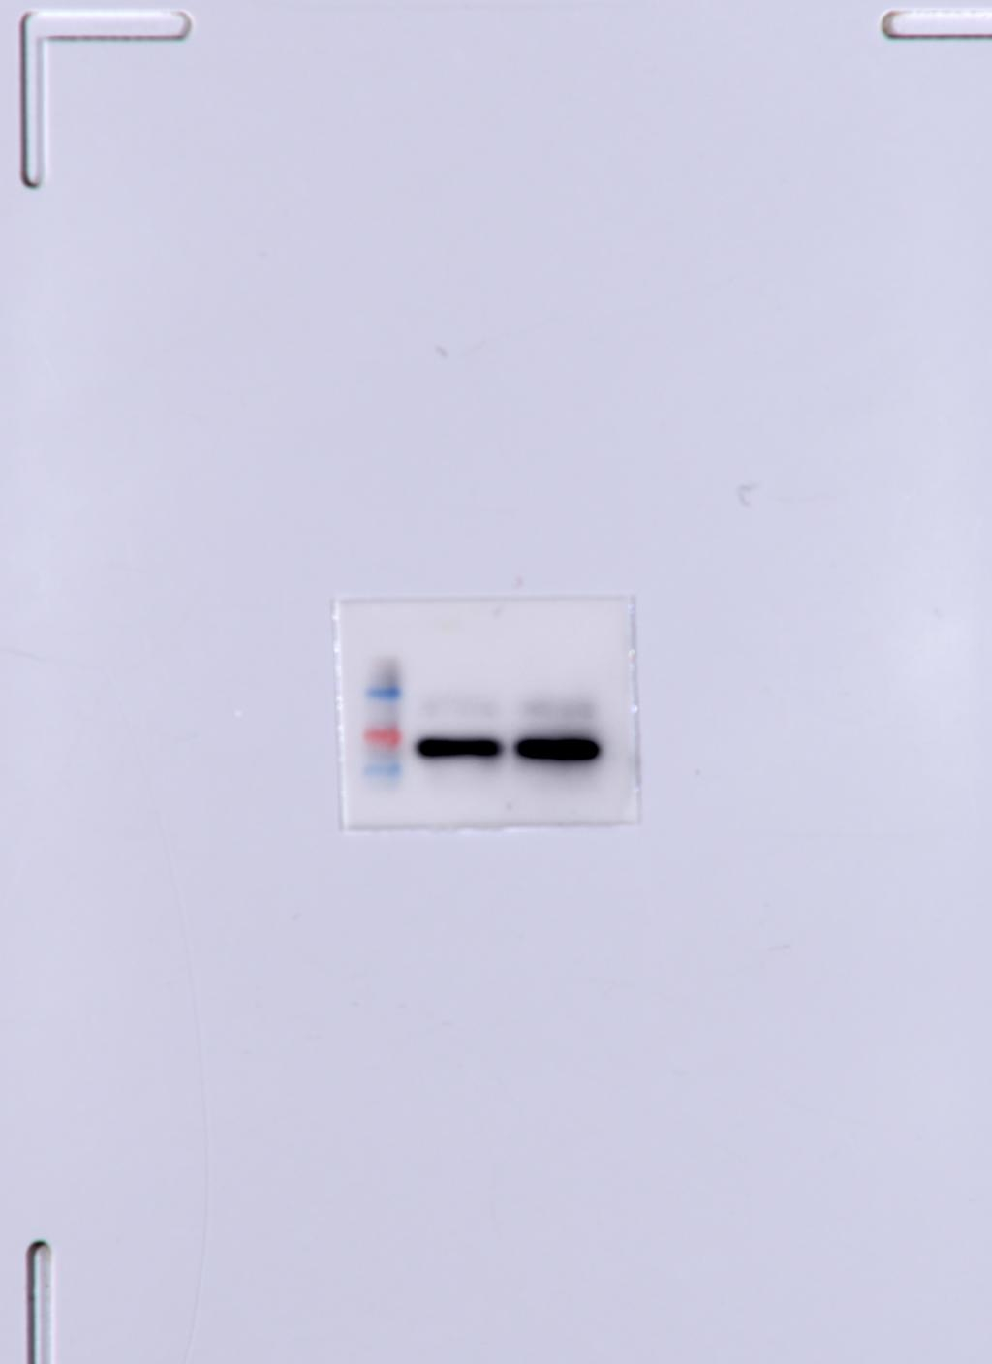
MDA5 MAVS TBK1
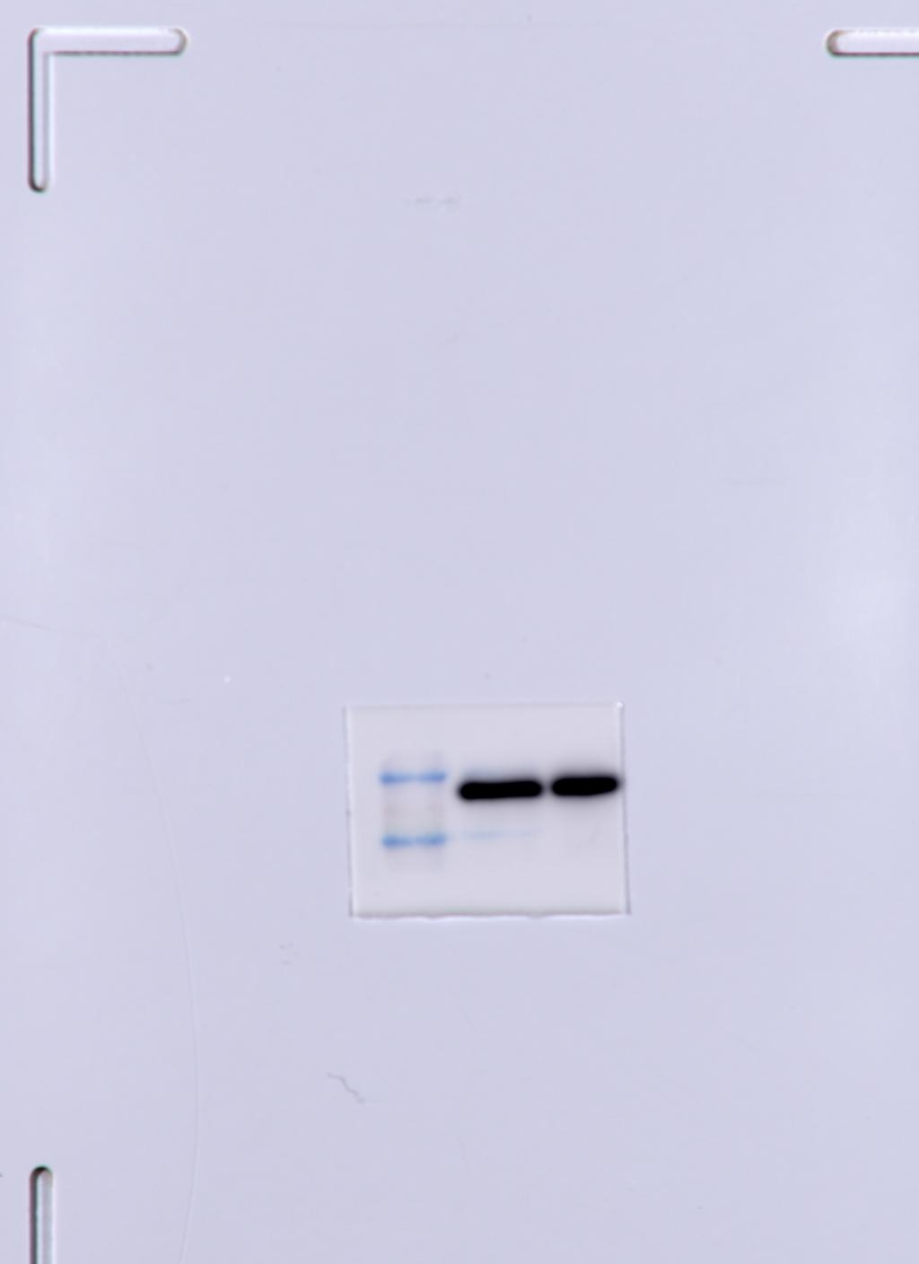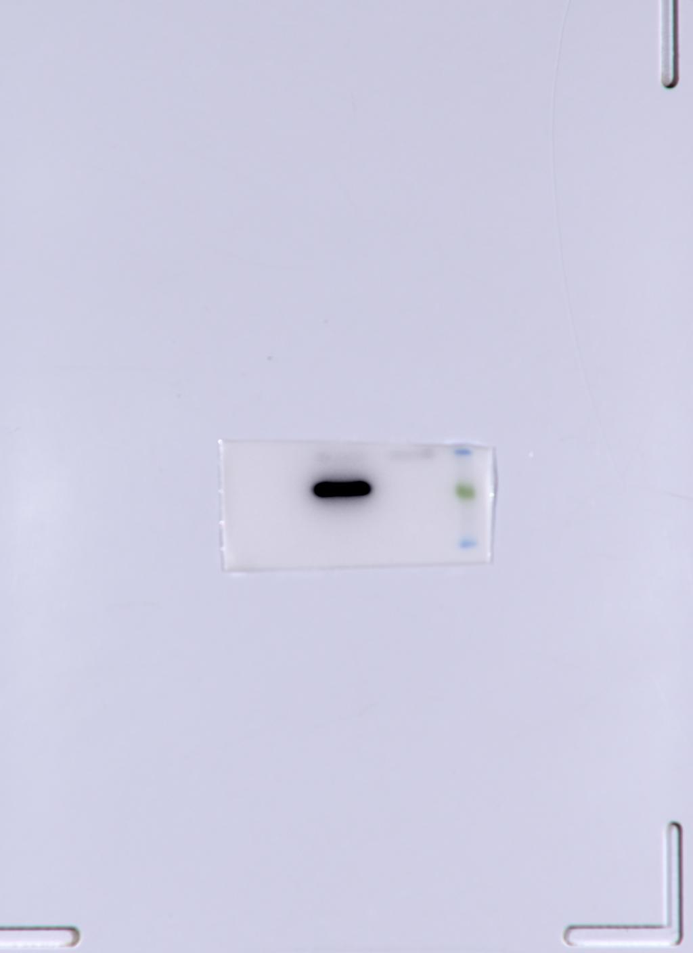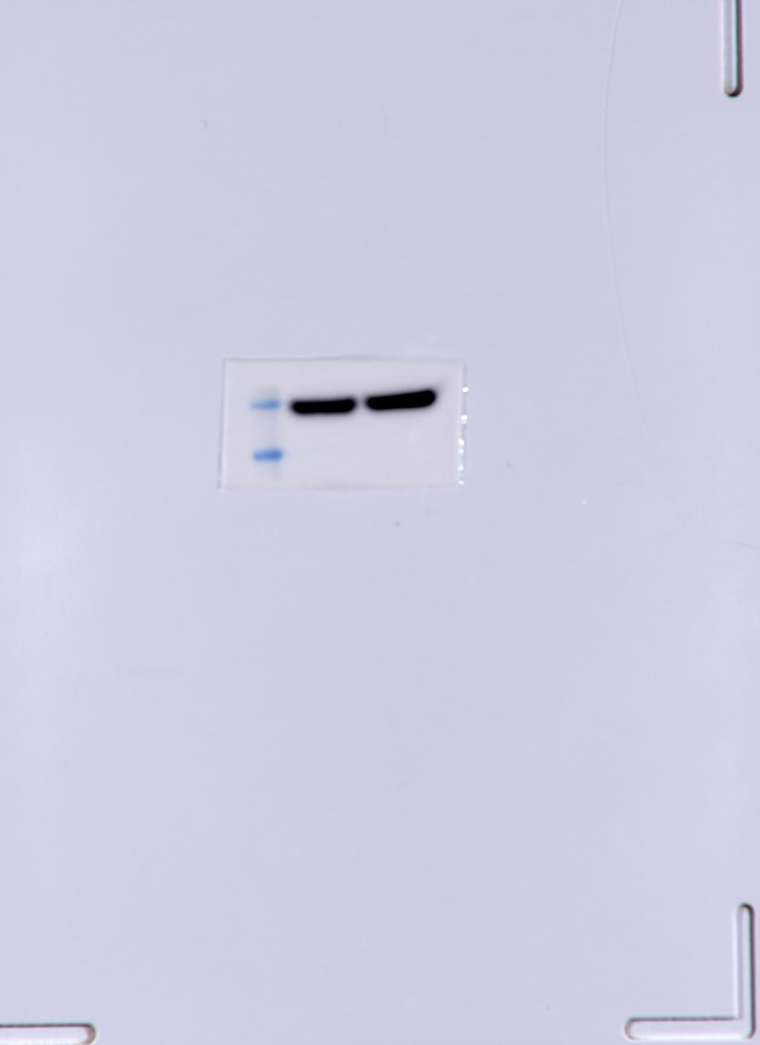
IRF3 Myc β-actin
 | pCMV-Myc |  |  | Myc-VP3
MDA5 | 1 | 1 | 1 | 0.902549 | 0.952549 | 0.992549
MAVS | 1 | 1 | 1 | 0.453829 | 0.553829 | 0.503829
TBK1 | 1 | 1 | 1 | 1.033297 | 0.983297 | 1.083297
IRF3 | 1 | 1 | 1 | 0.831775 | 0.900049 | 0.923549

C
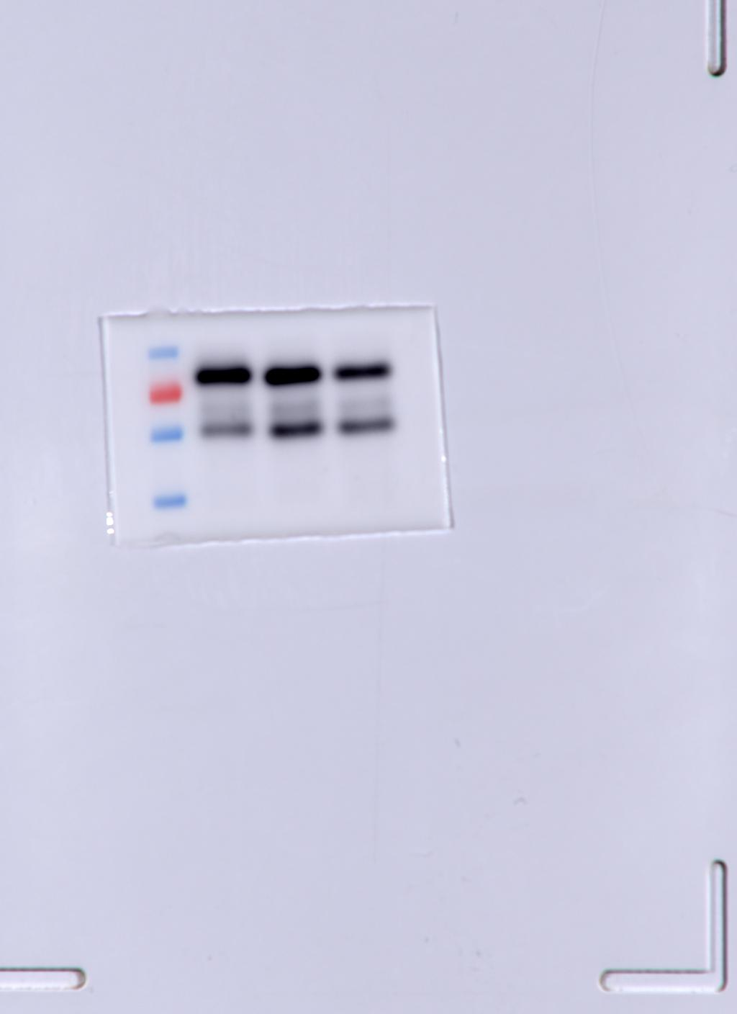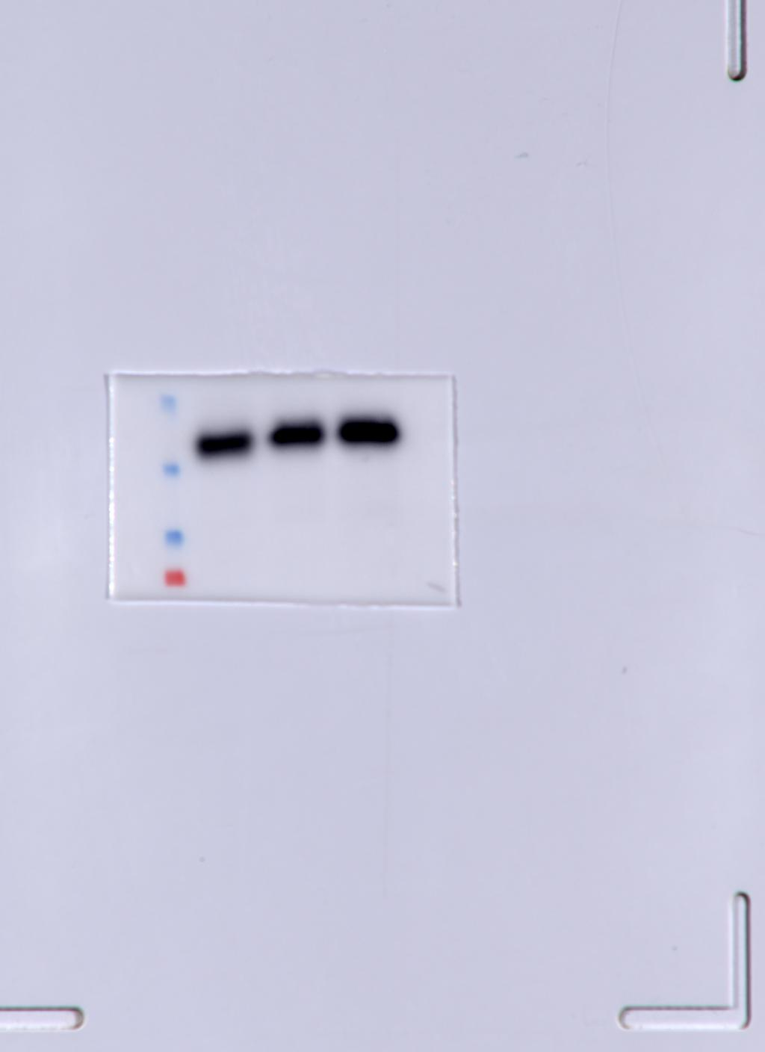
MAVS STING

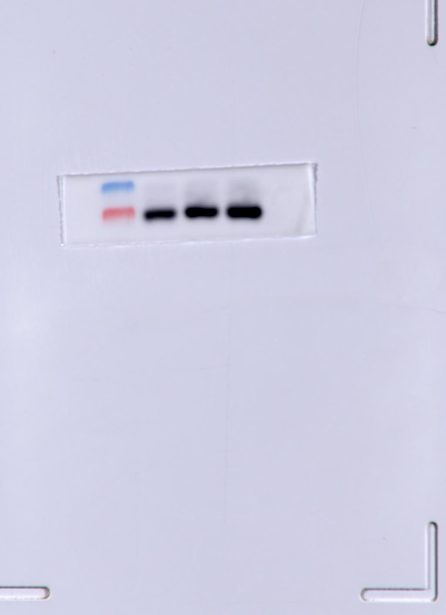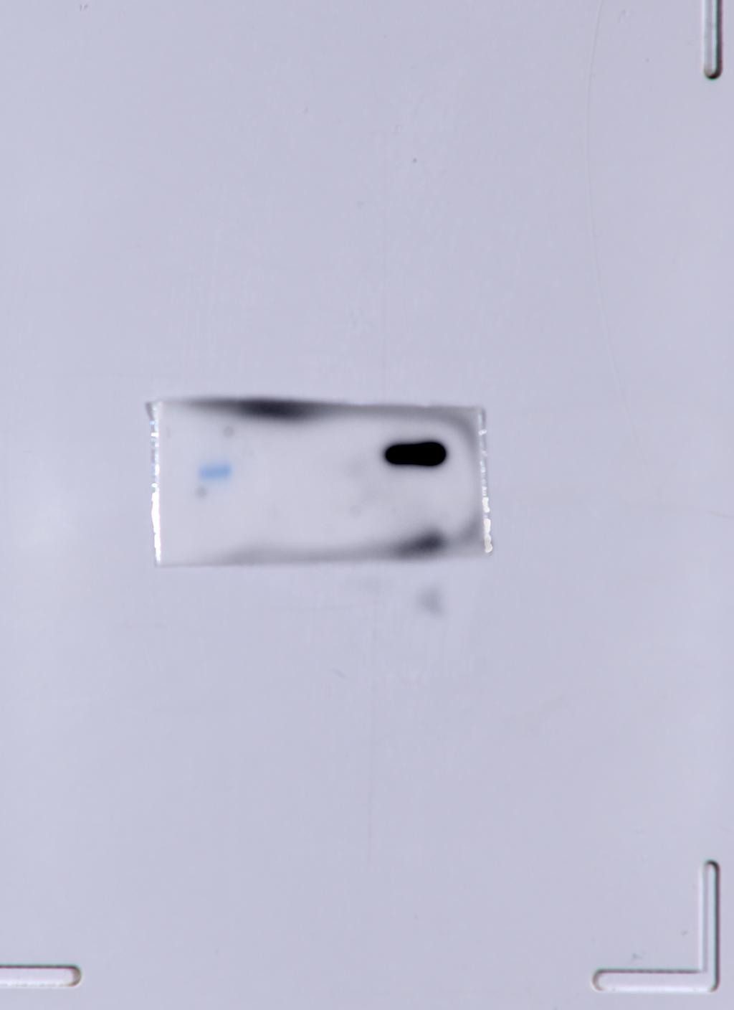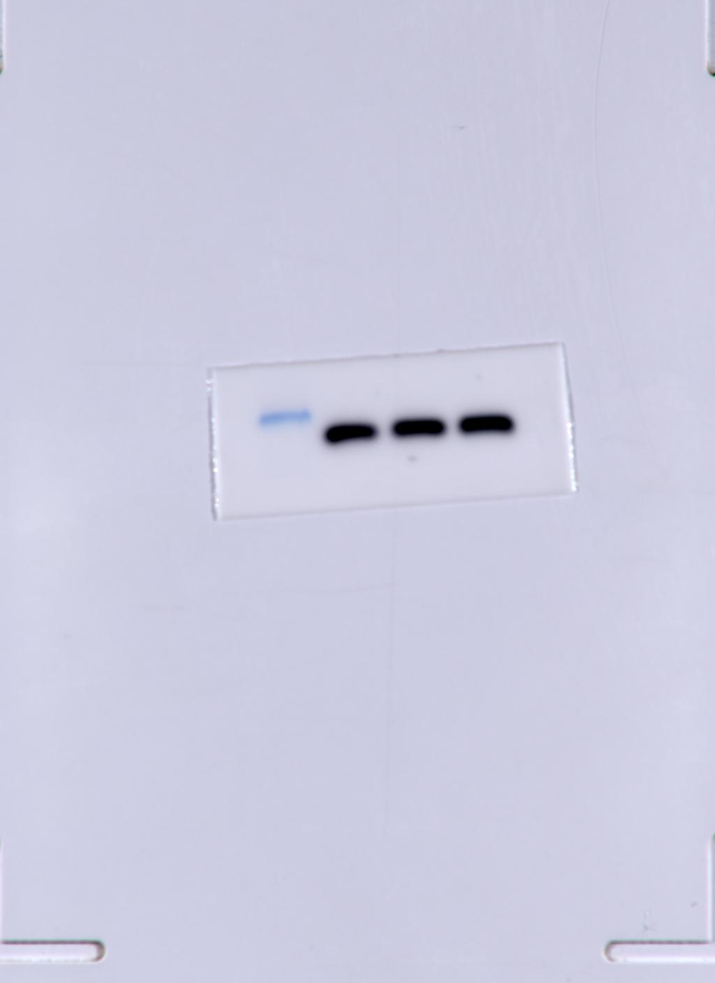
p65 Myc β-actin
D
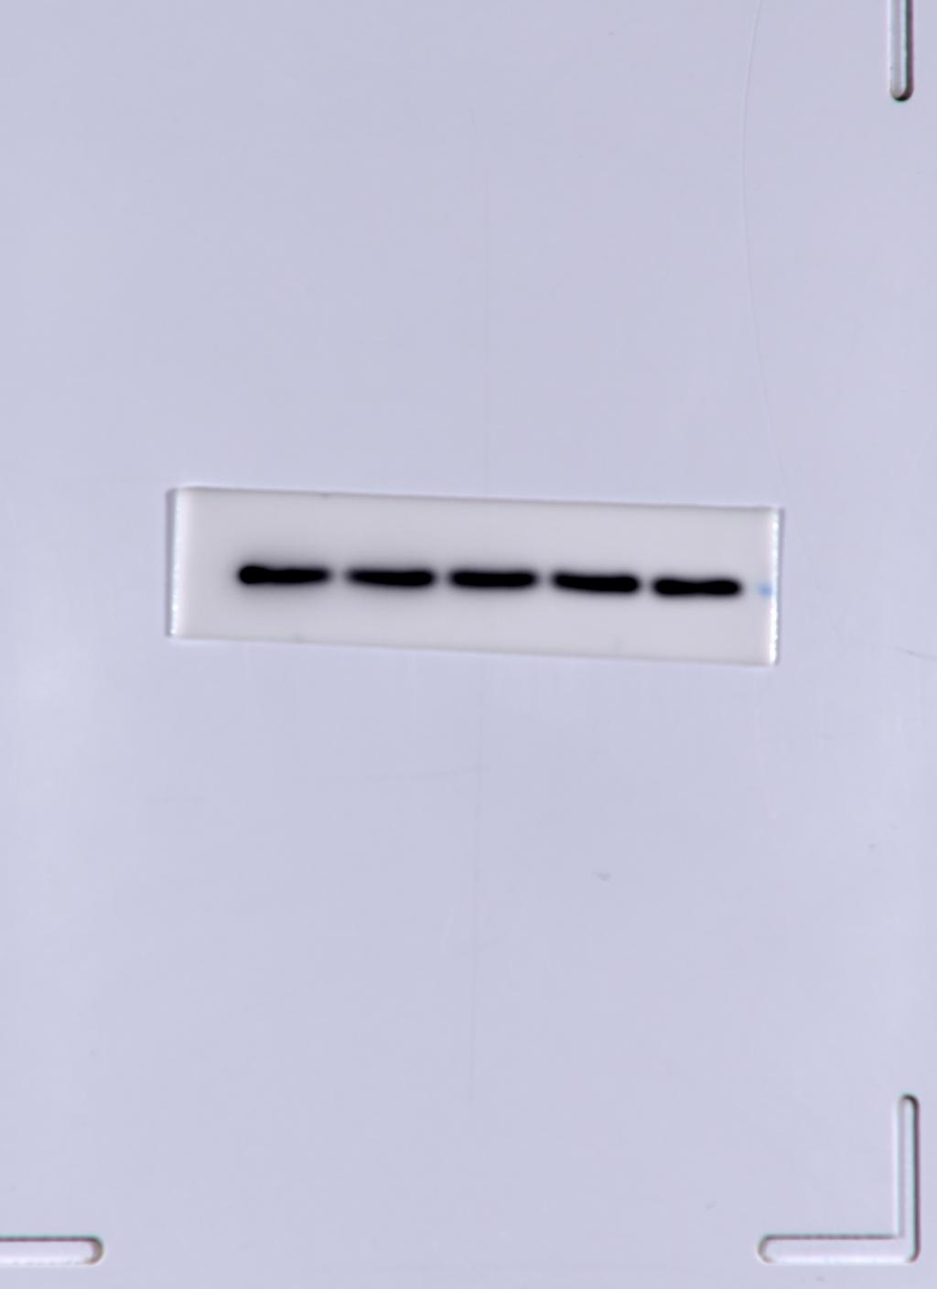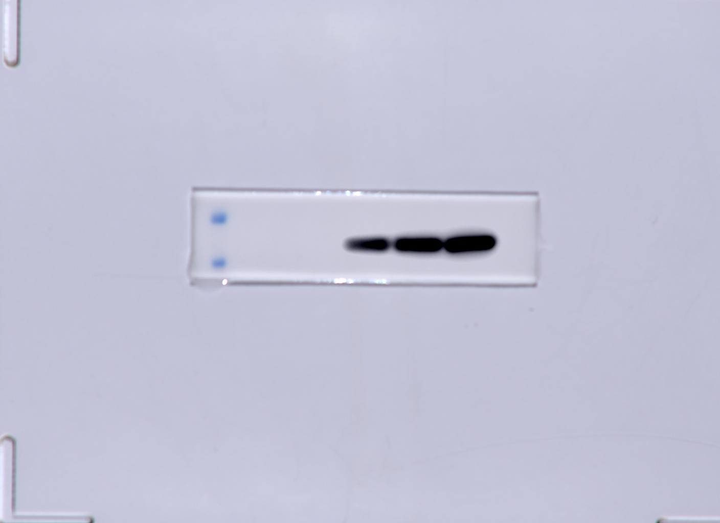
β-actin Myc
Blank
1 | 0.807965 | 1.237677
ploy(I:C)+EV
2051.967 | 2080.91 | 2064.279
ploy(I:C)+0.5ug Myc-VP3
1746.495 | 1745.89 | 1773.132
ploy(I:C)+1.0ug Myc-VP3
707.0571 | 650.6678 | 768.3334
ploy(I:C)+1.5ug Myc-VP3
673.3945 | 681.9915 | 679.1526

Fig4
A
Blank
1 | 0.856 | 1.168
HA-MAVS+EV
74.111 | 69.97 | 78.496
HA-MAVS+Myc-VP3
1.728 | 1.449 | 2.061

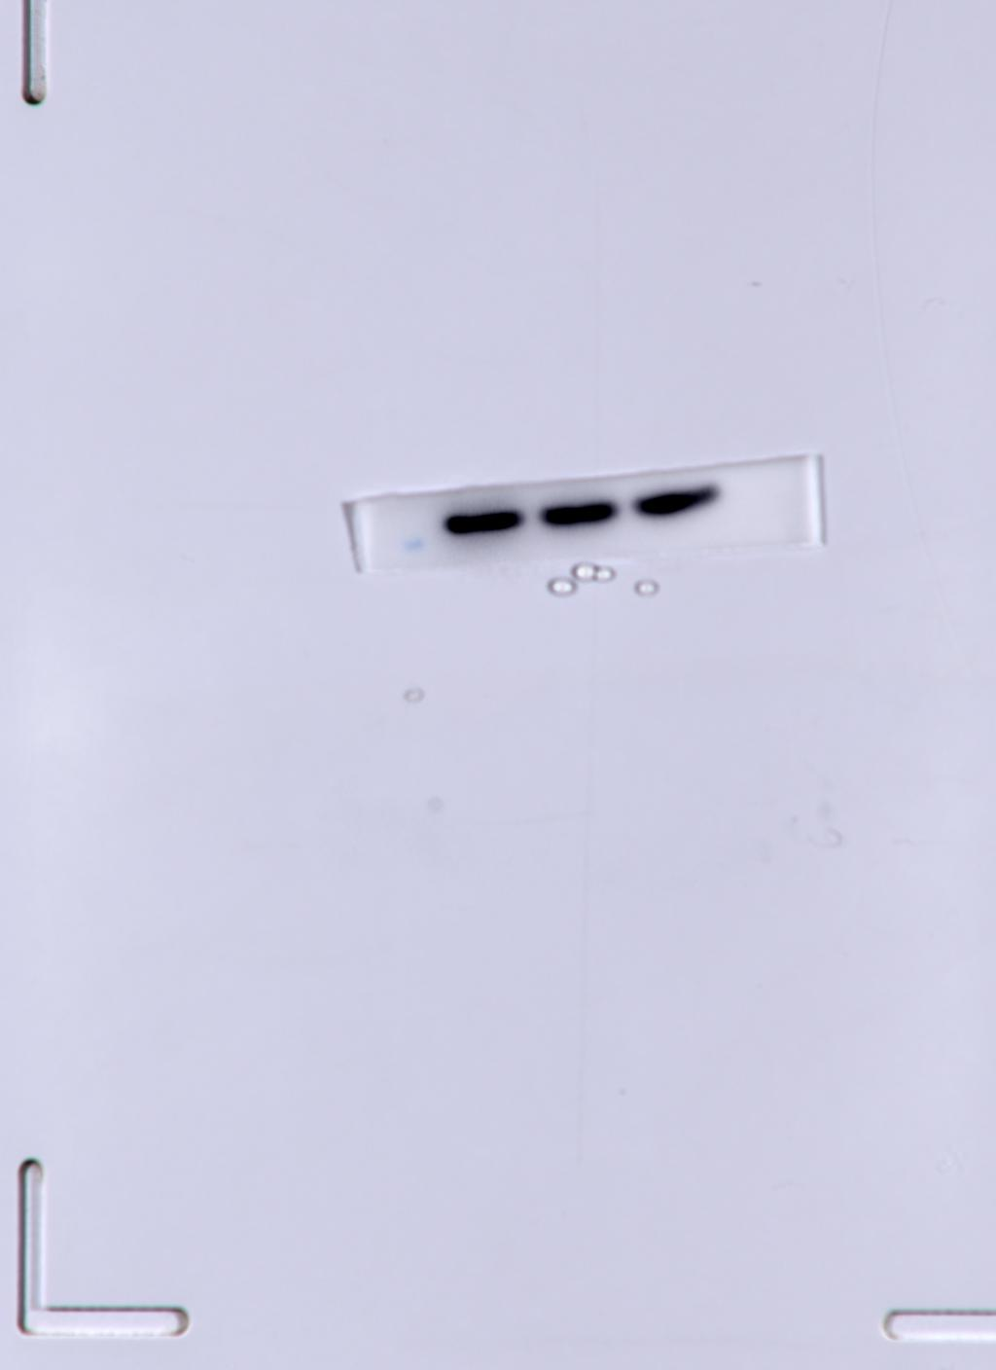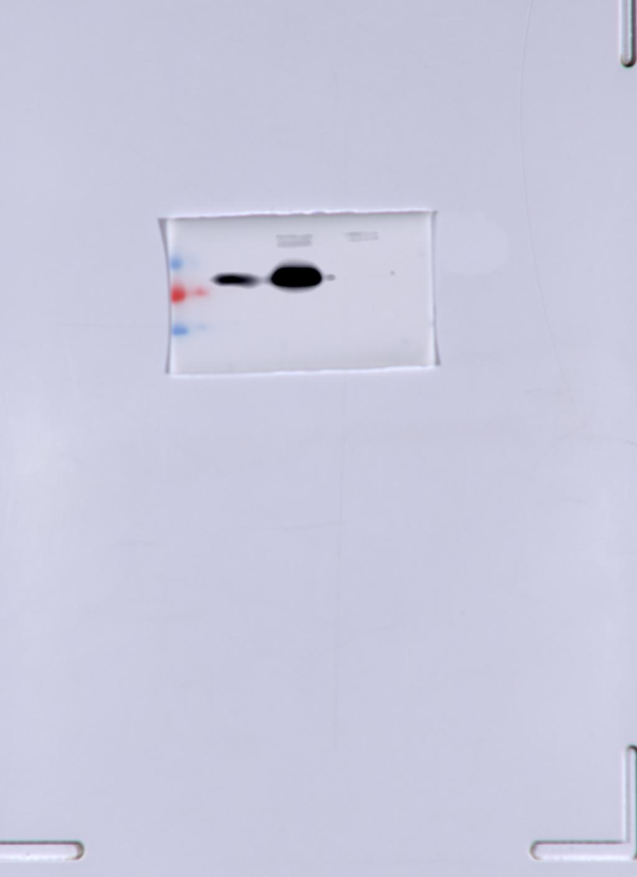
β-actin HA-MAVS
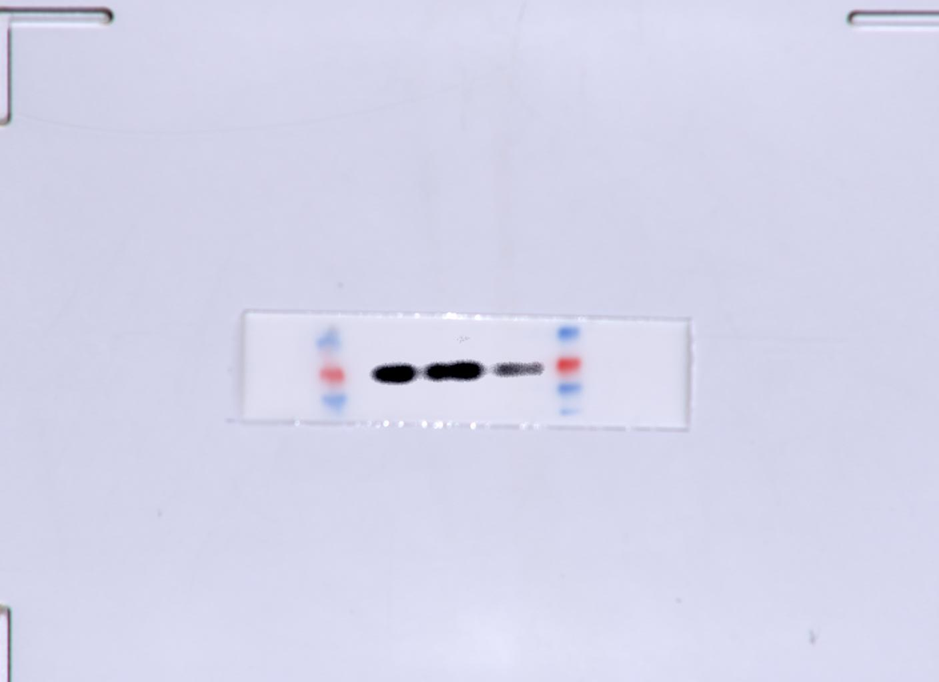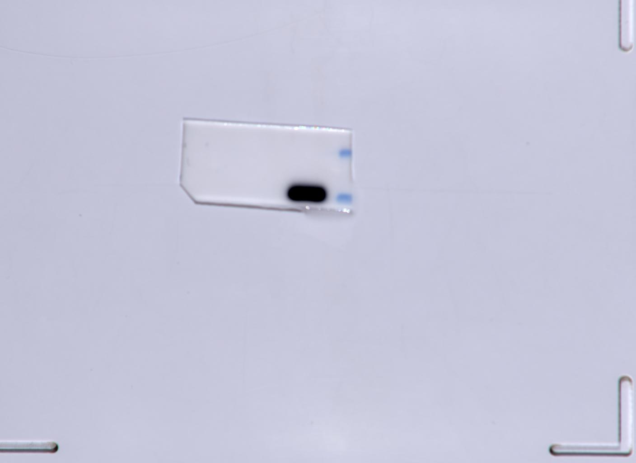
MAVS Myc-VP3
B
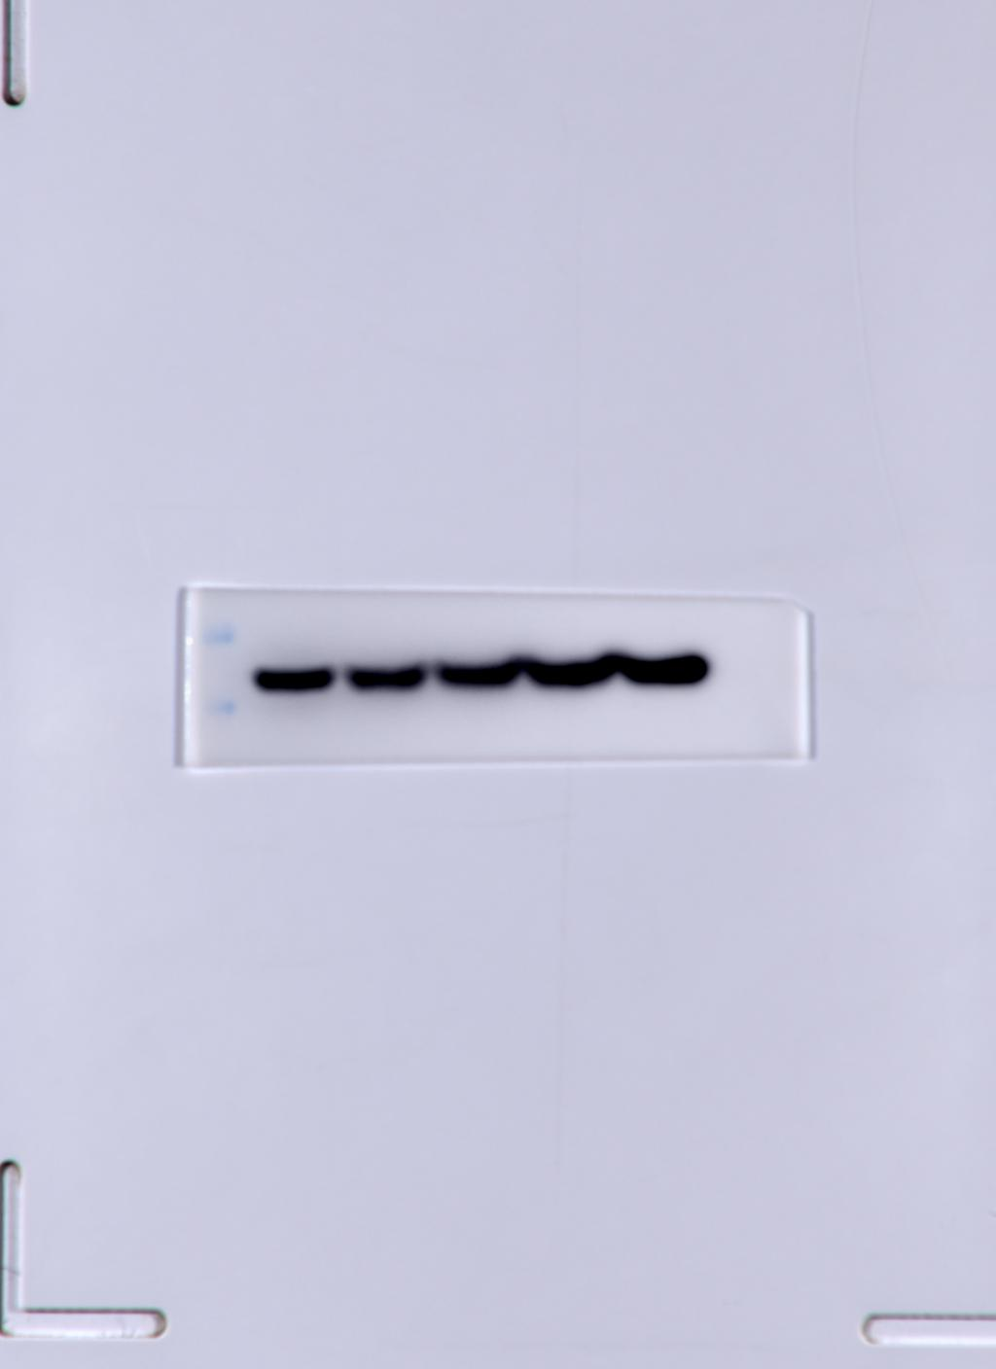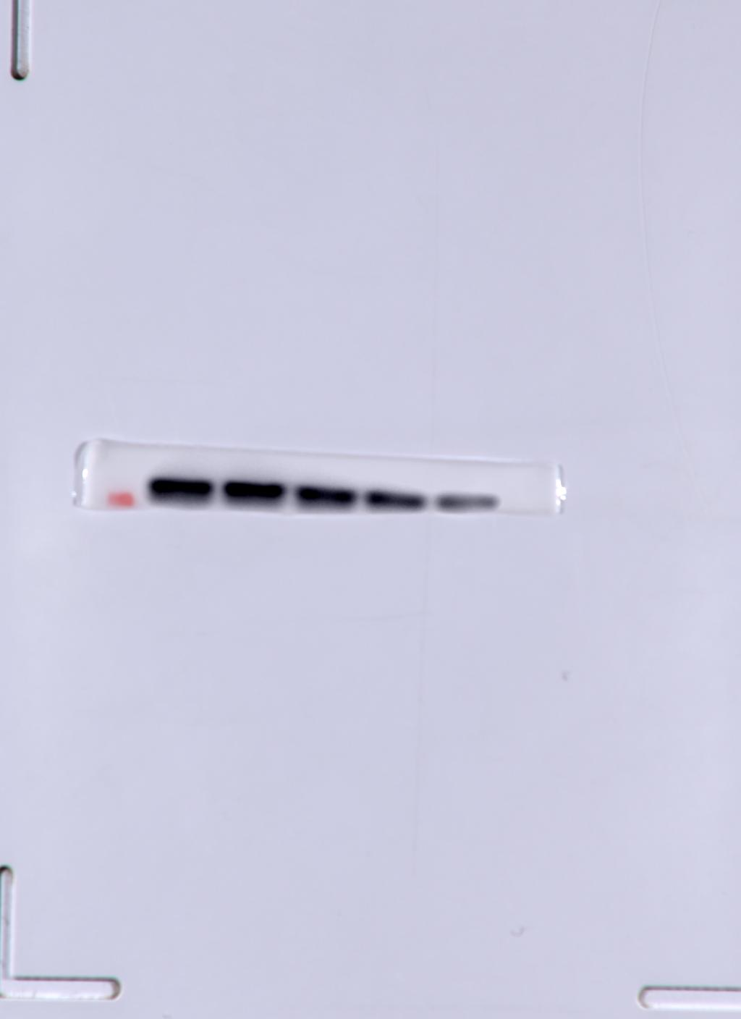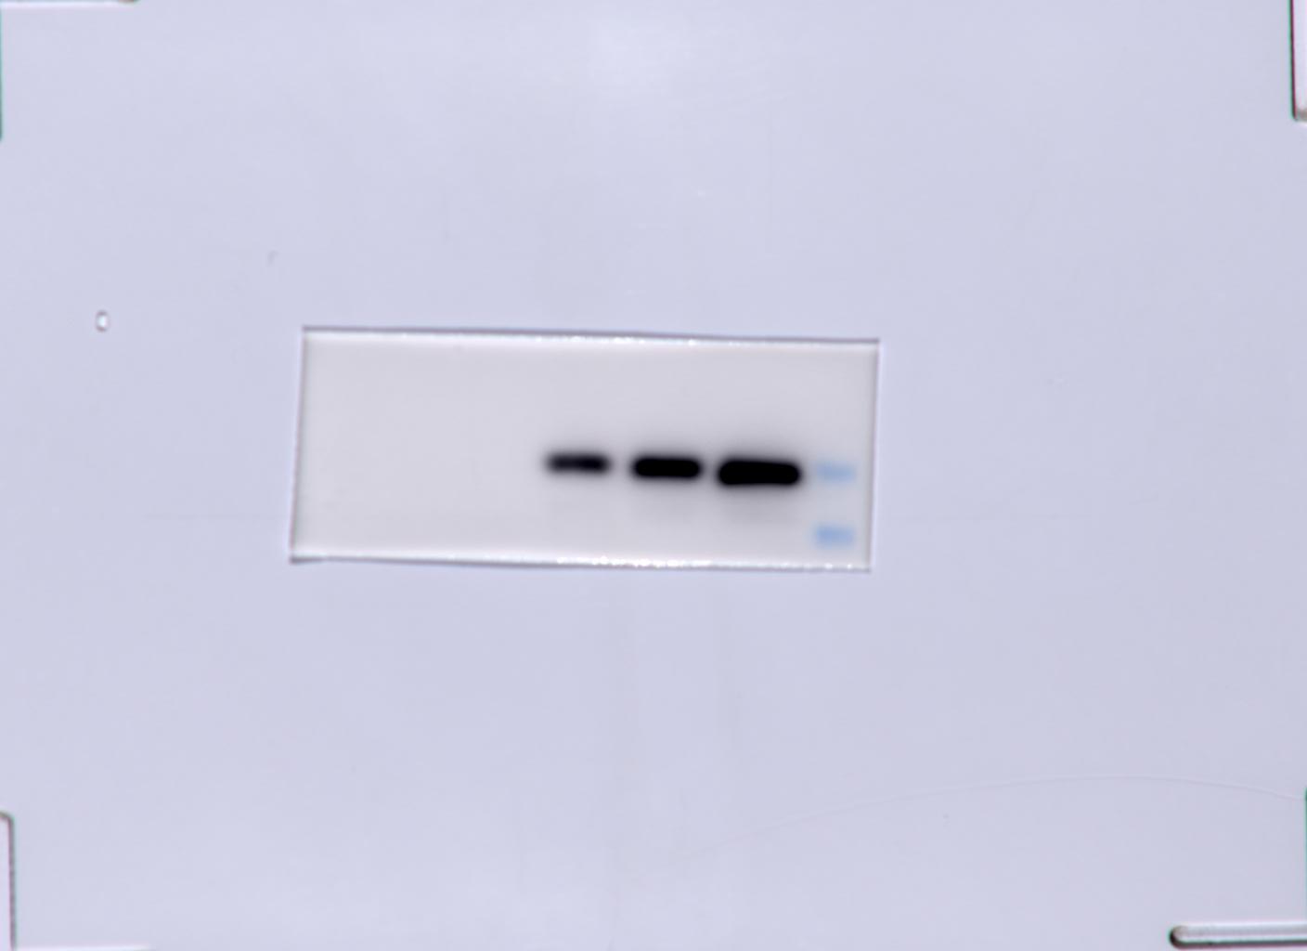
β-actin MAVS Myc-VP3

Fig5
A
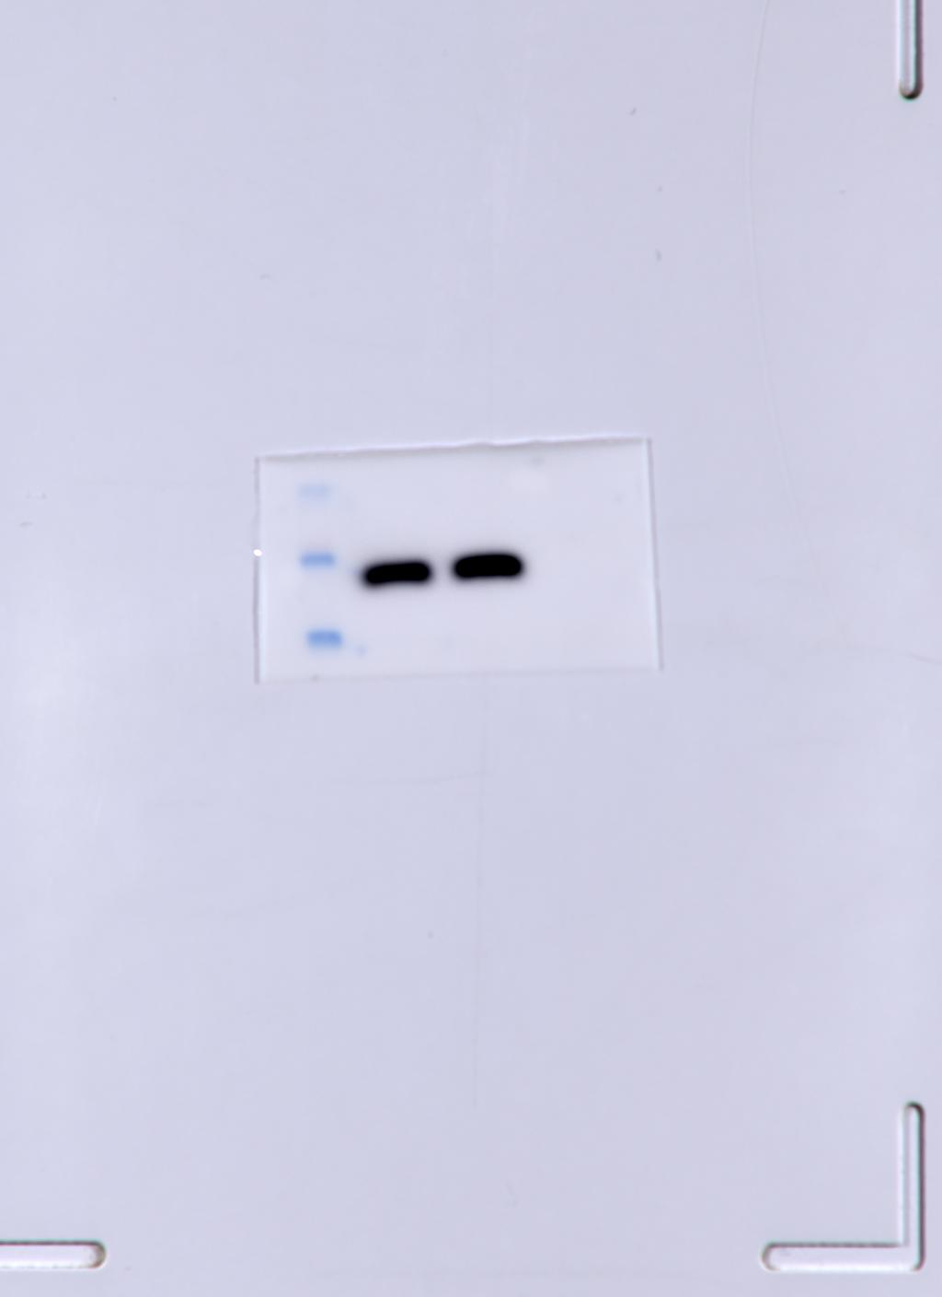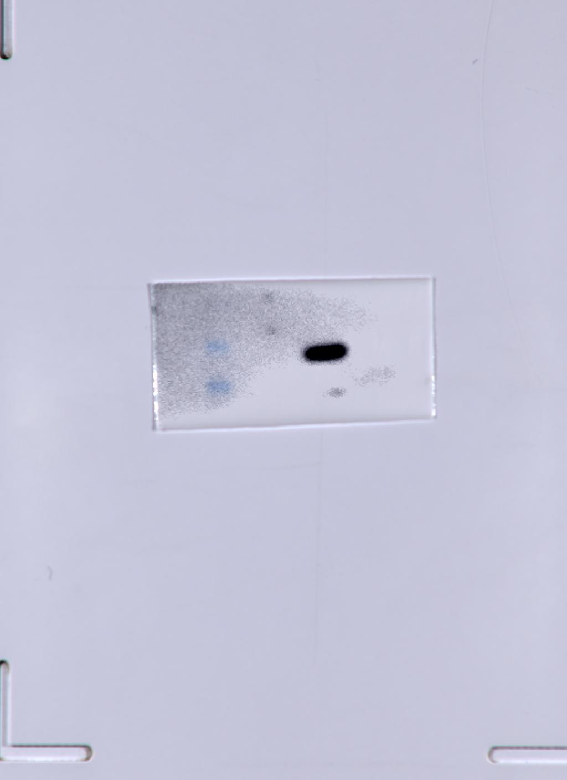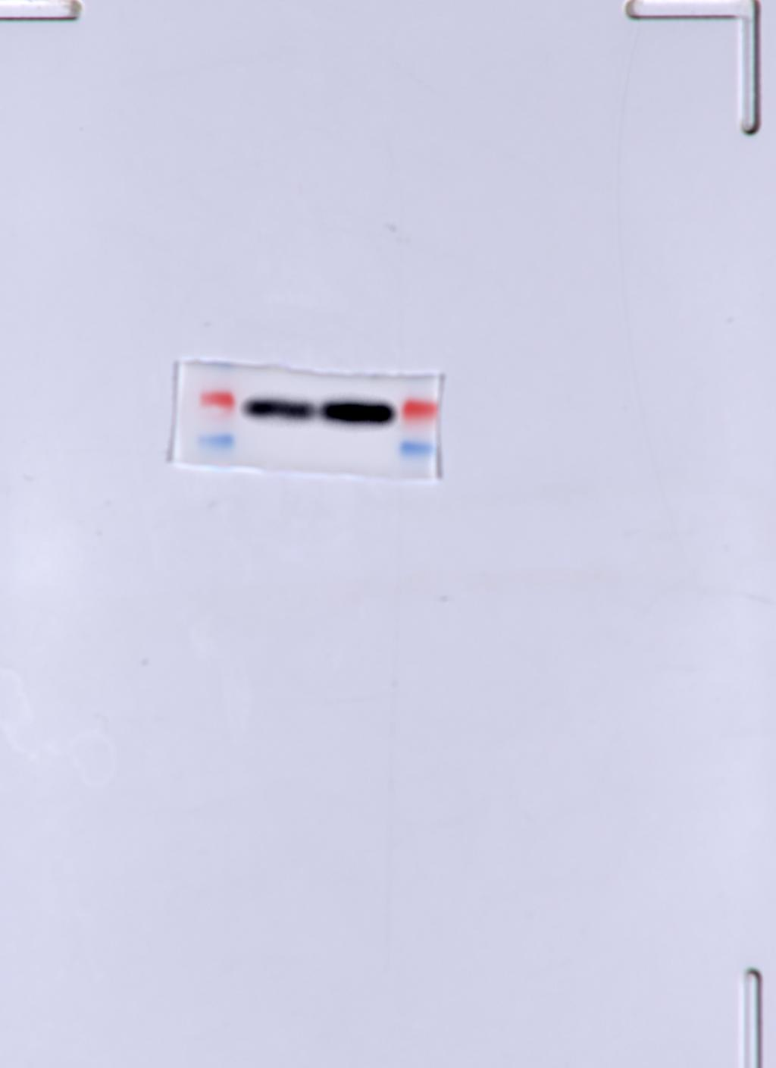
input β-actin input Myc-VP3 input MAVS

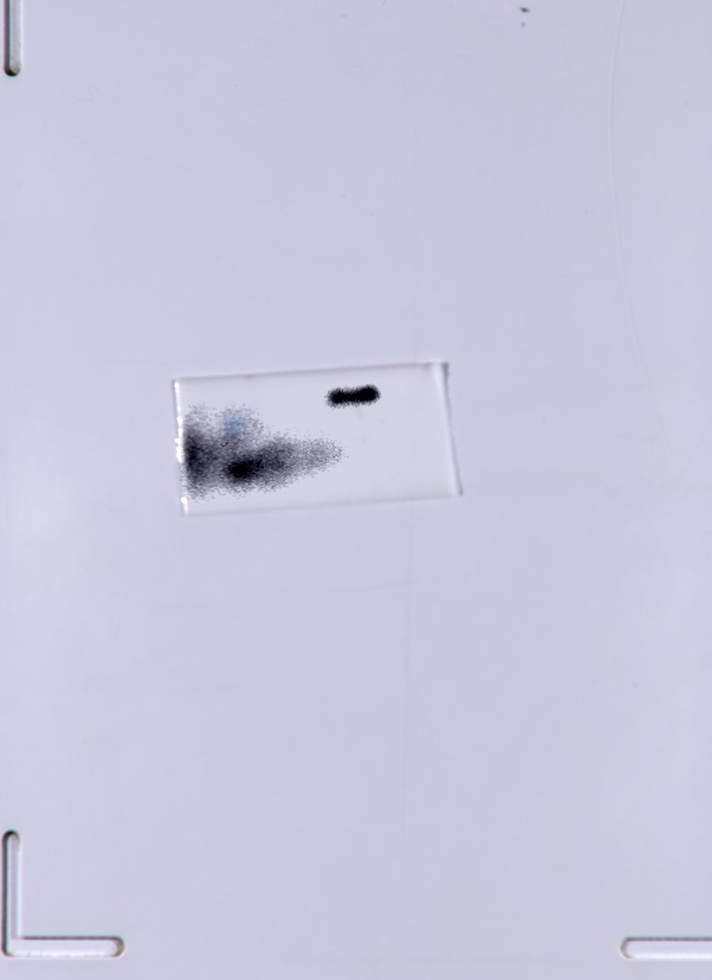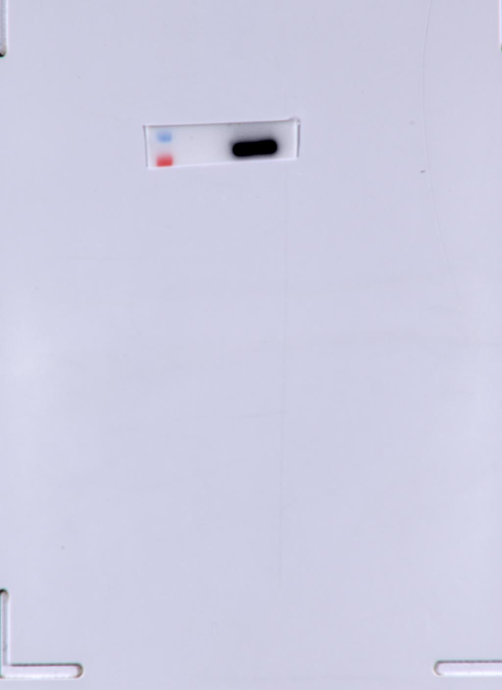
IP Myc-VP3 IP MAVS
B
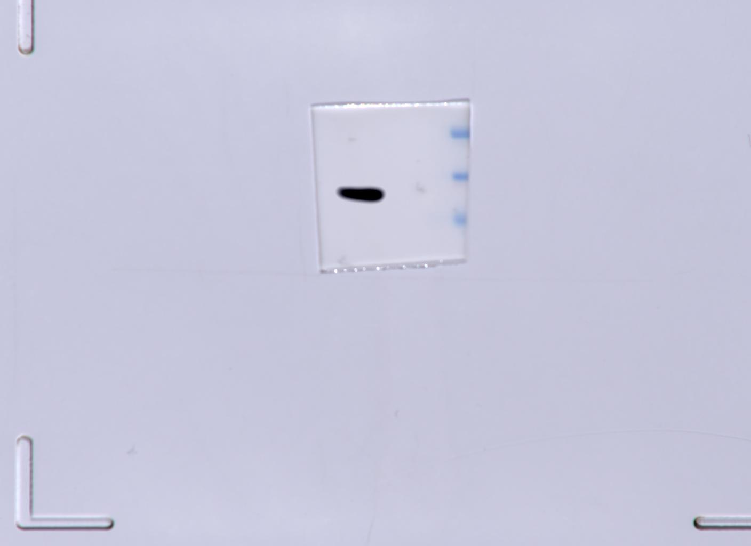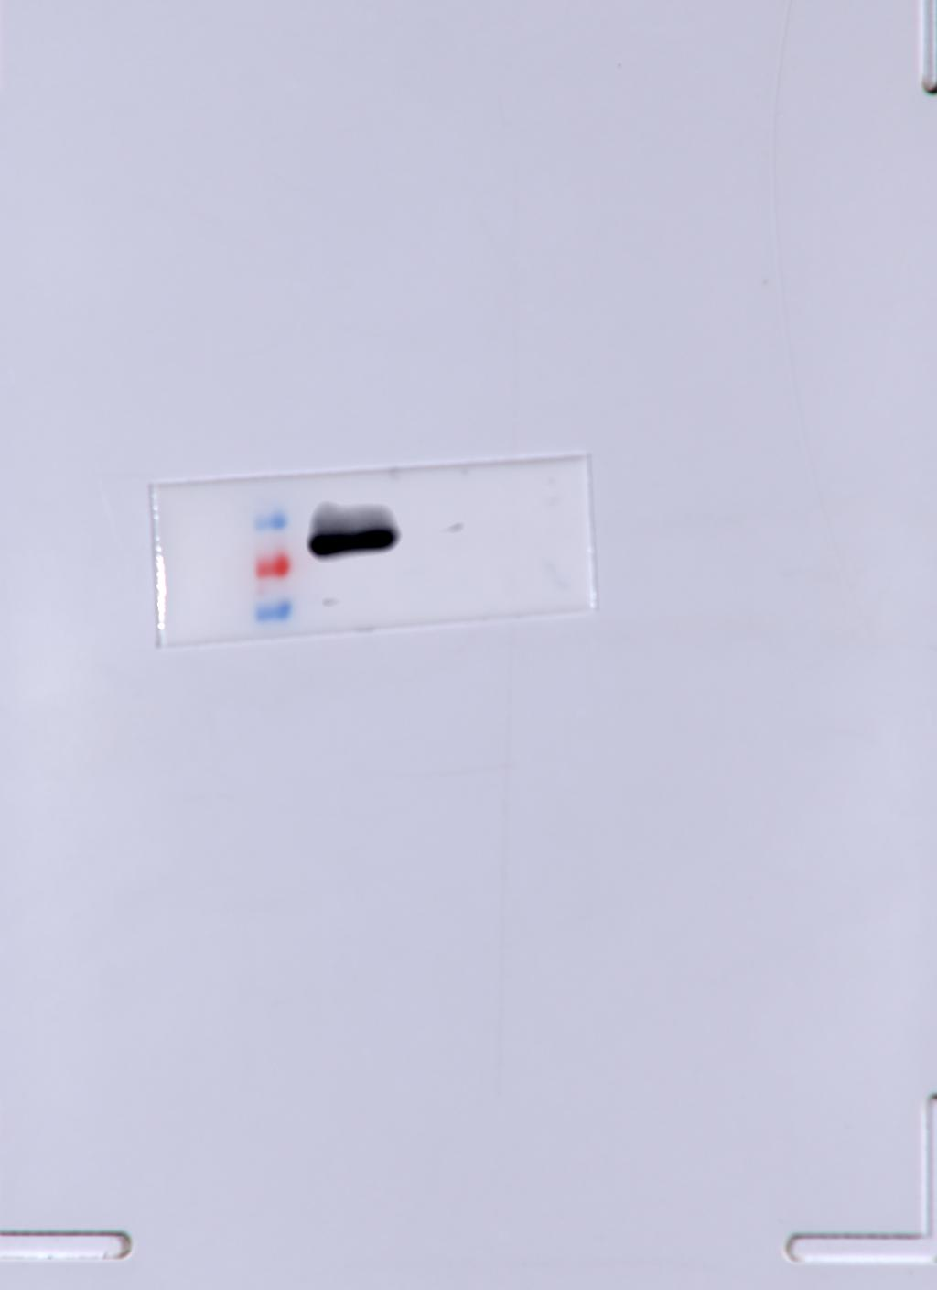
Input Myc-VP3 IP MAVS
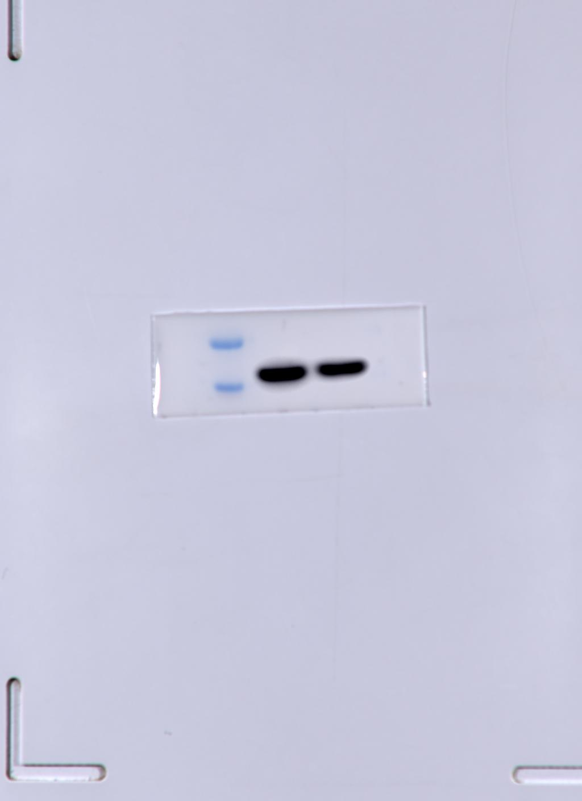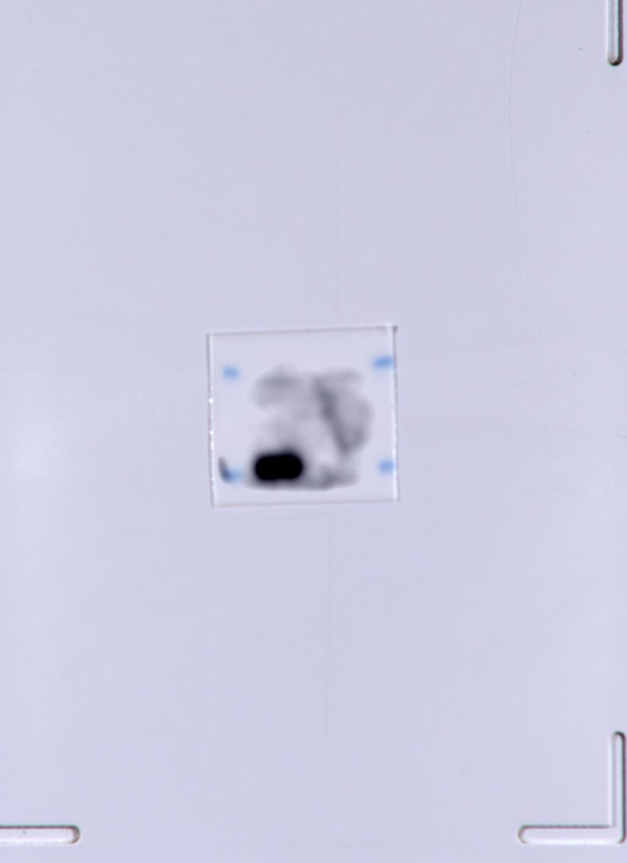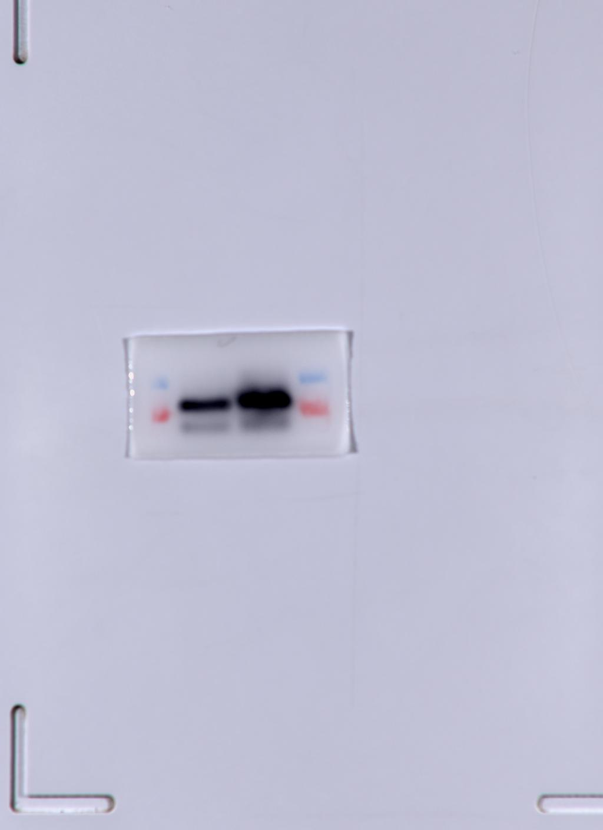
input β-actin IP Myc-VP3 input MAVS
C
pCMV-Myc group
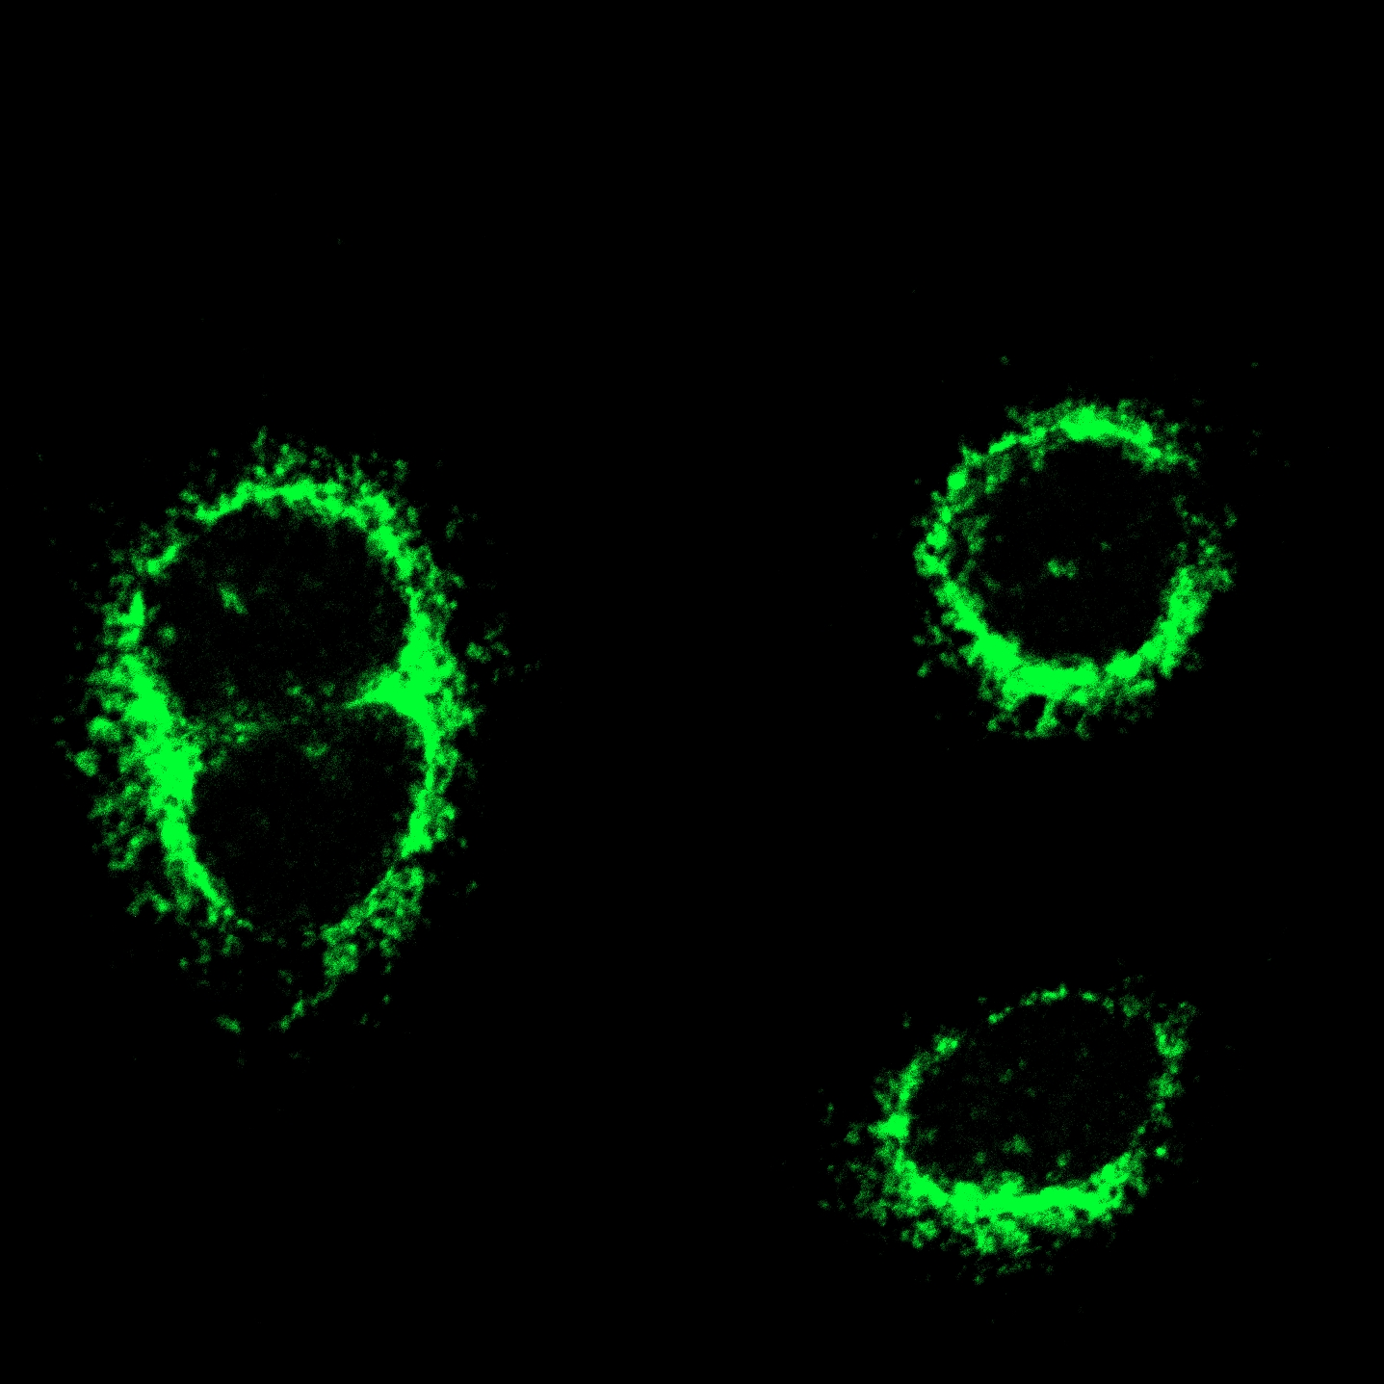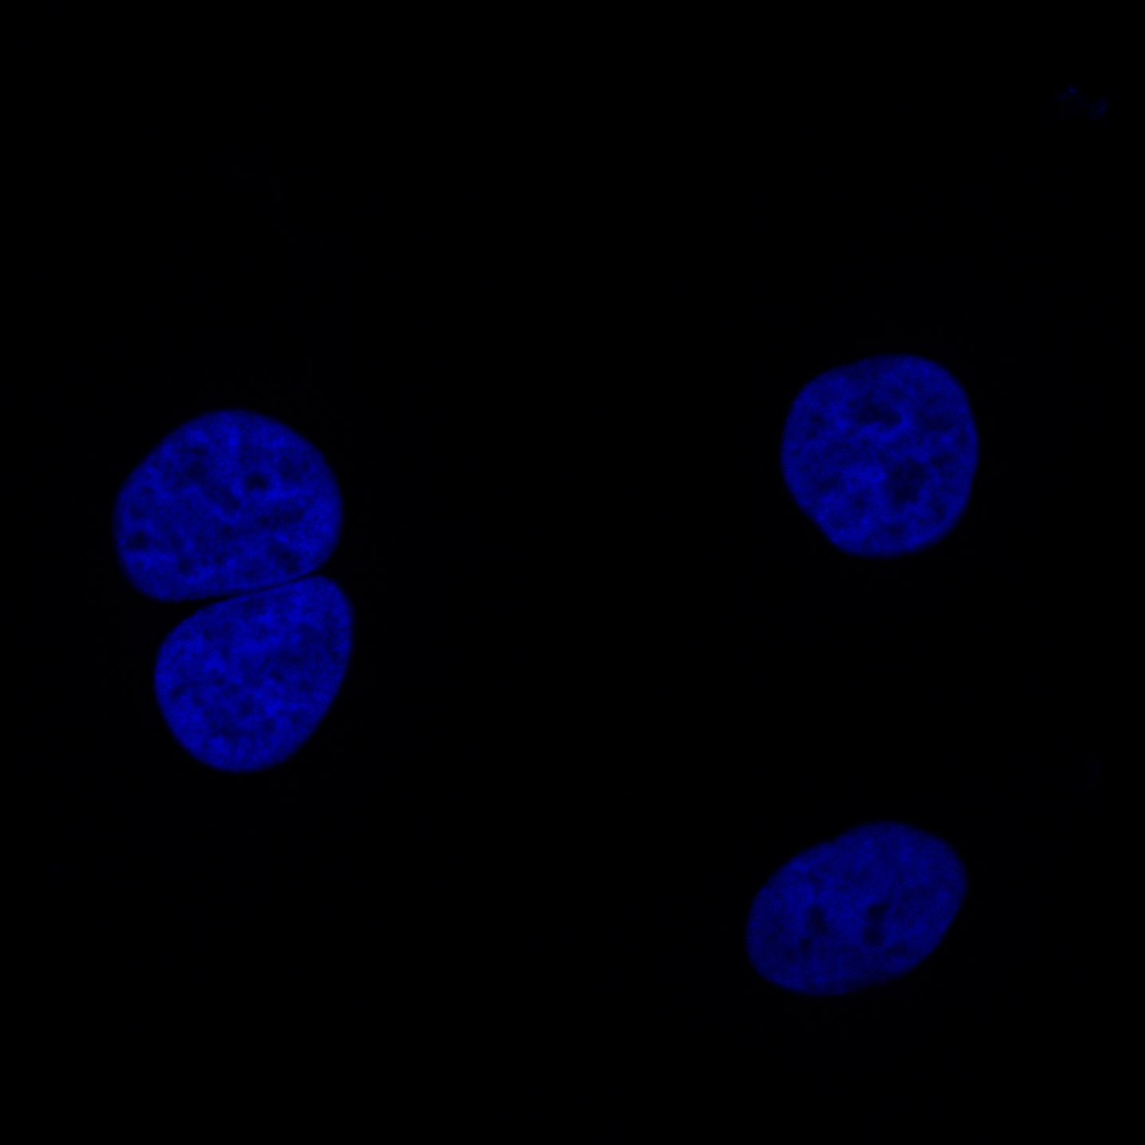
Myc(Cy3) MAVS(AF488) DAPI
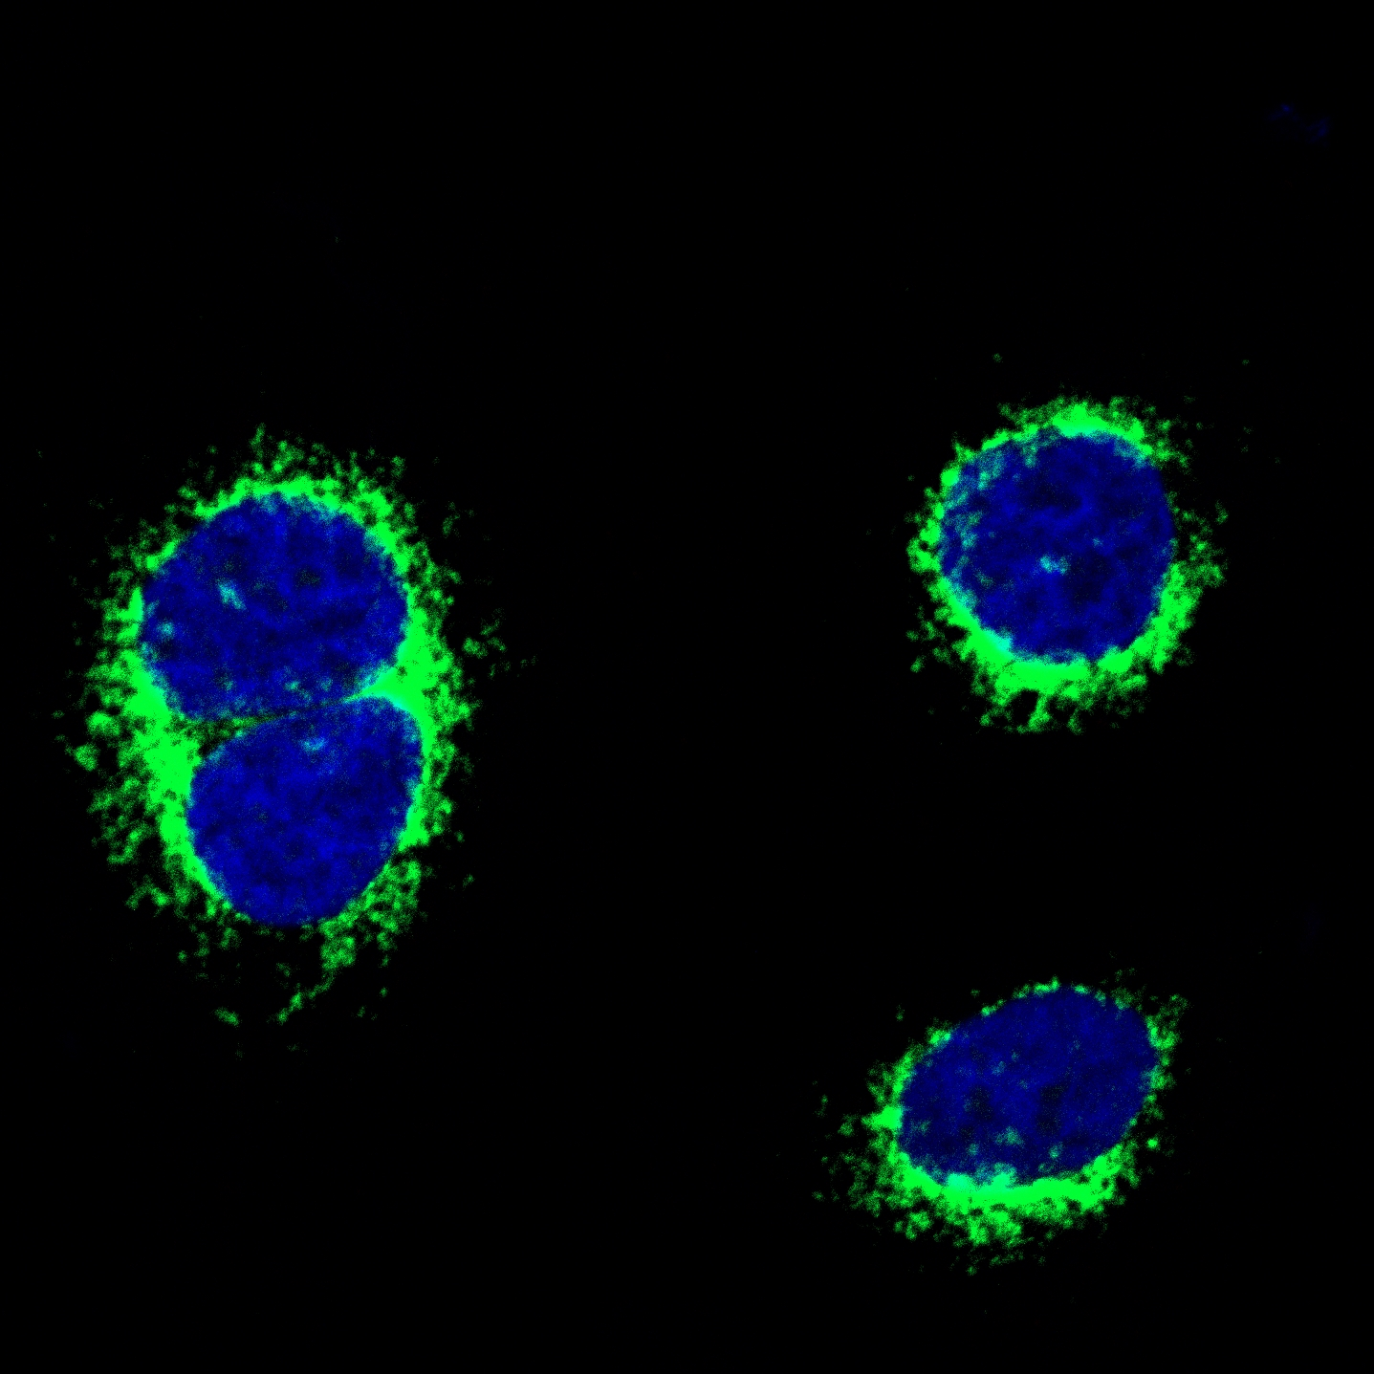
Merge
Myc-VP3 group
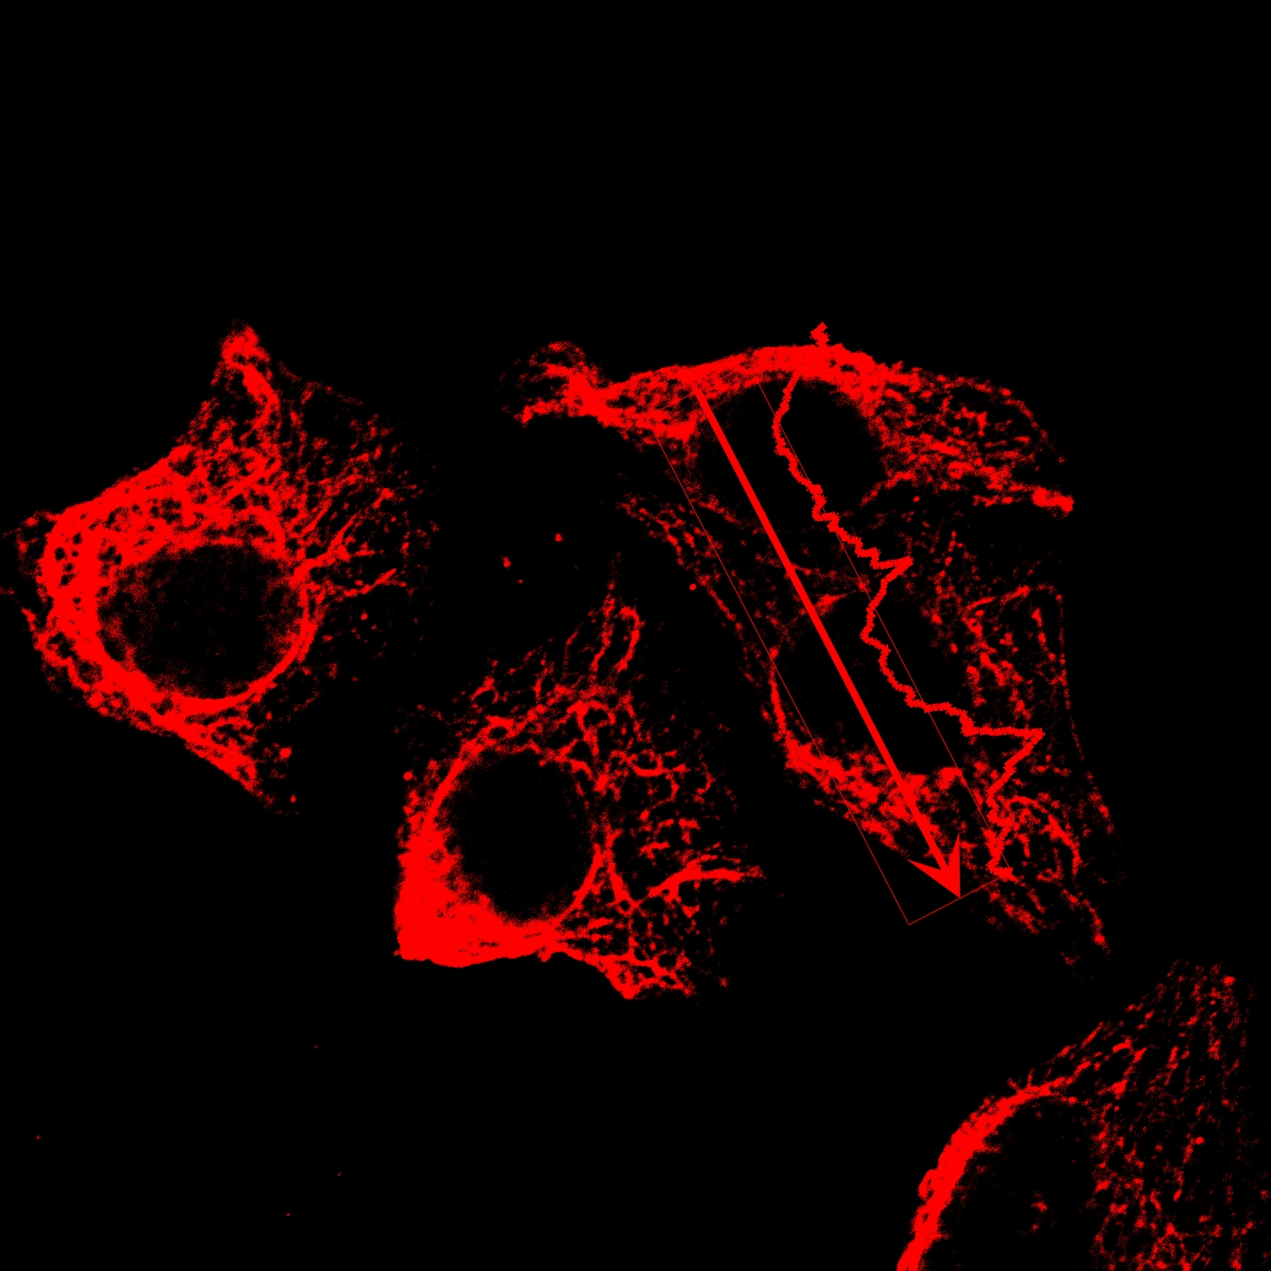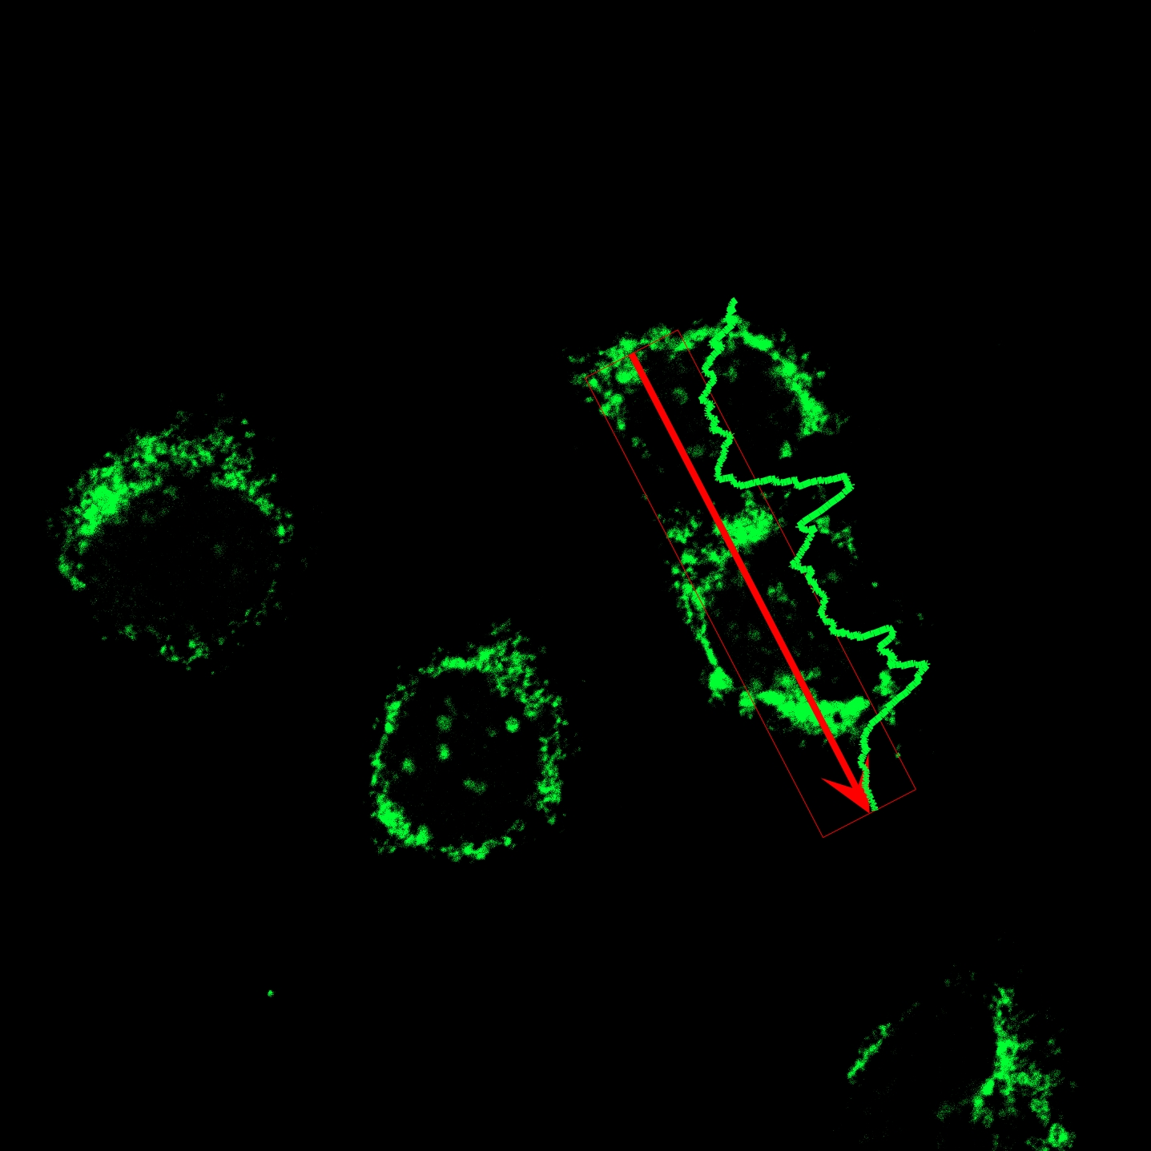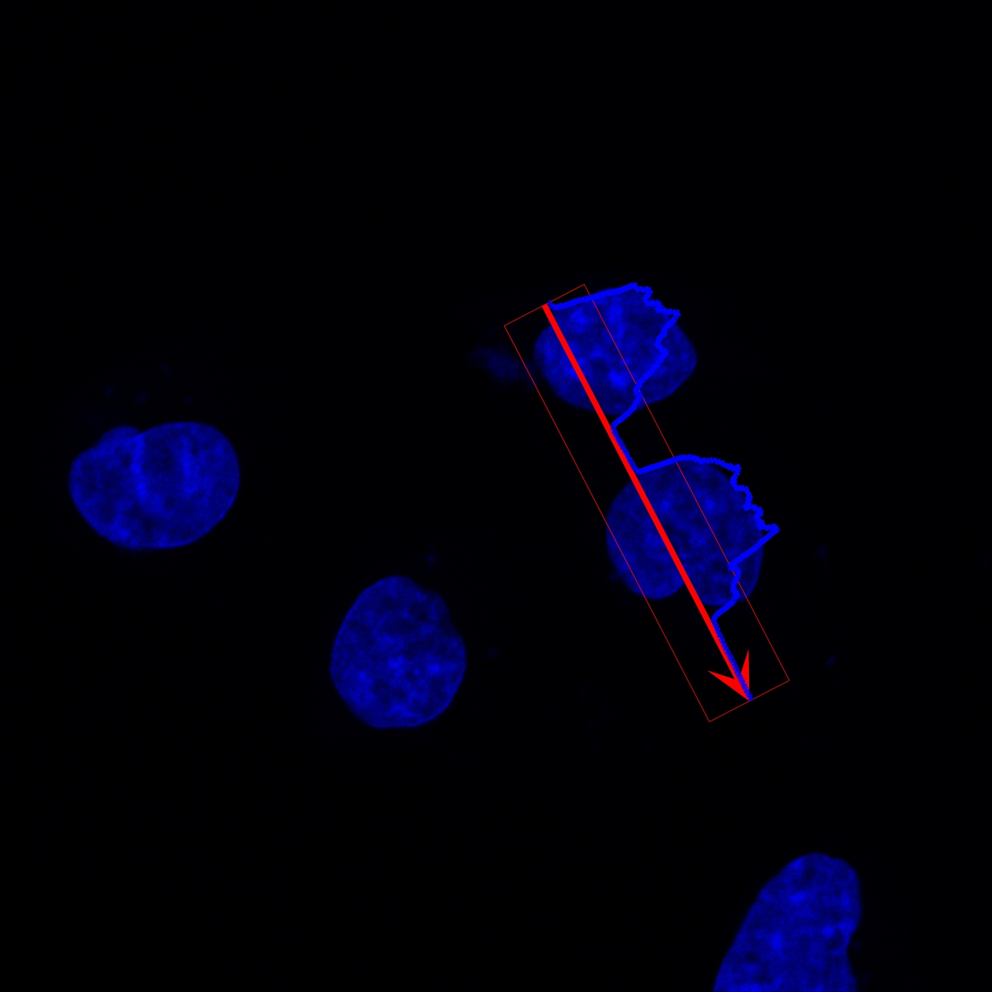
Myc(Cy3) MAVS(AF488) DAPI

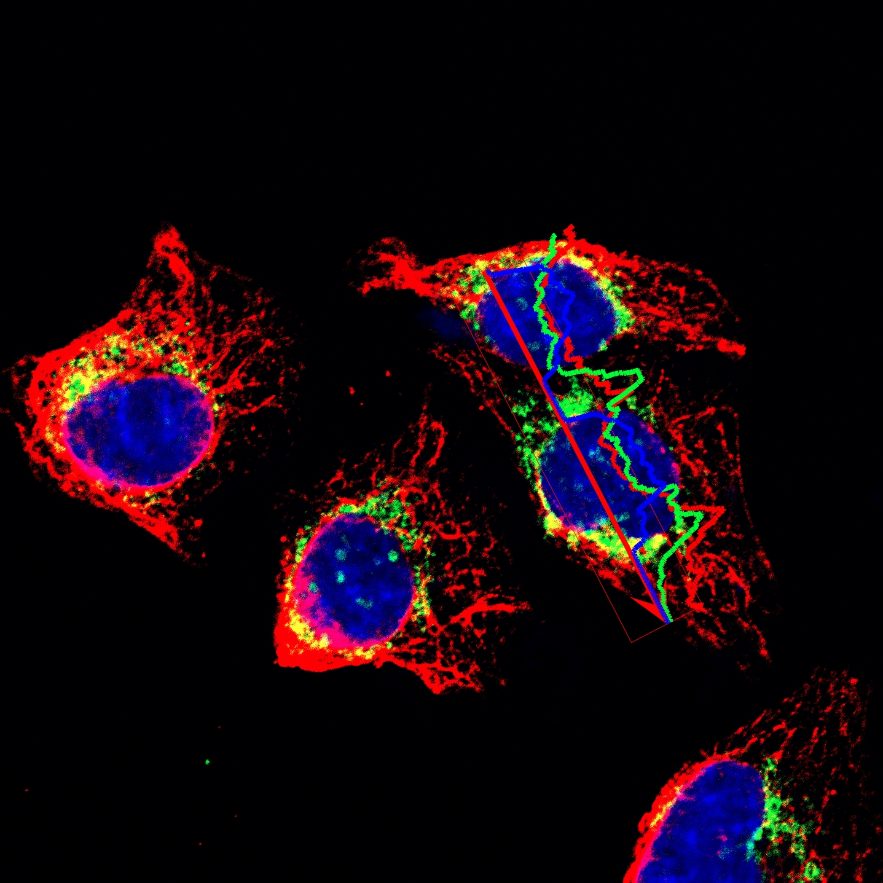
Merge
Distance[µm] | Cy3-T1 | AF488-T2 | DAPI-T3
0 | 55501.41 | 44545.47 | 1782.901
0.071 | 54283.68 | 42956.44 | 2094.702
0.141 | 52881.4 | 43063.05 | 1884.557
0.212 | 52886.24 | 42271.12 | 2011.069
0.282 | 49222.02 | 41872.95 | 1869.84
0.353 | 49222.02 | 41872.95 | 1869.84
0.424 | 49426.93 | 41518.3 | 1949.183
0.494 | 51133.7 | 41823.27 | 2002.053
0.565 | 50520.5 | 40139.04 | 2213.595
0.635 | 50680.93 | 42699.1 | 2221.481
0.706 | 52269.5 | 39615.23 | 2539.496
0.777 | 53445.06 | 40091.07 | 2922.244
0.847 | 53645.66 | 39966.84 | 4203.076
0.918 | 54080.18 | 40037.4 | 5155.237
0.988 | 54080.18 | 40037.4 | 5155.237
1.059 | 51751.05 | 39730.31 | 6991.725
1.13 | 50221.03 | 38226.31 | 8522.511
1.2 | 49627.16 | 37936.18 | 10353.99
1.271 | 51551.37 | 37617.15 | 11499.79
1.341 | 52329.54 | 39519.98 | 11910.25
1.412 | 51616.44 | 39638.92 | 12819.57
1.483 | 51224.85 | 39710.13 | 14238.09
1.553 | 51009.63 | 40418.59 | 14931.6
1.624 | 52012.73 | 40080.41 | 15788.29
1.694 | 50972.37 | 39767.42 | 16738.21
1.765 | 51549.32 | 39045.54 | 17679.02
1.836 | 51155.75 | 39061.36 | 19753.57
1.906 | 48485.05 | 37229.81 | 19991.26
1.977 | 45684.33 | 35914.21 | 21195.99
2.048 | 45351.01 | 35215.44 | 21963.51
2.118 | 44455.24 | 34803.92 | 22614.99
2.189 | 43693.24 | 32264.25 | 23295.58
2.259 | 42739.37 | 31643.6 | 24585.24
2.33 | 41910.25 | 31077.58 | 26912.95
2.401 | 38777.44 | 29289.37 | 29262.92
2.471 | 38034.89 | 28303.73 | 29838.41
2.542 | 35660.69 | 28216.89 | 29831.33
2.612 | 36658.89 | 28751.26 | 30383.21
2.683 | 35687.35 | 29607.68 | 29306.54
2.754 | 35468.58 | 28883.17 | 29395.53
2.824 | 34641.8 | 31333.39 | 29761.81
2.895 | 34498.47 | 31098.19 | 29186.86
2.965 | 33701 | 32257.7 | 30042.16
3.036 | 33683.44 | 31835.84 | 30353.5
3.107 | 32508 | 31824.26 | 30725.68
3.177 | 32839.66 | 31097.39 | 31378.36
3.248 | 31593.22 | 30519.46 | 31144.22
3.318 | 31215 | 28931.07 | 32020.09
3.389 | 29393.18 | 27938.39 | 32418.97
3.46 | 30715.06 | 26898.32 | 33325.79
3.53 | 30715.06 | 26898.32 | 33325.79
3.601 | 30448.38 | 26079.21 | 33085.5
3.671 | 30817.94 | 24757.12 | 33798.44
3.742 | 29669.86 | 24896.28 | 33372.73
3.813 | 29373.54 | 25548.28 | 32931.47
3.883 | 28734.8 | 24181.82 | 32179.54
3.954 | 28390.61 | 23633.06 | 32668.66
4.024 | 28236.83 | 22877.99 | 31597.17
4.095 | 28648.36 | 22179.22 | 30886.7
4.166 | 28648.36 | 22179.22 | 30886.7
4.236 | 27456.37 | 21411.14 | 30424.24
4.307 | 25905.28 | 21477.5 | 31025.43
4.377 | 28100.9 | 22982.98 | 30319.28
4.448 | 27087.78 | 21811.86 | 30163.05
4.519 | 25827.06 | 22132.61 | 30501.93
4.589 | 24796.93 | 21794.68 | 30796.37
4.66 | 24168.98 | 21932.08 | 30018.37
4.73 | 23244.41 | 22668.96 | 31036.02
4.801 | 23244.41 | 22668.96 | 31036.02
4.872 | 22544.91 | 24451.38 | 31474.66
4.942 | 22283.75 | 23303.47 | 31478.04
5.013 | 22051.41 | 23488.04 | 33144.4
5.083 | 21837.99 | 24194.49 | 33239.21
5.154 | 21601.69 | 23413.5 | 33810.2
5.225 | 21648.16 | 23235.74 | 34150.28
5.295 | 20981.87 | 23746.71 | 33726.79
5.366 | 21290.82 | 23139.47 | 33968.29
5.436 | 21176.07 | 23283.5 | 34169.32
5.507 | 20244.62 | 21850 | 34548.37
5.578 | 19340.01 | 21179.88 | 34326.61
5.648 | 20694.7 | 20807.32 | 33748.56
5.719 | 20184.12 | 19869.73 | 32743.34
5.79 | 20469.55 | 20017.98 | 32248.08
5.86 | 20291.42 | 20136.62 | 33100.27
5.931 | 19344.98 | 19120.01 | 34172.95
6.001 | 19344.98 | 19120.01 | 34172.95
6.072 | 18801.08 | 18549.96 | 33953.88
6.143 | 18772.17 | 17360.51 | 34356.68
6.213 | 19892.07 | 17055.18 | 35121.53
6.284 | 19994.05 | 16852.96 | 34749.2
6.354 | 18589.8 | 17258.74 | 35391.76
6.425 | 18803.33 | 14904.5 | 34872.28
6.496 | 19849.92 | 15552.65 | 35516.32
6.566 | 19261.88 | 16046.35 | 36807.99
6.637 | 19261.88 | 16046.35 | 36807.99
6.707 | 20100.37 | 16592.37 | 36849.21
6.778 | 20825.04 | 17010.5 | 36711.03
6.849 | 19596.47 | 17264.27 | 37918.87
6.919 | 19313.73 | 17137.13 | 38068.61
6.99 | 19017.44 | 16978.12 | 38095.34
7.06 | 18446.92 | 17102.34 | 38715.69
7.131 | 17053.35 | 18126.23 | 37609.55
7.202 | 16917.95 | 18481.47 | 37234.59
7.272 | 16917.95 | 18481.47 | 37234.59
7.343 | 17085.07 | 17836.75 | 36634.6
7.413 | 17795.02 | 16198.57 | 36471.28
7.484 | 18699.05 | 15741.94 | 35574.1
7.555 | 19861.26 | 15553.44 | 35188.97
7.625 | 19823.39 | 16054.47 | 34250.31
7.696 | 20949.7 | 16134.82 | 33015.02
7.766 | 20125.24 | 15343.01 | 32636.83
7.837 | 19582.97 | 15112.57 | 32493.52
7.908 | 19582.97 | 15112.57 | 32493.52
7.978 | 19889.07 | 14916.72 | 31024.66
8.049 | 19642.62 | 15088.05 | 31863.07
8.119 | 20346.73 | 15865.67 | 30362.02
8.19 | 19291.92 | 15548.25 | 30732.6
8.261 | 20347.42 | 15580.32 | 31454.96
8.331 | 21069.08 | 16087.18 | 30205.48
8.402 | 21228.24 | 16599.49 | 29024.7
8.472 | 21453.58 | 16757.68 | 28301.02
8.543 | 21133.53 | 16824.48 | 28946.34
8.614 | 21116.99 | 17488.22 | 28689.21
8.684 | 20217.46 | 16765.86 | 28553.79
8.755 | 20510.7 | 16504.75 | 27495.65
8.825 | 19507.94 | 15601 | 28044.2
8.896 | 18450.72 | 14837.11 | 27624.04
8.967 | 18906.34 | 14990.53 | 26538.92
9.037 | 18703.44 | 14300.09 | 27606.44
9.108 | 18351.82 | 14184.82 | 27452.19
9.178 | 17853.2 | 13849.01 | 27636.33
9.249 | 18932.65 | 13945.55 | 27311.96
9.32 | 18399.07 | 13685.92 | 27228.28
9.39 | 19542.31 | 14578.27 | 27714.03
9.461 | 20107.2 | 16395.89 | 28419.65
9.532 | 19815.67 | 15897.27 | 27360.89
9.602 | 19922.54 | 16594.6 | 27501.44
9.673 | 18984.79 | 16083.63 | 27594.73
9.743 | 18874.83 | 17202.57 | 27341.37
9.814 | 19098.95 | 16950.83 | 27982.89
9.885 | 18647.48 | 16555.76 | 28521.8
9.955 | 19993.6 | 16737.19 | 29099.75
10.026 | 20368.05 | 17611.01 | 29129.62
10.096 | 19927.33 | 17915.94 | 28223.63
10.167 | 19546.18 | 18545.71 | 27659
10.238 | 19543.27 | 18464.79 | 26909.69
10.308 | 20868.6 | 18626.94 | 26450.29
10.379 | 20517.73 | 19511.46 | 26555.13
10.449 | 20517.73 | 19511.46 | 26555.13
10.52 | 21462.69 | 18570.04 | 25328.38
10.591 | 21782.74 | 18683.02 | 25141.8
10.661 | 21768.03 | 18607.97 | 24987.82
10.732 | 21350.33 | 17666.6 | 24482.25
10.802 | 22499.51 | 18219.8 | 23283.38
10.873 | 22191.57 | 16199.08 | 22531.91
10.944 | 21493.51 | 15518.86 | 22055.43
11.014 | 20998.07 | 15187.86 | 21605.66
11.085 | 20998.07 | 15187.86 | 21605.66
11.155 | 20964.35 | 14039.73 | 21192.01
11.226 | 22017.93 | 15240.31 | 19852.9
11.297 | 23525.66 | 15247.28 | 18456.75
11.367 | 24718.57 | 14684.47 | 18292.41
11.438 | 24188.66 | 14505.01 | 17869.74
11.508 | 24945.21 | 13684.07 | 16325.89
11.579 | 23316.41 | 13134.59 | 15398.88
11.65 | 22762.14 | 13488.83 | 16648.29
11.72 | 22762.14 | 13488.83 | 16648.29
11.791 | 21470.87 | 13052.44 | 14759.02
11.861 | 21517.89 | 12663.02 | 15198.79
11.932 | 21159.98 | 12068.62 | 14780.47
12.003 | 21194.31 | 11505.38 | 14137.4
12.073 | 21882.41 | 10569.29 | 14156.53
12.144 | 22036.94 | 10536.21 | 13411.44
12.214 | 23632.77 | 10735.76 | 14042.35
12.285 | 24220.08 | 10064.41 | 13474.36
12.356 | 24220.08 | 10064.41 | 13474.36
12.426 | 23618.31 | 9974.305 | 13562.26
12.497 | 22475.39 | 8663.076 | 14252.92
12.567 | 20833.08 | 9477.466 | 14345.17
12.638 | 20863.08 | 8057.389 | 14340.93
12.709 | 20140.47 | 8787.885 | 15004.87
12.779 | 19743.61 | 8927.473 | 14490
12.85 | 19204.17 | 8069.954 | 14131.12
12.92 | 19845.66 | 8332.328 | 13977.14
12.991 | 19499.54 | 8270.954 | 13615.53
13.062 | 17932.85 | 7512.046 | 13202.11
13.132 | 18134.97 | 7170.046 | 12436.53
13.203 | 18436 | 7317.29 | 11792.05
13.273 | 17824.26 | 7607.725 | 11810.32
13.344 | 18523.63 | 7518.695 | 11810.47
13.415 | 18222.81 | 7374.214 | 10897.69
13.485 | 19927.89 | 9011.756 | 11414.18
13.556 | 20236.22 | 9808.71 | 10182.5
13.627 | 20801.33 | 10771.49 | 9734.809
13.697 | 22106.42 | 12000.38 | 9240.481
13.768 | 22789.36 | 12863.36 | 8540.237
13.838 | 24409.88 | 12704.17 | 7521.153
13.909 | 25237.17 | 11979.53 | 6203.649
13.98 | 25353.73 | 11715.21 | 5408.534
14.05 | 25657.02 | 11542.31 | 3734.702
14.121 | 25468.7 | 11841.37 | 2694.29
14.191 | 24781.05 | 12430.28 | 2061.198
14.262 | 24911.41 | 11820.97 | 1868.275
14.333 | 23647.59 | 11439.35 | 1744.595
14.403 | 23969.08 | 13171.75 | 1670.473
14.474 | 22912.43 | 13197.81 | 1389.916
14.544 | 21873.92 | 13446.82 | 1364.748
14.615 | 20675.91 | 12949.37 | 1211.641
14.686 | 21490.53 | 13216.41 | 1333.908
14.756 | 22751.63 | 13141.03 | 1383.962
14.827 | 23168.77 | 15182.47 | 1319.634
14.897 | 23168.77 | 15182.47 | 1319.634
14.968 | 24047.9 | 16659.91 | 1258.954
15.039 | 23531.36 | 18573.58 | 1227.176
15.109 | 23052.99 | 19326.07 | 1370.58
15.18 | 23861.92 | 21137.71 | 1292.313
15.25 | 23740.8 | 21203.79 | 1322.031
15.321 | 25463.05 | 21974.94 | 1362.802
15.392 | 25160.7 | 23880.84 | 1514.076
15.462 | 24843.38 | 25503.67 | 1214.58
15.533 | 24843.38 | 25503.67 | 1214.58
15.603 | 23715.21 | 26789.18 | 1303.931
15.674 | 24280.14 | 26846.88 | 1457.595
15.745 | 23331.77 | 25473.76 | 1379.252
15.815 | 24624.1 | 25548.54 | 1283.153
15.886 | 25285.35 | 25869.25 | 1359.847
15.956 | 25600.18 | 26349.6 | 1300.275
16.027 | 25900.35 | 27697.92 | 1402.893
16.098 | 24780.84 | 27906.03 | 1360.183
16.168 | 26057.57 | 27836.14 | 1435.275
16.239 | 26149.41 | 28683.85 | 1376.817
16.309 | 26711.89 | 29844.47 | 1401.702
16.38 | 27438.55 | 31585.83 | 1590.198
16.451 | 27854.53 | 32065.06 | 1578.802
16.521 | 28644.21 | 33238.18 | 1434.374
16.592 | 28753.75 | 33828.28 | 1473.527
16.662 | 29300.33 | 32473.53 | 1540.046
16.733 | 28306.1 | 32971.75 | 1459.29
16.804 | 27525.93 | 33296.86 | 1457.344
16.874 | 28417.05 | 32117.99 | 1368.45
16.945 | 27894.31 | 32395.47 | 1453.374
17.015 | 27794.89 | 32870.18 | 1482.023
17.086 | 27009.37 | 33251.53 | 1466.26
17.157 | 27361.7 | 32800.96 | 1546.87
17.227 | 26970.47 | 34686.93 | 1588.634
17.298 | 26631.32 | 38051.2 | 1667.13
17.369 | 26631.32 | 38051.2 | 1667.13
17.439 | 25934.92 | 40318.98 | 1682.359
17.51 | 26658.81 | 40600.47 | 1433.863
17.58 | 26915.71 | 42309.34 | 1532.992
17.651 | 28981.28 | 42130.64 | 1718.74
17.722 | 28425.92 | 42578.08 | 1338.855
17.792 | 29561.95 | 42852.67 | 1753.603
17.863 | 32097.76 | 43785.51 | 1615.344
17.933 | 33172.24 | 45811.2 | 1454.679
18.004 | 33172.24 | 45811.2 | 1454.679
18.075 | 32954.89 | 47837.78 | 1608.947
18.145 | 32051.99 | 48995.99 | 1627.122
18.216 | 31383.53 | 50785.36 | 1589.435
18.286 | 31956.57 | 50506.47 | 1526.359
18.357 | 32296.71 | 51174.42 | 1722.534
18.428 | 30243.43 | 51085.37 | 1610.29
18.498 | 30446.5 | 50594.75 | 1550.069
18.569 | 30850.6 | 50097.51 | 1680.099
18.639 | 30850.6 | 50097.51 | 1680.099
18.71 | 29319.28 | 50241.93 | 1716.237
18.781 | 29407.89 | 49450.88 | 1631.405
18.851 | 29024.13 | 49764.91 | 1710.107
18.922 | 30304.57 | 50069.73 | 1644.252
18.992 | 30606.93 | 49267.93 | 1677.87
19.063 | 31260.63 | 50022.21 | 1757.611
19.134 | 31459.8 | 51216.02 | 1717.672
19.204 | 33163.58 | 51064.51 | 1797.16
19.275 | 33163.58 | 51064.51 | 1797.16
19.345 | 35692.59 | 50413.58 | 2120.008
19.416 | 36513.37 | 48549.4 | 1730.718
19.487 | 36732.98 | 47223.21 | 1914.748
19.557 | 37860.24 | 46968.07 | 2155.458
19.628 | 38706.21 | 45302.05 | 2877.145
19.698 | 41319.95 | 43250.79 | 3626.168
19.769 | 43297.77 | 40618.76 | 5815.435
19.84 | 43049.28 | 39268.14 | 7576.618
19.91 | 43290.83 | 37616.63 | 8265.405
19.981 | 41042.38 | 35600.47 | 9846.366
20.051 | 39188.05 | 31528.02 | 11788.26
20.122 | 36987.22 | 28689.34 | 13069.41
20.193 | 34638.69 | 27743.05 | 14682.38
20.263 | 35203.99 | 26276.18 | 16071.89
20.334 | 31508.05 | 26192.08 | 17325.61
20.404 | 31089.69 | 25970.19 | 17807.44
20.475 | 29246.63 | 27166.43 | 18448.31
20.546 | 29432.66 | 26377.44 | 18186.38
20.616 | 30092.89 | 27735.2 | 18456.28
20.687 | 28665.11 | 26830.97 | 20130.18
20.757 | 28866.62 | 28005.91 | 19883.05
20.828 | 28910.14 | 27517.66 | 20442.44
20.899 | 28930 | 28896.92 | 20852.66
20.969 | 28277.54 | 29162.53 | 20598.63
21.04 | 28715.16 | 29834.84 | 21406.17
21.111 | 26908.92 | 31764.9 | 20585.02
21.181 | 26957.06 | 29253.98 | 21399.69
21.252 | 26350.14 | 28601.48 | 22262.28
21.322 | 25532.41 | 28754.84 | 21904.83
21.393 | 25144.45 | 29740.37 | 21803.77
21.464 | 24300.8 | 28695.79 | 22243.84
21.534 | 24332.76 | 28587.94 | 21537.27
21.605 | 22663.39 | 28526.28 | 22827.81
21.675 | 22120.21 | 27357.79 | 24003.05
21.746 | 20901.44 | 26959.92 | 24063.06
21.817 | 20901.44 | 26959.92 | 24063.06
21.887 | 20496.57 | 26980.79 | 24901.71
21.958 | 19201.2 | 25568.14 | 25106.31
22.028 | 20185.49 | 25430.02 | 26125.8
22.099 | 19559.89 | 25944.82 | 26372.07
22.17 | 19580.71 | 24657.19 | 26474.72
22.24 | 20763.92 | 23981.45 | 27031.12
22.311 | 20117.35 | 23558.04 | 26443.83
22.381 | 19380.69 | 22683.57 | 27099.89
22.452 | 19380.69 | 22683.57 | 27099.89
22.523 | 17876.57 | 21897.7 | 28232.24
22.593 | 18154.59 | 21755.06 | 28062.48
22.664 | 17991.92 | 20705 | 27897.01
22.734 | 18491.62 | 20693.72 | 28239.47
22.805 | 18066.99 | 20644.64 | 28534.72
22.876 | 18421.53 | 19165.67 | 29007.02
22.946 | 18017.11 | 18652.4 | 28462.63
23.017 | 17528.18 | 17053.36 | 28696.5
23.087 | 17528.18 | 17053.36 | 28696.5
23.158 | 16080.75 | 17650.3 | 29076.01
23.229 | 15035 | 17637.8 | 29019.95
23.299 | 15217.35 | 18616.97 | 29953.84
23.37 | 13972.22 | 19083.84 | 29242.34
23.44 | 13397.21 | 19563.99 | 30998.24
23.511 | 13097.8 | 20024.44 | 29977.25
23.582 | 13103.22 | 19871.45 | 31086.43
23.652 | 13677.77 | 19271.18 | 30156.45
23.723 | 13677.77 | 19271.18 | 30156.45
23.793 | 13208.26 | 18949.25 | 30765.86
23.864 | 13998.01 | 20404.92 | 33098.21
23.935 | 14519.6 | 21487.42 | 31912.9
24.005 | 14408.84 | 21529.14 | 31597
24.076 | 14359.79 | 22193.29 | 31811.56
24.146 | 14960.73 | 23392.67 | 32096.18
24.217 | 16144.04 | 22879.41 | 31763.82
24.288 | 16335.84 | 22629.17 | 31123.03
24.358 | 16149.95 | 23206.56 | 31147.22
24.429 | 16364.33 | 22141.57 | 30823.05
24.499 | 15616.88 | 21568.32 | 30632.98
24.57 | 16893.28 | 21107.82 | 29727.51
24.641 | 17467.82 | 20616.43 | 29472.02
24.711 | 17084.41 | 20187.17 | 28989.11
24.782 | 17530.41 | 21501.62 | 29941.57
24.853 | 17436 | 19797.96 | 28281.79
24.923 | 17624.18 | 20914.04 | 29522.79
24.994 | 17634.09 | 19793.21 | 28842.18
25.064 | 17281.08 | 20425.91 | 27778.87
25.135 | 18821.3 | 20405.4 | 29314.27
25.206 | 19067.58 | 21266.96 | 28545.99
25.276 | 19748.41 | 21845.47 | 28697.96
25.347 | 19127.79 | 22038.39 | 28479.78
25.417 | 18723.5 | 22398.98 | 29123.72
25.488 | 17440.68 | 20926.94 | 28619.7
25.559 | 16840.62 | 21536.84 | 28083.05
25.629 | 17055.05 | 21249 | 28627.23
25.7 | 17015.39 | 22086.73 | 28769.88
25.77 | 16528.24 | 20502.51 | 29010.44
25.841 | 15863.54 | 20236.76 | 29633.08
25.912 | 15928.14 | 20486.83 | 30401.16
25.982 | 15107.15 | 20542.73 | 29848.25
26.053 | 14409.9 | 22023.5 | 31338.35
26.123 | 15656.38 | 21008.69 | 31383.02
26.194 | 15604.14 | 21433.53 | 31409.15
26.265 | 15265.67 | 22545.6 | 31337.16
26.335 | 15262.96 | 21590.84 | 31894.57
26.406 | 14415.35 | 22096.49 | 30822.01
26.476 | 15233.72 | 22183.59 | 31584.01
26.547 | 14491.67 | 22494.99 | 31846.76
26.618 | 14210.46 | 22813.6 | 31534.33
26.688 | 14118.4 | 22917.34 | 30779.98
26.759 | 14681.85 | 22444.71 | 31867.68
26.829 | 15037.99 | 22342.16 | 31511.71
26.9 | 14947.2 | 22714.46 | 30725.99
26.971 | 15273.86 | 22402.68 | 31475.95
27.041 | 15951.43 | 23066.31 | 32031.82
27.112 | 16071.87 | 22939.41 | 31173.3
27.182 | 15841.72 | 21536 | 30593.16
27.253 | 15969.12 | 20984.23 | 30691.25
27.324 | 16063.84 | 21204.52 | 29895.16
27.394 | 14872.29 | 20426.25 | 30840.69
27.465 | 14960.05 | 20530.12 | 30634.43
27.535 | 15355.59 | 20710.37 | 30686.76
27.606 | 15302.36 | 20466.91 | 29234.46
27.677 | 15265.95 | 20080.74 | 29844.13
27.747 | 16205.57 | 19784.68 | 29498.86
27.818 | 15797.02 | 19189.04 | 28625.08
27.888 | 15287.76 | 18621.31 | 27896.39
27.959 | 14983.36 | 18864.12 | 29427.63
28.03 | 15588.92 | 17847.22 | 30273.57
28.1 | 15707.33 | 17808.17 | 30268.93
28.171 | 16348.12 | 18829.7 | 30258.61
28.241 | 15429.74 | 19165.53 | 31277.79
28.312 | 16167.86 | 18797.79 | 31043.12
28.383 | 16377.37 | 19266.95 | 31843.75
28.453 | 16319.85 | 19258.41 | 31106.39
28.524 | 16990.41 | 19304.15 | 31295.86
28.595 | 17727.33 | 18265.75 | 31125.92
28.665 | 17970.05 | 18853.45 | 32032.84
28.736 | 17970.05 | 18853.45 | 32032.84
28.806 | 18322.93 | 18299.99 | 32930.21
28.877 | 19050.08 | 18826.82 | 32355.56
28.948 | 19834.52 | 19574.23 | 32370.18
29.018 | 19719.44 | 20249.41 | 31225.47
29.089 | 20215.63 | 20247.05 | 32654.4
29.159 | 19572.08 | 21208.92 | 30274.71
29.23 | 19465.38 | 20818.86 | 29856.47
29.301 | 20432.15 | 21272.7 | 29702.85
29.371 | 20432.15 | 21272.7 | 29702.85
29.442 | 19617.3 | 20711.99 | 29938.15
29.512 | 18727.93 | 19954.24 | 31071.64
29.583 | 17436.89 | 20283.13 | 30722.01
29.654 | 17296.5 | 20672.89 | 30556.47
29.724 | 17337.21 | 19717.34 | 29744.58
29.795 | 16690.67 | 18645.77 | 29746.16
29.865 | 18201.28 | 19137.34 | 30067.58
29.936 | 17346.8 | 20211.5 | 30480.67
30.007 | 17346.8 | 20211.5 | 30480.67
30.077 | 18065.2 | 19944.6 | 31009.63
30.148 | 18505.37 | 20397.17 | 31667.09
30.218 | 19725.73 | 20223.82 | 29874.07
30.289 | 21021.99 | 21400.18 | 29082.04
30.36 | 21265.9 | 23457.44 | 29923.46
30.43 | 20800.86 | 21643.62 | 31251.95
30.501 | 21099.63 | 22853.02 | 30932.28
30.571 | 21904.19 | 23391.76 | 30891.26
30.642 | 21904.19 | 23391.76 | 30891.26
30.713 | 21682.29 | 24765.08 | 31518.5
30.783 | 22448.53 | 23692.77 | 32128.35
30.854 | 21898.36 | 24465.47 | 33103.43
30.924 | 21234.64 | 24706.06 | 33452.31
30.995 | 21953.99 | 24112.19 | 34515.95
31.066 | 24121.6 | 25625.01 | 34082.66
31.136 | 24686.98 | 27230.01 | 34360.89
31.207 | 25756.86 | 27603.47 | 34341.13
31.277 | 26506.7 | 27817.72 | 34873.97
31.348 | 26751.63 | 26246.02 | 34660.79
31.419 | 27945.51 | 27130.73 | 32918.29
31.489 | 29610.7 | 27731.8 | 31622.95
31.56 | 30493.79 | 28577.12 | 31152.71
31.63 | 30524.39 | 31774.23 | 30348.7
31.701 | 29751.1 | 32818.01 | 29009.21
31.772 | 30805.27 | 35295.07 | 27530.83
31.842 | 29679.08 | 37929.75 | 26571.95
31.913 | 29292.97 | 38994.98 | 26447.56
31.983 | 29212.17 | 39242.12 | 25855.53
32.054 | 29222.44 | 39040.53 | 23858.7
32.125 | 30502.99 | 39936.76 | 22496.44
32.195 | 32251.75 | 38679.15 | 19578.05
32.266 | 31856.9 | 40207.47 | 19489.12
32.336 | 32080.95 | 39746.12 | 16432.82
32.407 | 32540.13 | 38800.28 | 15921.11
32.478 | 32878.24 | 39759.27 | 14883.96
32.548 | 32868.38 | 38145.44 | 14465.66
32.619 | 33549.99 | 38962.96 | 14647.42
32.69 | 33976.48 | 38168.35 | 14720.5
32.76 | 34495.7 | 37450.79 | 14982.76
32.831 | 34761.02 | 36082.64 | 16008.01
32.901 | 33339 | 34552.49 | 16156.7
32.972 | 33281.33 | 32509.02 | 16302.03
33.043 | 32935.1 | 32706.56 | 16473.11
33.113 | 32537.61 | 31965.19 | 16604.83
33.184 | 32537.61 | 31965.19 | 16604.83
33.254 | 31727.31 | 32117.75 | 16230.42
33.325 | 32666.54 | 32092.89 | 17111.87
33.396 | 33970.55 | 33016.83 | 16551.63
33.466 | 34599.14 | 31966.66 | 16762.21
33.537 | 35493.12 | 32205.31 | 15616.91
33.607 | 35280.62 | 33785.64 | 15836.51
33.678 | 34009.34 | 33349.28 | 15886.92
33.749 | 32077.28 | 35026.3 | 15588.04
33.819 | 32077.28 | 35026.3 | 15588.04
33.89 | 30737.2 | 35251.57 | 15062.21
33.96 | 30763.28 | 34260.15 | 14295.41
34.031 | 31358.42 | 34671.28 | 13983.05
34.102 | 30861.57 | 33453.43 | 14520.93
34.172 | 32118.73 | 34269.26 | 13499.06
34.243 | 34008.37 | 35996.53 | 12971.31
34.313 | 35525.89 | 35328.82 | 13328.28
34.384 | 36094.33 | 35702.53 | 12534.28
34.455 | 36094.33 | 35702.53 | 12534.28
34.525 | 36274.02 | 35207.65 | 13265.2
34.596 | 37204.07 | 34254.9 | 12356.06
34.666 | 38242.86 | 33507.96 | 12017.87
34.737 | 39614.89 | 32708.08 | 12112.44
34.808 | 39061.92 | 32918.78 | 12163.76
34.878 | 39770.98 | 32212.54 | 11798.82
34.949 | 39523.99 | 33403.15 | 11767.02
35.019 | 40955.6 | 34733.99 | 12370.98
35.09 | 40955.6 | 34733.99 | 12370.98
35.161 | 41440.35 | 35963.11 | 13133.04
35.231 | 42523.5 | 36711.38 | 12277.54
35.302 | 43819.73 | 36319.27 | 12862.17
35.372 | 44333.28 | 36289.97 | 13255.81
35.443 | 45227.78 | 37173.6 | 12562.03
35.514 | 45810.63 | 38824.19 | 11290.95
35.584 | 47890.92 | 40052.54 | 11163.34
35.655 | 47705.55 | 40990.49 | 10849.95
35.725 | 48139.1 | 41353.77 | 10837.86
35.796 | 48046.48 | 41237.62 | 10705.81
35.867 | 47912.28 | 41311.83 | 10294.21
35.937 | 49310.59 | 42243.89 | 8893.389
36.008 | 48729.12 | 42170.38 | 8474.916
36.078 | 49773.21 | 43475.34 | 6730.023
36.149 | 50628.31 | 45141.82 | 5446.496
36.22 | 51316.71 | 45396.24 | 3678.832
36.29 | 51510.73 | 45261.12 | 3189.214
36.361 | 52309.66 | 45190.85 | 3116.206
36.432 | 50700.63 | 44353.69 | 2476.985
36.502 | 53730.42 | 43443.76 | 1909.847
36.573 | 54524.94 | 42860.37 | 1807.496
36.643 | 56044.61 | 41543.1 | 1656.519
36.714 | 56593.56 | 41094.71 | 1598.809
36.785 | 56983.78 | 40801.16 | 1916.939
36.855 | 57668.63 | 40180.48 | 1712.595
36.926 | 57289.76 | 39338.08 | 1555.298
36.996 | 56845.97 | 40983.89 | 1677.252
37.067 | 54458.26 | 39764.61 | 1681.702
37.138 | 54357.44 | 39341.14 | 1785.656
37.208 | 52451.53 | 39925.04 | 1574.359
37.279 | 52256.2 | 38223.08 | 1609.573
37.349 | 52120.93 | 37223.34 | 1695.305
37.42 | 49913.21 | 35406.95 | 1829.802
37.491 | 49271.43 | 34685.43 | 1566.183
37.561 | 49271.43 | 34685.43 | 1566.183
37.632 | 47595.7 | 33886.47 | 1521.534
37.702 | 45396.41 | 32185.36 | 1450.557
37.773 | 44368.4 | 29556.33 | 1485.374
37.844 | 42145.52 | 28554.08 | 1540.458
37.914 | 40741.19 | 27512.82 | 1228.962
37.985 | 39359.01 | 26617.14 | 1470.985
38.055 | 39216.69 | 24272.92 | 1368.046
38.126 | 38992.69 | 24377.27 | 1238.855
38.197 | 39344.12 | 24336.21 | 1318.702
38.267 | 38550.92 | 23841.44 | 1316.832
38.338 | 41074.17 | 22011.57 | 1291.924
38.408 | 41005.79 | 21326.8 | 1309.16
38.479 | 40343.27 | 20737.52 | 1160.023
38.55 | 38307.02 | 18838.14 | 1323.237
38.62 | 38389.74 | 17645.98 | 1368.824
38.691 | 36596.36 | 15861.51 | 1345.519
38.761 | 37069.25 | 15889.06 | 1172.107
38.832 | 35888.5 | 15870.86 | 1191.351
38.903 | 35305.93 | 14911.92 | 1302.573
38.973 | 32991.37 | 14777.79 | 1163.588
39.044 | 31759.37 | 14092.78 | 1248.603
39.114 | 31243.08 | 12670.04 | 1066.794
39.185 | 30109.88 | 13057.52 | 1282.282
39.256 | 28337.98 | 12641.82 | 1129.145
39.326 | 28276.7 | 12125.47 | 1167.16
39.397 | 28238.85 | 11789.33 | 1076.954
39.467 | 28404.81 | 11193.3 | 1172.763
39.538 | 28684.37 | 10828.7 | 1036.664
39.609 | 28601.24 | 11750.89 | 1202.382
39.679 | 28741.1 | 11508.51 | 1075.405
39.75 | 27993.52 | 10948.93 | 1043.893
39.82 | 27776.6 | 10350.73 | 1072.031
39.891 | 27042.64 | 9604.397 | 1128.847
39.962 | 26223.73 | 9459.023 | 887.603
40.032 | 27591.78 | 9966.328 | 1026.595
40.103 | 27591.78 | 9966.328 | 1026.595
40.174 | 27657.57 | 10098.21 | 1057.794
40.244 | 29086.89 | 9688.084 | 1107.221
40.315 | 28561.88 | 10252.74 | 1120.58
40.385 | 28173.97 | 11171.29 | 1040.344
40.456 | 28637.28 | 10655.6 | 1053.885
40.527 | 28463.56 | 9980.748 | 1233.519
40.597 | 27631.77 | 9130.794 | 1190.824
40.668 | 27540.24 | 8439.649 | 1181.733
40.738 | 27540.24 | 8439.649 | 1181.733
40.809 | 26631.41 | 8296.206 | 1118.763
40.88 | 25366.12 | 7949.427 | 1108.603
40.95 | 25042.64 | 7413.282 | 1093.84
41.021 | 23951.52 | 6698.947 | 1068.87
41.091 | 24520.76 | 6150.817 | 1046.252
41.162 | 26418.18 | 6280.313 | 1175.756
41.233 | 24935 | 6149.573 | 1101.626
41.303 | 27169.24 | 6282.305 | 1124.763
41.374 | 27169.24 | 6282.305 | 1124.763
41.444 | 26753.28 | 5126.405 | 1033.672
41.515 | 26410.44 | 5896.313 | 1135.847
41.586 | 27273.04 | 5697.198 | 1124.603
41.656 | 26183.54 | 5678.313 | 947.191
41.727 | 26844.37 | 6477.527 | 937.221
41.797 | 26929.5 | 6281.061 | 1041.664
41.868 | 28676.6 | 6647.45 | 1061.45
41.939 | 31234.53 | 6194.122 | 1063.611
42.009 | 31234.53 | 6194.122 | 1063.611
42.08 | 31280.08 | 6516.29 | 1110.328
42.15 | 29785.51 | 6227.557 | 1032.45
42.221 | 29189.92 | 6216.733 | 1070.359
42.292 | 29381.91 | 6332.87 | 1110.473
42.362 | 29274.3 | 6075.618 | 856.42
42.433 | 28423.76 | 6164.115 | 839.252
42.503 | 27731.26 | 5493.847 | 915.198
42.574 | 26647.49 | 5180.198 | 821.008
42.645 | 26664.18 | 5230.664 | 913.328
42.715 | 25985.77 | 4778.382 | 863.588
42.786 | 25757.82 | 4646.427 | 964.985
42.856 | 24451.82 | 5109.313 | 899.557
42.927 | 24261.7 | 4721.481 | 909.252
42.998 | 23197.08 | 4185.672 | 838.458
43.068 | 22774.32 | 3964.733 | 917.168
43.139 | 22843.41 | 3743.435 | 894.443
43.209 | 23992.11 | 3441.718 | 789.244
43.28 | 24017.94 | 3248.573 | 799.122
43.351 | 23686 | 3195.412 | 908
43.421 | 23845.63 | 3447.809 | 892.939
43.492 | 22859.96 | 3211.153 | 861.099
43.562 | 22276.16 | 3404.542 | 811.985
43.633 | 20724.68 | 3051.298 | 962.435
43.704 | 20573.18 | 3180.046 | 922.718
43.774 | 19504.16 | 3346.511 | 733.954
43.845 | 19399.17 | 3339.313 | 923.672
43.916 | 20457.8 | 3401.656 | 854.053
43.986 | 19675.92 | 3514.458 | 811.504
44.057 | 20392.73 | 3611.641 | 784.786
44.127 | 19195.83 | 3042.504 | 770.573
44.198 | 19325.87 | 3108.42 | 837.656
44.269 | 19264.99 | 3148.786 | 768.817
44.339 | 17575.01 | 3206.519 | 701.962
44.41 | 15827.24 | 3049.756 | 843.763
44.48 | 15228.66 | 3132.656 | 761.069
44.551 | 15228.66 | 3132.656 | 761.069
44.622 | 15340.3 | 3427.901 | 790.756
44.692 | 16310.48 | 2964.618 | 805.168
44.763 | 15852.75 | 2872.298 | 671.45
44.833 | 16167.63 | 2898.481 | 783.603
44.904 | 16174.13 | 2599.214 | 646.29
44.975 | 17156.79 | 2699.015 | 866.038
45.045 | 16830 | 2879.336 | 903.466
45.116 | 18328.28 | 2933.252 | 824.168
45.186 | 18328.28 | 2933.252 | 824.168
45.257 | 19786.21 | 3138.901 | 839.893
45.328 | 20041.71 | 2850.466 | 658.153
45.398 | 19996.84 | 2655.725 | 731.511
45.469 | 21349.66 | 2558.489 | 847.794
45.539 | 22202.26 | 2519.573 | 839.534
45.61 | 22690.29 | 2401.511 | 791.084

Fig6
A
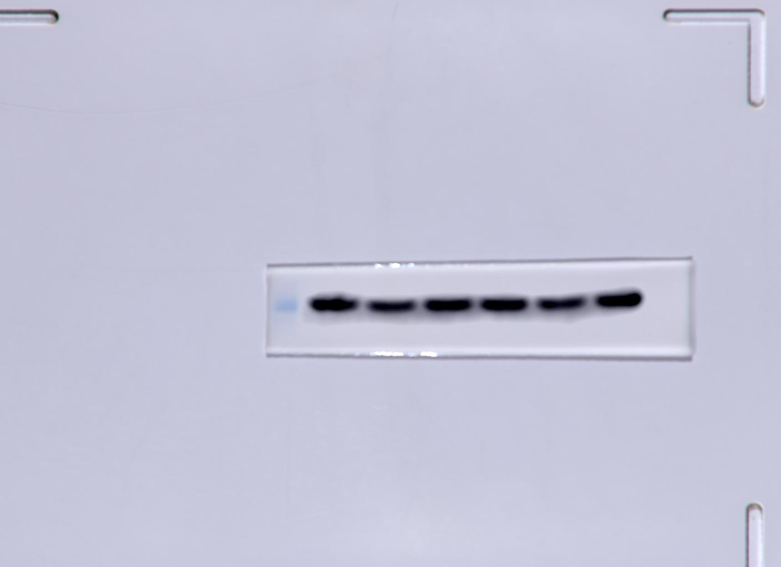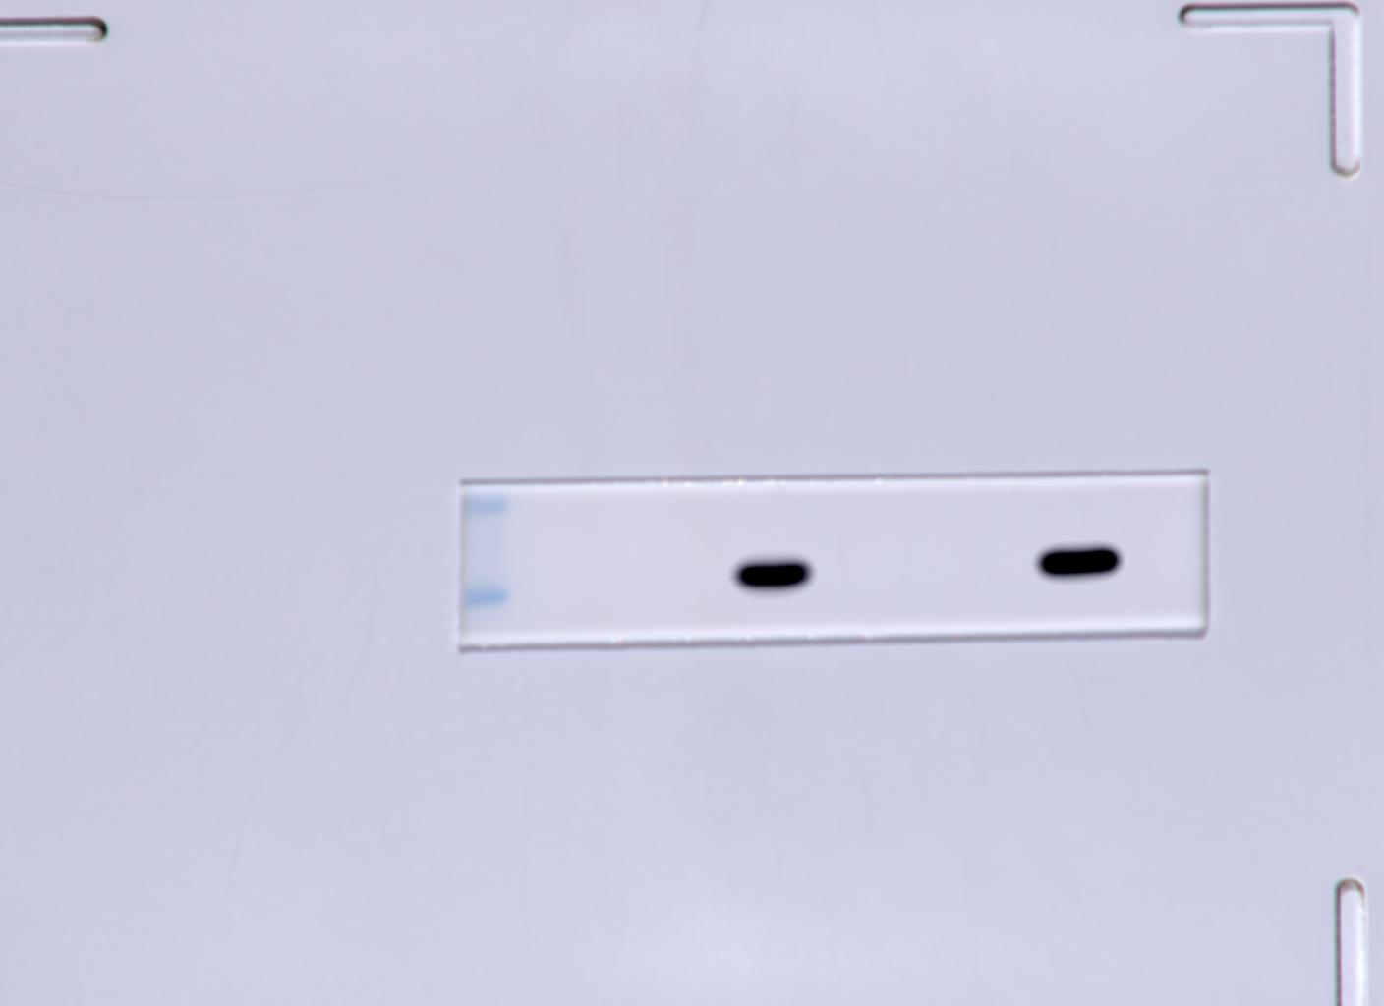
β-actin Myc-vp3

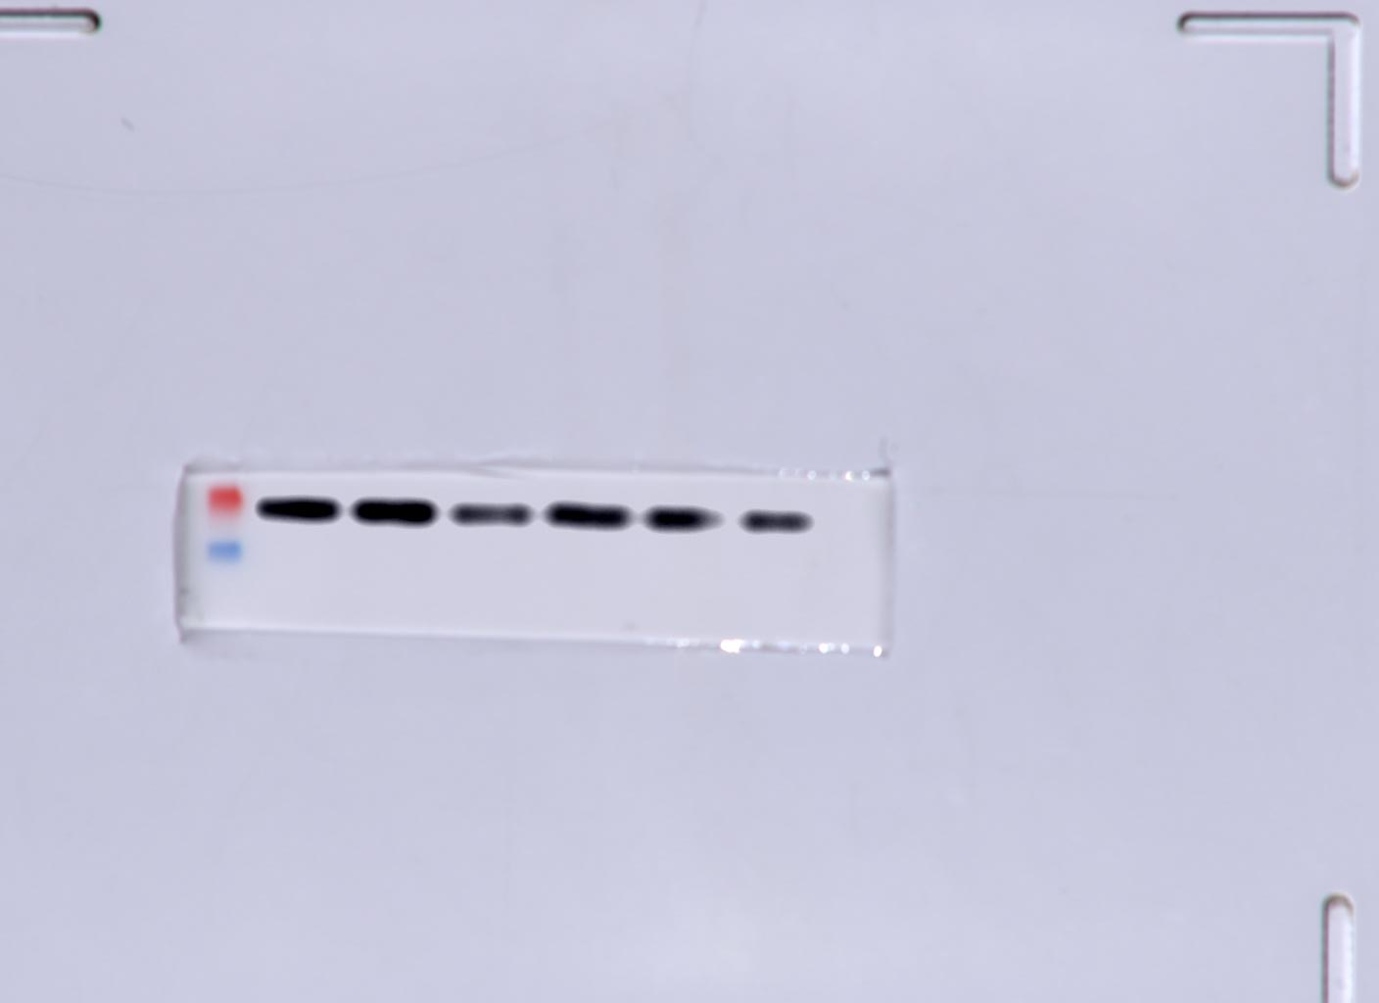
MAVS
B
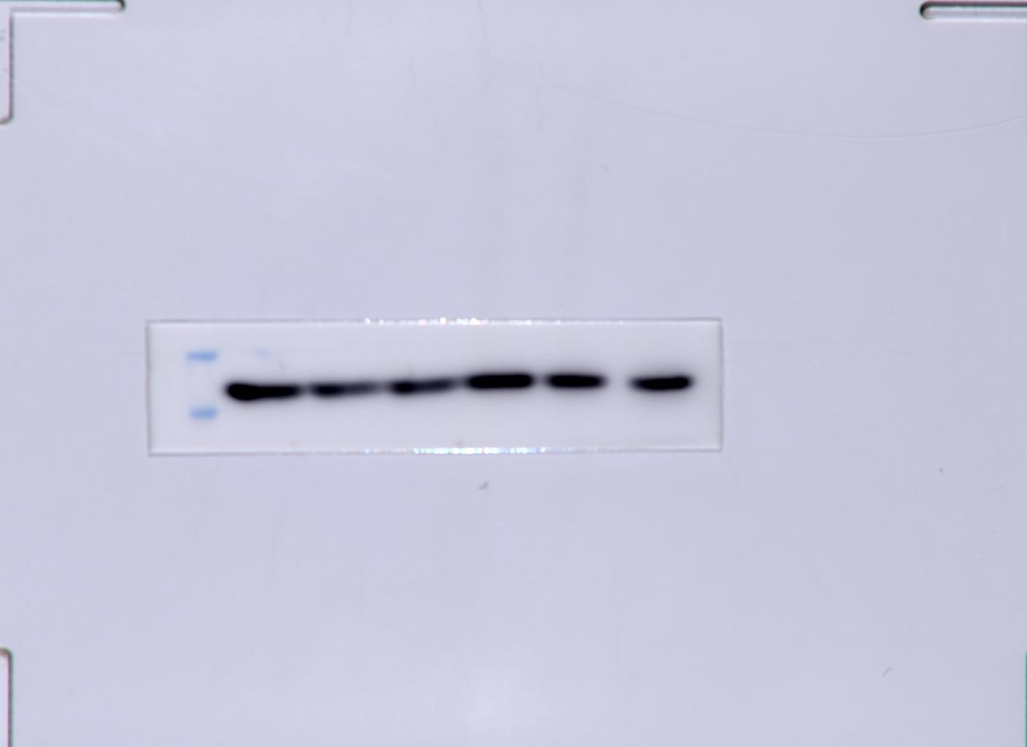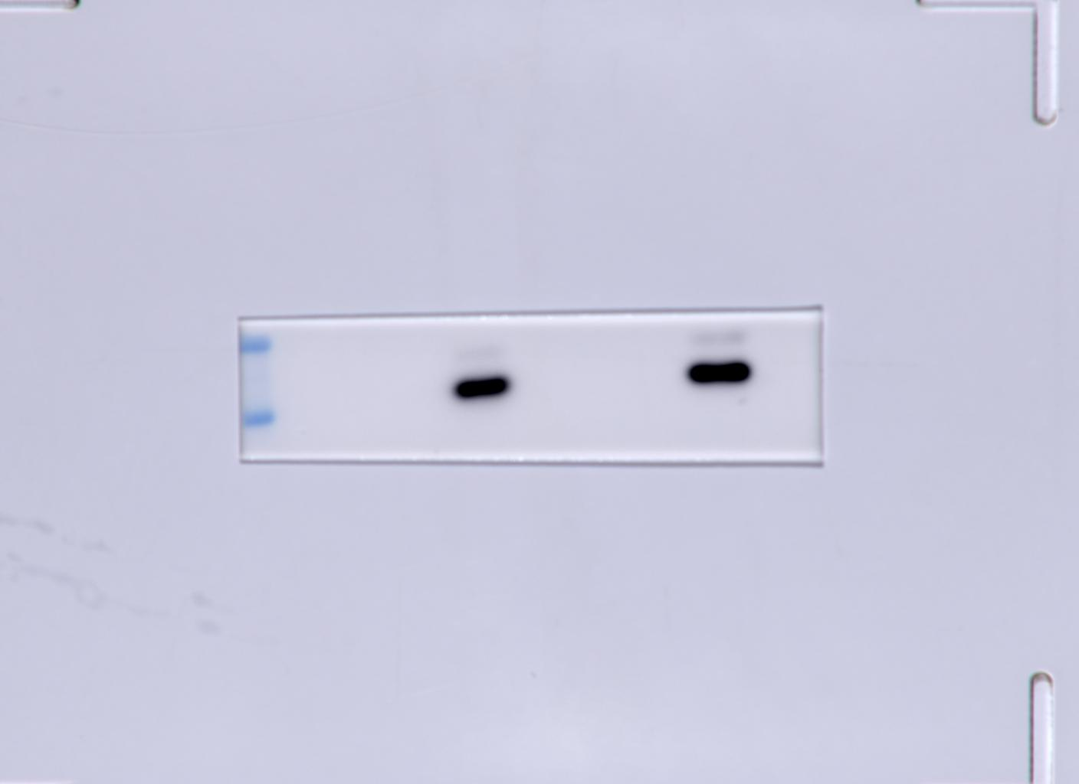
β-actin Myc-vp3

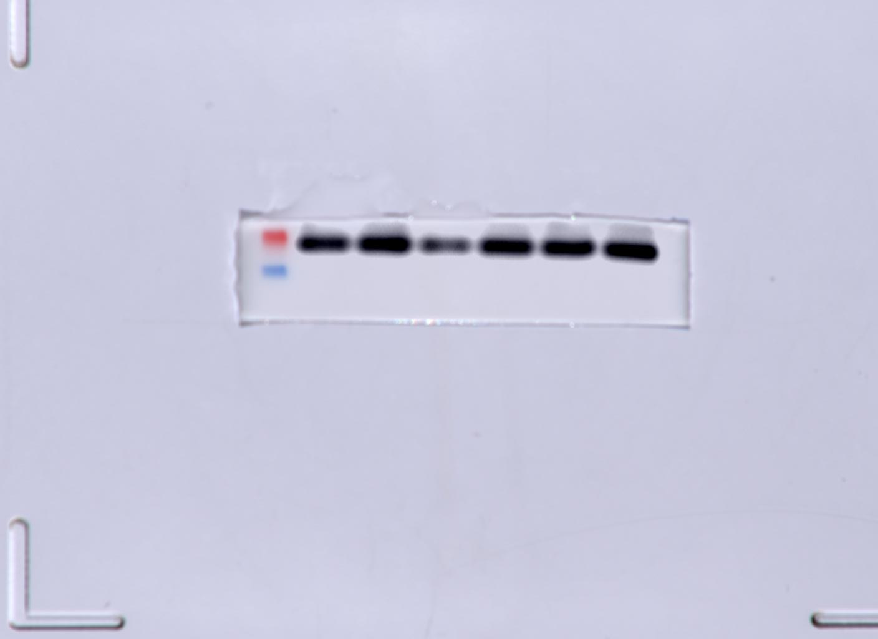
MAVS
C
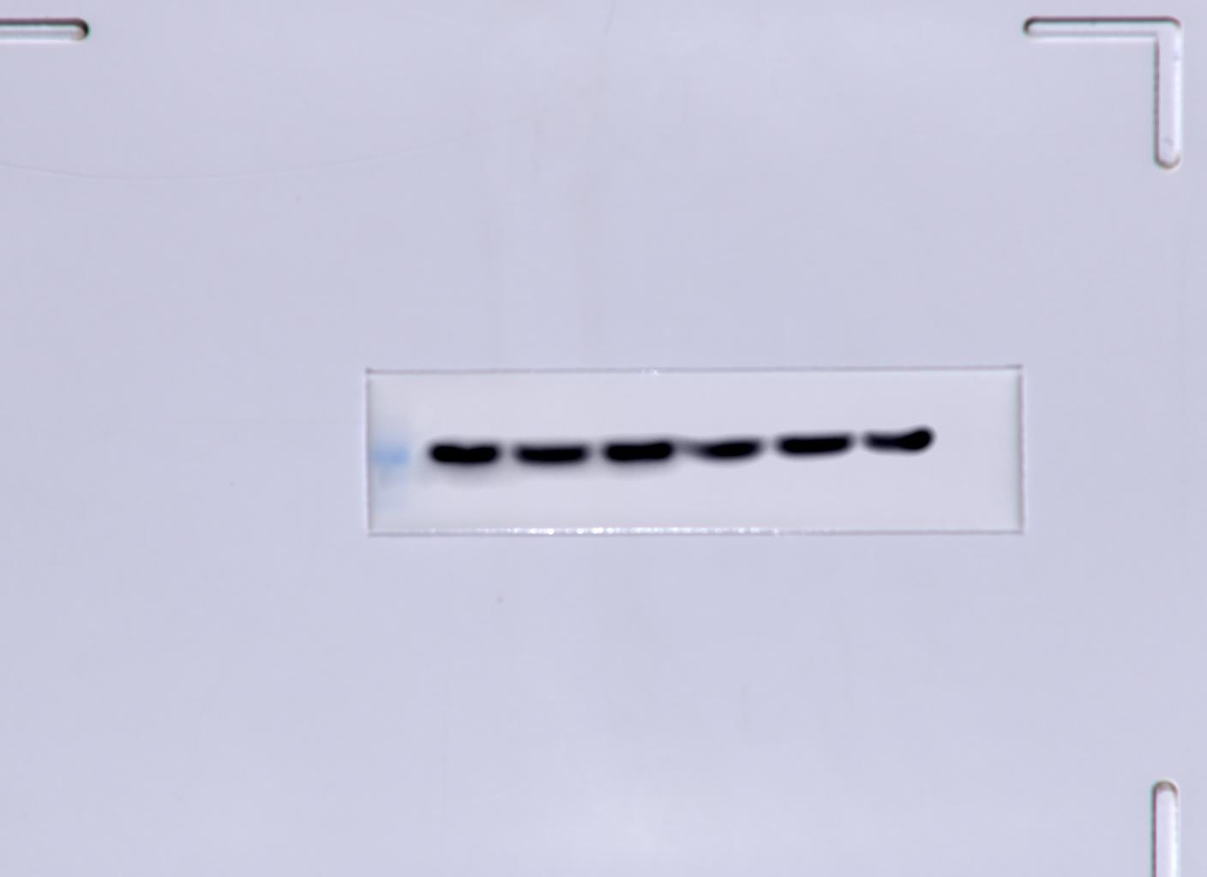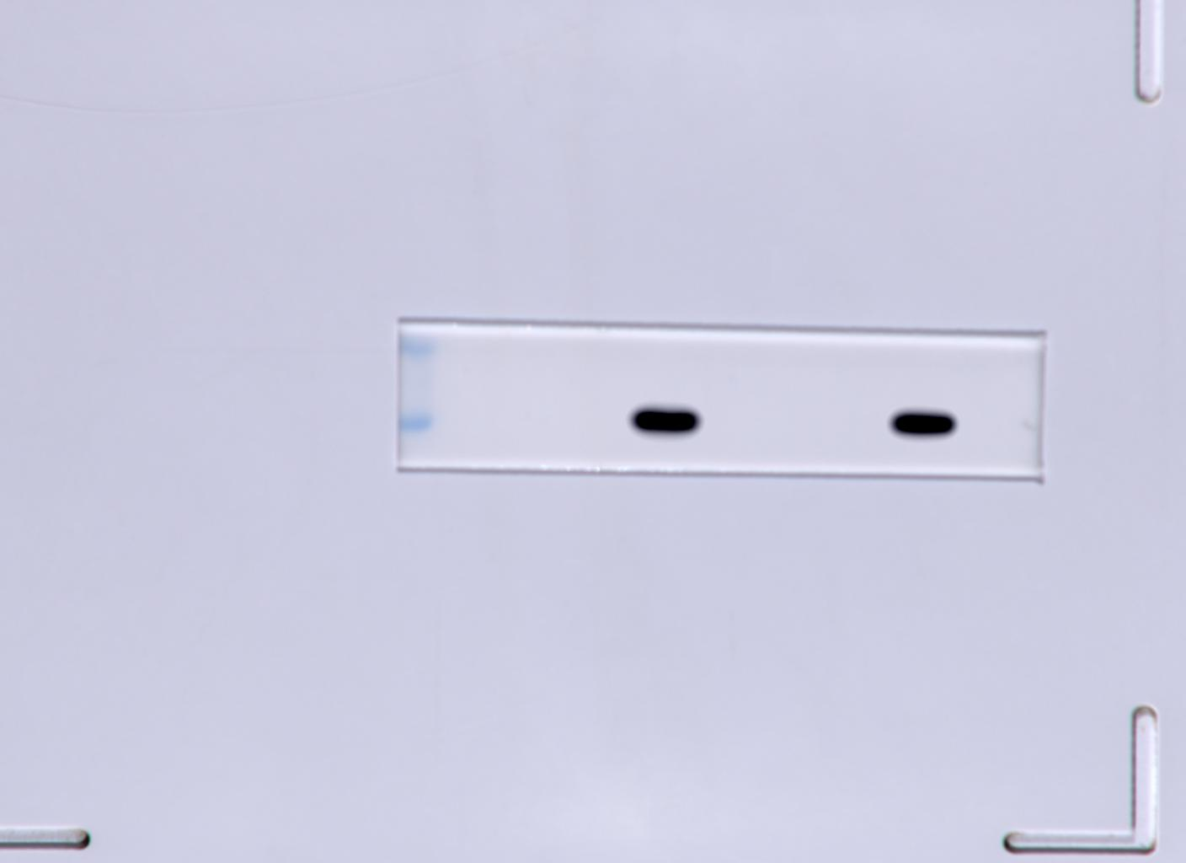
β-actin Myc-vp3

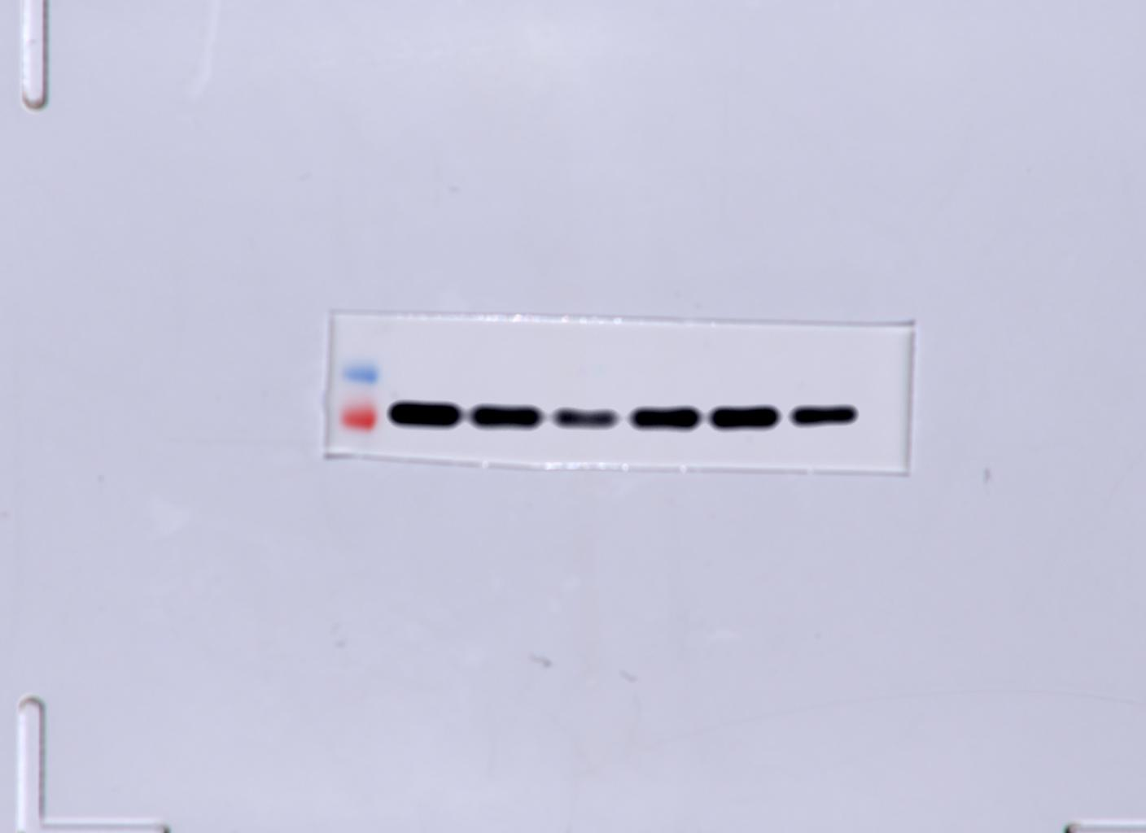
MAVS
D
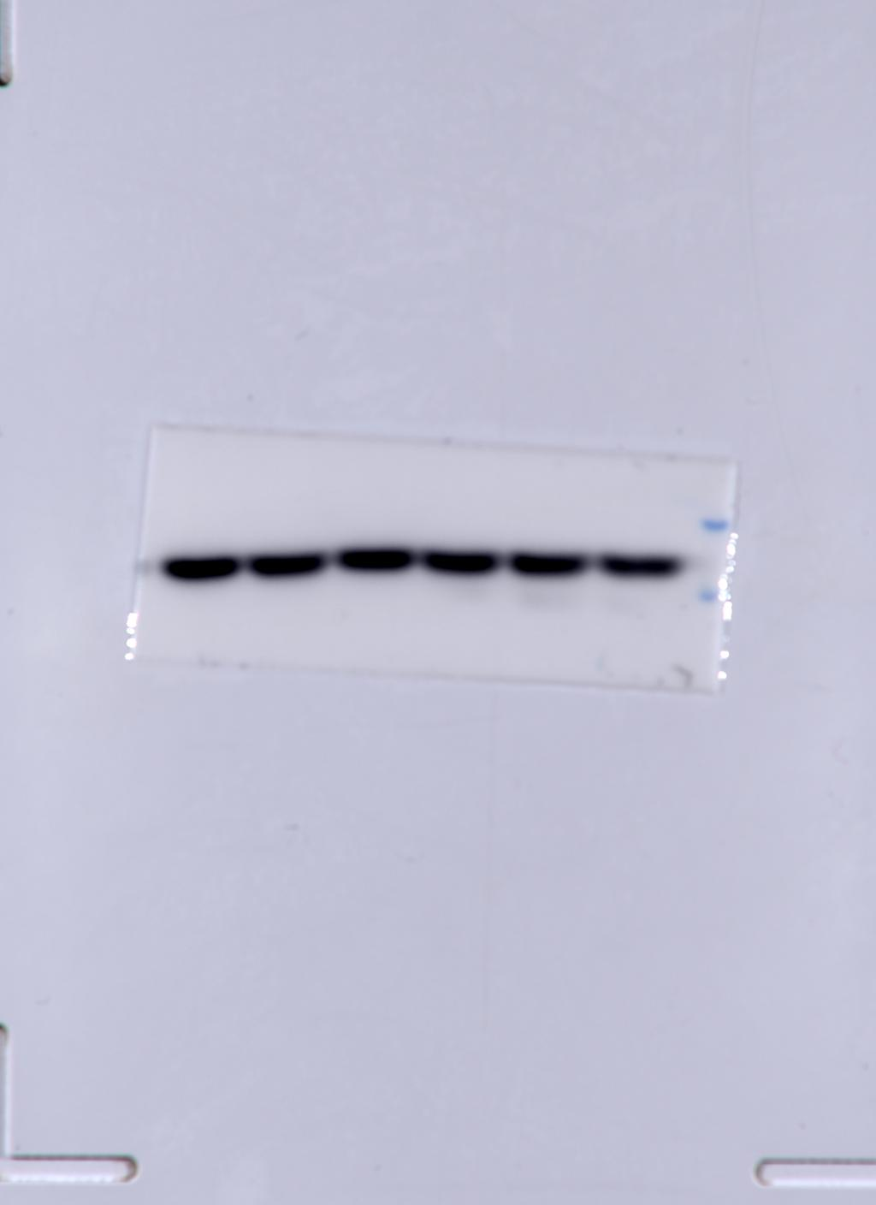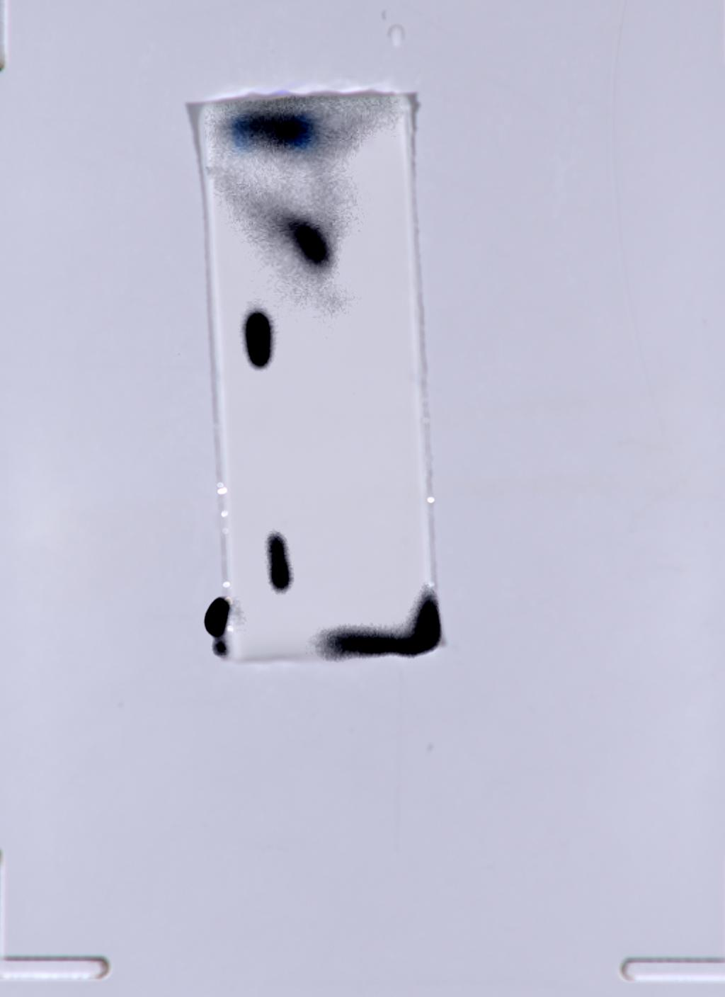
β-actin Myc-VP3
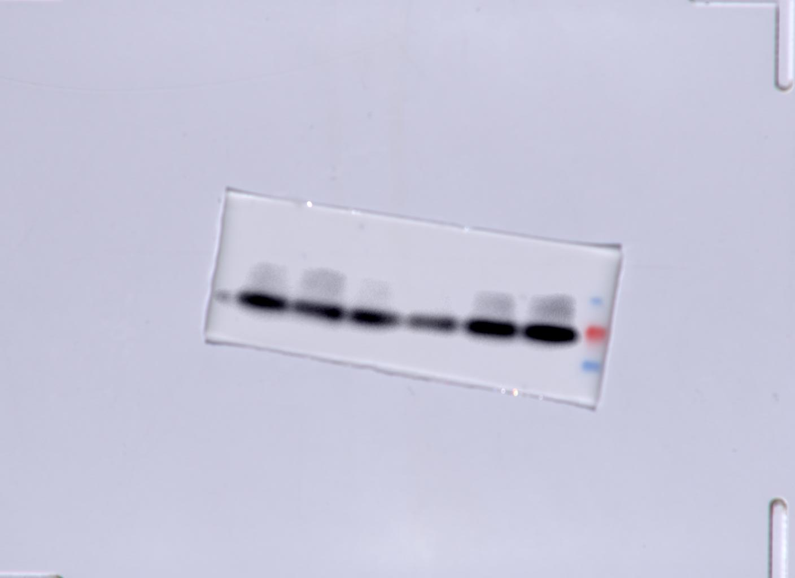
MAVS
E
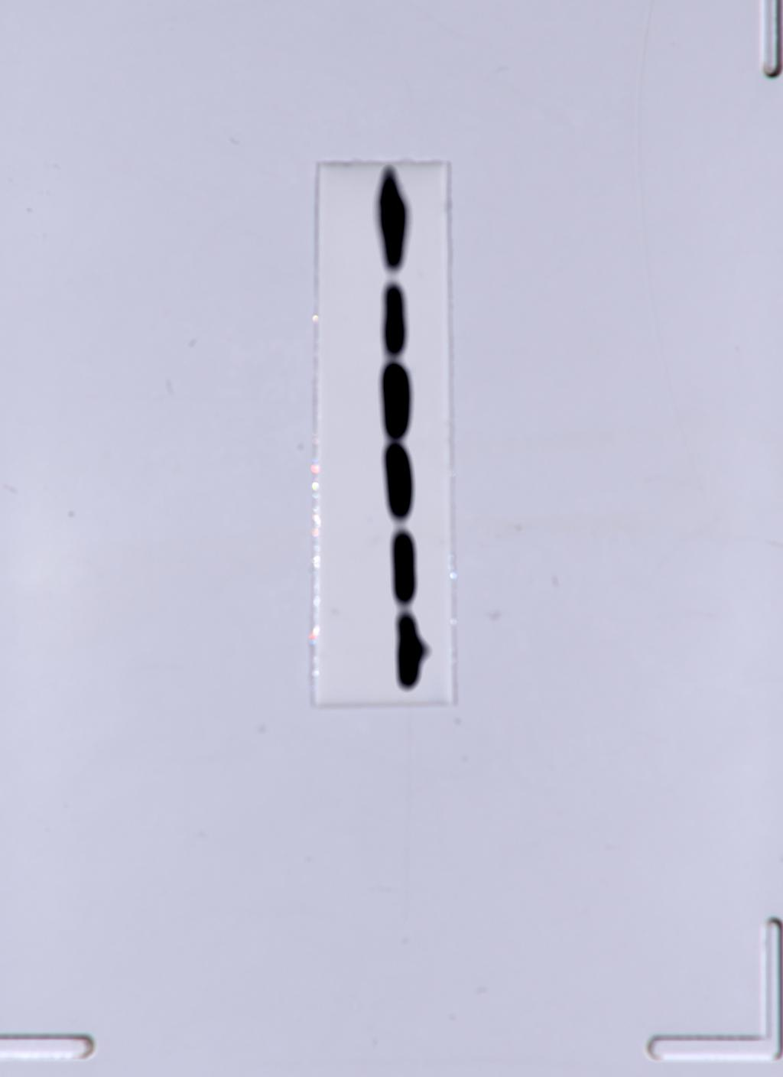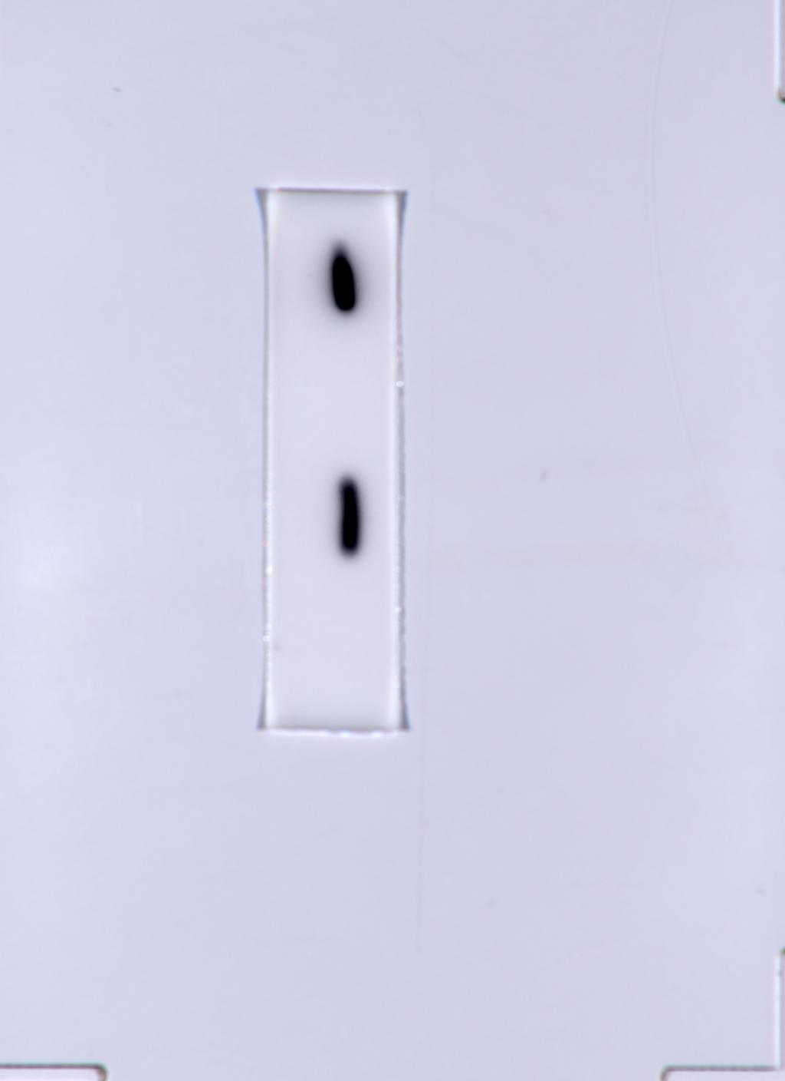
β-actin Myc-VP3
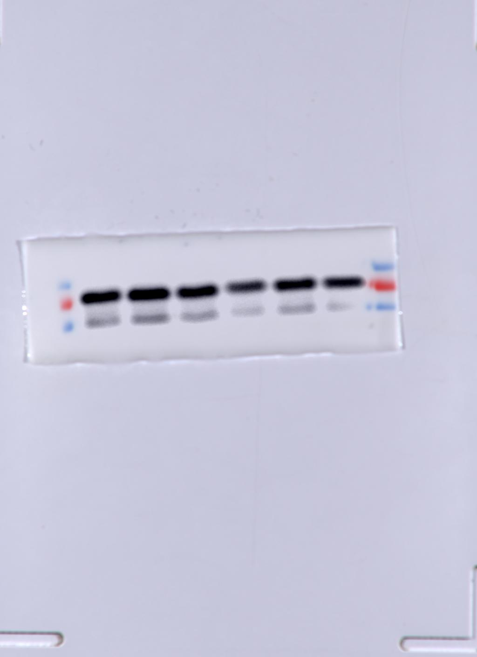
MAVS

F
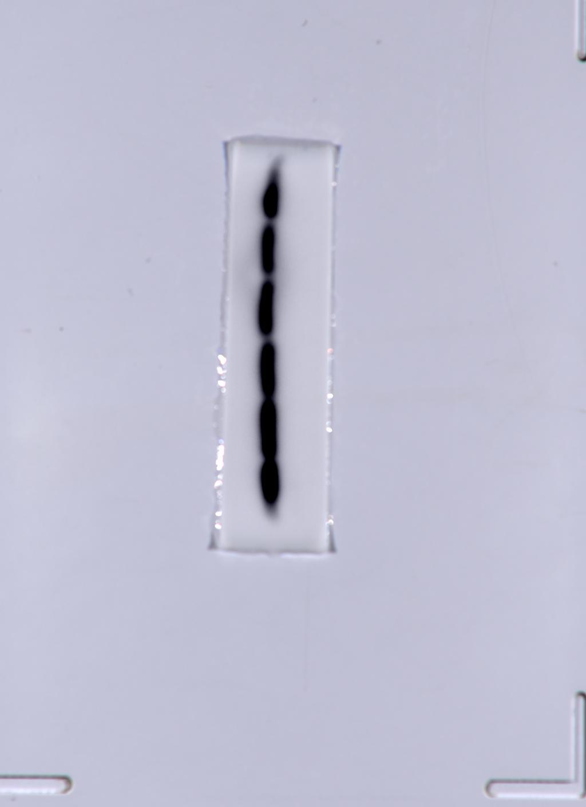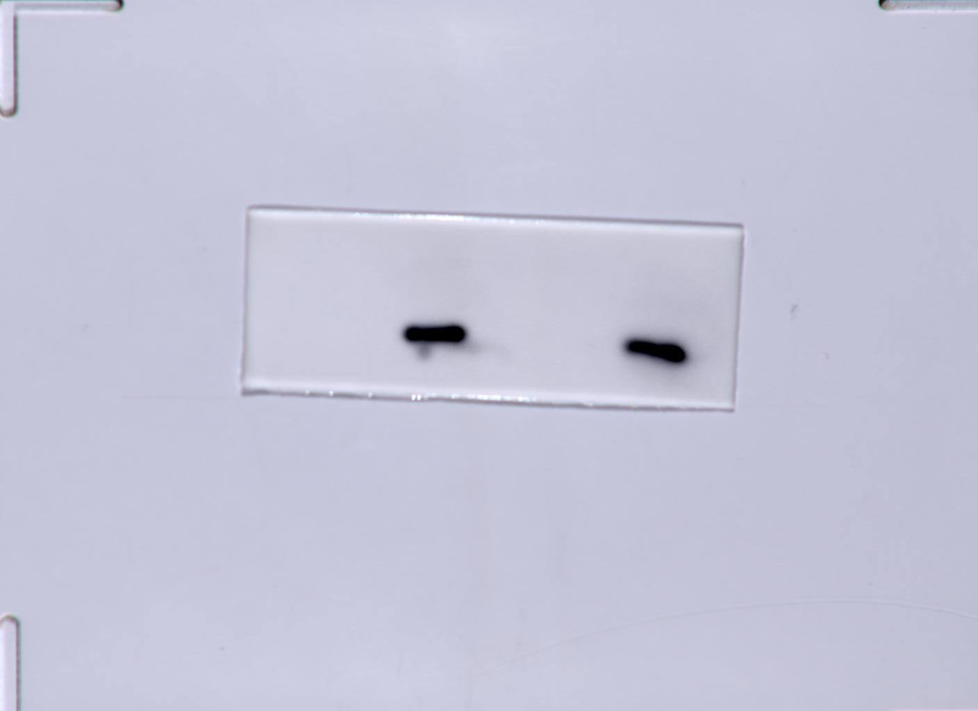
β-actin Myc-VP3
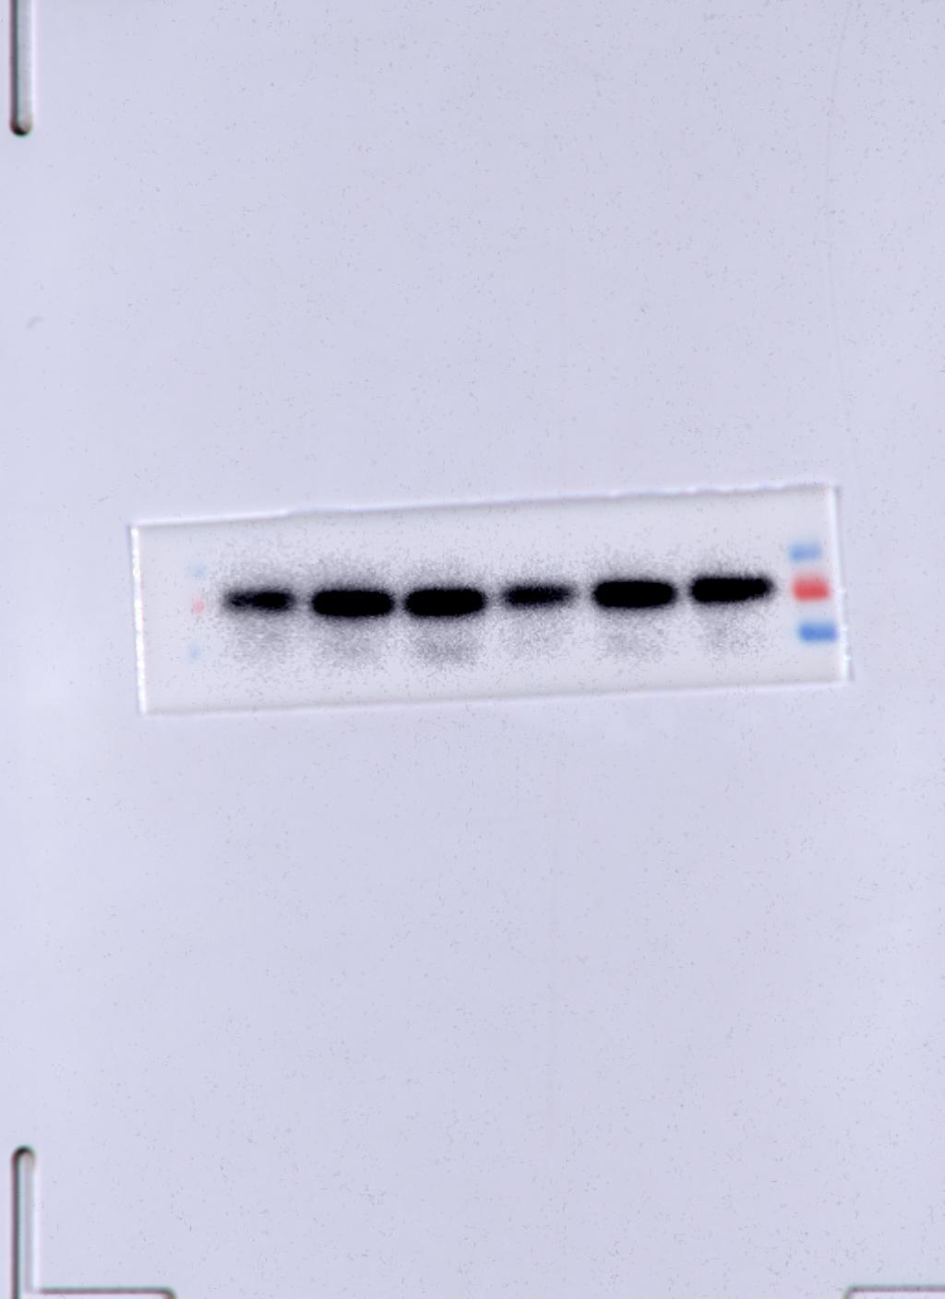
MAVS

G
EV group
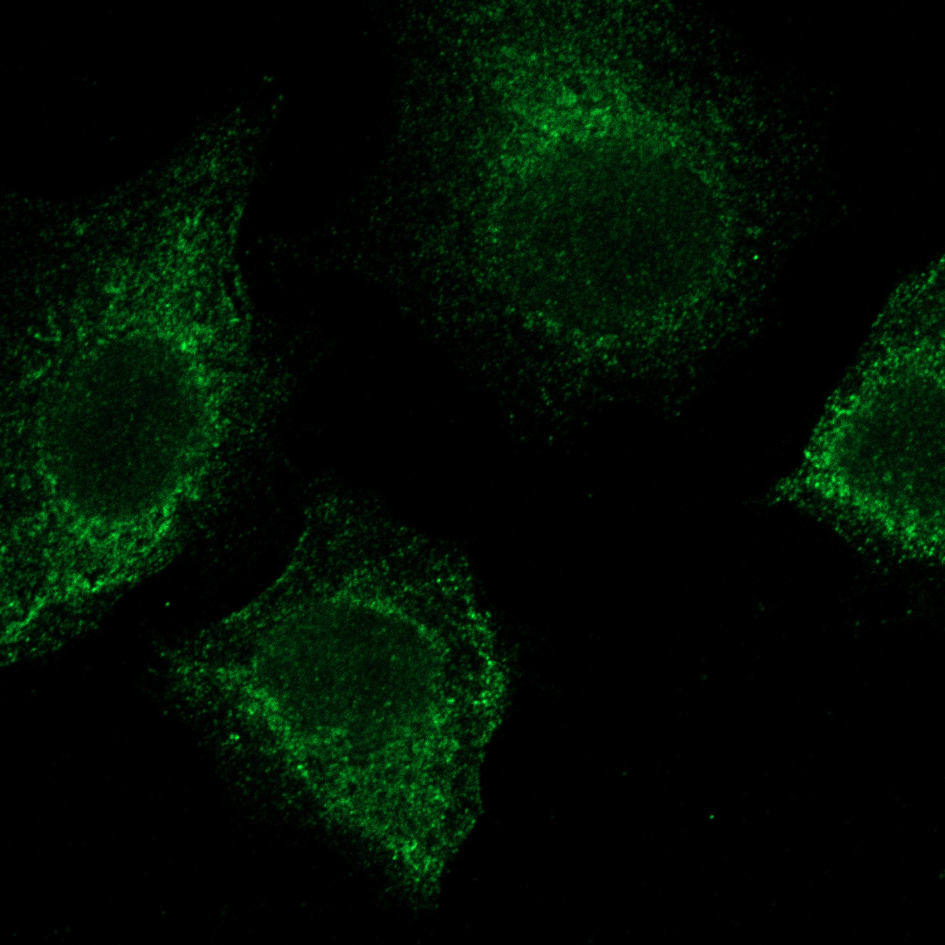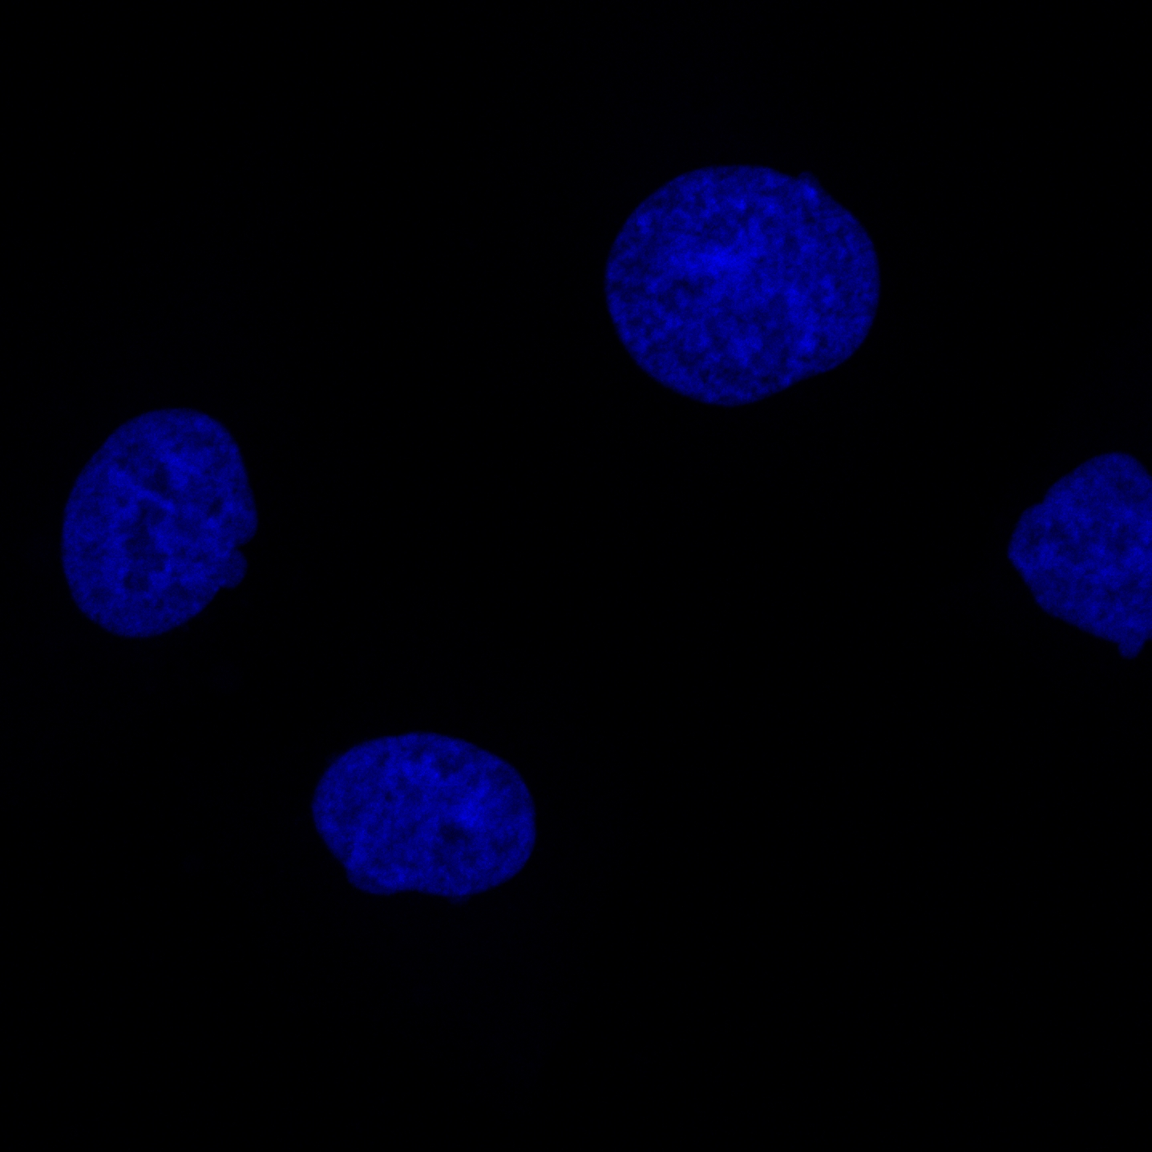
Myc(Cy3) LC3(AF488) DAPI
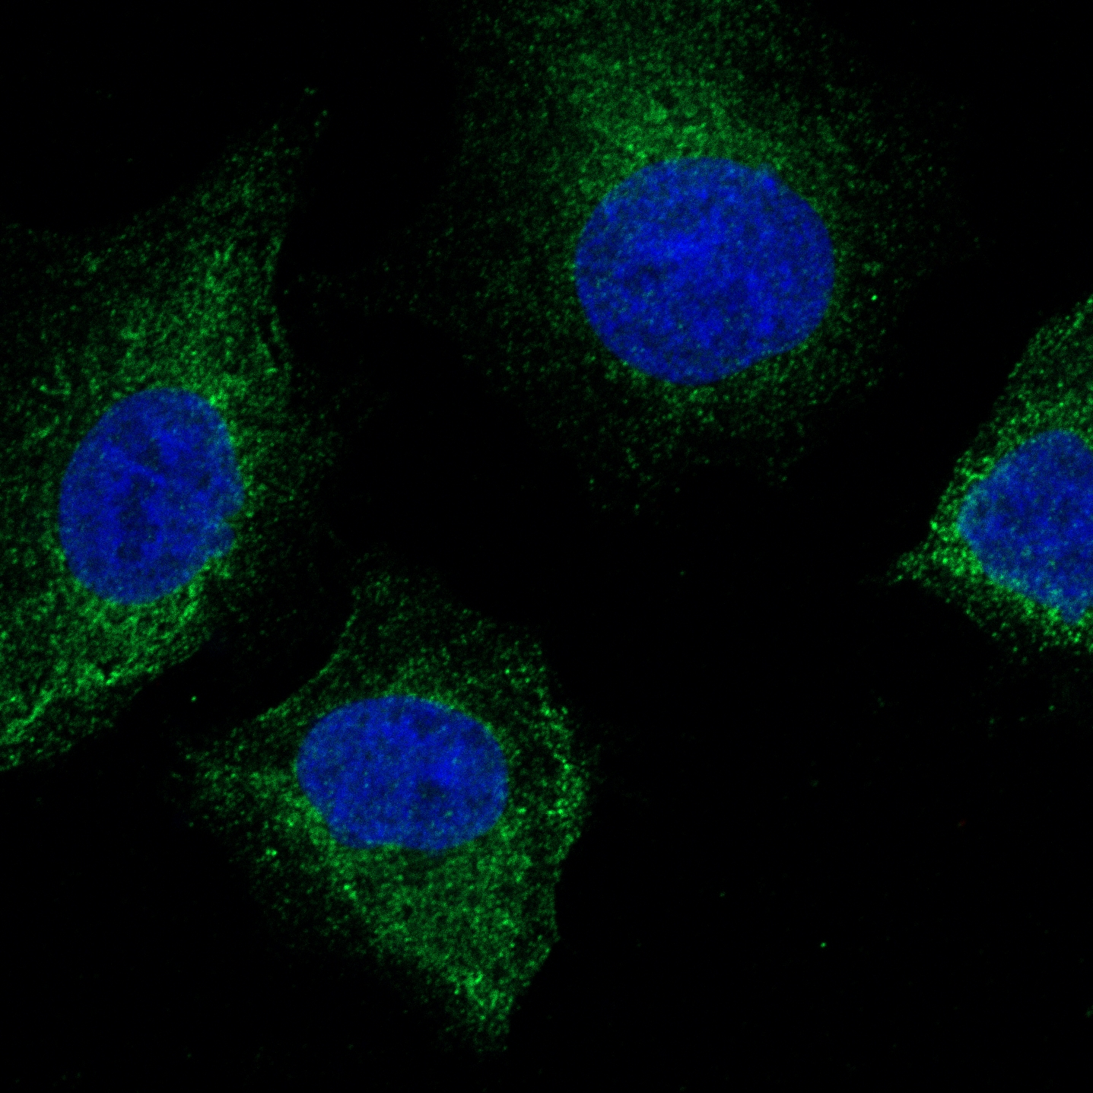
Merge
Myc-VP3 group

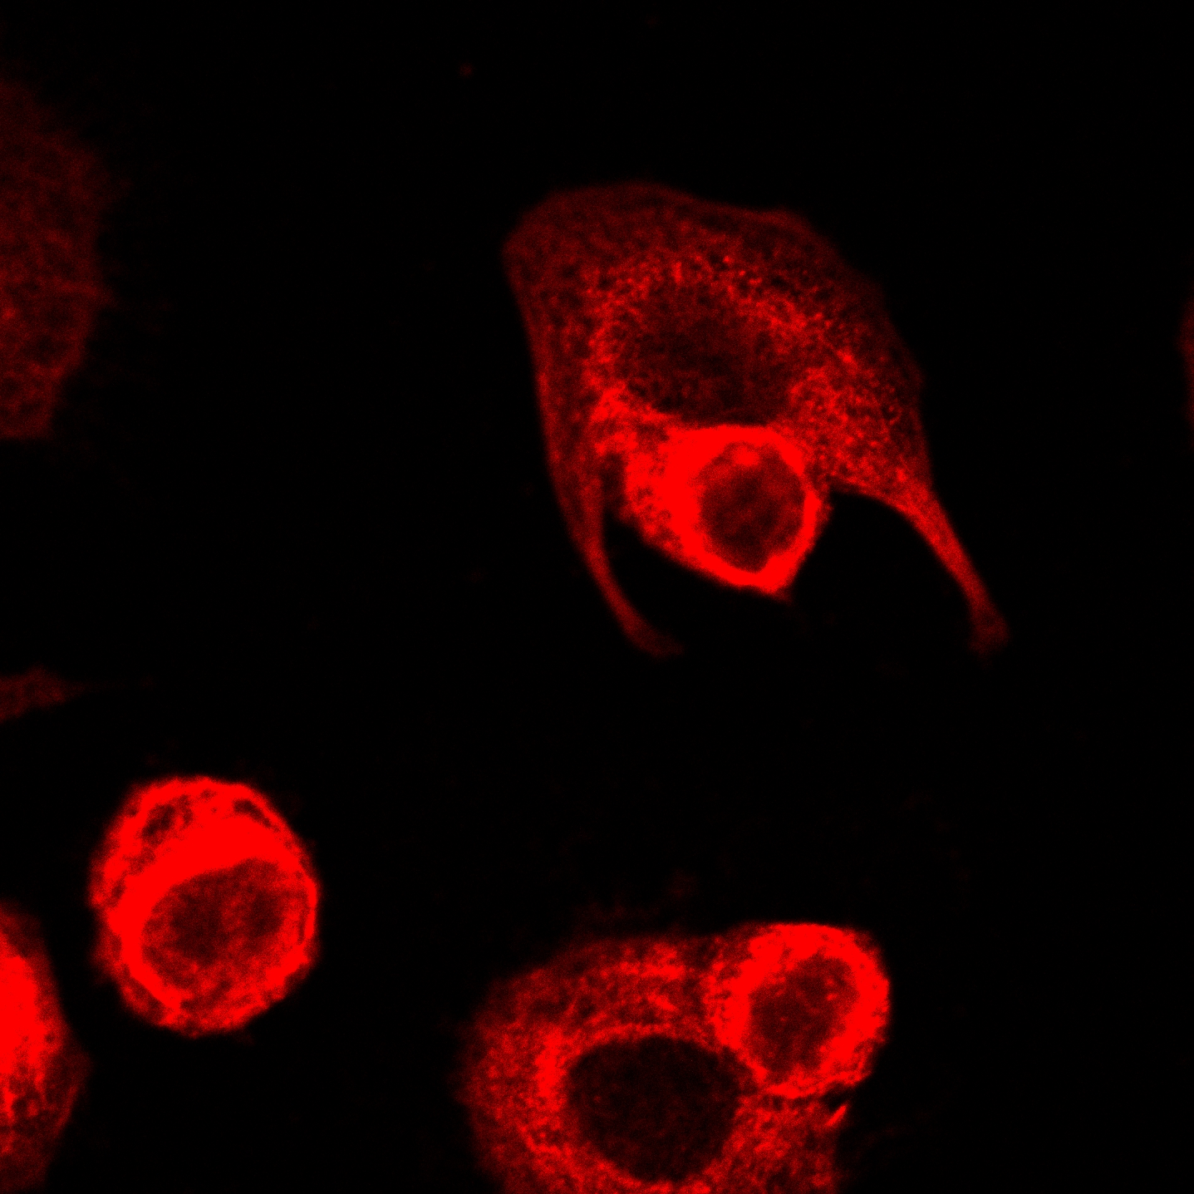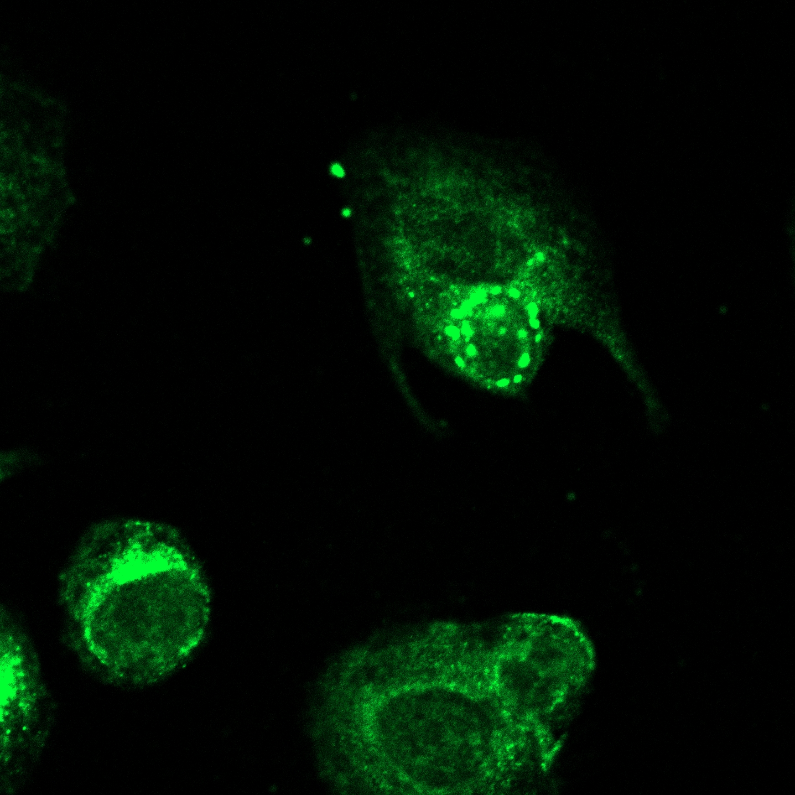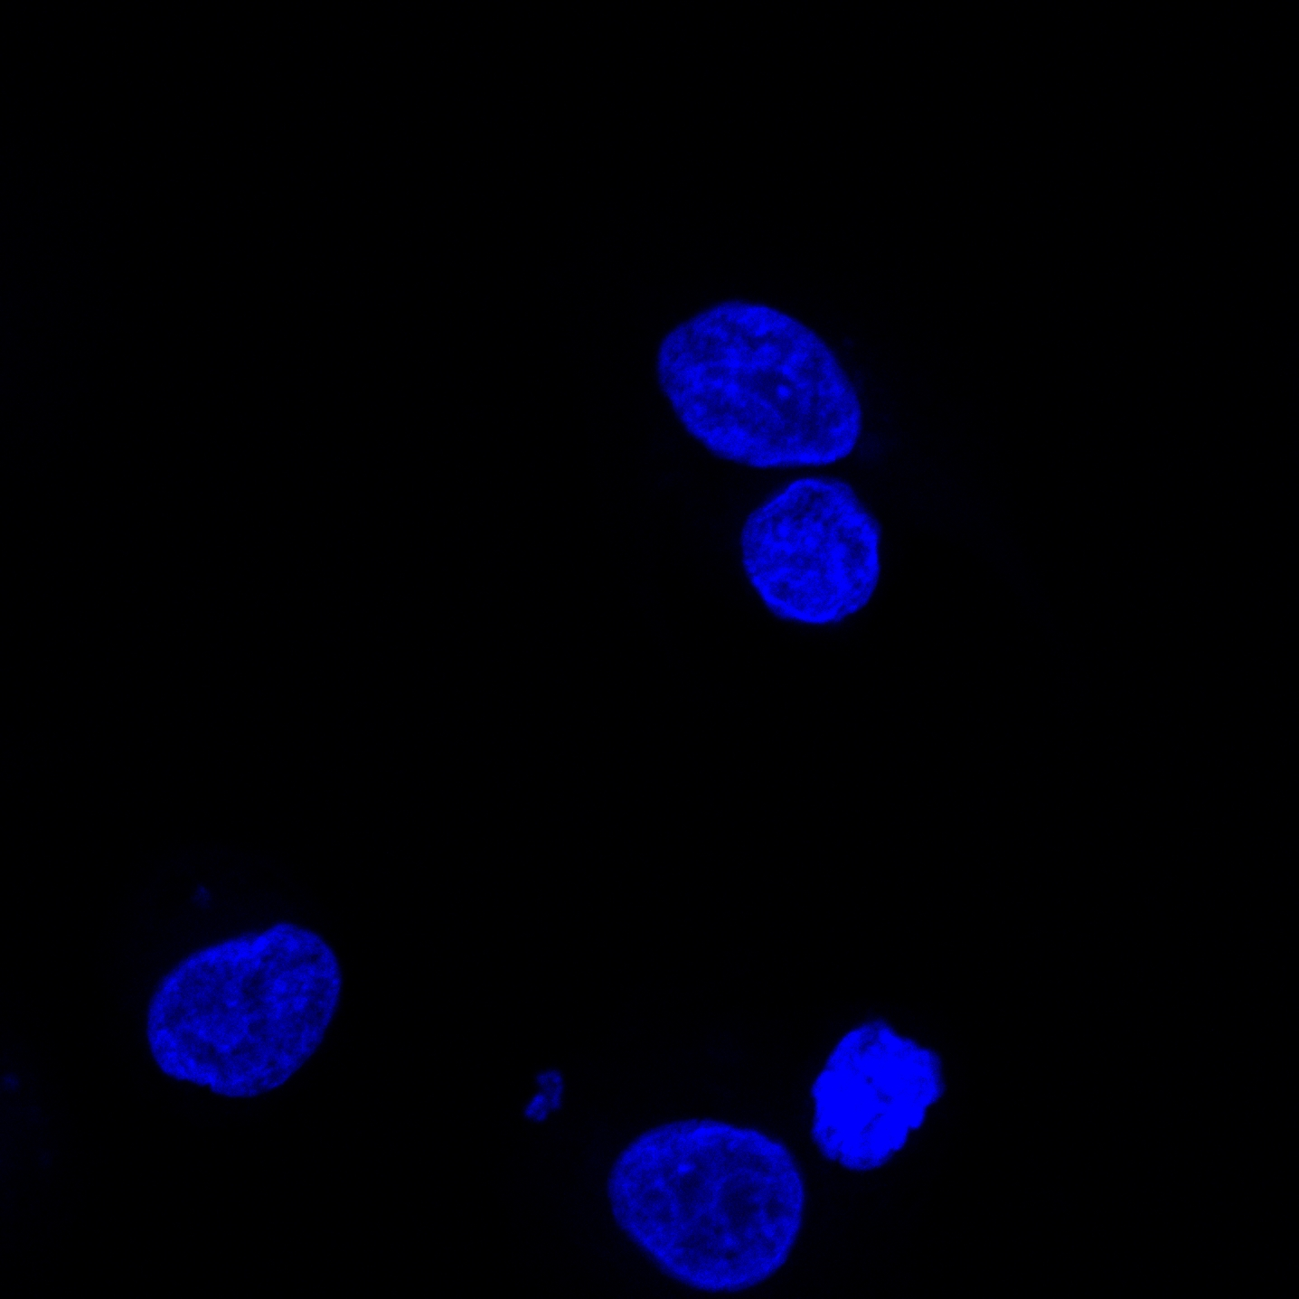
Myc(Cy3) LC3(AF488) DAPI
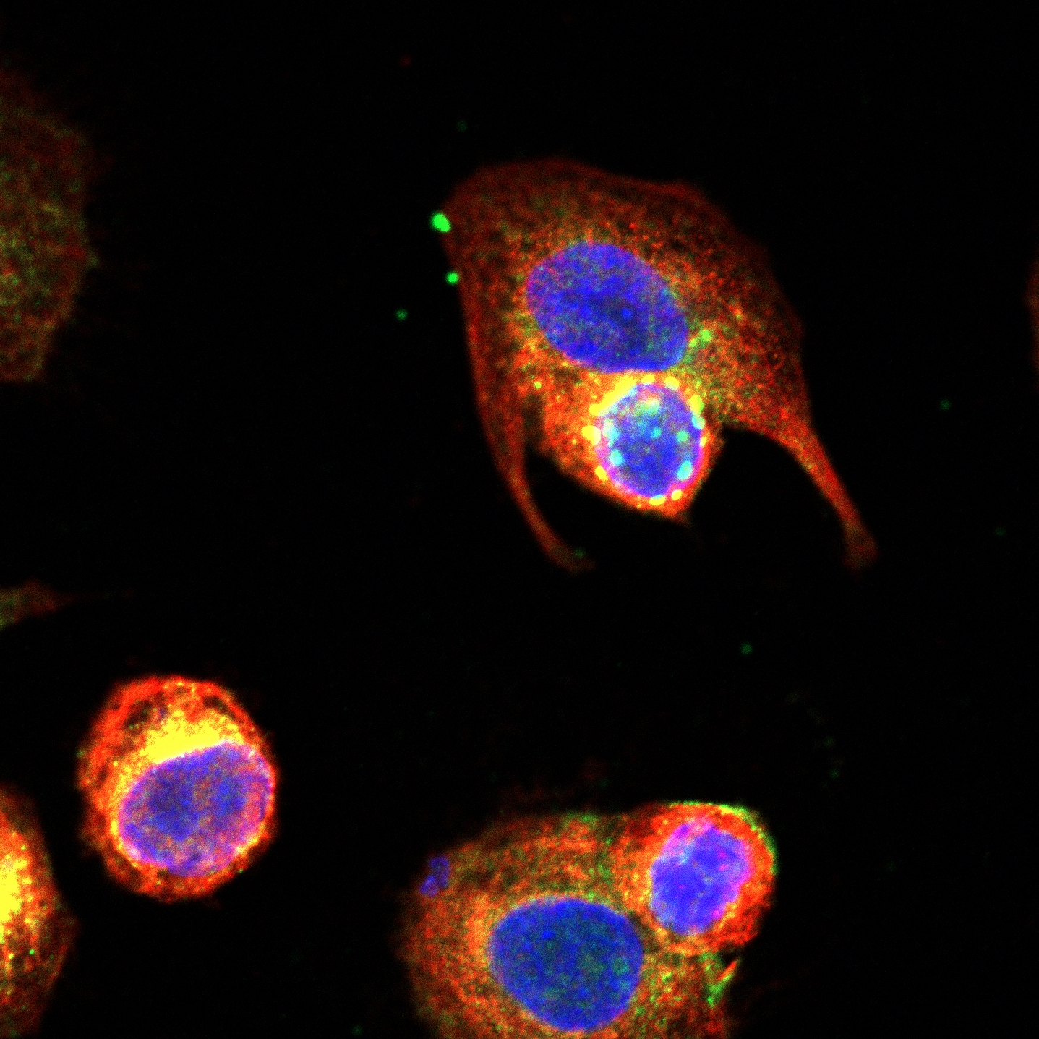
Merge
H
EV group
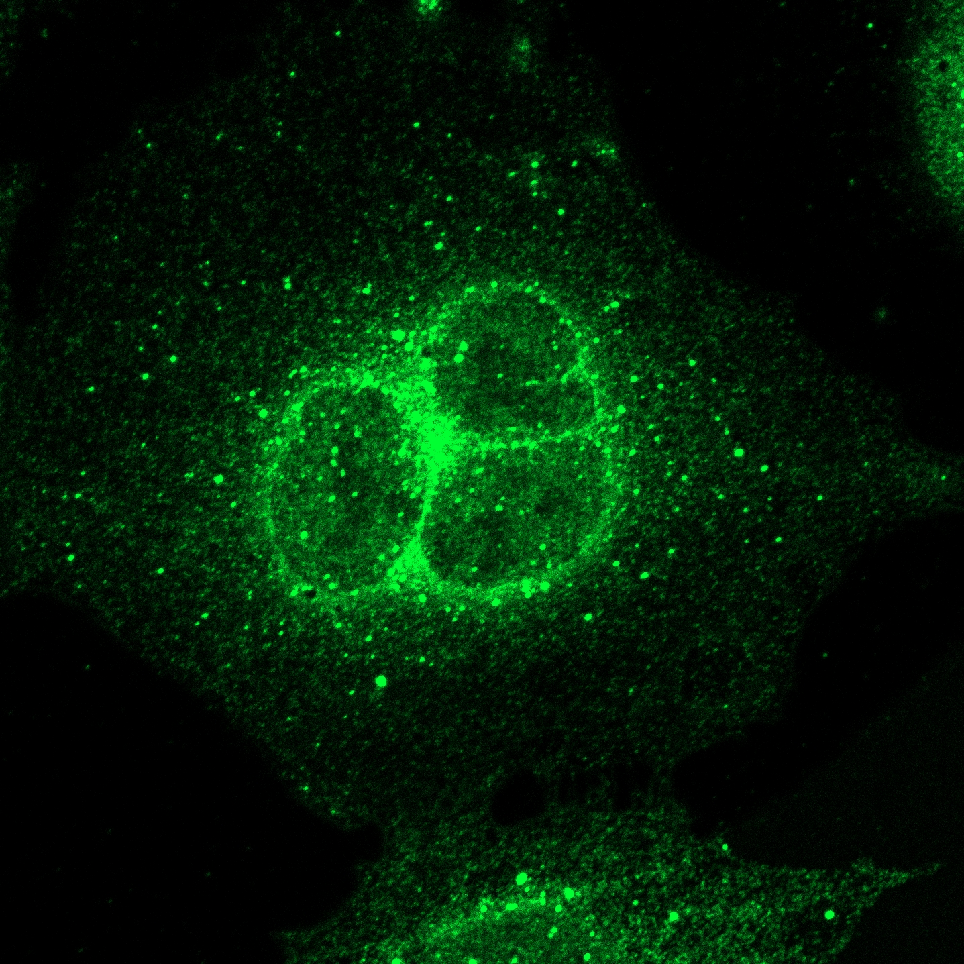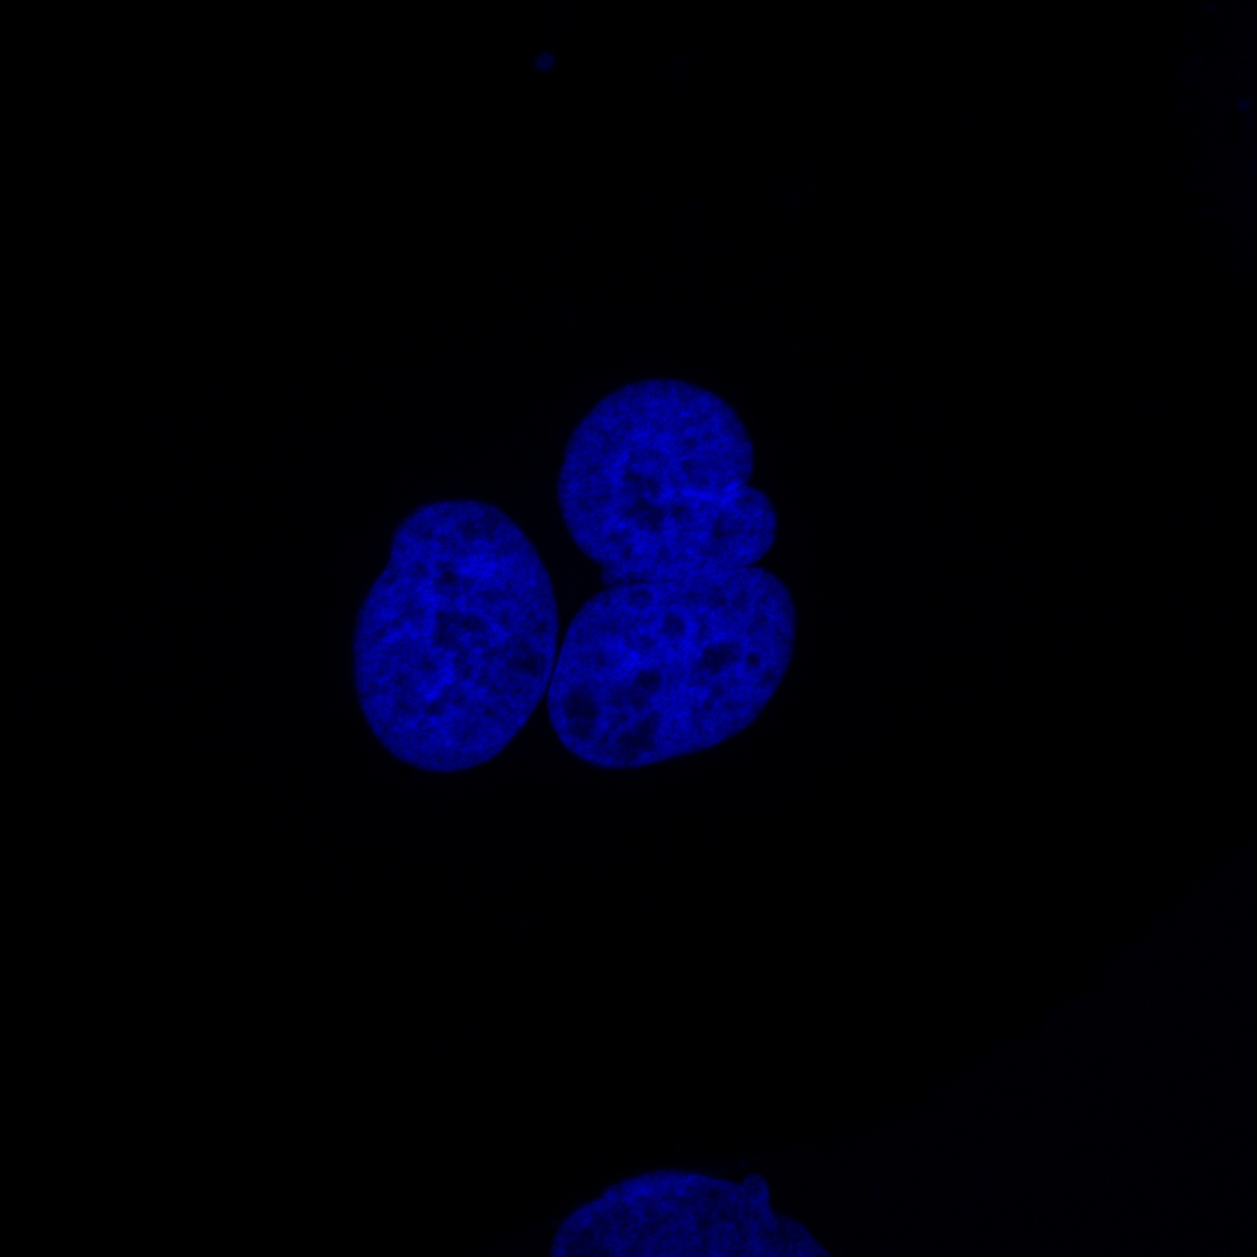
Myc(Cy3) p62(AF488) DAPI
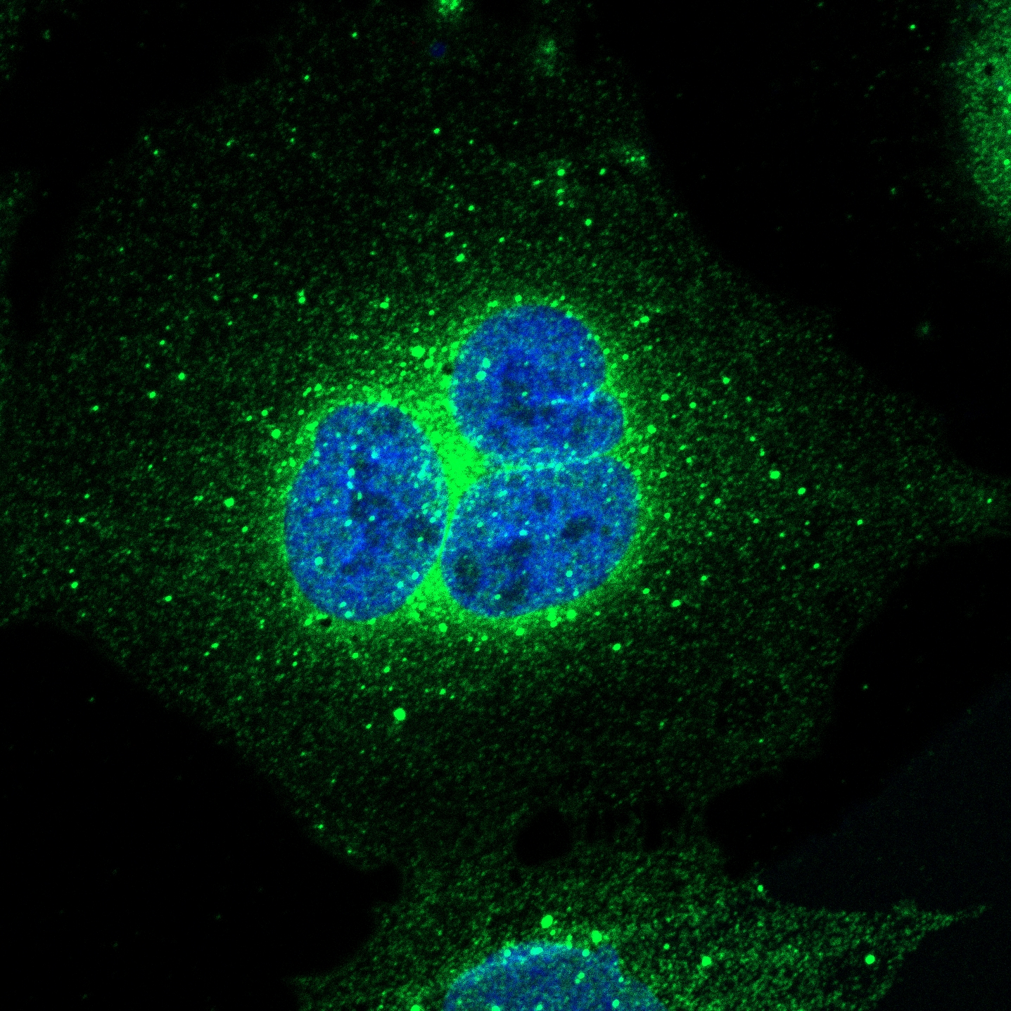
Merge
VP3 group
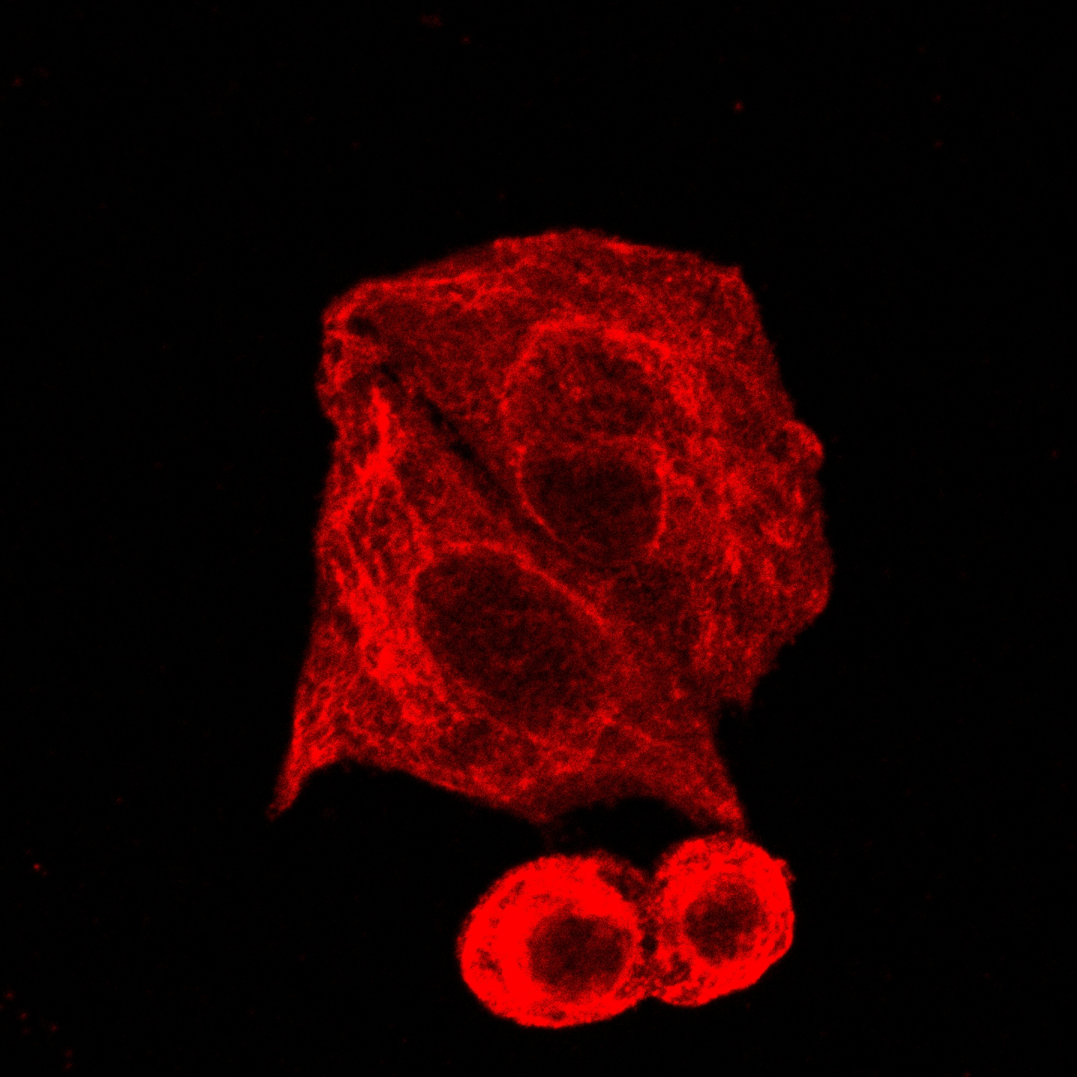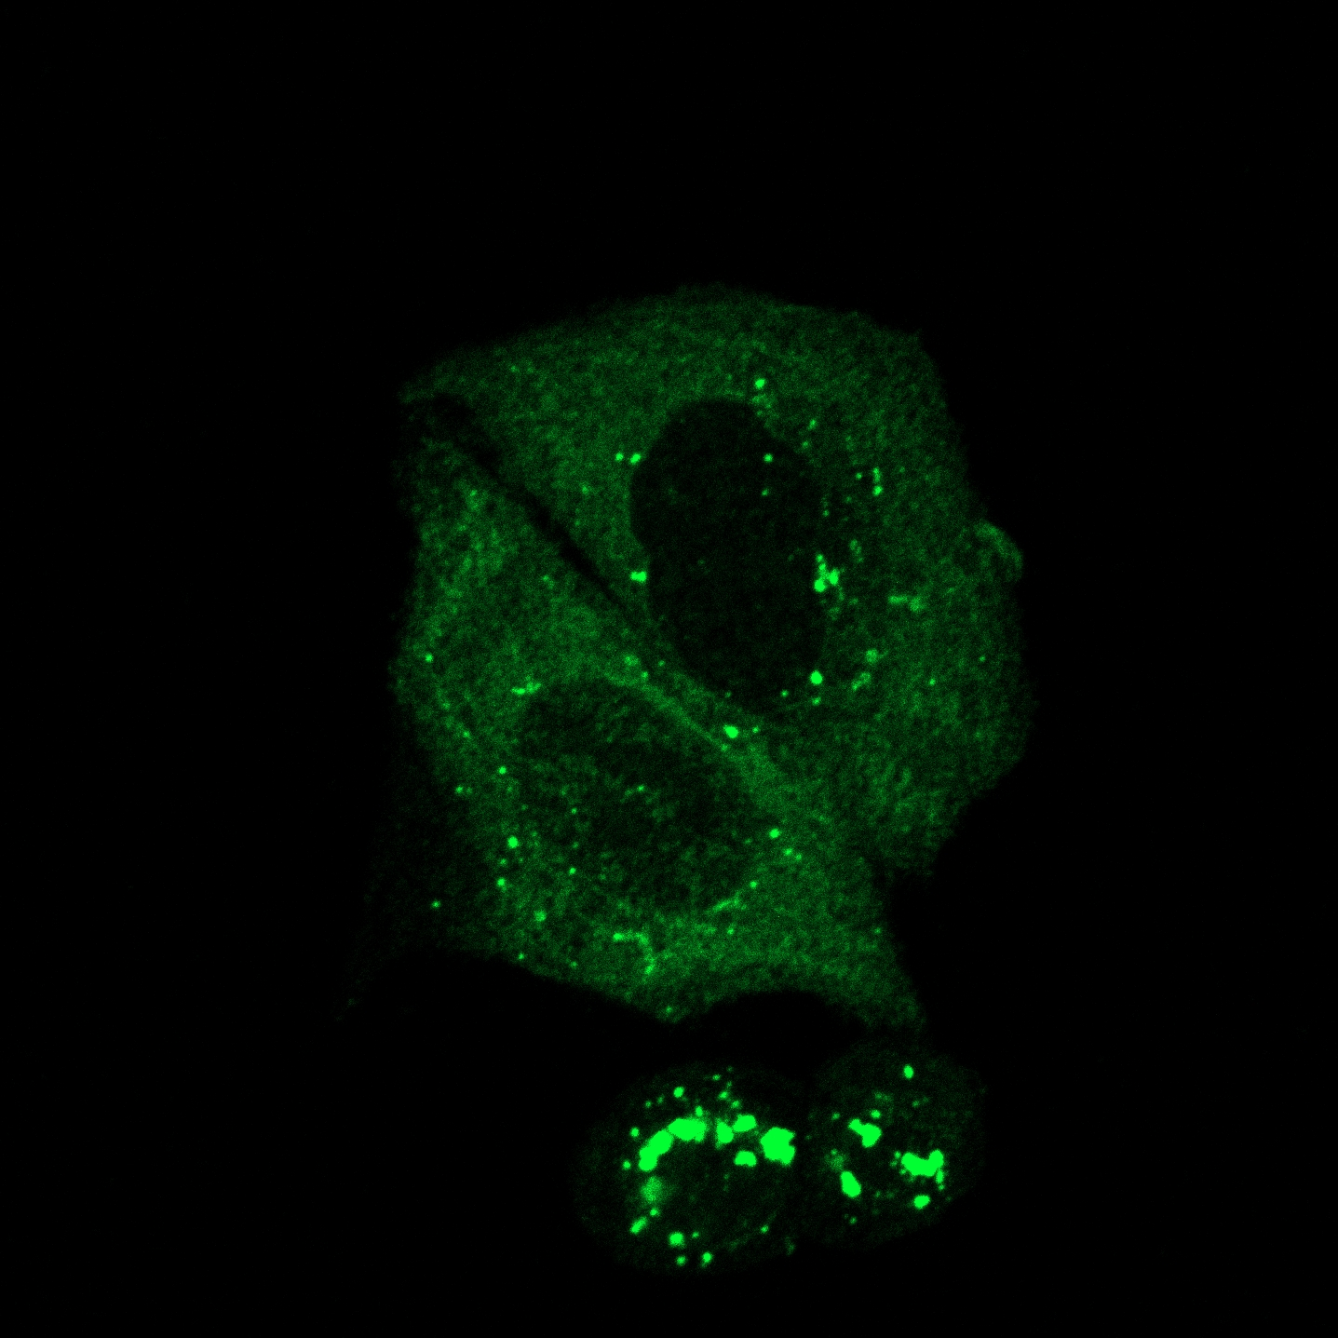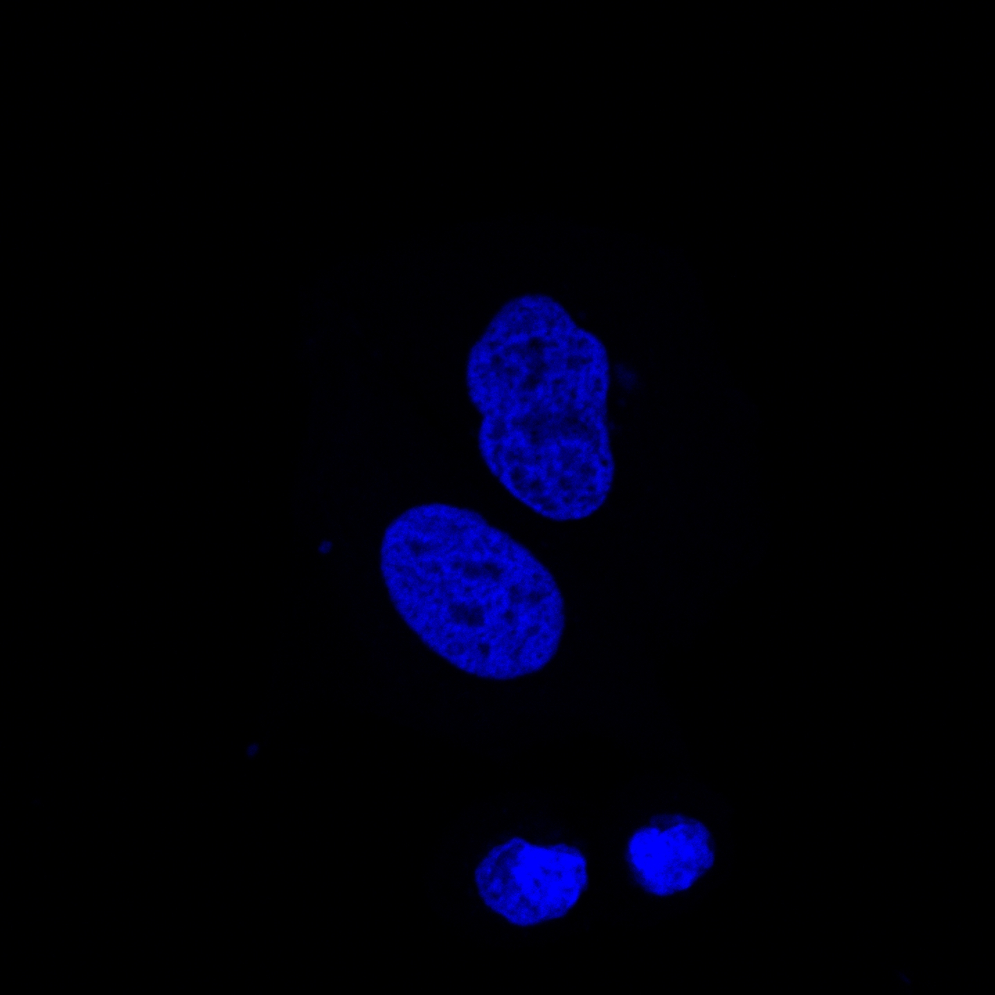
Myc(Cy3) p62(AF488) DAPI

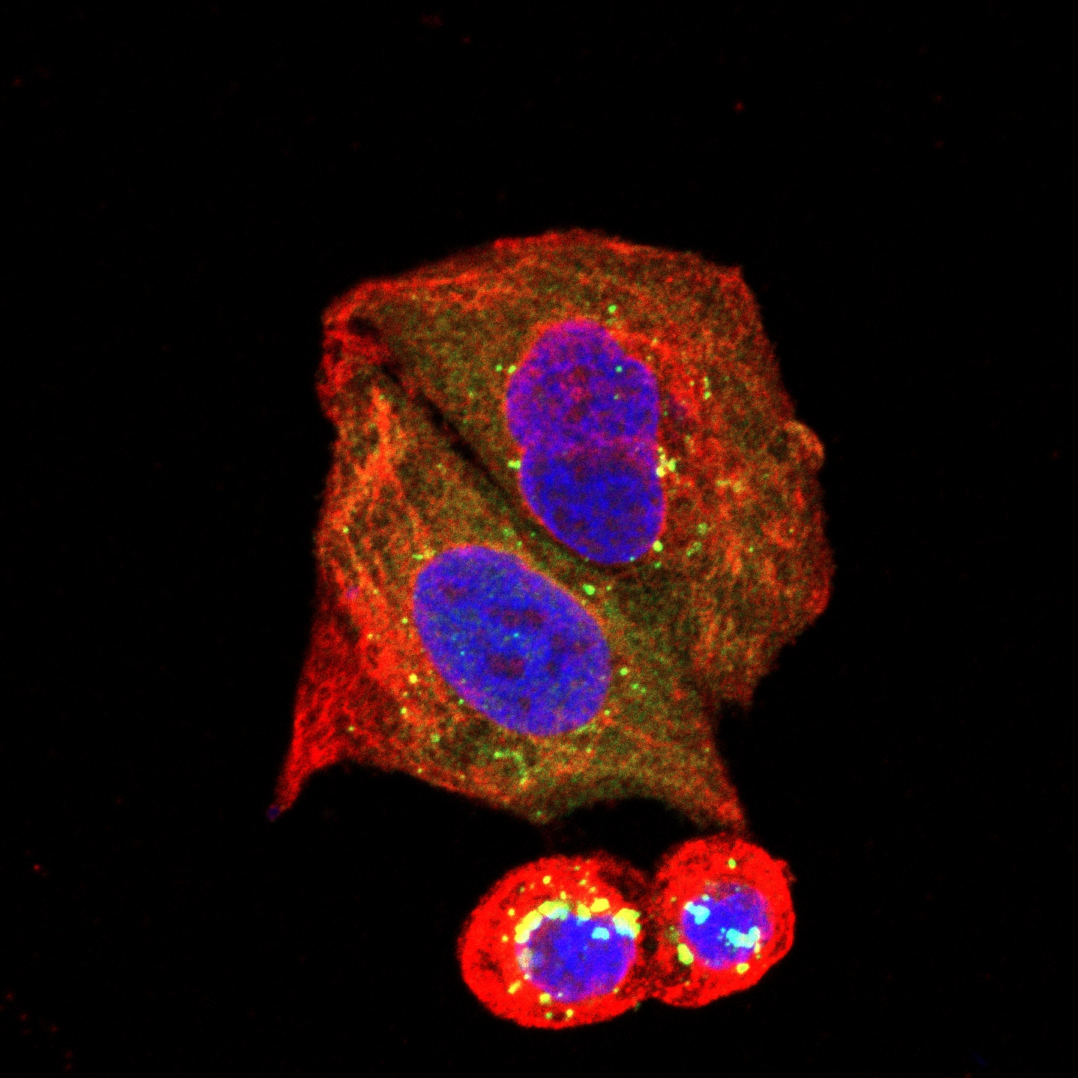
Merge
I
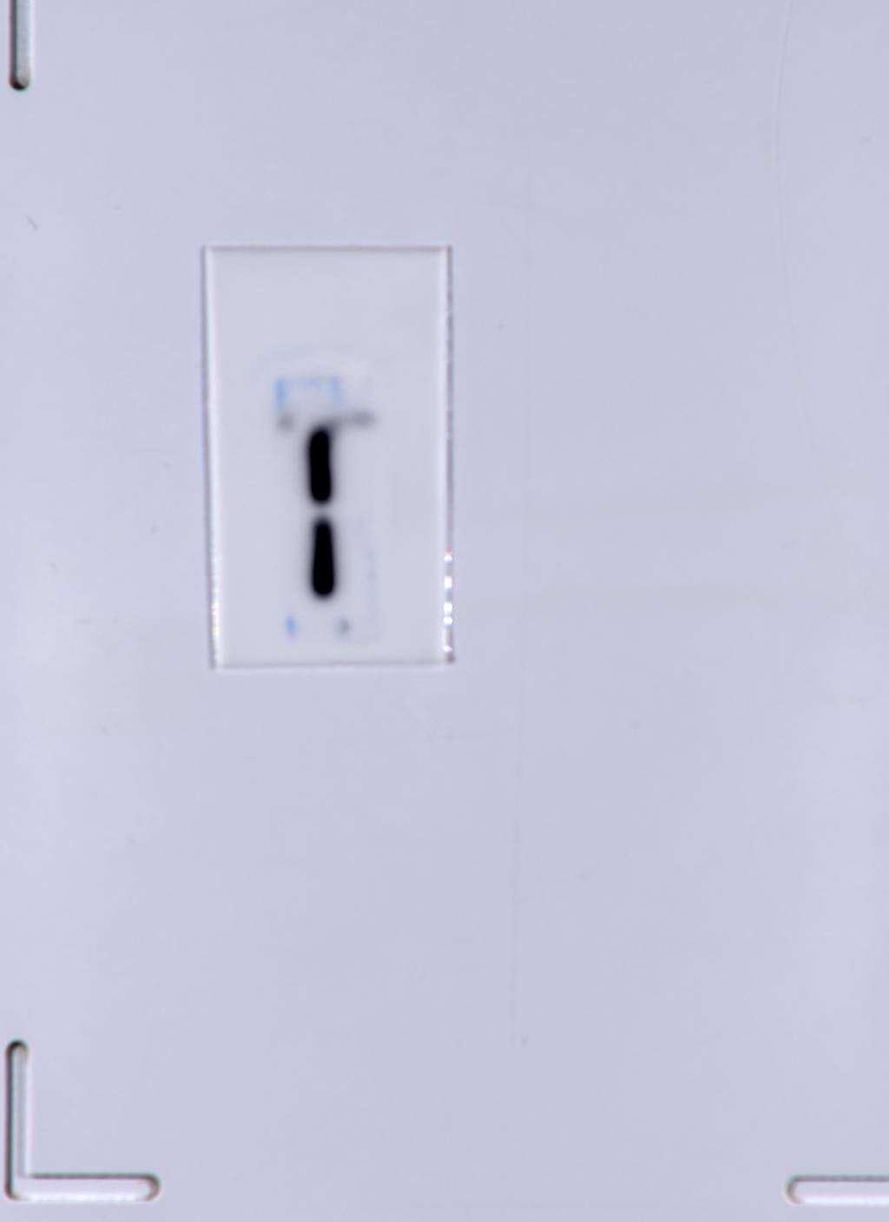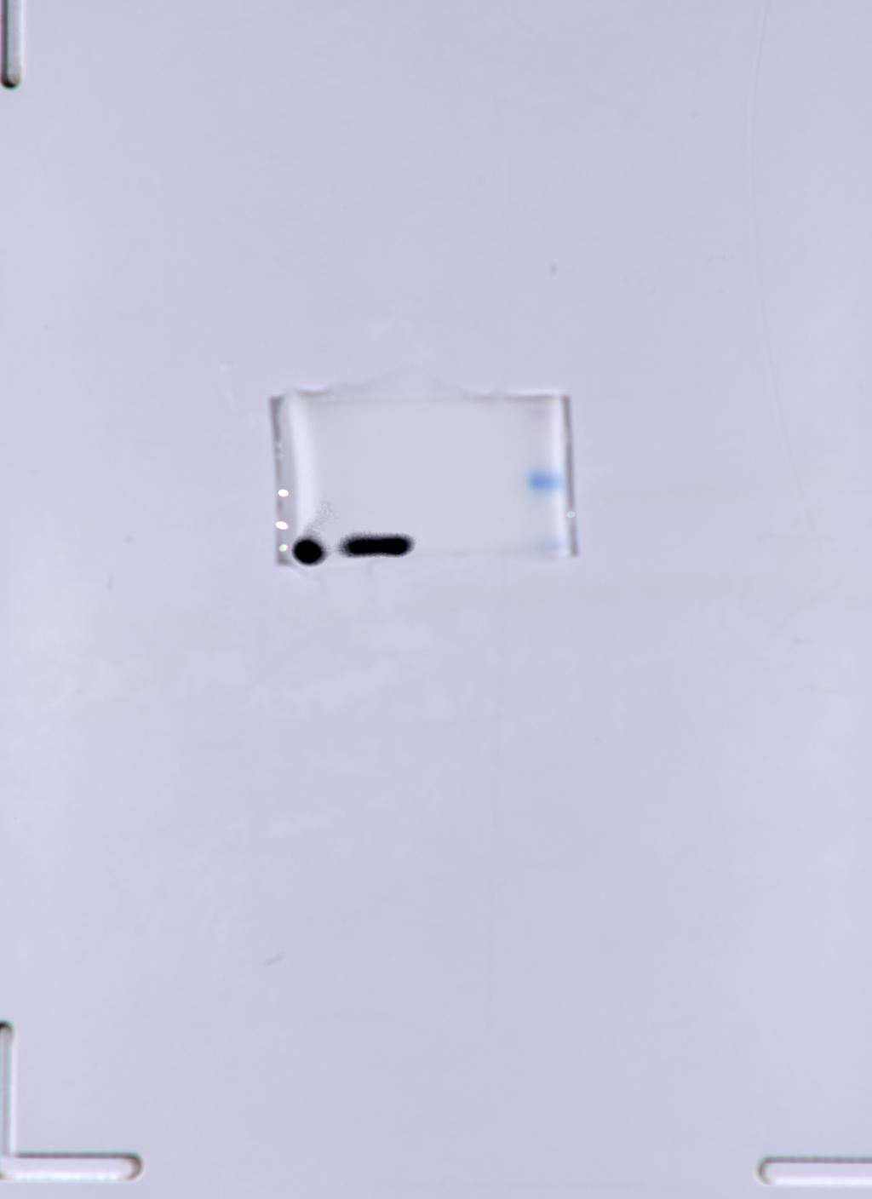
Input:β-actin Input:Myc-VP3
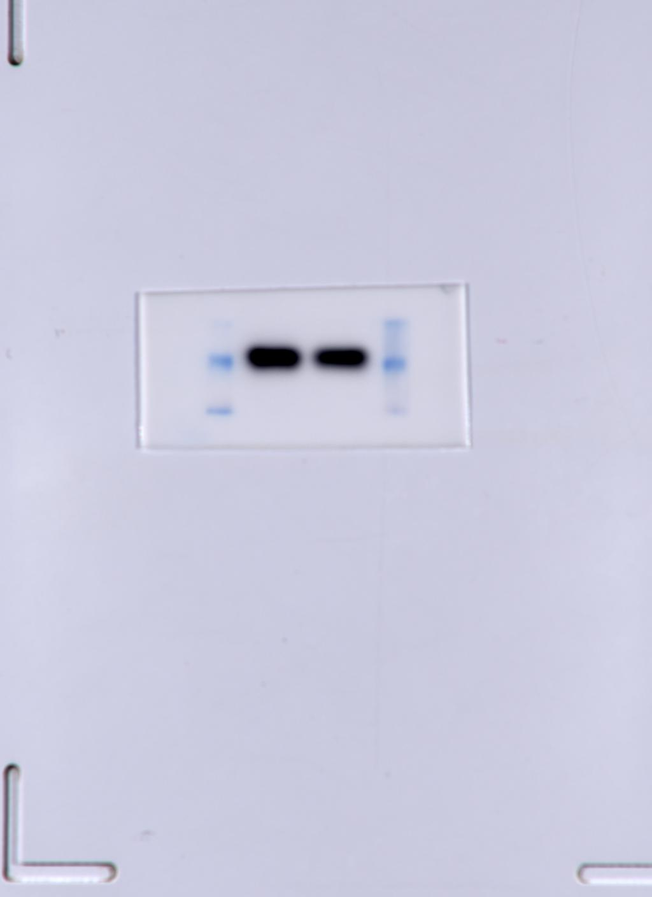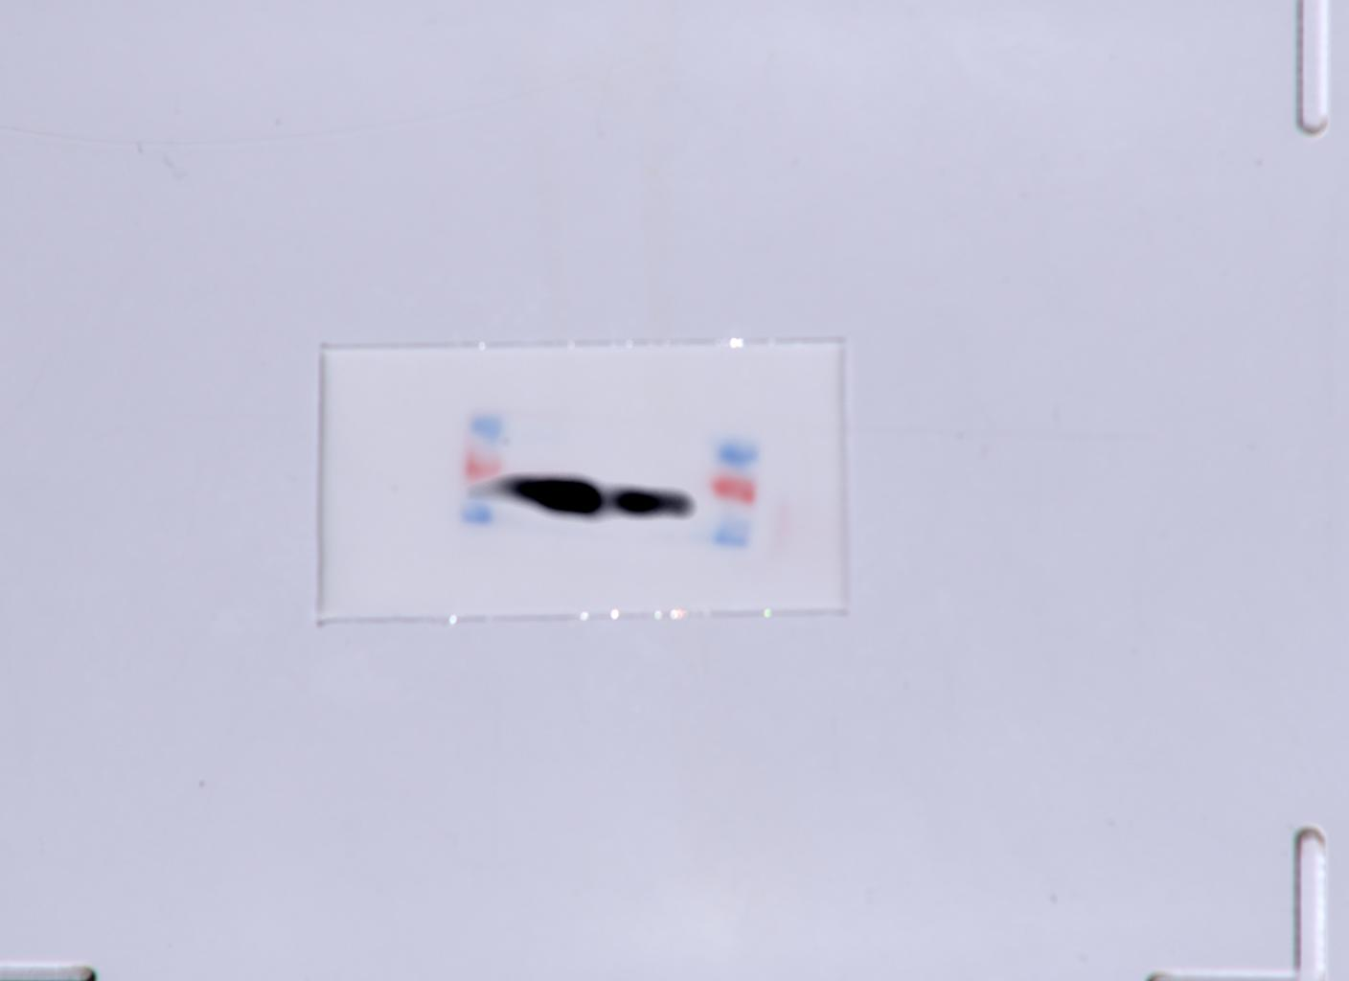
Input:Tollip Input: p62
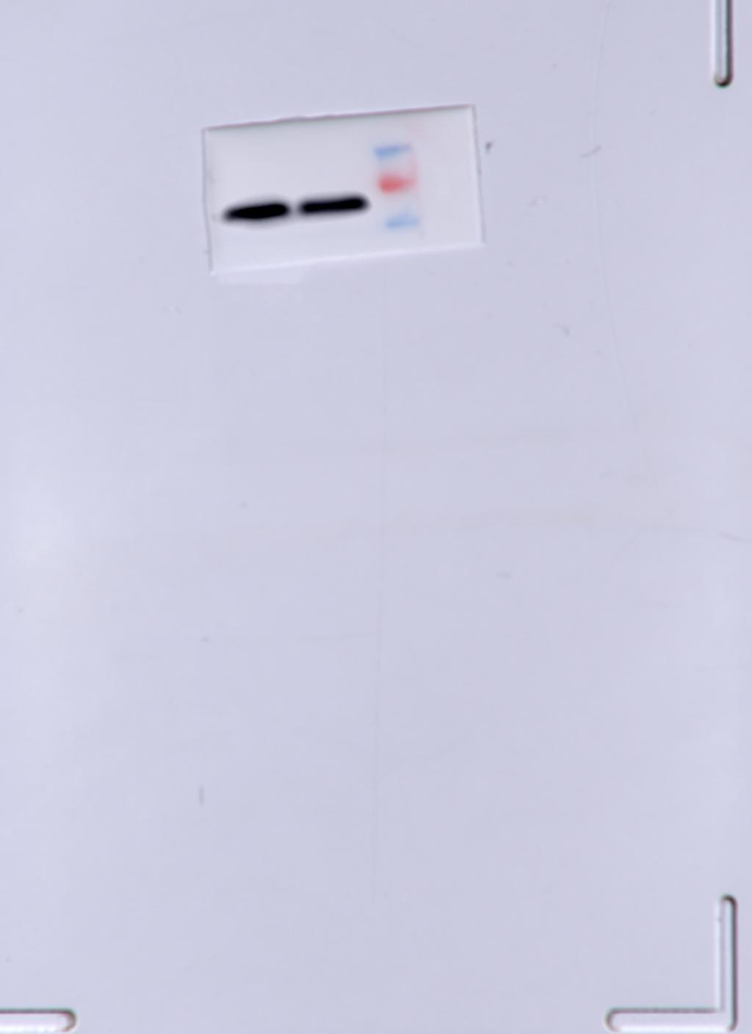
Input:NDP52

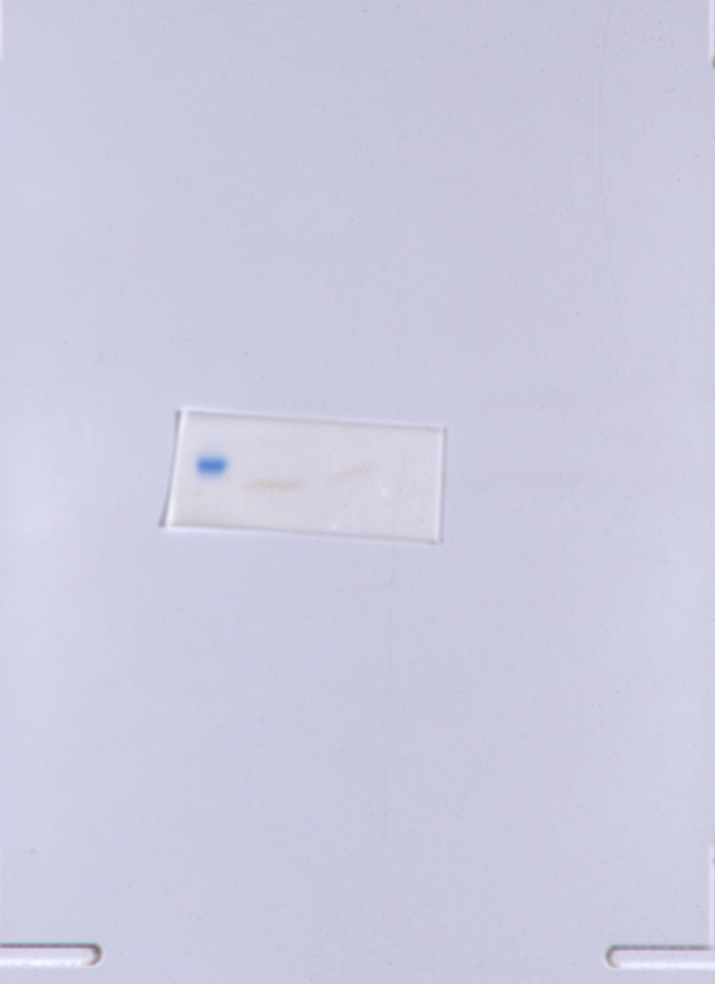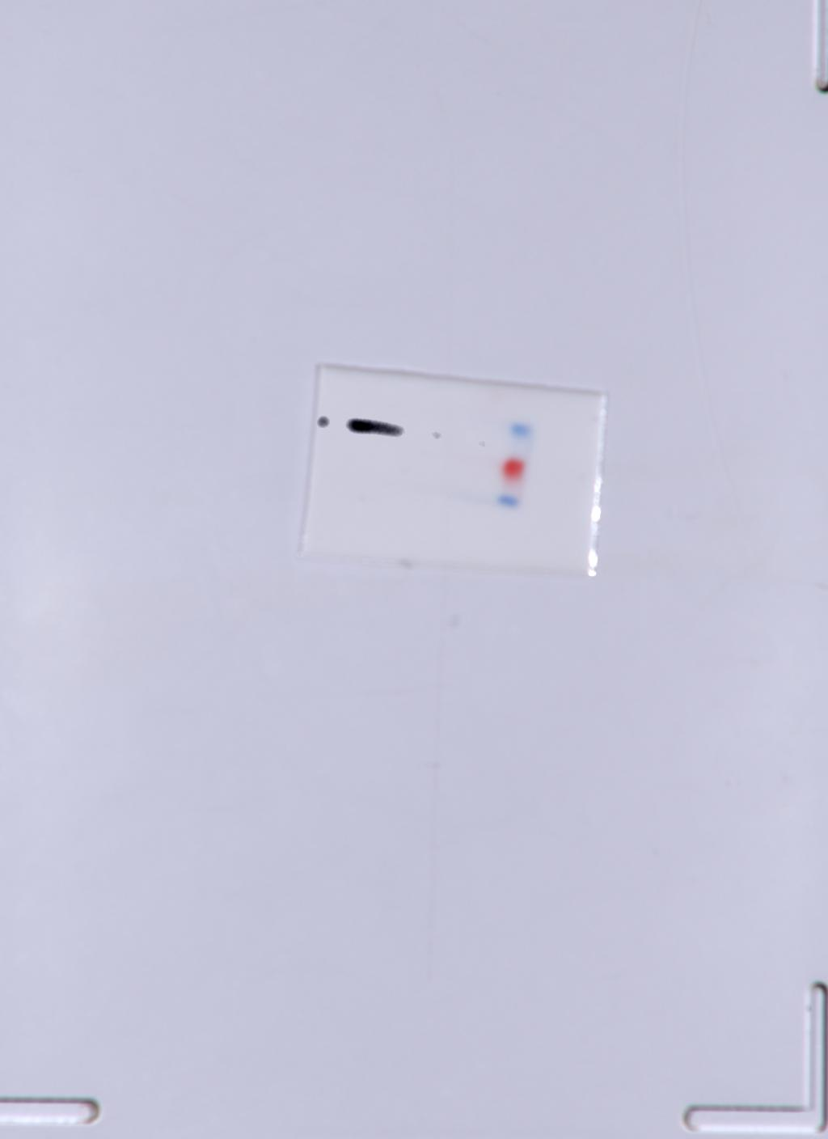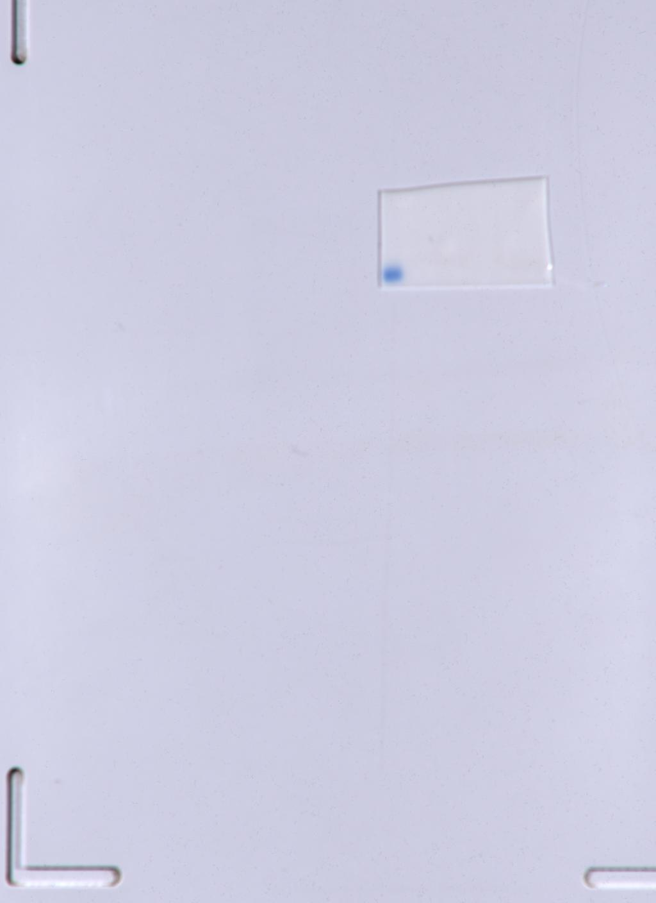
IP:NDP52 IP:62 IP:Tollip
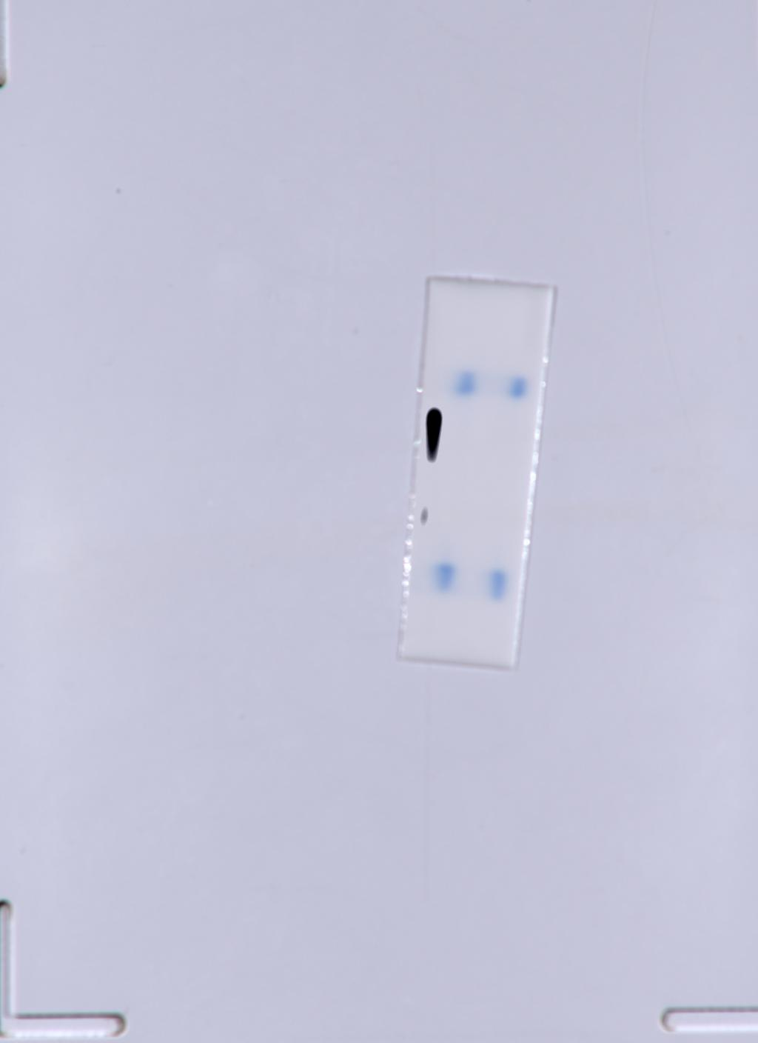
IPMyc-VP3

J
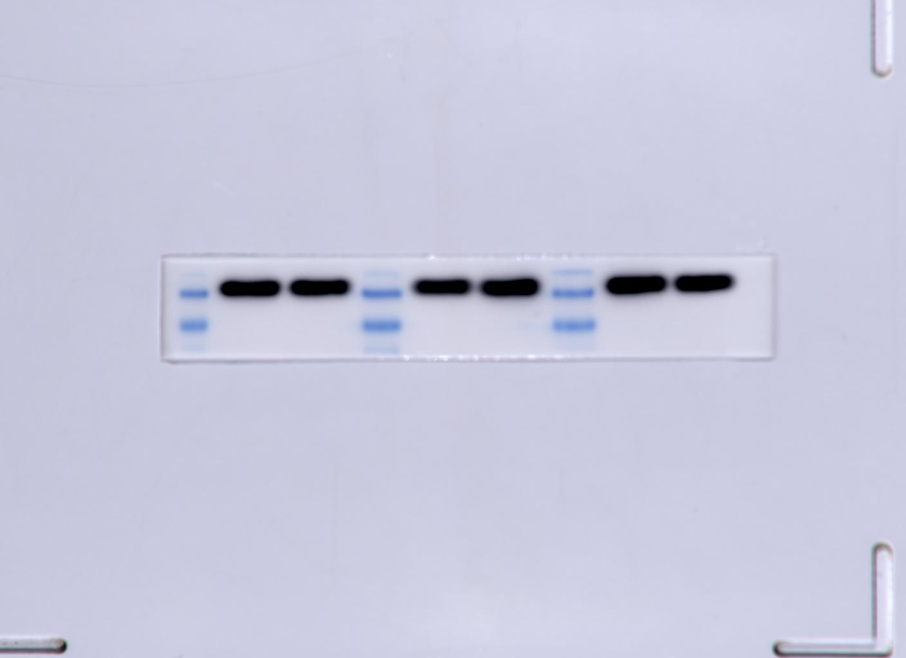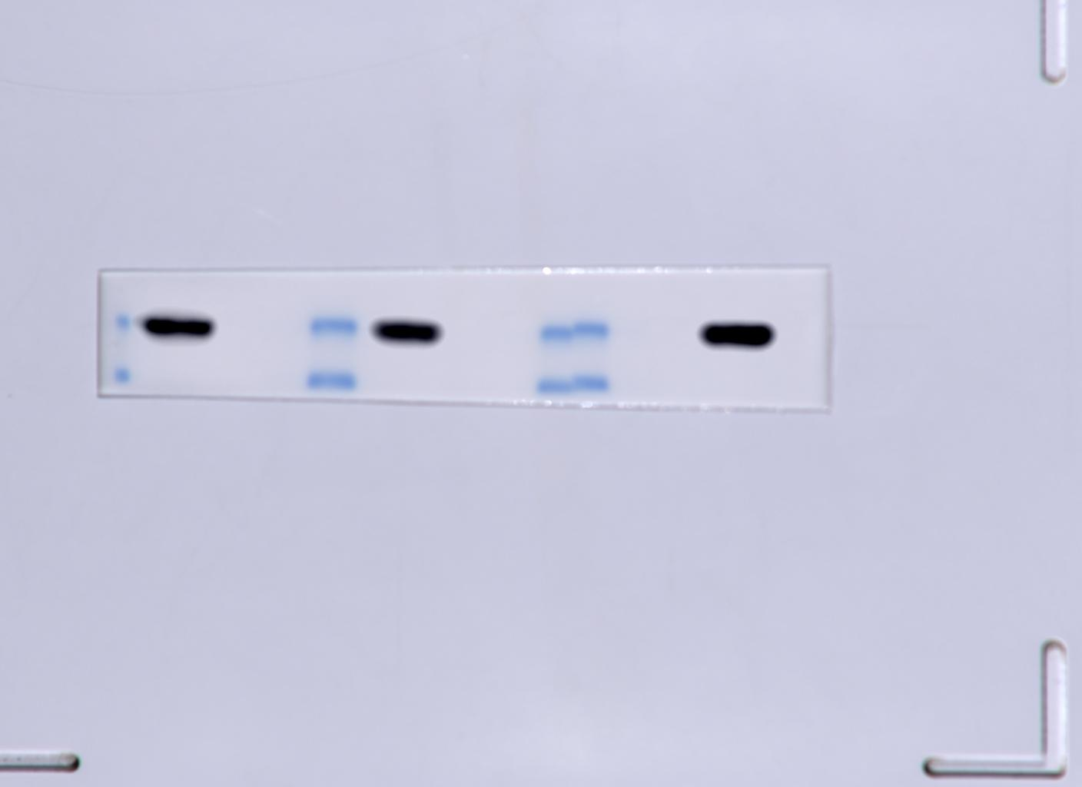
input β-actin input Myc-VP3
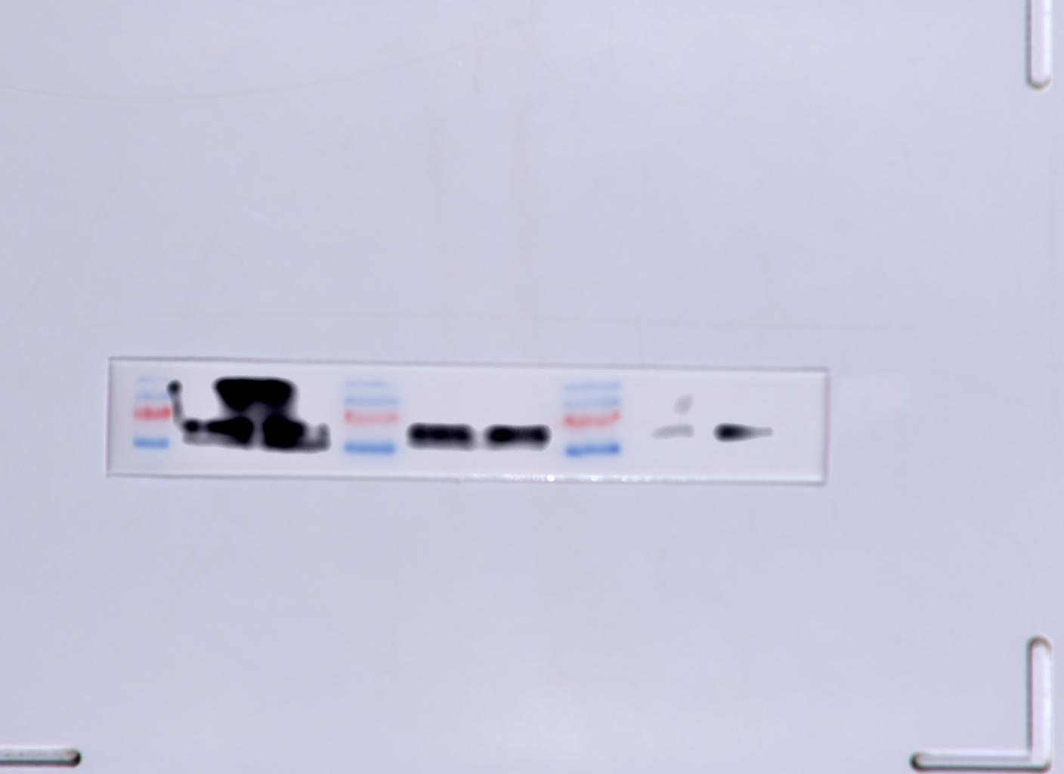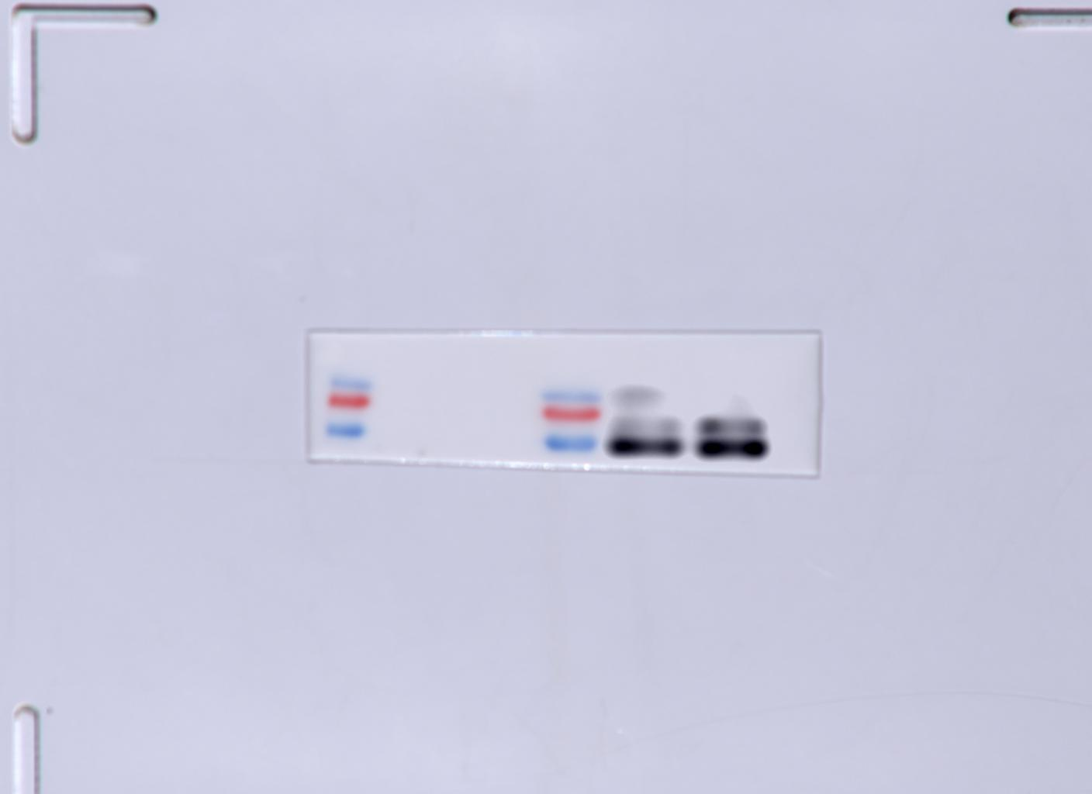
input p62 ip p62
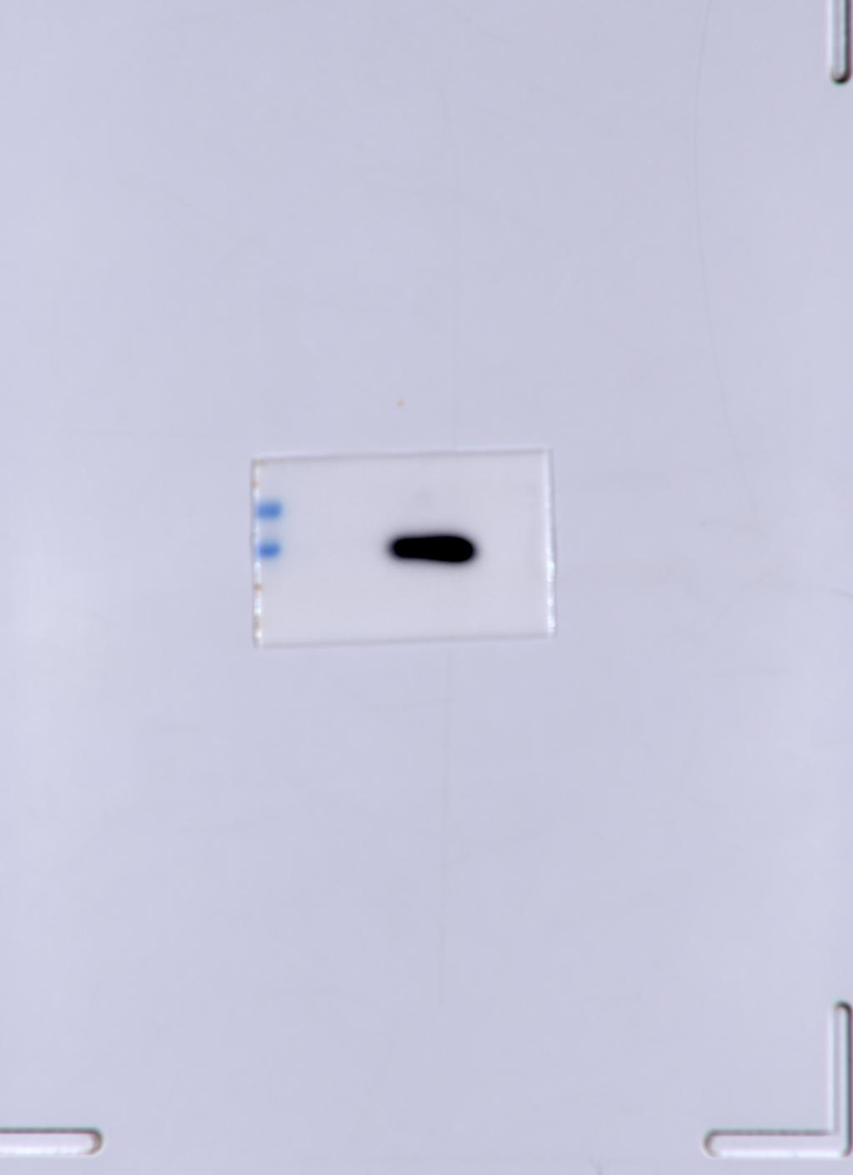
ip Myc-VP3

K
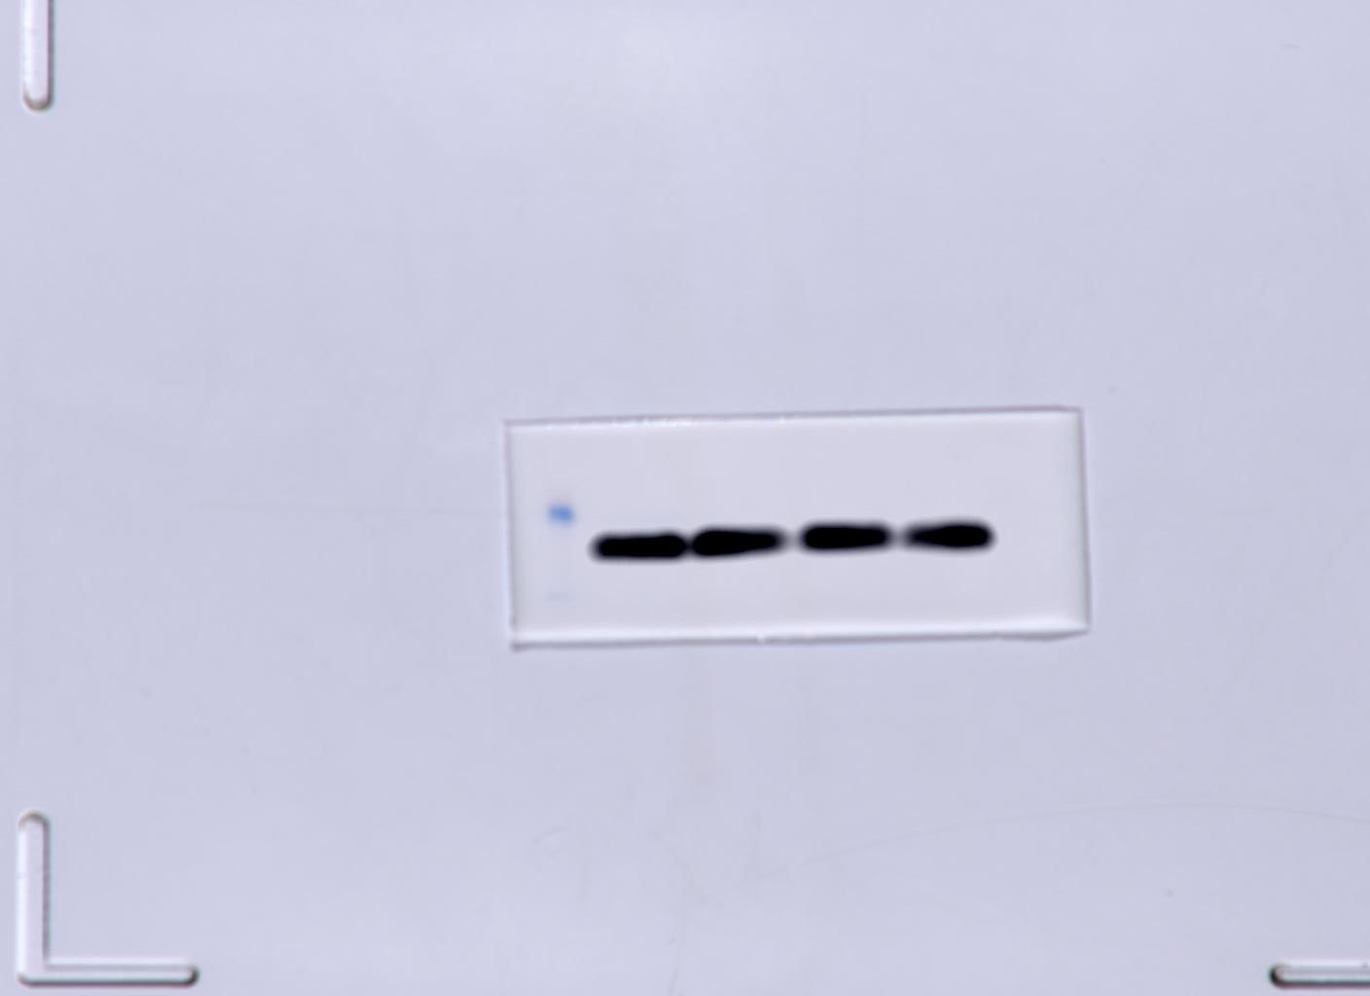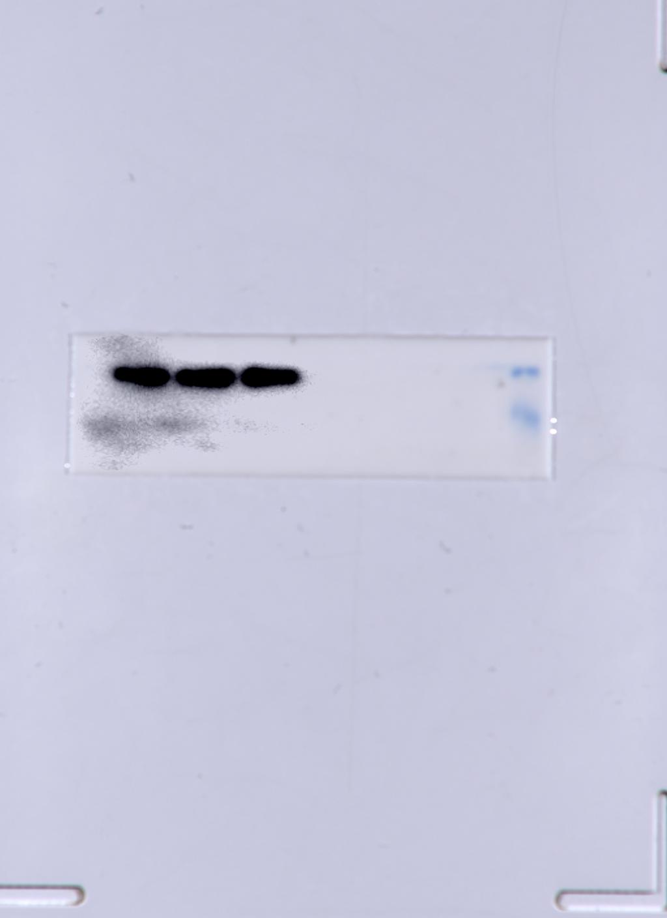
β-actin Myc-vp3
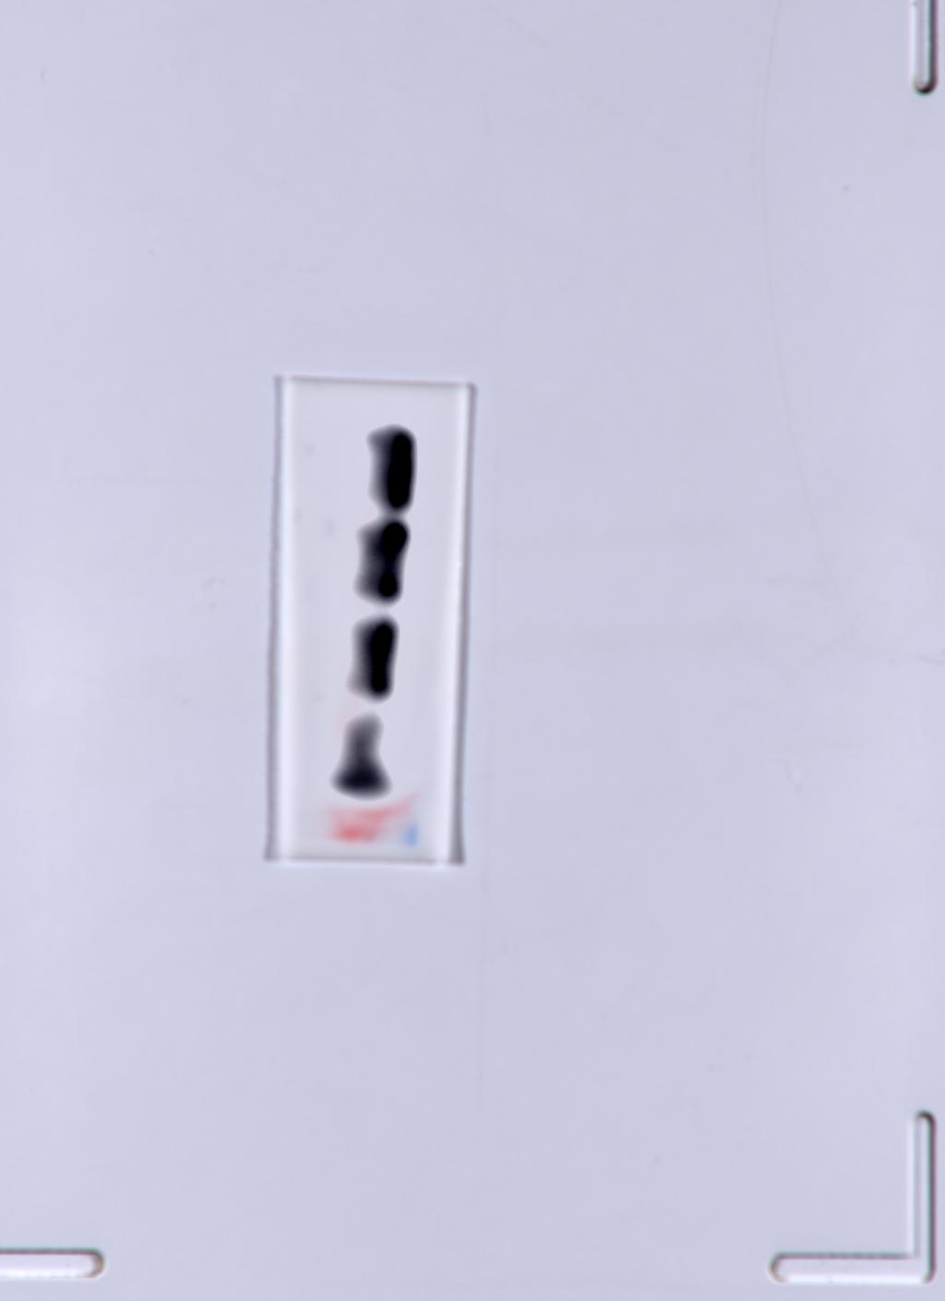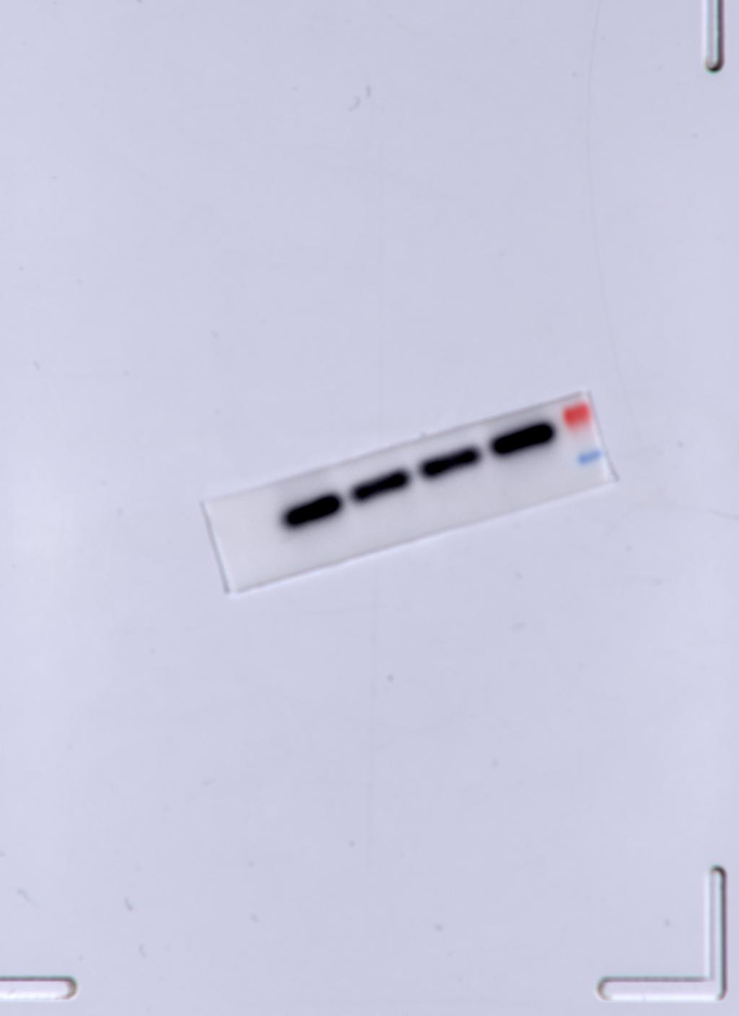
p62 MAVS
Prey scale analysis
MAVS
EV
1 | 1 | 1
Myc-vp3
0.721099 | 0.701099 | 0.721099
siNC+Myc-vp3
0.772538 | 0.792538 | 0.772538
sip62+Myc-vp3
1.221584 | 1.221584 | 1.221584
p62
EV
1 | 1 | 1
Myc-vp3
0.963969 | 0.933969 | 0.963969
siNC+Myc-vp3
0.870981 | 0.850981 | 0.870981
sip62+Myc-vp3
0.520261 | 0.500261 | 0.540261

Note：
1. We did RT-qPCR in an ABI 7500 Real-Time PCR system, results exported as Excel format. For ease of reference, I copied the data needed for this study into this document.
2. As we have other studies in our project group, sometimes we do WB experiments at the same time to save time and cost.

