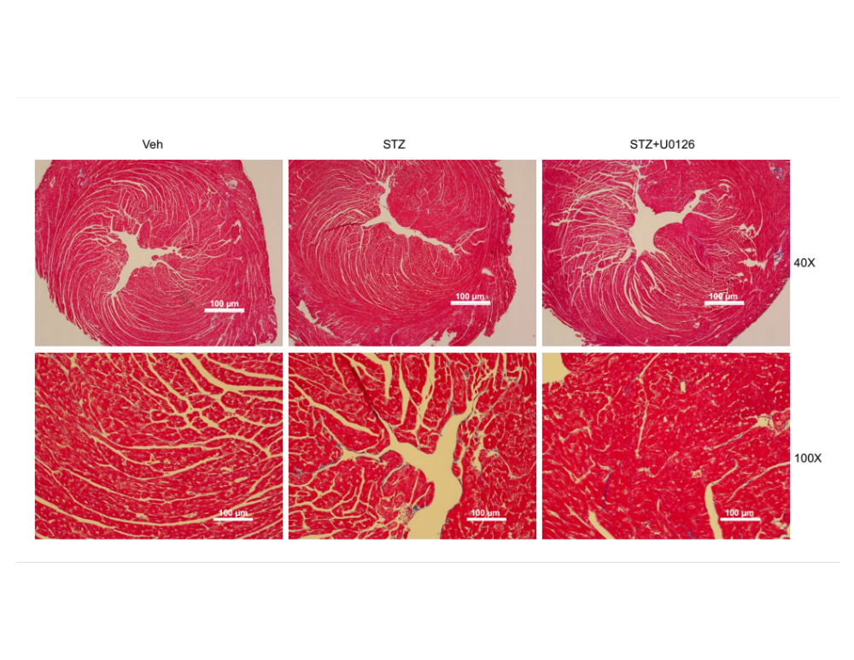
Supplementary Figure 1. Masson’s trichrome staining of cross-sectioned mouse heart tissues. Images from the top row were taken under 4× objective lens for a view of the whole heart chambers. Images from the bottom row were taken under 10× objective lens and were the same as the images in Fig. 2K in the main text. Veh, mice without STZ injection. Scale bar: 100 μm.

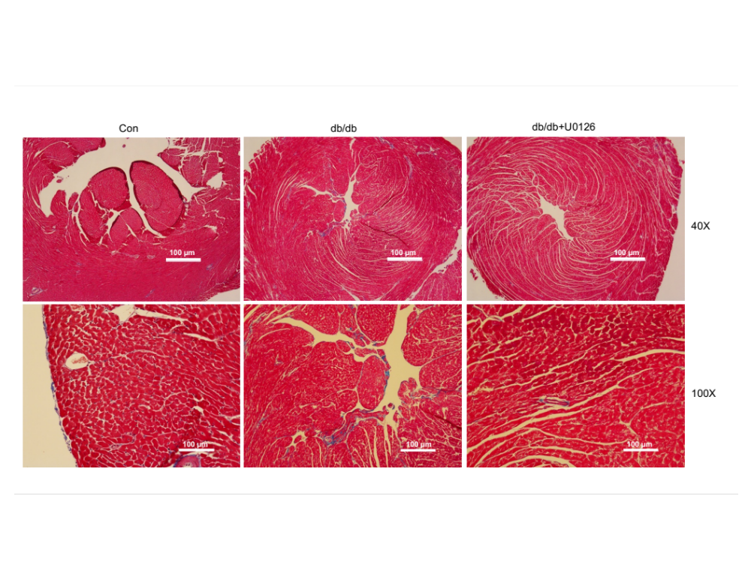
Supplementary Figure 2. Masson’s trichrome staining of cross-sectioned mouse heart tissues. Images from the top row were taken under 4× objective lens for a view of the whole heart chambers. Images from the bottom row were taken under 10× objective lens and were the same as the images in Fig. 3G in the main text. Con, age and sex matched wide type mice. Scale bar: 100 μm.

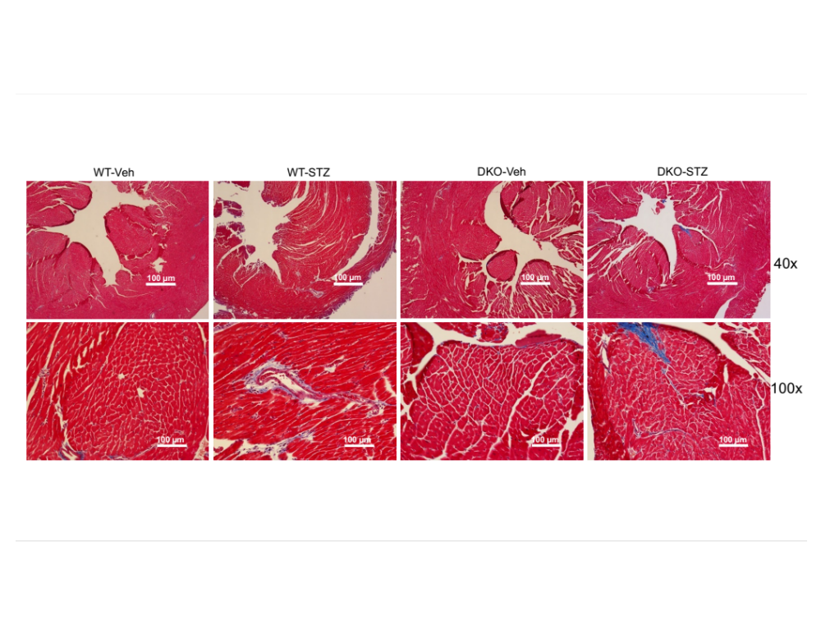
Supplementary Figure 3. Masson’s trichrome staining of cross-sectioned mouse heart tissues. Images in 40X were taken under the 4× objective lens for a view of the whole heart chambers. Images in 100X were taken under the 10× objective lens and were the same as the images in Fig. 4E in the main text. Veh, mice without STZ injection. Scale bar: 100 μm.

