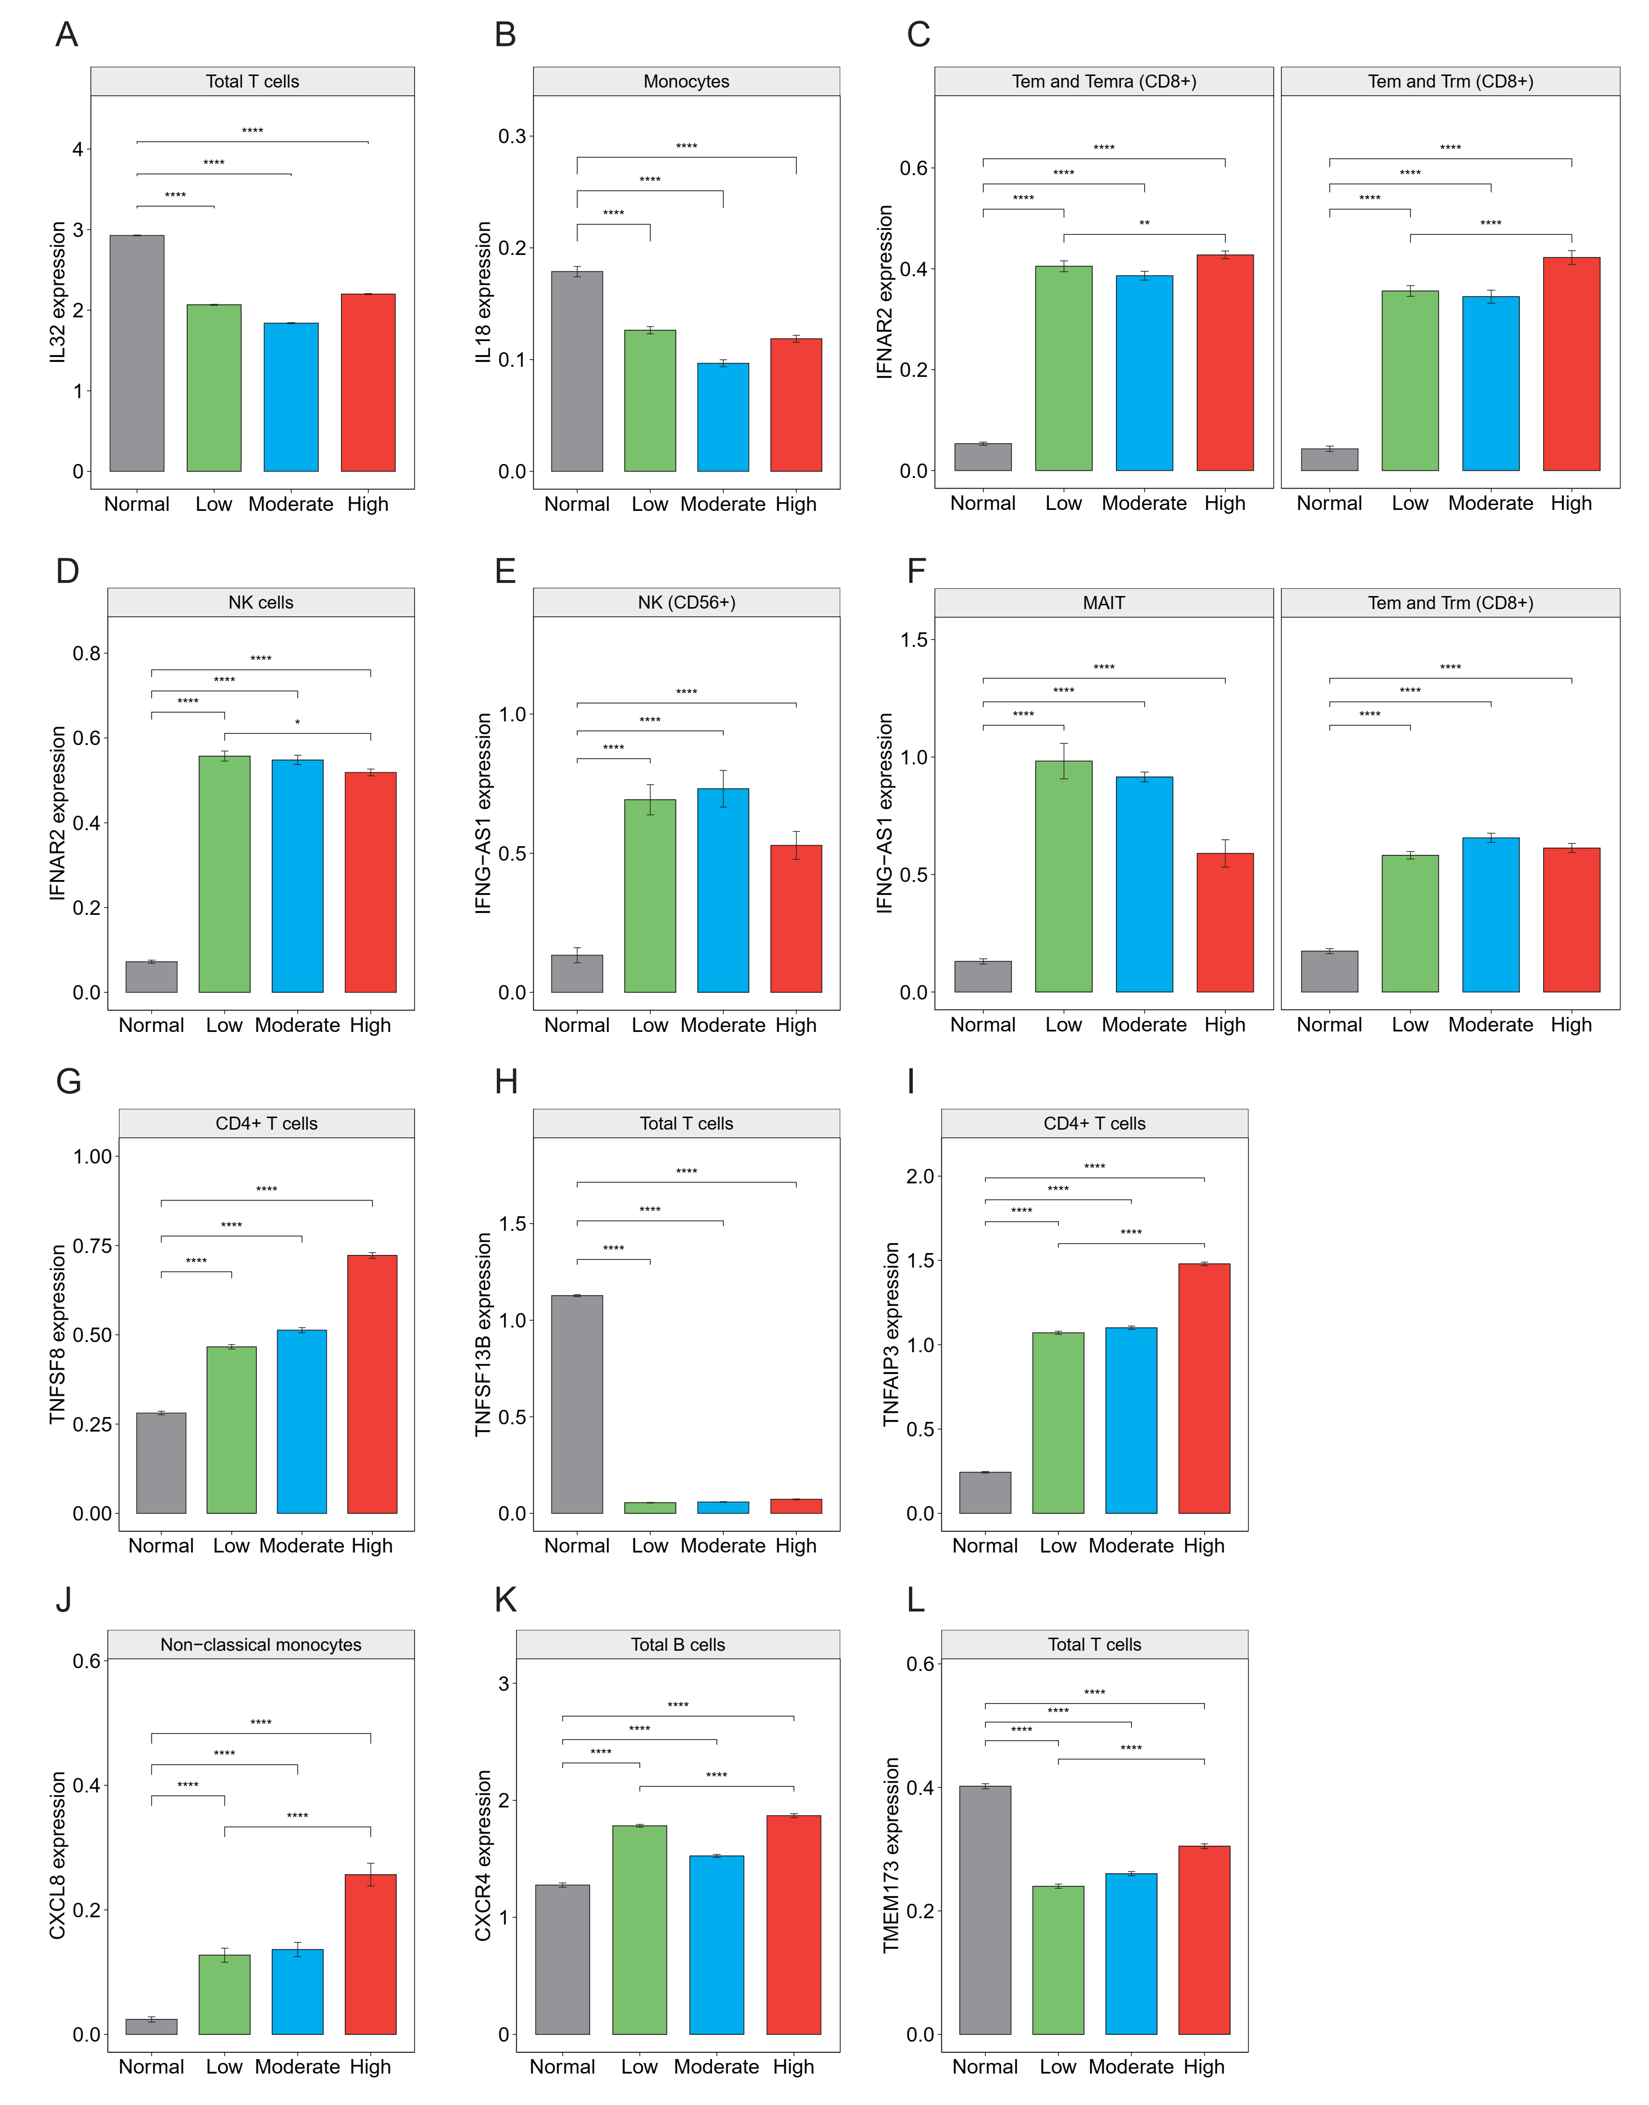
Supplementary Fig. 1. Gene expression of proinflammatory and pattern recognition receptor signaling pathway across different groups. (A and B) Average expression of IL32 and IL18 in total T cells and monocytes, respectively. (C and D) Average expression of IFNAR2 in Tem, Temra (CD8+) and NK cells, respectively. (E and F) Average expression of IFNG-AS1 expression in NK (CD56+), MAIT, Tem and Trm (CD8+) cells, respectively. (G, H and I) Average expression of TNFSF8, TFNSF13B and TNFAIP3 in CD4+ T, total T and CD4+ T cells, respectively. (J, K, L) Average expression of CXCL8, CXCR4 and TMEM173 in non-classical monocytes, total B and T cells, respectively. ** <0.01; **** <0.0001.
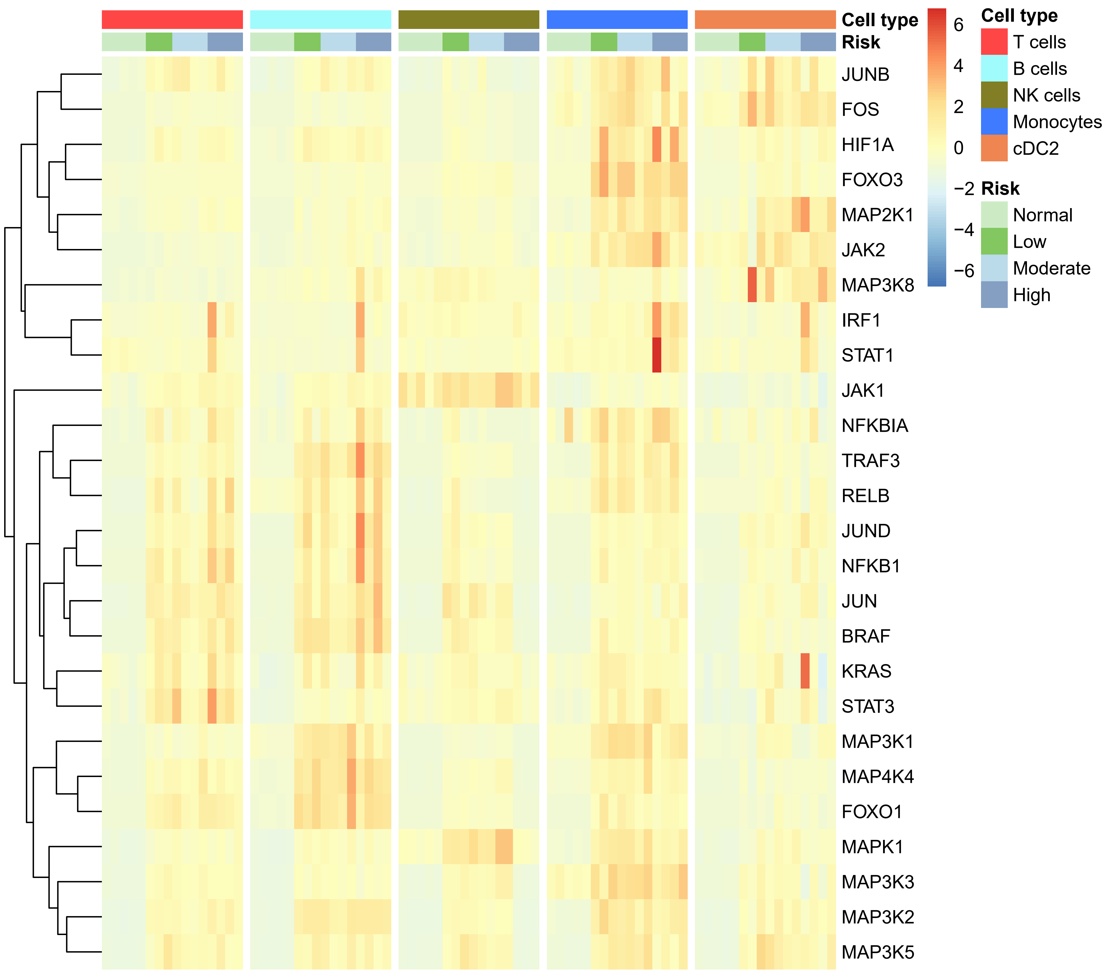
Supplementary Fig. 2. Key transcript factor signalings involved into the development of pMN. Significant up-regulated transcript factor pathways in individual type cells from patients.

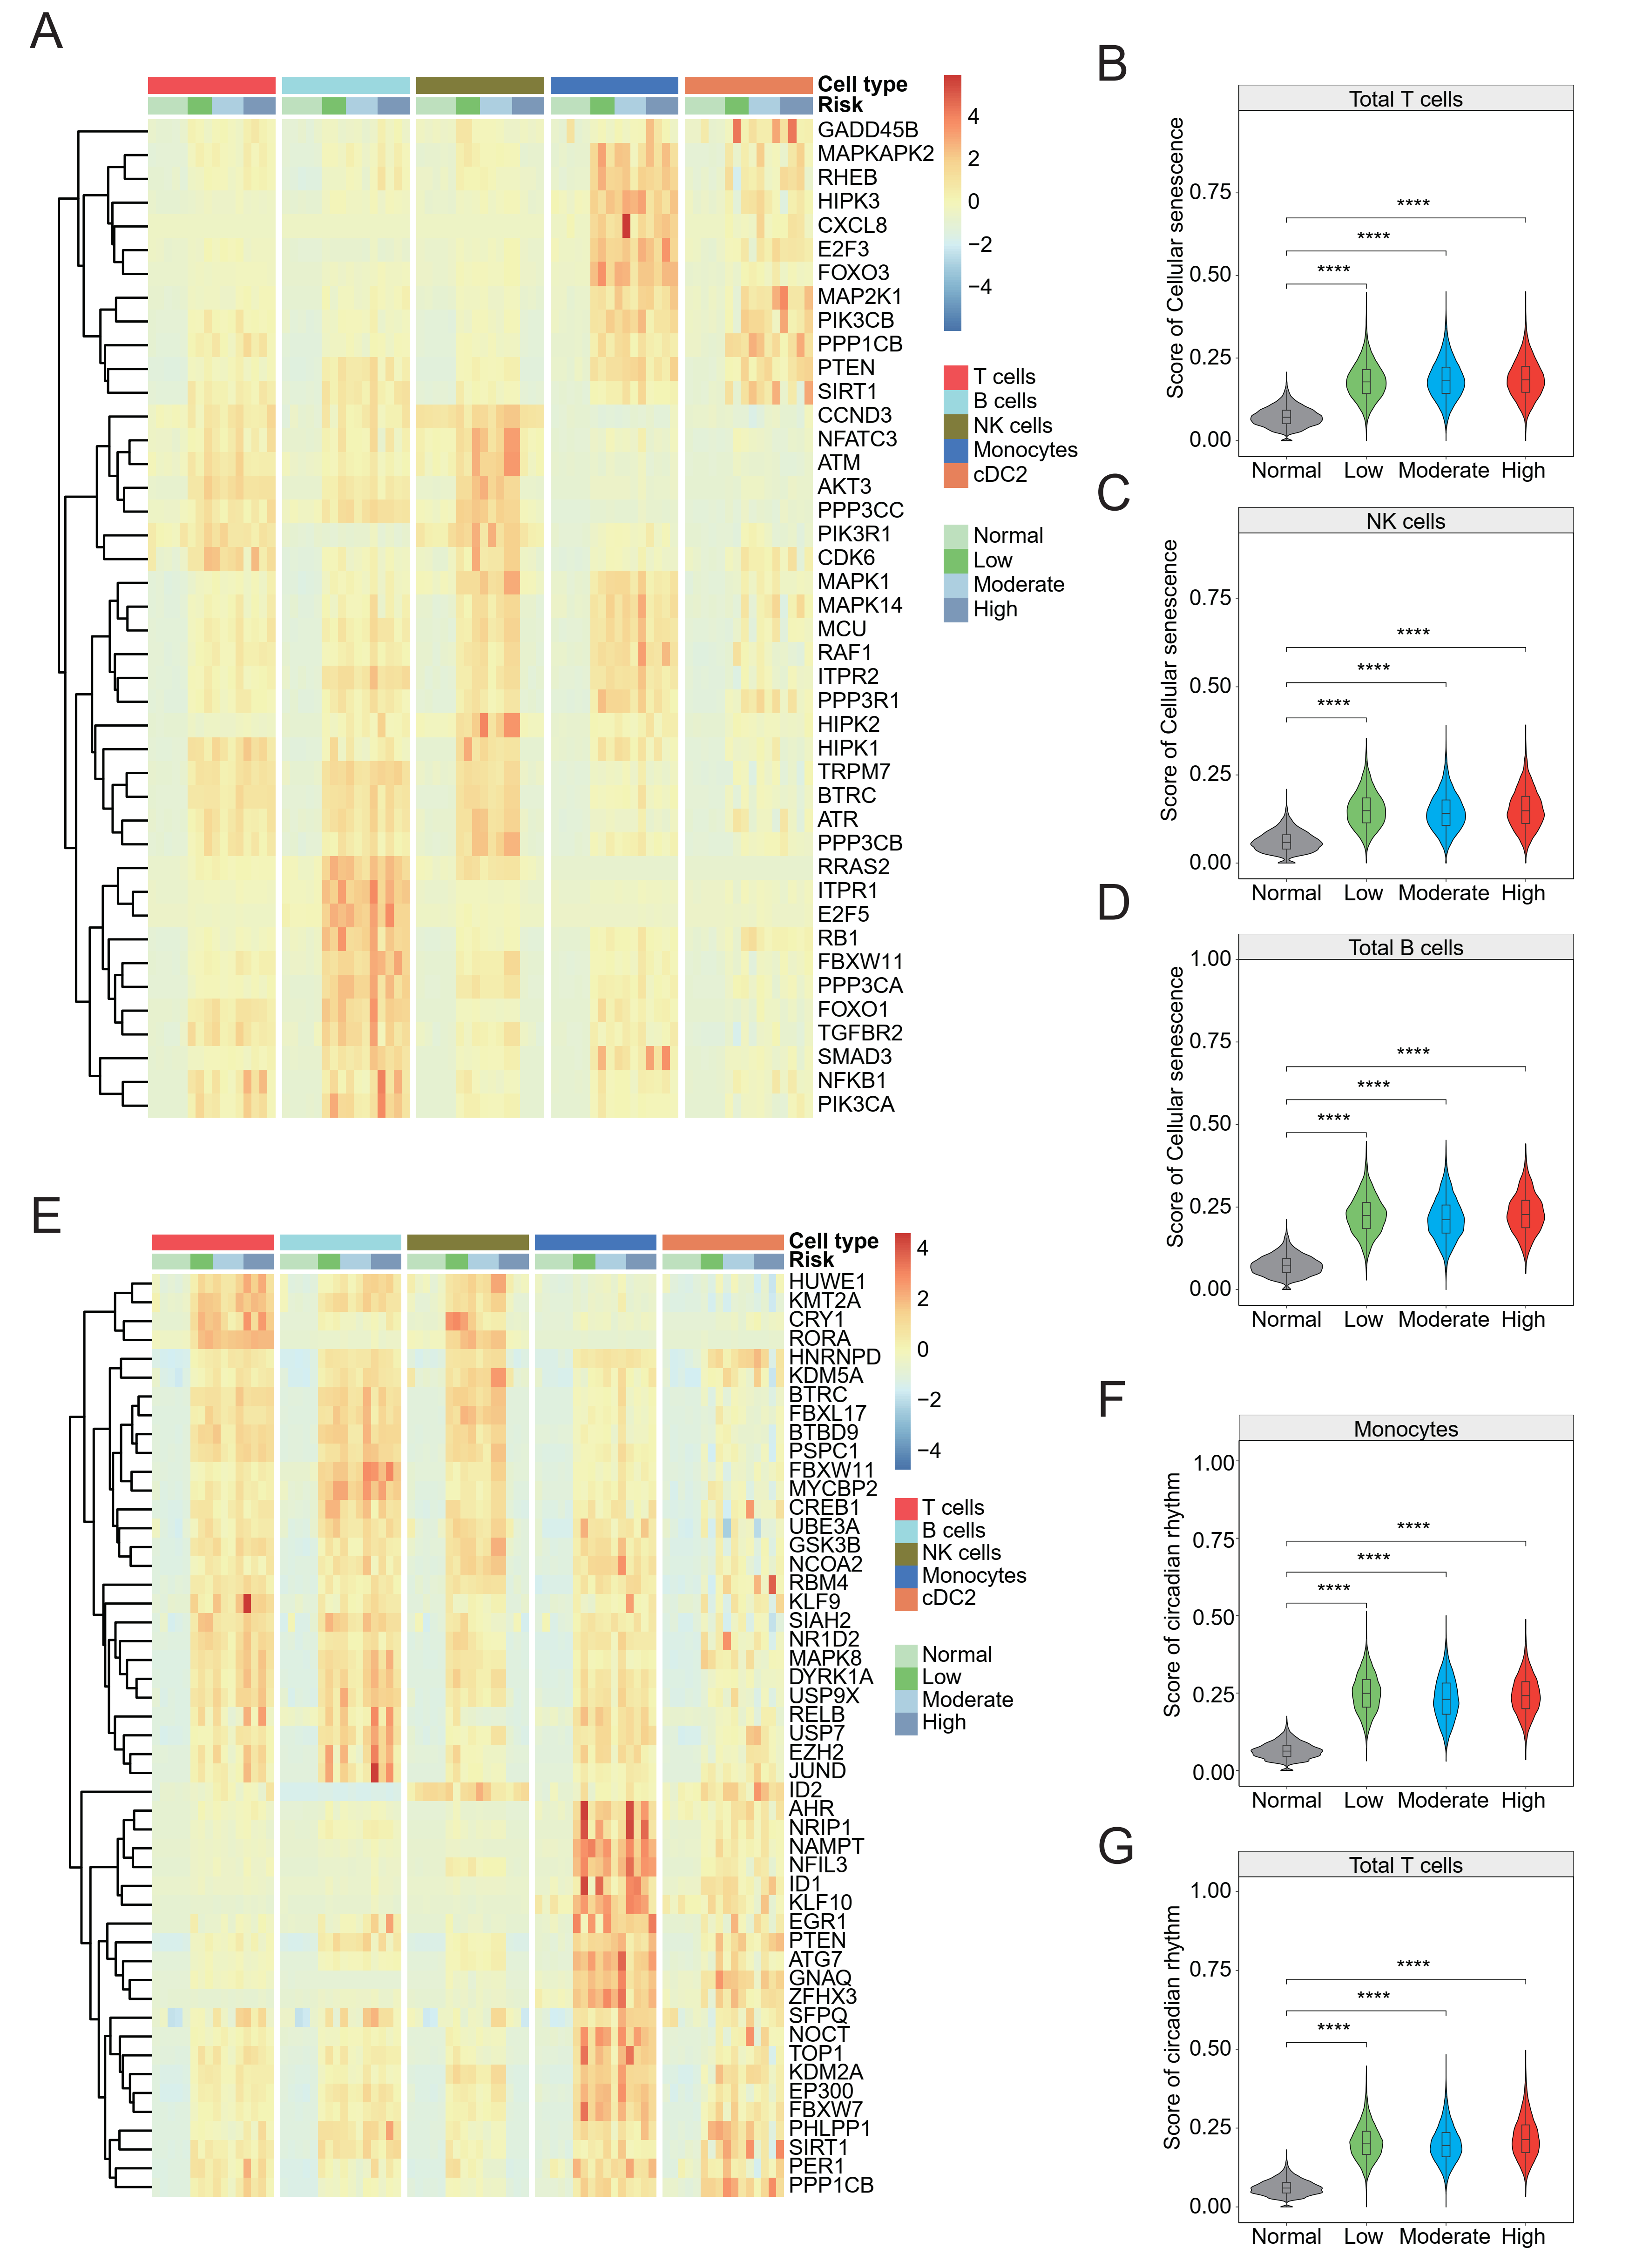

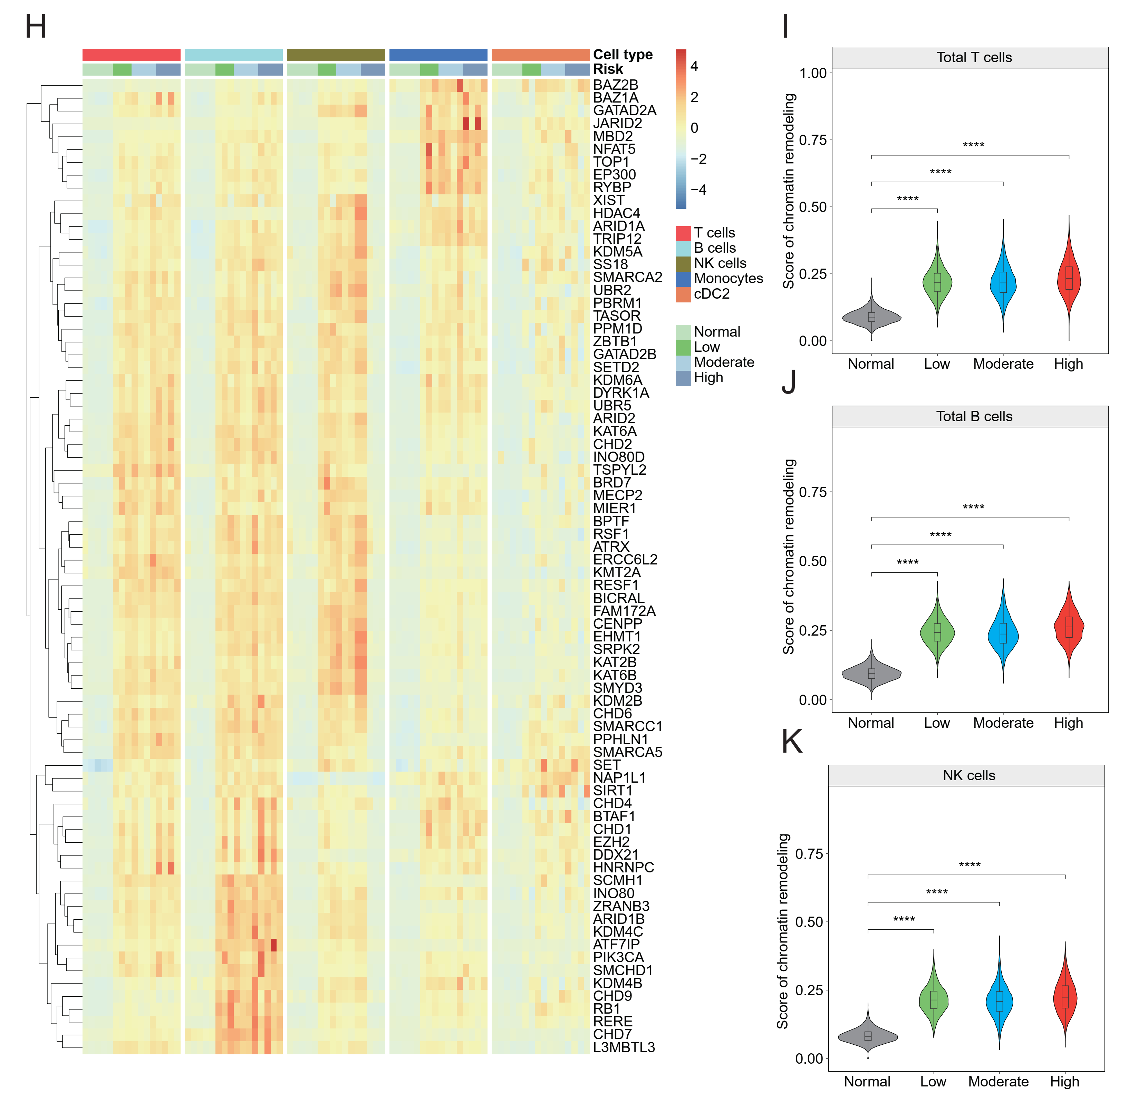
Supplementary Fig. 3. Important biological processes participating into the development of pMN. (A) Heat map showing expression levels of cellular senescence-related genes were higher in patients than in healthy control. (B, C and D) Violin plots showing score of cellular senescence in total T, B and NK cells. (E) Heat map analysis showed expression levels of genes about circadian rhythm in a specific type cell were higher in patients than in healthy donors. Patients were classified into low-risk, moderate-risk and high-risk patients. Cell types included T, B, NK, monocytes and cDC2 cells. (F and G) Violin plots showing score of circadian-rhythm genes in monocytes and total T cells, respectively. (H) Heat map analysis showed expression levels of genes about chromatin remodeling in a specific type cell were higher in patients than in healthy donors. Patients were classified into low-risk, moderate-risk and high-risk patients. Cell types included T, B, NK, monocytes and cDC2 cells. (I, J and K) Violin plots showing score of chromatin-remodeling genes in total T, B and NK cells across different groups, respectively. **** <0.0001.
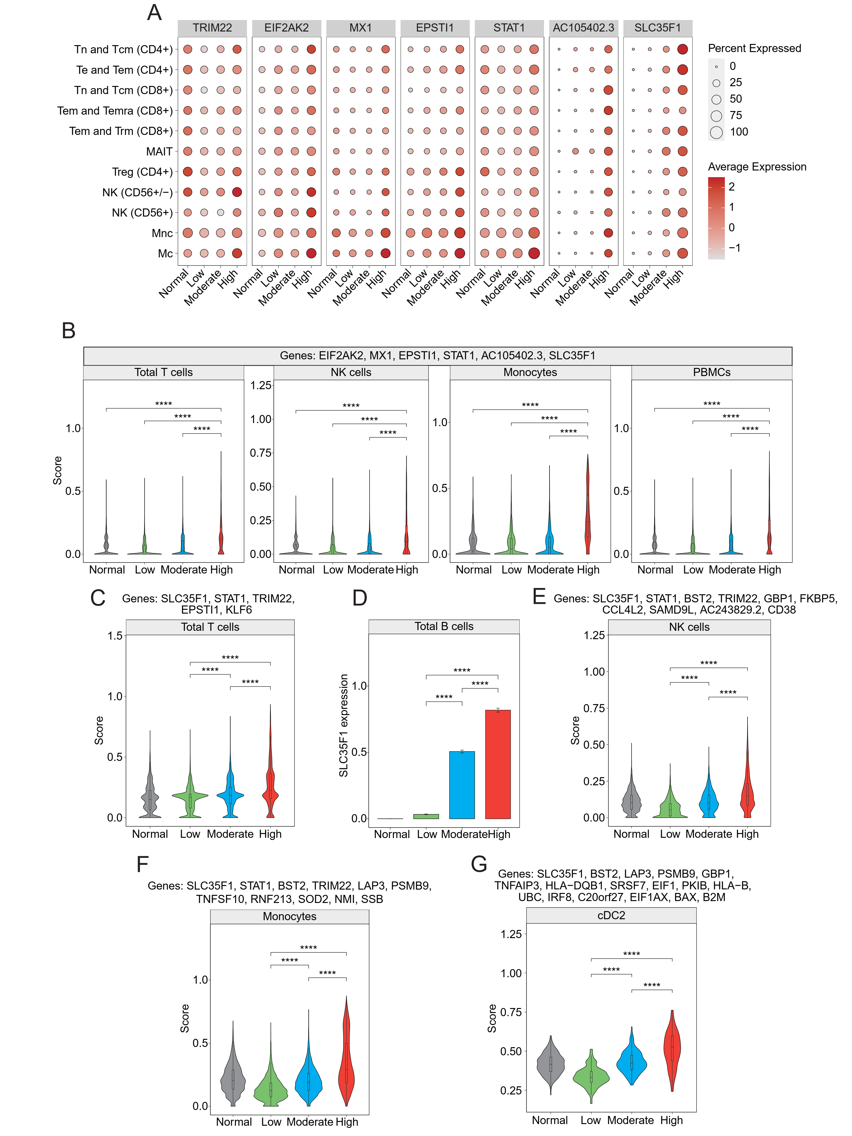
Supplementary Fig. 4. Selected biomarkers for distinguishing high-risk patients from low-risk and moderate-risk individuals. (A) Dot plot showing expression of selected genes in multiple type cells across different groups. (B) Violin plots showing score of enriched genes in T, NK and monocytes from high-risk patients, similar trend was showed in PBMCs including T, B, NK, monocytes and cDC2 cells. (C, E, F and G) Violin plots showing individual scores of different gene panels for distinguishing moderate-risk from high-risk and low-risk patients. (D) Average expression of SLC35F1 in total B cells across three patient groups. **** <0.0001.
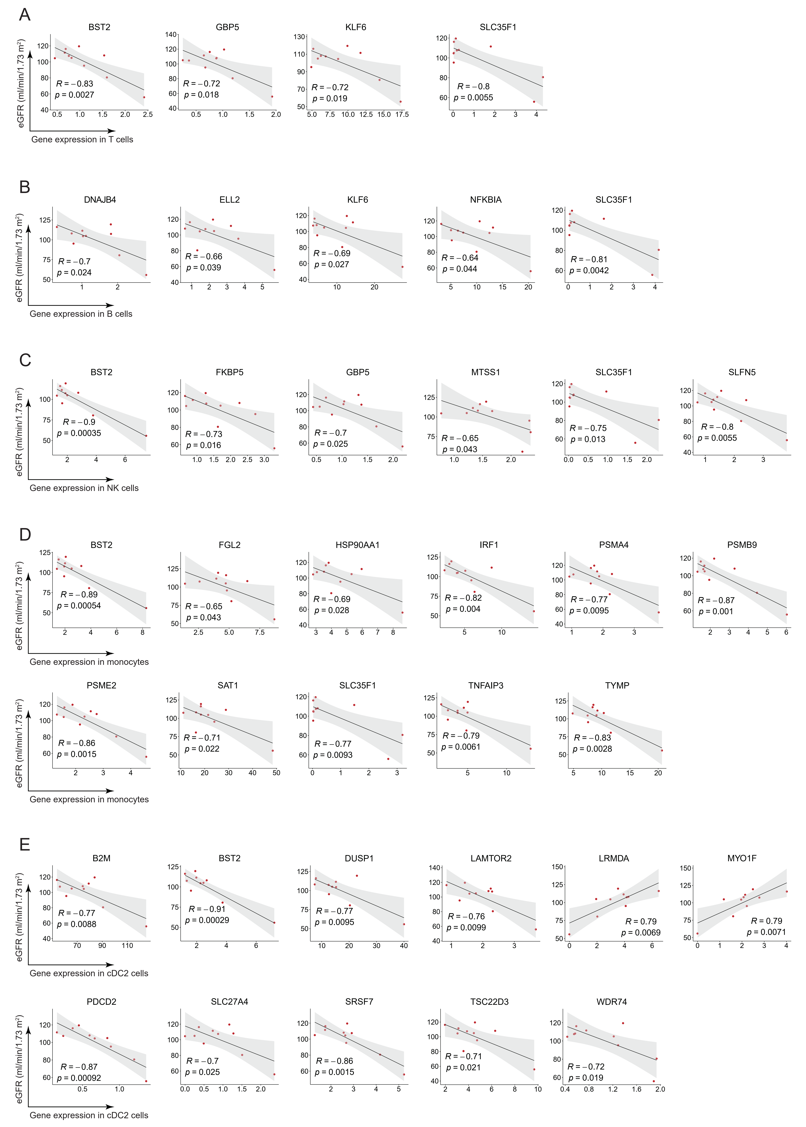
Supplementary Fig. 5. correlation analysis between signature genes and the value of eGFR. All of signature genes were upregulated in high-risk patients with newly-diagnosed pMN compared with low-risk individuals. (A) signature genes enriched in T cells were negatively correlated with the value of eGFR. (B) signature genes enriched in B cells were negatively correlated with the value of eGFR. (C) signature genes enriched in NK cells were negatively correlated with the value of eGFR. (D) signature genes enriched in monocytes were negatively correlated with the value of eGFR. (E) signature genes enriched in monocytes were negatively correlated with the value of eGFR except for LRMDA and MYO1F.
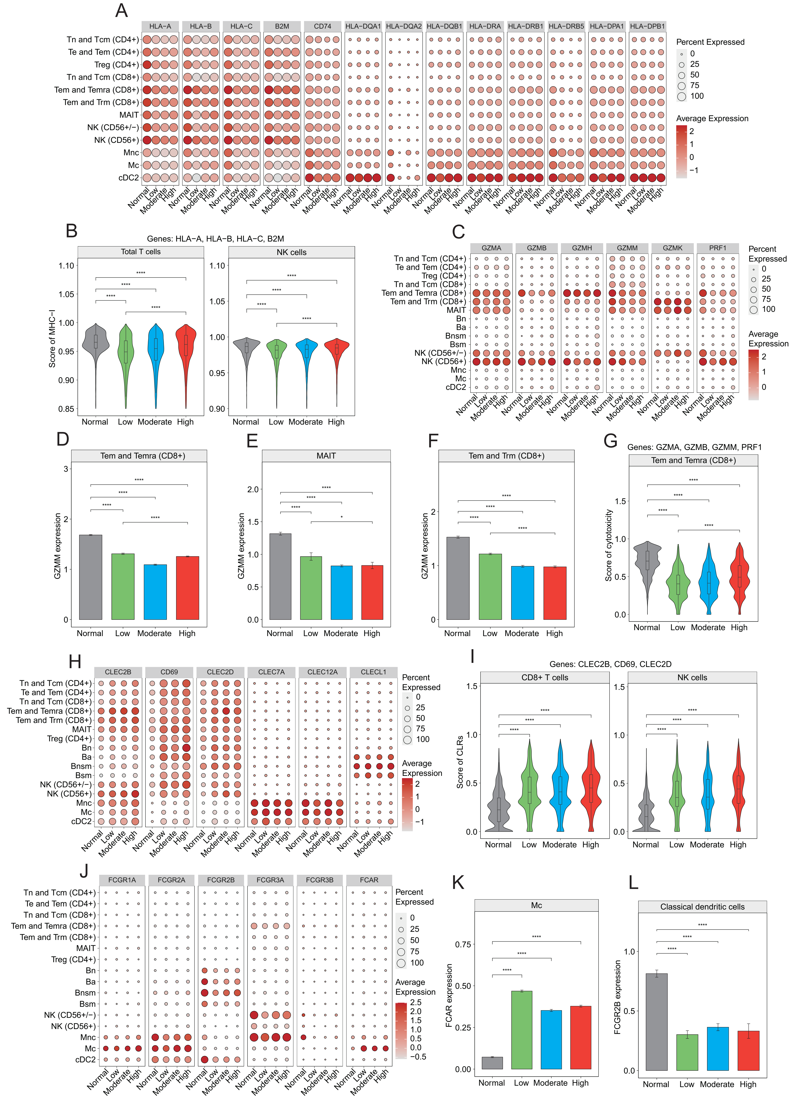
Supplementary Fig. 6. Signaling pathways selected according to the analysis of cell-cell communications. (A) Dot plot showing expression of HLA-I and HLA-II genes in T, NK, monocytes and cDC2 cells. (B) Violin plots showing score of HLA-I genes in total T and NK cells. (C) Dot plot showing gene expression of granzymes and perforin in individual type cells. (D, E, F) Average expression of granzyme M in memory T and MAIT cells, respectively. (G) Violin plot showing score of cytotoxicity including GZMA, GZMB, GZMM and PRF1 in Tem and Temra (CD8+). (H) Dot plot showing expression of CLECs (CLRs) in individual type cells. (I) Violin plot showing score of CLRs in T (CD8+) and NK cells. (J) Dot plot showing expression of Fc receptors in individual type cells. (K and L) Average expression of FCAR and FCGR2B in classical monocytes and cDC2 cells, respectively. **** <0.0001.

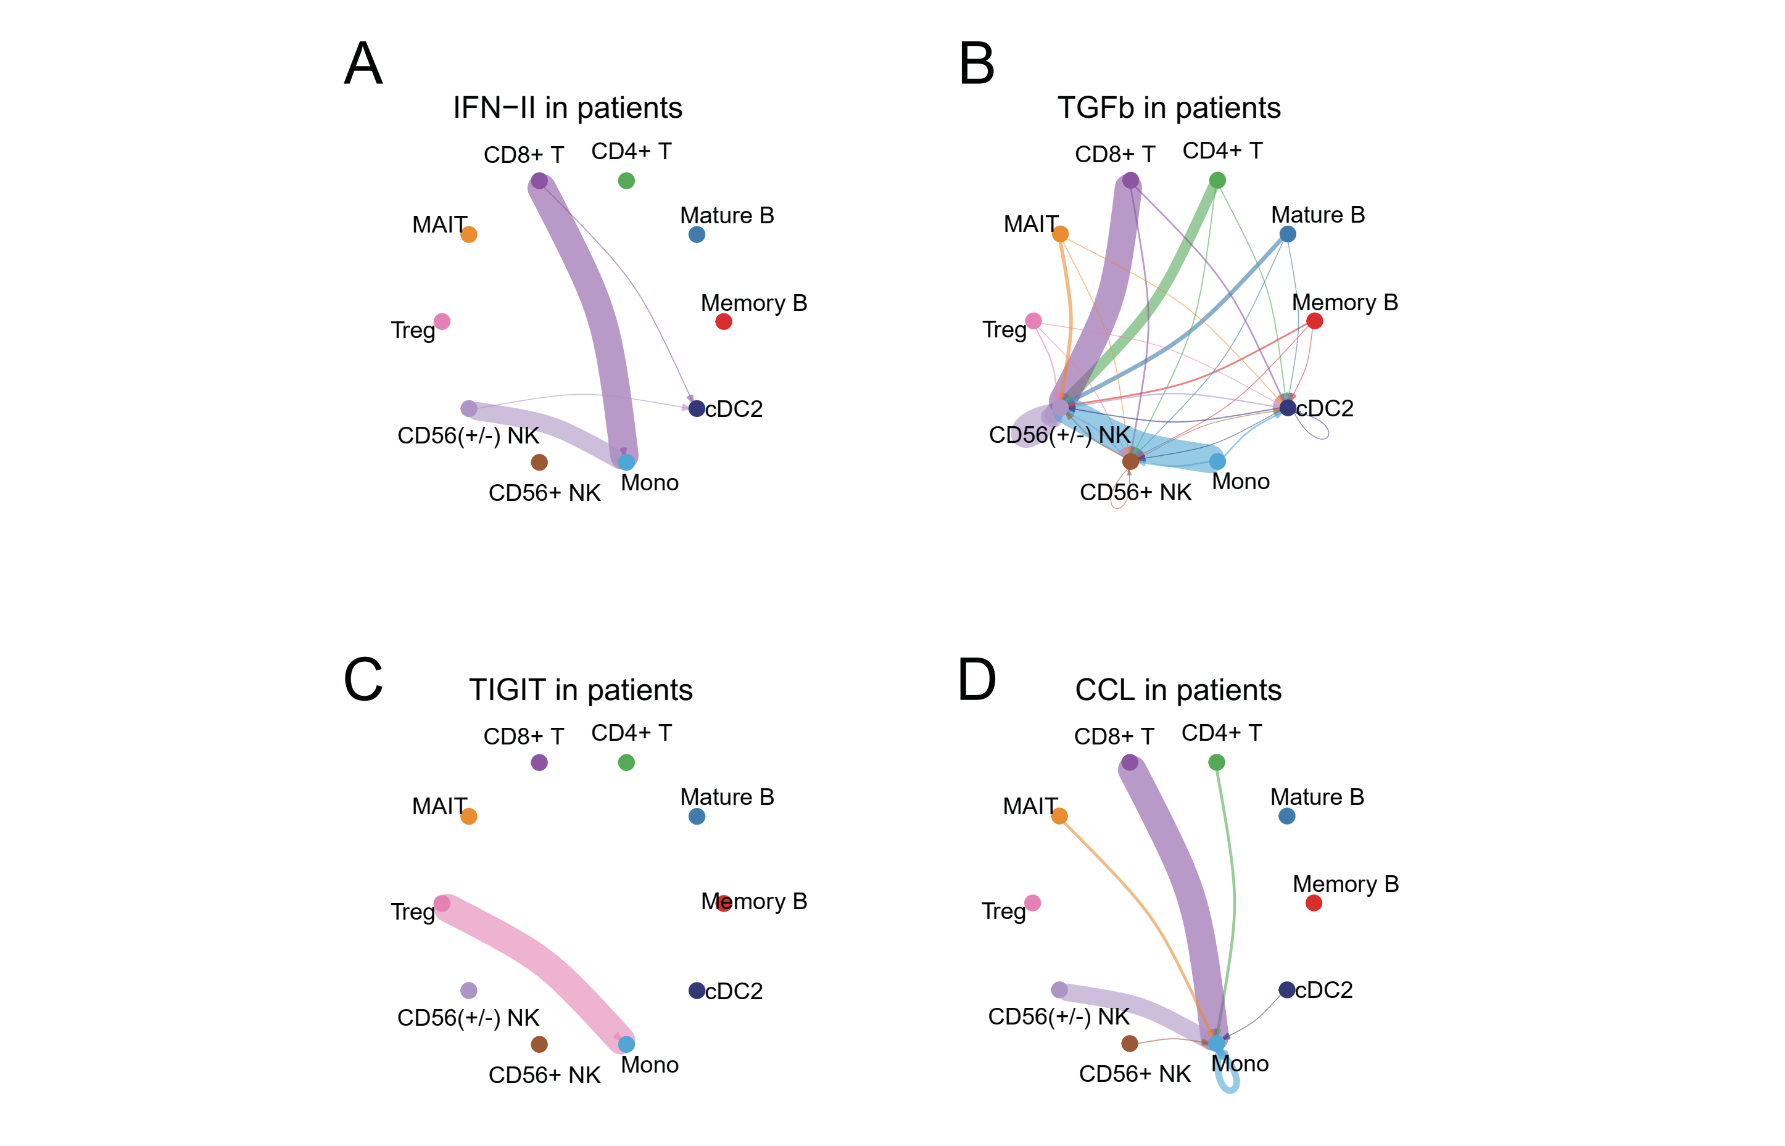

Supplementary Fig. 7. Cell-to-cell interactions were stronger in patients compared to healthy donors. (A, B, C and D) Chord plots showing changes of IFN-II, TGFb, TIGIT and CCL signaling pathways in patients respectively. The width of a band indicated the predicted strength of a specific ligand-receptor pair interactions. The wider the band, the stronger relationship between the pairs. Vacancy implied that no ligand-receptor pair interaction was detected in the healthy control or the patient group.

Supplementary Table 1. Information of healthy donors used as a control group in the study.
Sample  ID | Patient  ID | Age  (years) | Sex | SARS-CoV-2 | ScRNA-seq  platform | New data  (PMID) | Sample  type
S-HC013 | P-HC013 | 45 | male | negative | 10X 5' | 32377375 | frozen PBMC
S-HC014 | P-HC014 | 37 | male | negative | 10X 5' | 32377375 | frozen PBMC
S-HC015 | P-HC015 | 69 | female | negative | 10X 5' | 32377375 | frozen PBMC
S-HC016 | P-HC016 | 55 | female | negative | 10X 5' | 32377375 | frozen PBMC
S-HC017 | P-HC017 | 71 | female | negative | 10X 5' | 32377375 | frozen PBMC

PBMC, peripheral blood mononuclear cell; SARS-CoV-2, severe acute respiratory syndrome coronavirus-2

Supplementary Table 2. Biomarkers identified in high-risk patients predict declined eGFR in multiple kidney diseases.
Gene | Disease | Tissue | Samples (n) | Outcome | R | p
B2M | IgA-N | tubulointerstitium | 24 | eGFR | -0.54 | **
BST2 | FSG | tubulointerstitium | 17 | eGFR | -0.59 | *
DNAJB4 | FSG | tubulointerstitium | 17 | eGFR | -0.74 | ****
DUSP1 | FSG | tubulointerstitium | 17 | eGFR | -0.68 | **
FGL2 | NS | tubulointerstitium | 49 | eGFR | -0.68 | ****
FKBP5 | DN | glomeruli | 22 | eGFR | 0.59 | **
GBP5 | FSG | tubulointerstitium | 17 | eGFR | -0.61 | **
HSP90AA1 | DN | glomeruli | 22 | eGFR | 0.63 | *
IRF1 | FSG | tubulointerstitium | 17 | eGFR | -0.78 | ****
KLF6 | FSG | tubulointerstitium | 86 | eGFR | -0.51 | ****
LAMTOR2 | IgA-N | blood cells | 8 | eGFR | -0.89 | **
MTSS1 | CKD | tubulointerstitium | 186 | eGFR | 0.56 | ****
MYO1F | FSG | tubulointerstitium | 17 | eGFR | -0.75 | ****
NFKBIA | NS | tubulointerstitium | 49 | eGFR | -0.55 | ****
PDCD2 | FSG | tubulointerstitium | 17 | eGFR | -0.77 | ****
PSMA4 | FSG | tubulointerstitium | 17 | eGFR | -0.81 | *
PSMB9 | CKD | tubulointerstitium | 186 | eGFR | -0.51 | ****
PSME2 | FSG | tubulointerstitium | 17 | eGFR | -0.86 | ****
SAT1 | NS | tubulointerstitium | 37 | eGFR | -0.53 | ****
SFRS7 | IgA-N | tubulointerstitium | 24 | eGFR | -0.51 | *
SLC27A4 | FSG | tubulointerstitium | 17 | eGFR | -0.65 | **
SLC35F1 | IgA-N | blood cells | 8 | eGFR | -0.81 | *
SLFN5 | FSG | tubulointerstitium | 17 | eGFR | -0.70 | **
TNFAIP3 | FSG | tubulointerstitium | 17 | eGFR | -0.67 | **
TSC22D3 | IgA-N | blood cells | 8 | eGFR | -0.89 | **
TYMP | FSG | tubulointerstitium | 17 | eGFR | -0.84 | ****
WDR74 | IgA-N | blood cells | 8 | eGFR | 0.80 | *

NS, nephrotic Syndrome; CKD, chronic kidney disease; FSG, focal segmental glomerulosclerosis; IgA-N, IgA nephropathy; DN, diabetic nephropathy; n, number of samples; eGFR, estimated glomerular filtration rate; R, correlation coefficient; *, p ＜ 0.05；**, p ＜ 0.01； ***, p ＜ 0.001；****, p ＜ 0.0001.

Supplementary Table 3. Biomarkers identified in the study predict declined eGFR in multiple kidney diseases.
Gene | Disease | Tissue | Samples (n) | Outcome | R | p
IGHG3 | NS | tubulointerstitium | 49 | eGFR | -0.51 | ****
IGHG4 | NS | tubulointerstitium | 49 | eGFR | -0.60 | ****
IGLC2 | NS | tubulointerstitium | 49 | eGFR | -0.57 | ****
IGKC | NS | tubulointerstitium | 49 | eGFR | -0.62 | ****
CR1 | CKD | glomeruli | 192 | eGFR | 0.52 | ****
CD55 | NS | tubulointerstitium | 49 | eGFR | -0.63 | ****
IL1B | FSG | tubulointerstitium | 17 | eGFR | -0.61 | **
IL15 | FSG | tubulointerstitium | 17 | eGFR | -0.73 | ****
IL2RG | NS | tubulointerstitium | 49 | eGFR | -0.65 | ****
IL6ST | FSG | tubulointerstitium | 17 | eGFR | -0.55 | ****
IL10RB | FSG | tubulointerstitium | 16 | eGFR | -0.61 | *
IFNG | FSG | tubulointerstitium | 17 | eGFR | -0.67 | ****
IFNAR2 | CKD | tubulointerstitium | 186 | eGFR | -0.57 | ****
TNFAIP3 | NS | tubulointerstitium | 49 | eGFR | -0.57 | ****
TNFAIP8 | CKD | tubulointerstitium | 186 | eGFR | -0.55 | ****
TNFSF8 | FSG | tubulointerstitium | 17 | eGFR | -0.58 | *
TNFRSF13C | FSG | tubulointerstitium | 17 | eGFR | -0.54 | *
CXCL8 | CKD | tubulointerstitium | 42 | eGFR | -0.52 | ****
CXCL10 | FSG | tubulointerstitium | 17 | eGFR | -0.73 | ****
CXCR4 | CKD | tubulointerstitium | 186 | eGFR | -0.50 | ****
TGFBR1 | IgA-N | blood cells | 8 | eGFR | 0.74 | *
TGFBR2 | FSG | tubulointerstitium | 17 | eGFR | -0.73 | ****
TGFBR3 | CKD | tubulointerstitium | 186 | eGFR | 0.57 | ****
IGF2R | DN | glomeruli | 22 | eGFR | -0.52 | *
PDGFD | FSG | tubulointerstitium | 17 | eGFR | -0.55 | *
NLRP1 | FSG | tubulointerstitium | 17 | eGFR | -0.66 | ***
NLRC5 | FSG | tubulointerstitium | 17 | eGFR | -0.72 | ***
DHX9 | IgA-N | blood cells | 8 | eGFR | -0.78 | *
DHX36 | IgA-N | blood cells | 8 | eGFR | 0.76 | *
IFI16 | FSG | tubulointerstitium | 17 | eGFR | -0.76 | ****
HLA-DRB1 | IgA-N | tubulointerstitium | 24 | eGFR | -0.54 | ***
HLA-DQA1 | IgA-N | tubulointerstitium | 24 | eGFR | -0.61 | ***
EIF2AK3 | FSG | tubulointerstitium | 17 | eGFR | -0.65 | ***
MX1 | FSG | tubulointerstitium | 17 | eGFR | -0.59 | *
EPSTI1 | FSG | tubulointerstitium | 16 | eGFR | -0.52 | *
STAT1 | FSG | tubulointerstitium | 17 | eGFR | -0.67 | ***
CLEC2B | FSG | tubulointerstitium | 17 | eGFR | -0.72 | ***
CLEC2D | FSG | tubulointerstitium | 17 | eGFR | -0.67 | ***
CD69 | FSG | tubulointerstitium | 17 | eGFR | -0.65 | ***
FCAR | IgA-N | tubulointerstitium | 24 | eGFR | -0.53 | ***
NS, nephrotic Syndrome; CKD, chronic kidney disease; FSG, focal segmental glomerulosclerosis; IgA-N, IgA nephropathy; DN, diabetic nephropathy; n, number of samples; eGFR, estimated glomerular filtration rate; R, correlation coefficient; *, p ＜ 0.05；**, p ＜ 0.01； ***, p ＜ 0.001；****, p ＜ 0.0001.

