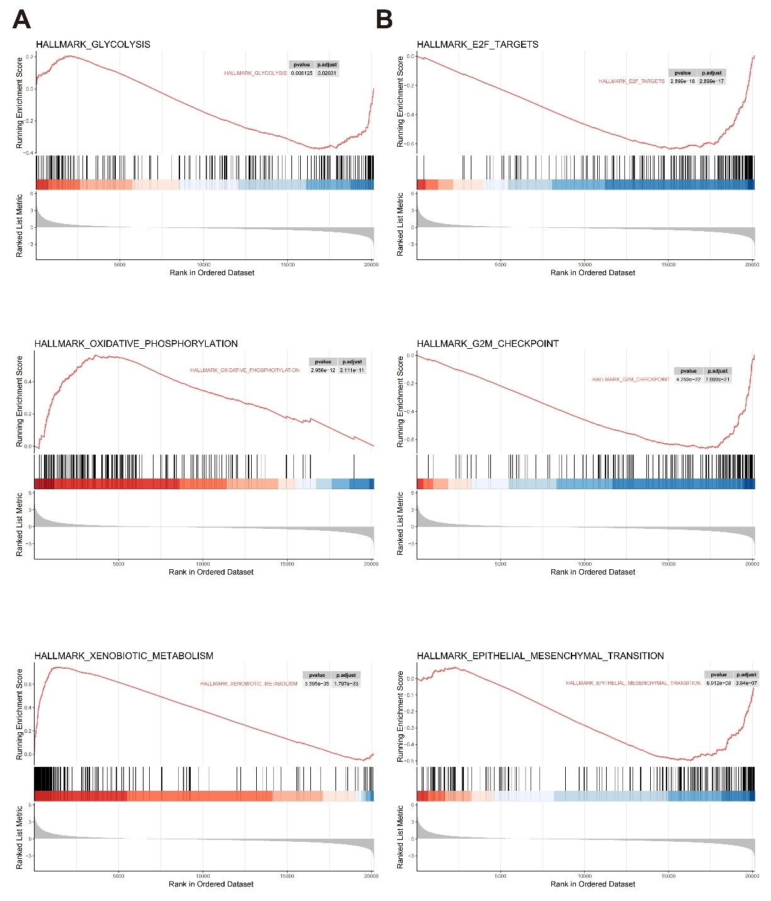
Supplementary Fig. 1. GSEA enrichment analysis in two clusters.
A. HALLMARK_GLYCOLYSIS, HALLMARK_OXIDATIVE_PHOSPHORYLATION and HALLMARK_XENOBIOTIC_METABOLISM was enriched in cluster1.
B. HALLMARK_E2F_TARGETS, HALLMARK_G2MCHECKPOINT and HALLMARK_EPITHELIAL_MESENCHYMAL_TRANSITION was enriched in cluster2.

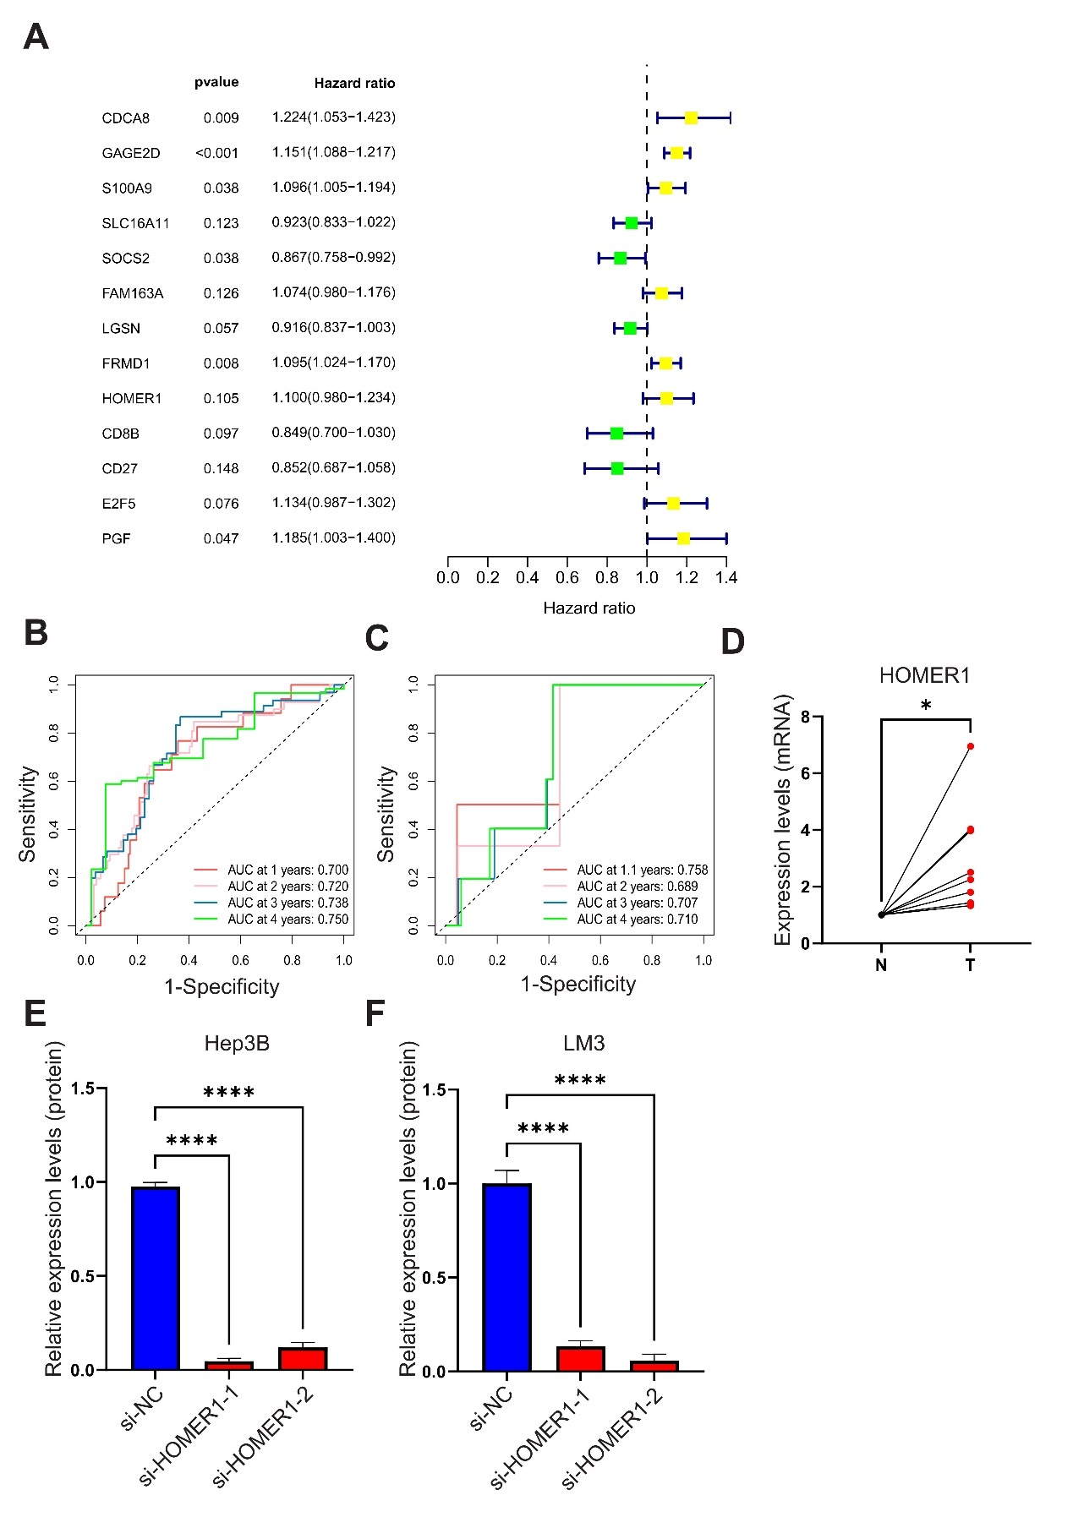
Supplementary Fig. 2. Forest plot and ROC curves of the 1-4 years survival rates of testing datasets.
A. The forest plot exhibits the 13 genes constructing the signature.
B. At 1-4 years, the AUC of the ROC curve for ICGC-LIHC are 0.700,0.720,0.738,0.750 respectively.
C. At 1-4 years, the AUC of the ROC curve for GSE148355 are 0.542,0.689,0.707,0.710 respectively.
D. mRNA expression confirmed that the expression of HOMER1 was evaluated in tumors than in adjacent tumors at RNA level.
E. The statistical graph of the Hep3B knockdown experiment.
F. The statistical graph of the LM3 knockdown experiment.
* p<0.05, **** p<0.0001

Supplementary Table 1. Clinical data of patients with HCC.
 | Age | Gender | Tumor Sizes(cm) | Tumor Number | Hepatitis | AFP | DFS | DFS.time | OS | OS.time
Patient1 | 38 | M | 10.8 | 2 | HBV | 3000 | 0 | 3281 | 0 | 3281
Patient2 | 48 | M | 8.6 | 1 | HBV | 666.5 | 0 | 194 | 0 | 194
Patient3 | 63 | M | 3.1 | 1 | HBV | 32.5 | 0 | 100 | 0 | 100
Patient4 | 60 | F | 3.8 | 1 | HBV | 2.67 | 0 | 117 | 0 | 117
Patient5 | 56 | M | 11 | 1 | HBV | 6.07 | 0 | 87 | 0 | 87
Patient6 | 59 | M | 4.3 | 1 | HBV | 1.59 | 0 | 1441 | 0 | 1441
Patient7 | 81 | M | 5.9 | 1 | HBV | 79.95 | 0 | 102 | 0 | 102
Patient8 | 18 | M | 10.6 | 1 | HBV | 800 | 1 | 136 | 0 | 2041

Supplementary Table 2. List of primer sequences for RT-qPCR.
Gene | Primer sequences
HOMER1-Forward | CCGGGCAAACACCGTTTATG
HOMER1-Reverse | TGCTAGTCGAGCAGCTTCTTTA
β-actin -Forward | CATGTACGTTGCTATCCAGGC
β-actin -Reverse | CTCCTTAATGTCACGCACGAT

Supplementary Table 3. List of siRNA sequences.
Symbol | Sense sequences | Antisense sequences
si-HOMER1-1 | 5’- GCACUCGAGCUCAUGUCUUTT-3’ | 5’- AAGACAUGAGCUCGAGUGCTT-3’
si-HOMER1-2 | 5’- GGUACCCACCAGCAAGCAUTT-3’ | 5’- AUGCUUGCUGGUGGGUACCTT-3’
Control siRNA | 5’- UUCUCCGAACGUGUCACGUTT-3’ | 5’- ACGUGACACGUUCGGAGAATT-3’

