Supporting Information
Functional and mechanistic insights into the fatty-acid CoA ligase FadK in Escherichia coli

Supplementary Table 1.

Supplementary Table 1. Primers used for constructions of fadK plasmid.
Construct | Primers | Primer sequence 5’-3’
pET28a-fadK | Forward primer | GCGCGGCAGCCATATGATGCATCCCACAGGC
pET28a-fadK | Reverse primer | GGTGCTCGAGTGCGGCCGCAAGCTTTTATTCAATCTCTTC
Note: The endonuclease restriction sites were underlined and displayed in bold.

Supplementary Table 2.

Supplementary Table 2. K_{m} and V_{max} values of FadK with various substrates.
Substrate | Butyric acid | Hexanoic acid | Caprylic acid | Capric acid
K_{m} (μM) | 946.4 | 857.2 | 330.2 | 749.5
V_{max} (nmol/min/mg) | 97.5 | 147.4 | 249.9 | 98.8
Note: K_{m} and V_{max} values were determined by using the Hanes-Woolf plot.

Supplementary Table 3.

Supplementary Table 3. Primers used for RT-qPCR.
Primer | Primer sequence 5’-3’
fadK (F)  fadK (R) | ATGCATCCCACAGGCCCGCATC  TTATTCAATCTCTTCACAGACATCCTGCG
gyrA (F)  gyrA (R) | GTTCCATCAGCCCTTCAATG  TTGATAACTATGACGGCACGG

Supplementary Table 4.

Supplementary Table 4. Search for structural homologs of FadK using SWISS-MODEL.
Rank | PDB code | GMQE | Identity (%) | Method | Oligo State | Ligands | Description
1 | 5kei | 0.59 | 33.59 | X-ray, 2.3 Å | monomer | None | 2,3-dihydroxybenzoate-AMP ligase; Mycobacterium smegmatis MbtA apo structure
2 | 6e8o | 0.62 | 33.27 | X-ray, 1.7 Å | monomer | 1xAMP | 2,3-dihydroxybenzoate-AMP ligase; Crystal structure of aryl acid adenylating enzyme FscC from Fuscachelin NRPS in complex with AMP
3 | 5wm2 | 0.63 | 32.69 | X-ray, 1.5 Å | monomer | 1xSAL, 1xAMP | Salicylate-AMP ligase; Crystal Structure of CahJ in Complex with Salicylic Acid and AMP
4 | 3rg2 | 0.61 | 32.35 | X-ray, 3.1 Å | homo-dimer | 2xSVS, 2xPNS | Enterobactin synthase component E (entE), 2,3-dihydro-2,3-dihydroxybenzoate synthetase, isochroismatase (Entb); Structure of a two-domain NRPS fusion protein containing the EntE adenylation domain and EntB aryl-carrier protein from enterobactin biosynthesis
5 | 3o82 | 0.48 | 32.33 | X-ray, 2.7 Å | monomer | 1xHP8, 2xCA | Peptide arylation enzyme; Structure of BasE N-terminal domain from Acinetobacter baumannii bound to 5'-O-[N-(2,3-dihydroxybenzoyl)sulfamoyl] adenosine

Supplementary Fig. 1.

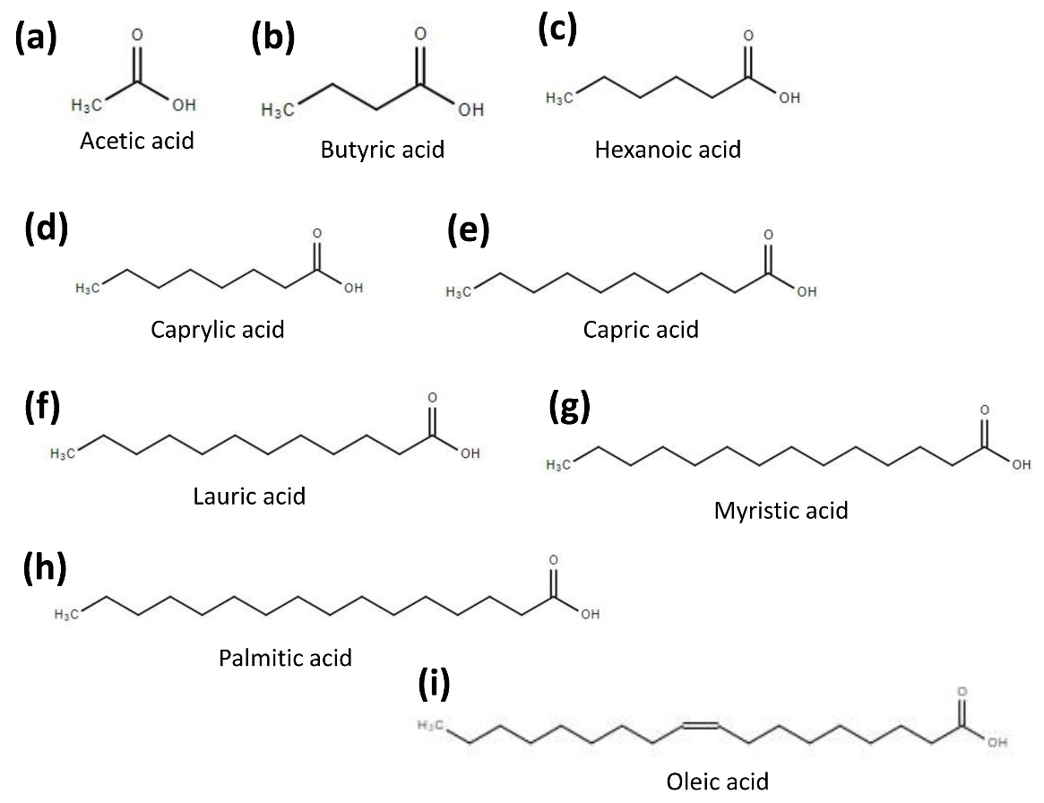

Supplementary Fig. 1. Chemical structures of the substrates used in this study. (a) Acetic acid. (b) Butyric acid. (c) Hexanoic acid. (d) Caprylic acid. (e) Capric acid. (f) Lauric acid. (g) Myristic acid. (h) Palmitic acid. (i) Oleic acid.

