Supplementary figure legend
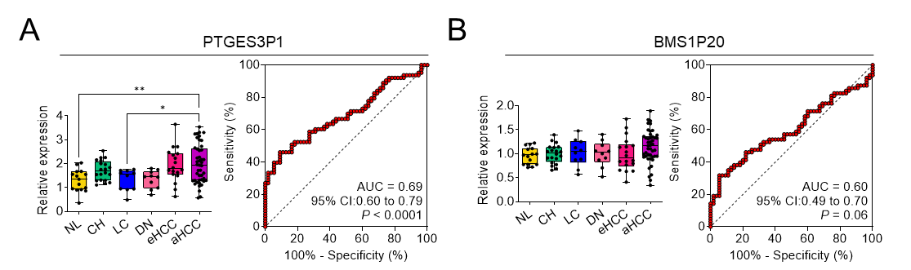
Supplementary Fig. 1. Diagnostic evaluation of PTGES3P1 and BMS1P20 in HCC.
The Relative expression level of (A) PTGES3P1 and (B) BMS1P20 in normal liver (NL), chronic hepatitis (CH), liver cirrhosis (LC), dysplastic nodule (DN), early-stage HCC (eHCC), and advanced HCC (aHCC), based on the GSE114564 dataset (left box plot graph of the each panel). ROC curves demonstrate the diagnostic performance of each pseudogene in distinguishing HCC from non-tumor liver tissue, with AUC value and 95% CIs (right ROC curve graph of the each panel).
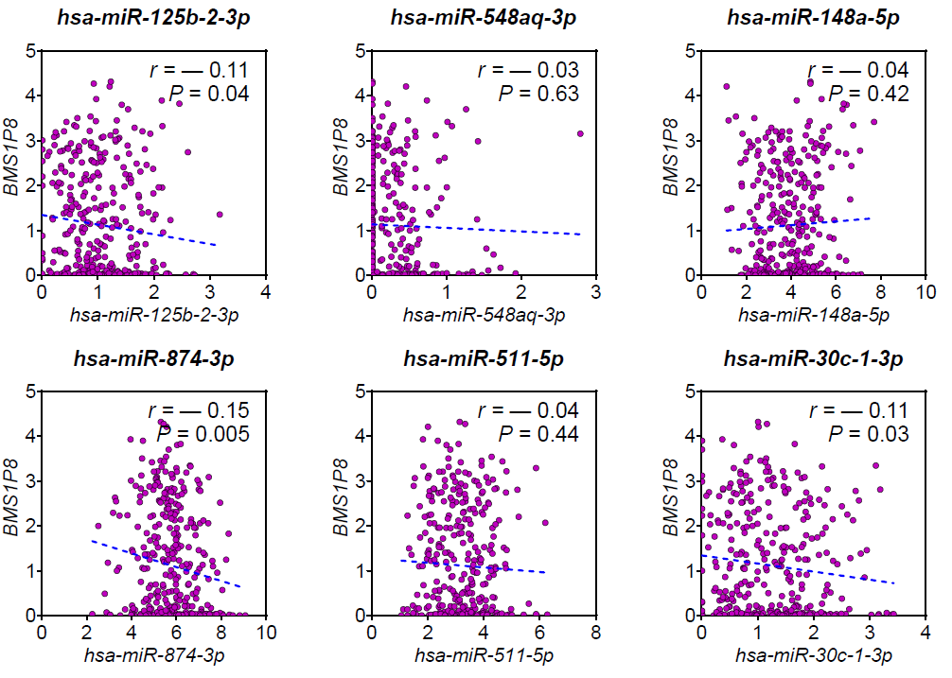
Supplementary Figure S2. Pearson correlation analysis between BMS1P8 and six candidate miRNAs in TCGA_LIHC tumors.
Scatter plots display log₂-transformed TPM values for BMS1P8 (y-axis) versus each miRNA (x-axis) in tumors with matched mRNA- and miRNA-seq data. Dashed lines denote simple linear-regression fits. Pearson correlation coefficients (r) and two-tailed P values are provided in each panel. miRNAs tested: hsa-miR-125b-2-3p, hsa-miR-548aq-3p, hsa-miR-148a-5p, hsa-miR-874-3p, hsa-miR-511-5p, and hsa-miR-30c-1-3p.

Supplementary Table 1. Candidate miRNAs for BMS1P8 ceRNA Network
No. | Target Rank | Target Score | miRNA Name | P value | log2 Fold change
1 | 50 | 85 | hsa-miR-125b-2-3p | 1.34E-07 | -0.347
2 | 107 | 76 | hsa-miR-548aq-3p | 4.46E-07 | -0.282
3 | 118 | 76 | hsa-miR-148a-5p | 6.85E-11 | -0.577
4 | 130 | 75 | hsa-miR-874-3p | 7.33E-08 | -0.610
5 | 141 | 74 | hsa-miR-30c-2-3p | 8.17E-27 | -1.072
6 | 145 | 73 | hsa-miR-511-5p | 8.65E-26 | -1.224
7 | 152 | 73 | hsa-miR-30c-1-3p | 1.60E-08 | -0.425

Supplementary Table 2. hsa-miR-30c-2-3p Target Genes Upregulated & Positively Correlated with BMS1P8 in TCGA LIHC Tumors
 | miRDB prediction |  |  |  |  |  | TCGA LIHC
No. | Target  Rank | Target  Score | miRNA Name | Gene  Symbol | Gene Description |  | P value | log₂ Fold  change | Correlation  with BMS1P8
1 | 2 | 97 | hsa-miR-30c-2-3p | MARCKSL1 | MARCKS like 1 |  | 7.61E-14 | 0.88 | 0.03
2 | 9 | 95 | hsa-miR-30c-2-3p | DYDC2 | DPY30 domain containing 2 |  | 1.71E-39 | 0.57 | 0.25
3 | 24 | 93 | hsa-miR-30c-2-3p | MEPCE | methylphosphate capping enzyme |  | 4.75E-30 | 0.78 | 0.10
4 | 26 | 92 | hsa-miR-30c-2-3p | SEMA4G | semaphorin 4G |  | 4.24E-08 | 0.51 | 0.24
5 | 27 | 92 | hsa-miR-30c-2-3p | PAK1 | p21 (RAC1) activated kinase 1 |  | 4.21E-24 | 0.83 | 0.23
6 | 44 | 90 | hsa-miR-30c-2-3p | BAZ2A | bromodomain adjacent to zinc finger domain 2A |  | 1.65E-23 | 0.78 | 0.07
7 | 48 | 89 | hsa-miR-30c-2-3p | SSR2 | signal sequence receptor subunit 2 |  | 1.16E-61 | 1.60 | 0.20
8 | 49 | 89 | hsa-miR-30c-2-3p | GIGYF1 | GRB10 interacting GYF protein 1 |  | 3.39E-31 | 1.04 | 0.04
9 | 50 | 89 | hsa-miR-30c-2-3p | MKKS | McKusick-Kaufman syndrome |  | 3.98E-45 | 0.86 | 0.17
10 | 52 | 89 | hsa-miR-30c-2-3p | SF3A3 | splicing factor 3a subunit 3 |  | 1.85E-31 | 0.71 | 0.10
11 | 59 | 88 | hsa-miR-30c-2-3p | HNRNPL | heterogeneous nuclear ribonucleoprotein L |  | 1.62E-30 | 0.71 | 0.05
12 | 66 | 87 | hsa-miR-30c-2-3p | PGPEP1 | pyroglutamyl-peptidase I |  | 5.80E-16 | 0.63 | 0.09
13 | 72 | 86 | hsa-miR-30c-2-3p | PATZ1 | POZ/BTB and AT hook containing zinc finger 1 |  | 2.24E-26 | 0.58 | 0.14
14 | 75 | 86 | hsa-miR-30c-2-3p | URM1 | ubiquitin related modifier 1 |  | 5.00E-39 | 0.88 | 0.11
15 | 84 | 85 | hsa-miR-30c-2-3p | MPP6 | membrane palmitoylated protein 6 |  | 5.87E-30 | 0.52 | 0.04
16 | 86 | 85 | hsa-miR-30c-2-3p | TPM1 | tropomyosin 1 |  | 7.57E-14 | 0.92 | 0.10
17 | 92 | 84 | hsa-miR-30c-2-3p | MAML1 | mastermind like transcriptional coactivator 1 |  | 2.93E-32 | 0.61 | 0.03
18 | 94 | 83 | hsa-miR-30c-2-3p | RBM19 | RNA binding motif protein 19 |  | 2.33E-35 | 0.84 | 0.33
19 | 96 | 83 | hsa-miR-30c-2-3p | STX5 | syntaxin 5 |  | 6.37E-20 | 0.56 | 0.03
20 | 106 | 82 | hsa-miR-30c-2-3p | PLXNA2 | plexin A2 |  | 5.06E-34 | 0.66 | 0.16
21 | 108 | 82 | hsa-miR-30c-2-3p | CCT4 | chaperonin containing TCP1 subunit 4 |  | 3.52E-36 | 0.97 | 0.12
22 | 110 | 82 | hsa-miR-30c-2-3p | PPME1 | protein phosphatase methylesterase 1 |  | 2.48E-44 | 0.74 | 0.04
23 | 112 | 82 | hsa-miR-30c-2-3p | EBAG9 | estrogen receptor binding site associated, antigen, 9 |  | 1.60E-24 | 0.54 | 0.06
24 | 124 | 81 | hsa-miR-30c-2-3p | PLBD2 | phospholipase B domain containing 2 |  | 1.76E-21 | 0.61 | 0.22
25 | 126 | 81 | hsa-miR-30c-2-3p | ABCC4 | ATP binding cassette subfamily C member 4 |  | 3.06E-31 | 0.74 | 0.14
26 | 133 | 81 | hsa-miR-30c-2-3p | BCL9 | BCL9, transcription coactivator |  | 4.15E-54 | 1.08 | 0.16
27 | 140 | 80 | hsa-miR-30c-2-3p | IARS | isoleucyl-tRNA synthetase |  | 2.53E-29 | 0.98 | 0.03
28 | 144 | 80 | hsa-miR-30c-2-3p | SLC6A11 | solute carrier family 6 member 11 |  | 4.40E-12 | 0.61 | 0.17
29 | 152 | 79 | hsa-miR-30c-2-3p | BMI1 | BMI1 proto-oncogene, polycomb ring finger |  | 8.21E-31 | 0.75 | 0.09
30 | 153 | 79 | hsa-miR-30c-2-3p | C1QTNF6 | C1q and TNF related 6 |  | 3.52E-51 | 0.90 | 0.08
31 | 162 | 78 | hsa-miR-30c-2-3p | STAT1 | signal transducer and activator of transcription 1 |  | 5.44E-04 | 0.59 | 0.08
32 | 168 | 78 | hsa-miR-30c-2-3p | KHSRP | KH-type splicing regulatory protein |  | 2.38E-34 | 0.82 | 0.08
33 | 193 | 75 | hsa-miR-30c-2-3p | FUNDC1 | FUN14 domain containing 1 |  | 2.95E-31 | 0.72 | 0.02
34 | 196 | 75 | hsa-miR-30c-2-3p | DNAJC10 | DnaJ heat shock protein family (Hsp40) member C10 |  | 1.43E-32 | 0.66 | 0.01
35 | 199 | 75 | hsa-miR-30c-2-3p | MAGEB2 | MAGE family member B2 |  | 1.23E-16 | 0.58 | 0.14
36 | 203 | 75 | hsa-miR-30c-2-3p | MAPK13 | mitogen-activated protein kinase 13 |  | 2.19E-17 | 0.74 | 0.16
37 | 208 | 74 | hsa-miR-30c-2-3p | NDUFAF3 | NADH:ubiquinone oxidoreductase complex assembly factor 3 |  | 1.25E-32 | 0.70 | 0.08
38 | 218 | 74 | hsa-miR-30c-2-3p | BLOC1S3 | biogenesis of lysosomal organelles complex 1 subunit 3 |  | 1.32E-69 | 1.16 | 0.20
39 | 232 | 73 | hsa-miR-30c-2-3p | IER5 | immediate early response 5 |  | 7.24E-17 | 0.84 | 0.02
40 | 238 | 72 | hsa-miR-30c-2-3p | NME6 | NME/NM23 nucleoside diphosphate kinase 6 |  | 5.99E-55 | 0.72 | 0.32
41 | 249 | 71 | hsa-miR-30c-2-3p | CHD8 | chromodomain helicase DNA binding protein 8 |  | 2.37E-24 | 0.66 | 0.04
42 | 250 | 71 | hsa-miR-30c-2-3p | LRPAP1 | LDL receptor related protein associated protein 1 |  | 1.36E-30 | 0.66 | 0.02
43 | 257 | 70 | hsa-miR-30c-2-3p | PTPN18 | protein tyrosine phosphatase, non-receptor type 18 |  | 1.70E-25 | 0.55 | 0.08
44 | 264 | 70 | hsa-miR-30c-2-3p | F13A1 | coagulation factor XIII A chain |  | 1.40E-19 | 0.73 | 0.04
45 | 265 | 70 | hsa-miR-30c-2-3p | ACSL3 | acyl-CoA synthetase long chain family member 3 |  | 1.56E-11 | 0.57 | 0.18
46 | 267 | 70 | hsa-miR-30c-2-3p | GPATCH8 | G-patch domain containing 8 |  | 2.41E-21 | 0.59 | 0.02

