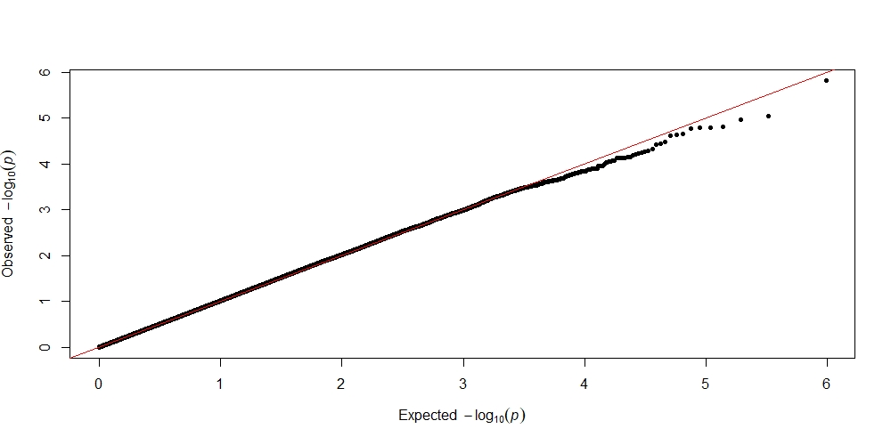
A
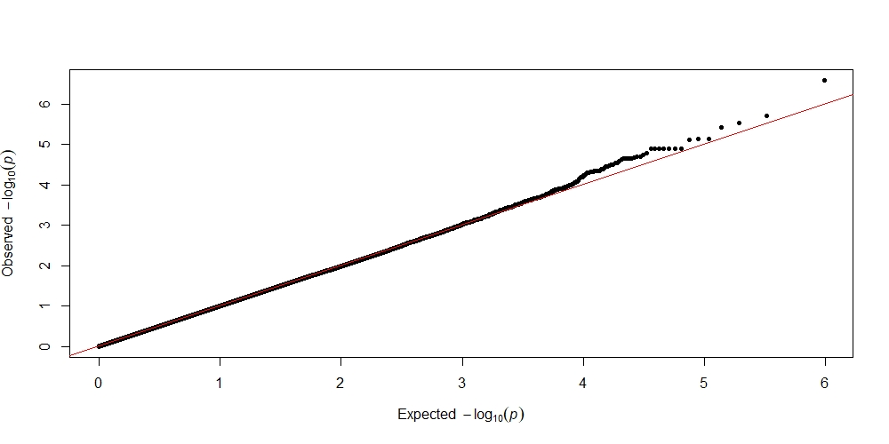
B
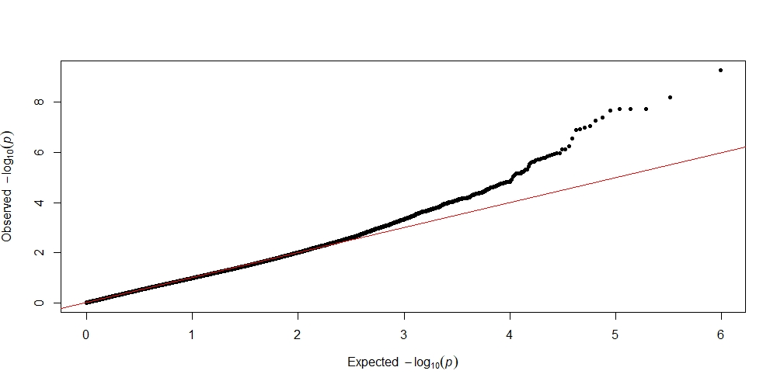
C
Supplementary Fig. 1. Quantile–quantile (Q–Q) plots of the GWAS results for the studied growth sperm quality traits. (A) forward progressive motility, (B) frequency of damaged membranes, and (C) sperm cell respiration rate. Q–Q graphs showed quantiles of the probability distribution of predicted and observed departures from the normal distribution for nominal significance values (−log₁₀ (p)).

