Supplementary Table 1. The univariate logistic analysis of variables associated with posttransplant ECMO use.
Variable | Odds Ratio | 95% confidence intervals | P value
Recipient age (years) | 0.985 | 0.956-1.014 | 0.31
Recipient height (m) | 85.718 | 0.26-28234.18 | 0.13
Recipient weight (kg) | 1.016 | 0.985-1.048 | 0.32
Recipient gender (male) (%) | 1.037 | 0.405-2.658 | 0.94
Donor height (m) | 181.182 | 0.074-443261.488 | 0.19
Donor weight (kg) | 1.036 | 0.983-1.092 | 0.18
Donor age (years) | 0.996 | 0.955-1.039 | 0.86
Donor gender (male) (%) | 0.563 | 0.161-1.971 | 0.37
Diabetes (%) | 0.266 | 0.33-2.11 | 0.21
Previous cardiac surgery (%) | 1.5 | 0.534-4.21 | 0.44
Pretransplant use of ARNI (%) | 0.418 | 0.179-0.978 | 0.044
ACEi/ARB (%) | 0.926 | 0.318-2.695 | 0.89
Beta blockers (%) | 0.932 | 0.417-2.083 | 0.86
Aldosterone receptor antagonists (%) | 0.633 | 0.288-1.392 | 0.26
Sodium-glucose cotransporter-2 inhibitors (%) | 0.226 | 0.029-1.778 | 0.16
Dosage of loop diuretics (furosemide mg/day) | 0.993 | 0.982-1.005 | 0.25
Left ventricular ejection fraction (%) | 0.995 | 0.965-1 | 0.75
Cardiac index (ml/min/m²) | 1.1 | 0.784-1.543 | 0.58
Central venous pressure (mmHg) | 1.017 | 0.979-1.057 | 0.38
Mean pulmonary artery pressure (>30 mmHg) (%) | 2.5 | 1.055-5.924 | 0.037
Pulmonary vascular resistance (Wood unit) | 0.986 | 0.812-1.198 | 0.89
Cardiopulmonary bypass time (hr) | 10.4 | 3.714-29.120 | <0.001
Ischemic time (>3 hours) (%) | 0.999 | 0.995-1.002 | 0.49
The year of transplant (later than 2017) (%) | 0.771 | 0.258-2.31 | 0.64
Nitric oxide inhalation (%) | 2.105 | 0.956-4.634 | 0.065
ACEI/ARB, angiotensin-converting enzyme inhibitors/angiotensin II receptor blockers; ARNI, angiotensin receptor-neprilysin inhibitor; ECMO, extracorporeal membrane oxygenation.

Supplementary Table 2. Baseline demographics of heart transplant recipients undergoing surgery before and after Year 2017.
Variable | Before 2017 (n = 20) | After 2017  (n = 132) | P value
Recipient age (years) | 50 (34.5, 59) | 52 (39, 58) | 0.97
Recipient height (m) | 1.7 ± 0.1 | 1.7 ± 0.1 | 0.50
Recipient weight (kg) | 65.8 ± 15.1 | 64.8 ± 12.1 | 0.73
Recipient gender (male) (%) | 16 (80%) | 102 (77.3%) | >0.99
Donor height (m) | 1.7 ± 0.1 | 1.7 ± 0.1 | 0.31
Donor weight (kg) | 67.7 ± 6.7 | 65.7 ± 8.3 | 0.36
Donor age (years) | 35.7 ± 7.6 | 38.3 ± 9.7 | 0.31
Donor gender (male) (%), n = 143 | 14 (93.3%) | 116 (90.6%) | >0.99
Diabetes (%) | 1 (5.0%) | 13 (9.8%) | 0.70
Previous cardiac surgery (%) | 1 (5.0%) | 21 (15.9%) | 0.31
Pretransplant use of ARNI (%) | 1 (5.0%) | 66 (50.0%) | <0.001
ACEi/ARB (%) | 3 (15.0%) | 20 (15.2%) | >0.99
Beta blockers (%) | 8 (40.0%) | 85 (64.4%) | 0.037
Aldosterone receptor antagonists (%) | 3 (15.0%) | 91 (68.9%) | <0.001
Sodium-glucose cotransporter-2 inhibitors (%) | 0 (0%) | 16 (12.1%) | 0.13
Loop diuretics (%) | 10 (50.0%) | 110 (83.3%) | 0.002
Left ventricular ejection fraction (%) | 28.3 ± 13.3 | 32.7 ± 13.3 | 0.17
Tricuspid annular plane systolic excursion <16mm (%) | 12 (60.0%) | 74 (56.1%) | 0.74
Cardiac index (ml/min/m²) | 2.0 (2.0, 4.0) | 2.0 (2.0, 3.0) | 0.055
Central venous pressure (mmHg) | 11.5 (8.0, 17.0) | 12.0 (8.0, 18.0) | 0.91
Mean pulmonary artery pressure (mmHg) | 28.5 (21.0, 40.0) | 28.0 (20.0, 36.0) | 0.69
Pulmonary vascular resistance (Woodunit) | 4.0 (2.0, 4.0) | 3.0 (2.0, 6.0) | 0.97
Ischemic time (min) | 263.5 ± 110.6 | 248.0 ± 104.9 | 0.54
Cardiopulmonary bypass time (min) | 179.1 ± 58.7 | 186.9 ± 76.1 | 0.66
Nitric oxide inhalation (%) | 4 (20.0%) | 55 (41.7%) | 0.064
ECMO support (%) | 5 (25.0%) | 27 (20.5%) | 0.77
ACEI/ARB, angiotensin-converting enzyme inhibitors/angiotensin II receptor blockers; ARNI, angiotensin receptor-neprilysin inhibitor; ECMO, extracorporeal membrane oxygenation.

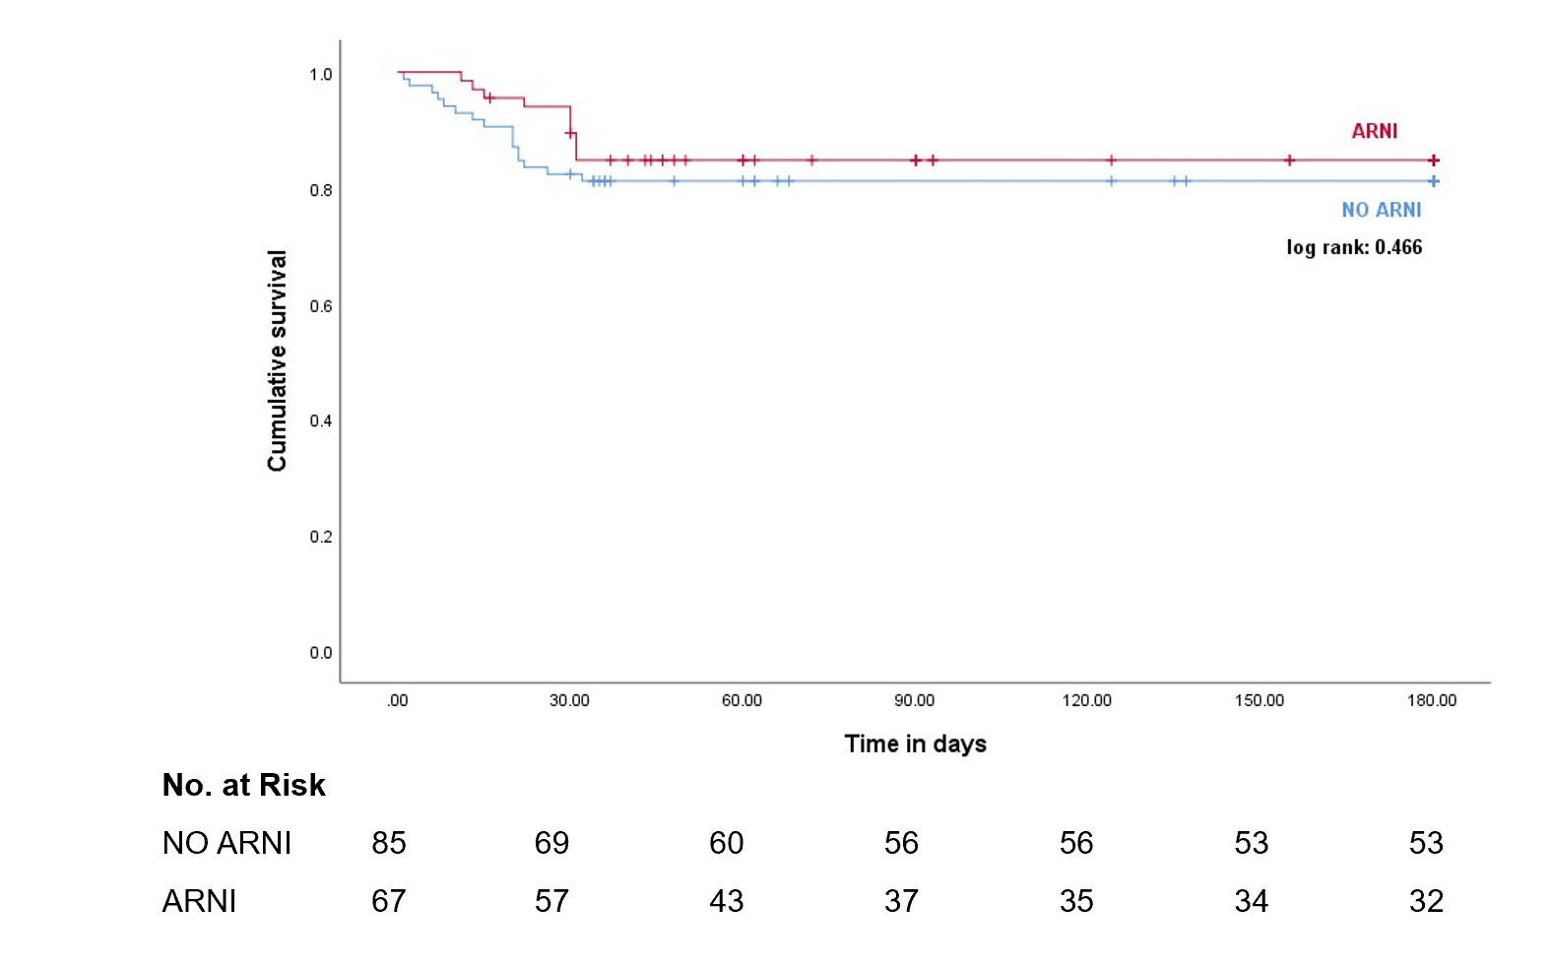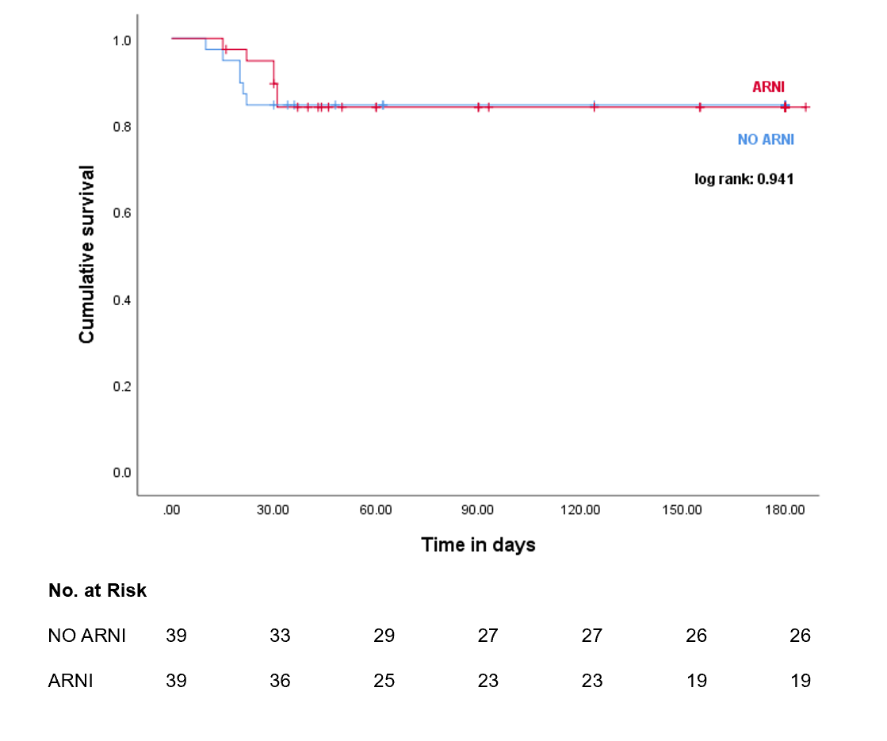
Supplementary Fig. 1. Kaplan–Meier survival curves between unmatched (A) and matched (B) HTx recipients with and without pretransplant ARNI therapy.

