Supplementary Table 1. Primer design for the tsNgR1.
Primers | Sequence (5’ to 3’) | Groups
RTN4R-1F | ATGGTGCCTTTATTCACCTCCT | Intermediate sequence
RTN4R-224R | CACACCGAGTCAAGAACACCA | amplification primers
RTN4R-728F | GACGGGATCAGCTTGTGCAGTG
RTN4R-1456R | CTGCAGCCACAGCACCCATG
RTN4R-1371F | GCACAGCCTCGACCGCCTC
RTN4R-1777R | CATCTGGCTGGCAGCACTT
RTN4R-1597F | AAGTTCCGAGGCTCCTCGTCCGA
RTN4R-2045R | CACTGGCTGCGGGTACGGTTCTT
RTN4R-1913F | GGACTCTGCCCAGCTCAGCCGA
RTN4R-2365R | ACGCCGACGCCAAACCCTGTA
RTN4R-F1 | TGCTCGGGCCCTGCTGACCA | 3’RACE specific primer
RTN4R-F2 | TCCGCAGCCAGGTGTGTGTACATAC
RTN4R-R4 | CACTGCACAAGCTGATCCCGTCG | 5’RACE specific primer
RTN4R-R3 | GATCAGGGCGGTGCTGCCAA
RTN4R-RT4 | TCCCCCAGGGTTGCCTCT
RTN4R-RT3 | GCTTCTGCGGTGTCTCCCAT

Supplementary Table 2. RT-qPCR primer sequences.
Primer | Sequence
NgR1-F | 5’-TGGTGCTGTGGACAGTGCTC-3’
NgR1-R | 5’-CACACCTGGCTGCGGAGA-3’
Probe | 5’FAM-CCAGCCACCAGCCACCAGGGCG-3’TAMRA
GAPDH- F | 5’-CTTCAACTCTGGCAAGGT-3’
GAPDH- R | 5’-AAGATGGTGATGGACTTCC-3’
Probe | 5’ FAM-ACCACAGTCCACGCCATCACTGCCACC-3’TAMRA

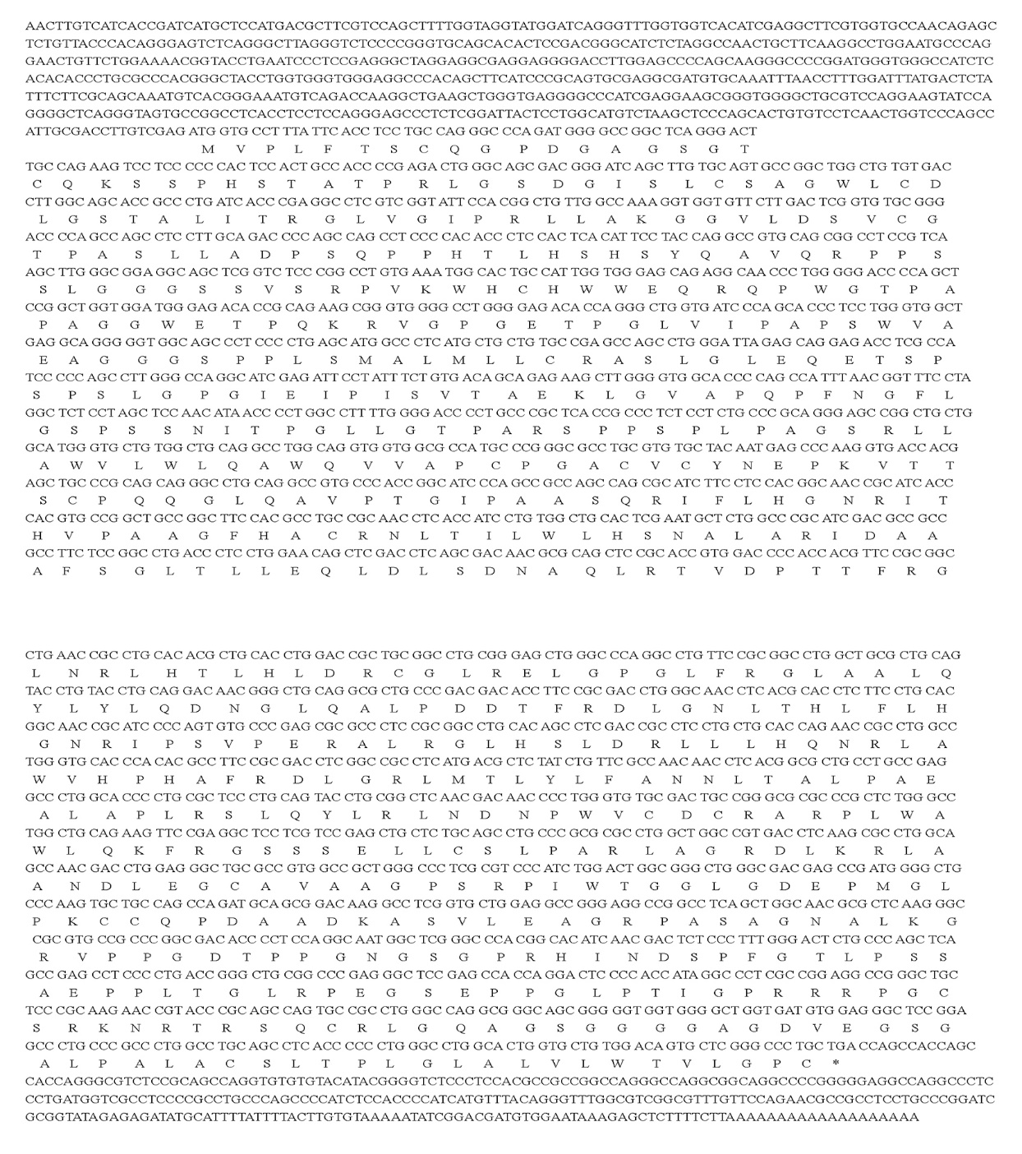
Supplementary Fig. 1. Nucleotide sequences and corresponding amino acids of NgR1.

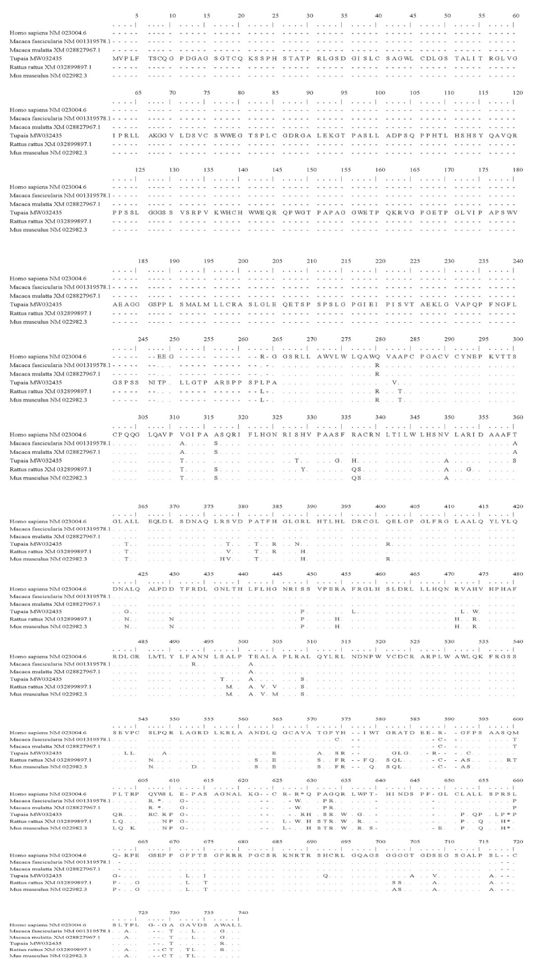
Supplementary Fig. 2. Comparison of NgR1 amino acids sequence between the tree shrew and other species. The conserved domain is marked with a black box.

Supplementary Fig. 3. Phylogenetic analysis of NgR1in the tree shrew. A phylogenetic tree with 1000 bootstrap repeats was constructed according to the Neighbor-joining (NJ) method.

