Chart 1- MRI, blood and CSF results, and treatment
Individual | MRI data | Treatments
Individual | MRI data | Hospital care | At home maintenance
1 | Prechiasmatic portions of the optic nerves showing contrast enhancement and diffusion restriction, with hypersignal on T2/FLAIR, discrete tumefactive effect and tiny foci in the pons | Methylprednisolone pulse therapy | Prednisolone
2 | Hypersignal on T2/FLAIR and hyposignal on T1 in the mammillary bodies, proximal chiasm-optic portion, more evident on the left, as well as in the oculomotor nerves along their entire length, without restriction to diffusion or post-contrast enhancement, with a slight tumefactive effect. Periaqueductal mesencephalic abnormality; no obvious abnormalities in the pons | Methylprednisolone pulse therapy,  Gamma Globulin pulse therapy | Rituximab,  Mycophenolate
3 | Hypersignal on FLAIR and hyposignal on T1 around the IV ventricle (periependymal distribution), in bulbar, pontine and cerebellar topography, observing an area of ​​restricted diffusibility in the right cerebellar hemisphere. There are also foci of high signal on T2 in the frontoparietal white matter, which are not very specific | Methylprednisolone pulse therapy, plasmapheresis | Prednisolone,  Azathioprine
4 | Signal abnormalities and contrast uptake on the left optic nerve, slight signal abnormality in the right postrema area, spinal cord injury D8-D11. Discreet restriction of diffusion of the optic nerves, more evident on the right. | Acyclovir, Clarithromycin, Ampicillin,  Methylprednisolone pulse therapy, plasmapheresis | Prednisolone,  Mycophenolate
5 | Apparently chronic lesion of the region postrema, signs of extensive bilateral optic neuritis involving 5 segments (including chiasm), asymmetricaly worse on the right, without contrast enhancement. Extensive myelitis involving 15 fragmented segments, from C2-T8, central, with bright spot. Debatable focus of hypersignal on T2/FLAIR in the left pons. | Methylprednisolone pulse therapy, plasmapheresis | Prednisolone
6 | Hypersignal on T2 associated with segmental enhancement of the left optic nerve in the optic canal. Abnormality in the left optic nerve signal. The remainder of the skull MRI showed no evident abnormalities. | Methylprednisolone pulse therapy | -
7 | Hypersignal on T2/FLAIR in the central region of the pons | Methylprednisolone pulse therapy | Prednisolone
8 | Foci of hypersignal on T2/FLAIR in the subcortical and periventricular white matter, without restriction to diffusion or contrast enhancement, located in the posterior segment of the internal capsule and periatrial region on the left. There is a similar lesion in the superior cerebellar peduncle on the left. Foci in the pons adjacent to the walls of the IV ventricle, most evident in its left anterior aspect. | - | Prednisolone,  Azathioprine
9 | Spinal cord injury, no further specifications | Methylprednisolone pulse therapy | Prednisolone,  Azathioprine
10 | Hypersignal on T2/Flair with imprecise limits in the right thalamo capsular region, bilateral pallidal capsular region, in the midbrain, in the pons (especially in the tegmentum), in the vicinity of the IV ventricle, in the medulla oblongata, in the deep white matter of the cerebellar hemispheres, in the superior and middle cerebellar peduncles and in the periphery of the right cerebellar hemisphere, without evident contrast or diffusion restriction. Hypersignal on T2/Flair of the intraorbital and canalicular portions of the optic nerves. | Methylprednisolone pulse therapy, plasmapheresis | Prednisolone,  Azathioprine,  Mycophenolate
11 | Multiple lesions with high signal on T2 and FLAIR of periventricular distribution, located in the periventricular white matter of the medulla and semi-oval centers and corpus callosum, in the fourth ventricle, callososeptal interface, right thalamus, tegmentum of the pons and postrema area. Does not present enhancement through contrast, surrounding edema or diffusion restriction. | Methylprednisolone pulse therapy, plasmapheresis | Prednisolone,  Azathioprine
12 | Areas of hypersignal on T2/FLAIR in the central portion of the spinal cord, sometimes confluent, identified from the bulbo medullary transition to the D6-D7 level. Areas of discrete segmental reductions in spinal caliber are associated at these levels, most evident in D1. Small foci of post-contrast enhancement, discontinuous, with imprecise limits, without evident mass effect, scattered throughout the spinal cord at the levels of D1 and between D3 and D6-D5, non-specific. Thinning, without contrast enhancement in the prechiasmatic segment of the left optic nerve, associated with ectasia of its sheath, as well as the anterolateral portion of the optic chiasm on this side. | Surgical procedure for Transverse myelitis and Syringomyelia, Methylprednisolone pulse therapy, Cyclophosphamide | Prednisolone,  Azathioprine

Fig. 1. Example of an ABR recording.
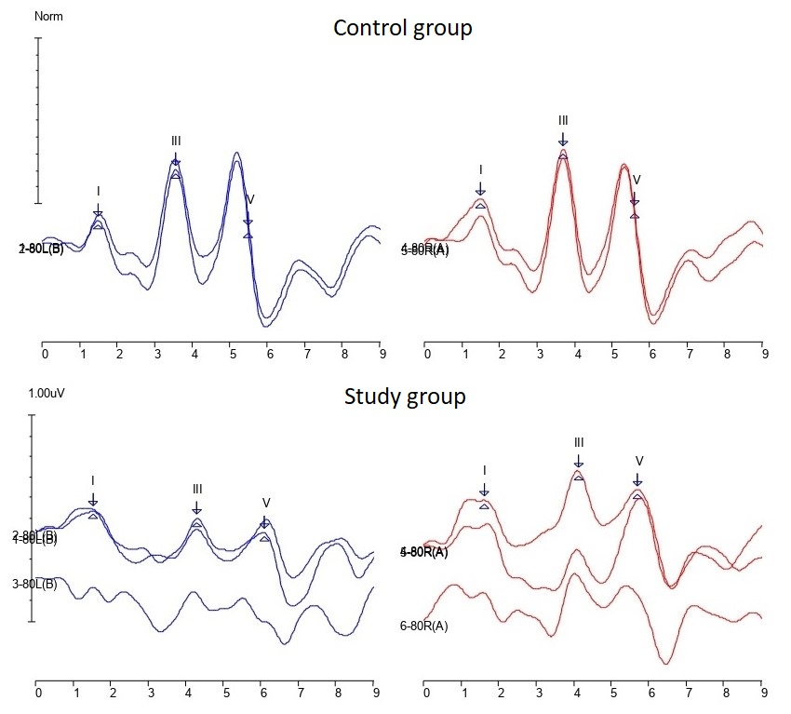

Fig. 2. Example of a CAEP recording.
