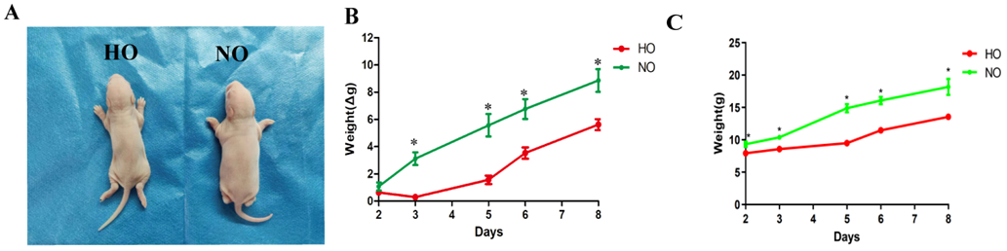
Supplementary Fig. 1. The weight gain of the pups slowed down after hyperoxia. (A) pups in the HO group were thinner; (B–C) weight gain in the HO group decreased; n = 20. NO, normoxia group; HO group, hyperoxia group; *, p＜0.05.

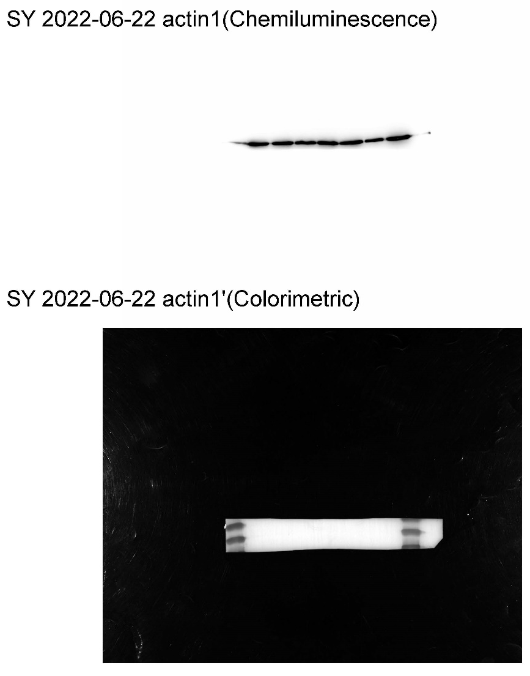
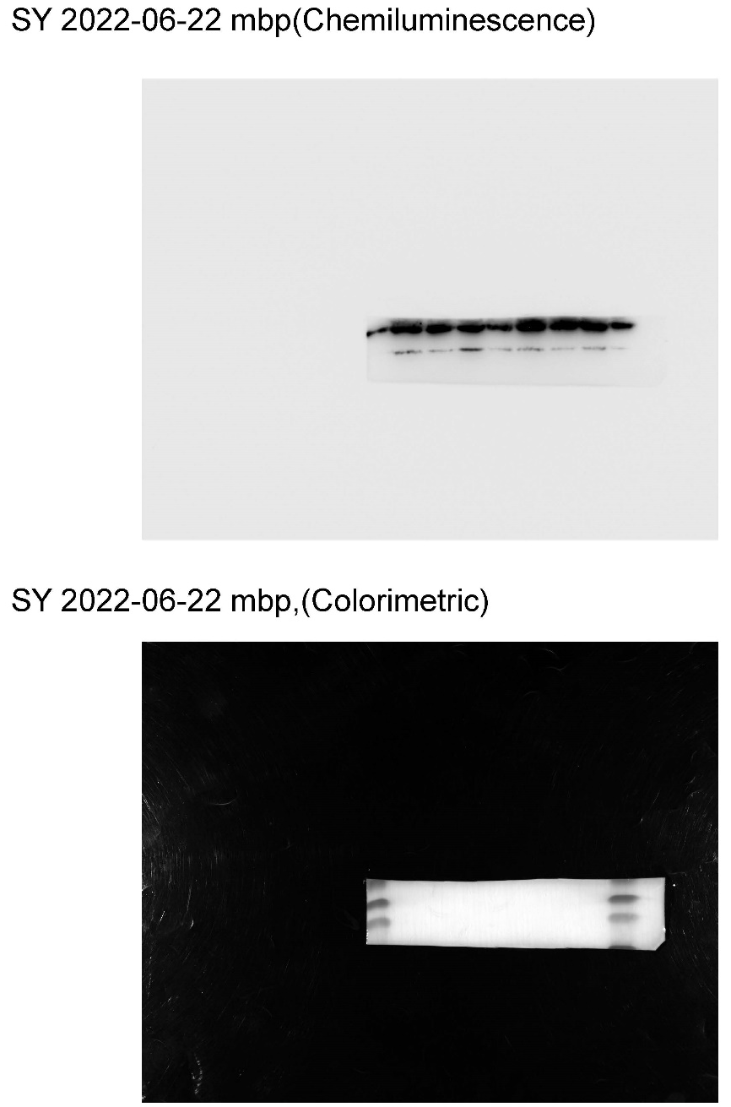
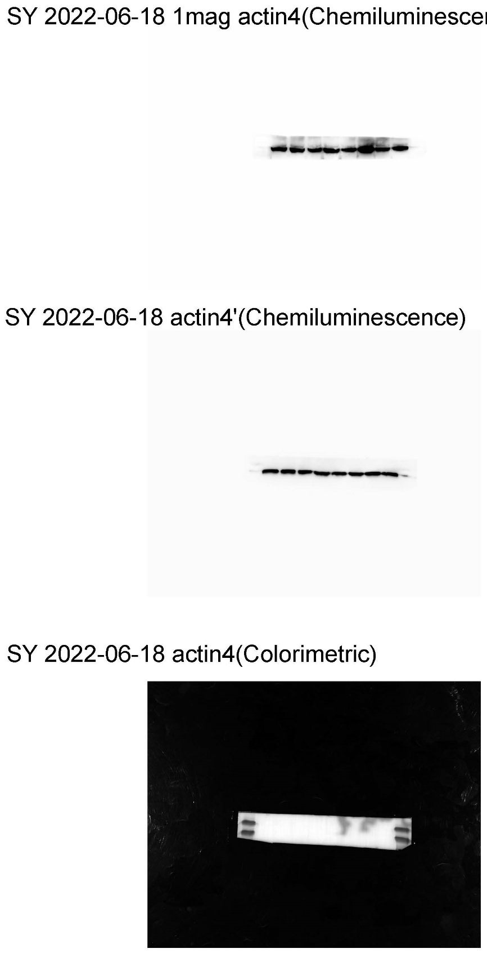
Supplementary Fig. 2. The original images of the western blot for Fig. 1C.

