Supplemental Video Captions
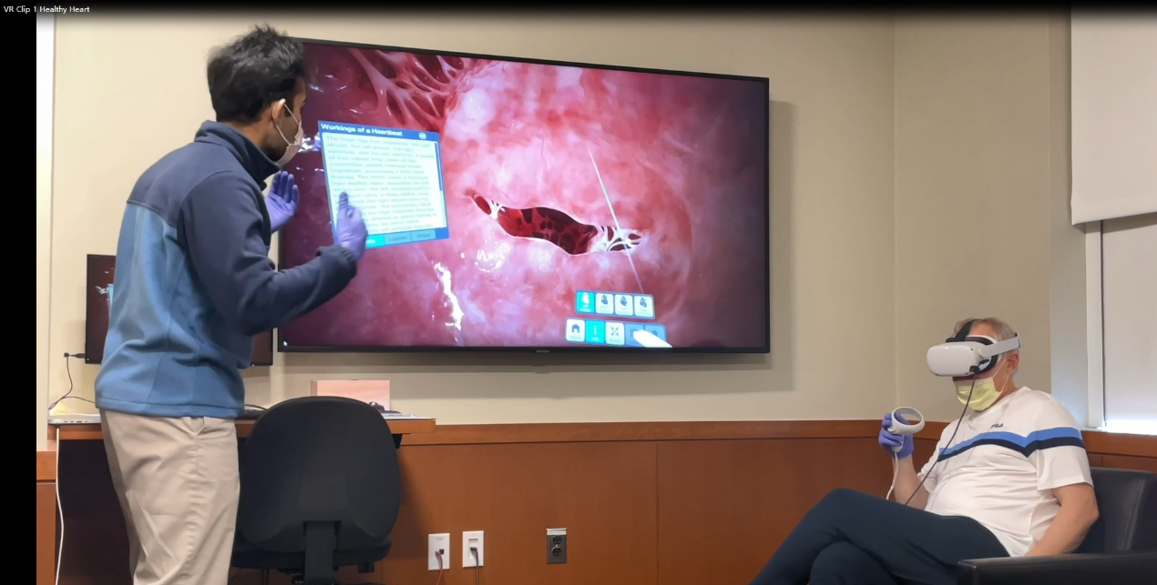
Video 1. Segment of an educational VR session reviewing mitral valve function.

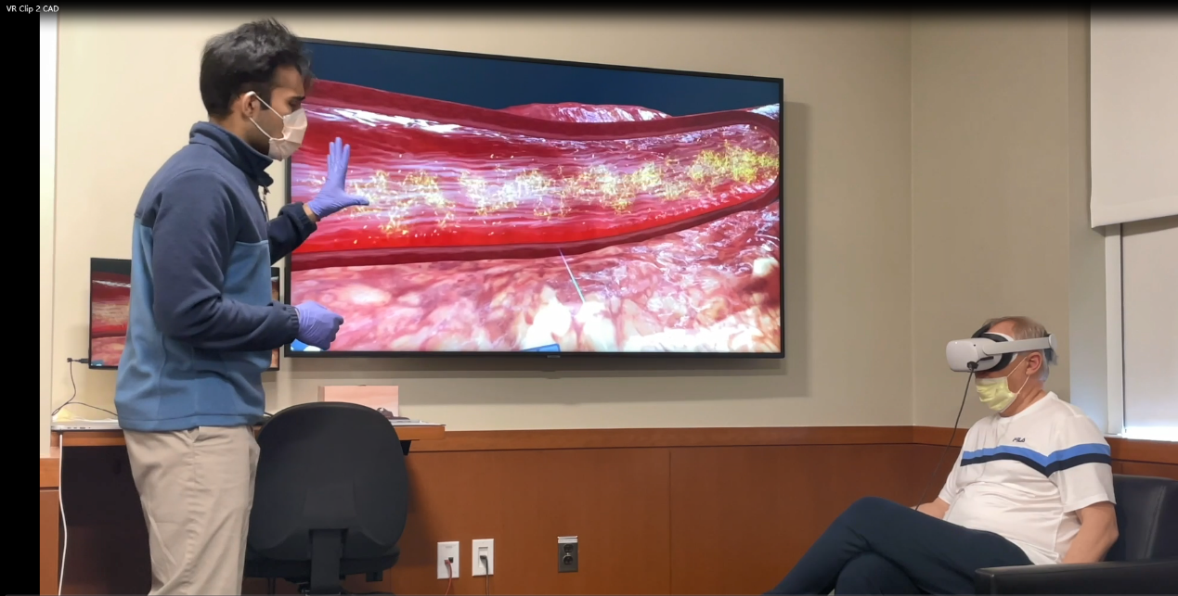
Video 2. Segment of an educational VR session reviewing the pathophysiology of atherosclerosis.

