Supplementary Table 1. Baseline characteristics for the overall cohort, DCM patients with LVEF 30-50% and LVEF <30%.
 | Overall | LVEF 30-50% | LVEF <30% | p-Value
N | 633 | 302 | 331
Clinical characteristics
Age(years) | 48 [36, 59] | 52 [39, 61] | 46 [33, 56] | <0.001
Female (%) | 151 (23.9) | 84 (27.8) | 67 (20.2) | 0.032
Heart rate (b.p.m) | 83 [72, 96] | 81.50 [71, 94] | 85 [75, 98] | 0.014
SBP (mmHg) | 112 [100, 124] | 116 [105, 128] | 108 [98, 120] | <0.001
DBP (mmHg) | 71 [63, 80] | 71.50 [65, 81] | 71 [62, 80] | 0.109
BMI (kg/m2) | 24.28 [21.48, 27.48] | 24.75 [22.07, 27.61] | 23.66 [20.91, 27.36] | 0.017
Diabetes (%) | 109 (17.2) | 62 (20.5) | 47 (14.2) | 0.045
Hypertension (%) | 186 (29.4) | 115 (38.1) | 71 (21.5) | <0.001
NYHA Class III/IV (%) | 505 (79.8) | 226 (74.8) | 279 (84.3) | 0.004
Smoking (%) | 200 (50.1) | 88 (47.1) | 112 (52.8) | 0.294
Length of stay (days) | 10 [8, 14] | 10 [8, 13] | 11 [8, 14] | 0.102
Electrocardiography
QRS duration (ms) | 108 [96, 128] | 106 [94, 126] | 112 [98, 132] | 0.003
PR interval (ms) | 176 [160, 196] | 174 [156, 192] | 180 [163, 200] | 0.041
QT interval (ms) | 392 [362, 434] | 396 [364, 435.75] | 390 [360, 429] | 0.17
QTc interval (ms) | 457 [430, 486] | 456 [428.30, 485] | 457 [431, 489] | 0.369
QRSd≥120ms (%) | 226 (35.7) | 92 (30.5) | 134 (40.5) | 0.011
AF (%) | 142 (22.4) | 79 (26.2) | 63 (19.0) | 0.04
LBBB (%) | 68 (10.7) | 29 (9.6) | 39 (11.8) | 0.45
NSVT (%) | 172 (27.2) | 69 (22.8) | 103 (31.1) | 0.025
Laboratory Test
Haemoglobin (g/L) | 147 [134, 160] | 147 [133, 159] | 148 [135, 161] | 0.586
WBC (10^9/L) | 7.22 [6.11, 8.64] | 7 [5.94, 8.46] | 7.39 [6.28, 8.86] | 0.017
K (mmol/L) | 3.95 [3.67, 4.26] | 3.93 [3.64, 4.27] | 3.96 [3.70, 4.24] | 0.27
Na (mmol/L) | 138 [135, 140] | 138 [136, 140] | 137 [134, 140] | 0.012
FBG (mmol/L) | 5.06 [4.60, 5.76] | 5.07 [4.64, 5.83] | 5.04 [4.54, 5.66] | 0.166
Scr (umol/L) | 90.05 [75.88, 107.05] | 89.30 [74.97, 105.66] | 91 [77.06, 108.59] | 0.188
NT-Pro BNP (pg/ml) | 2142 [953.50, 4886.65] | 1746.95 [736.35, 3495.05] | 2772.30 [1297, 5475] | <0.001
Echocardiography
LAD (mm) | 45 [41, 50] | 44 [40, 49] | 47 [42, 51] | <0.001
LVEDD (mm) | 69 [63, 75] | 65 [60, 71] | 71 [66, 78] | <0.001
LVEF (%) | 29 [24, 34] | 35 [31, 38.90] | 24 [20, 26] | <0.001
RVD (mm) | 25 [22, 29] | 24 [21, 28] | 26 [23, 30] | <0.001
Therapy
Digoxin (%) | 512 (80.9) | 235 (77.8) | 277 (83.7) | 0.076
ACEI/ARB (%) | 453 (71.6) | 231 (76.5) | 222 (67.1) | 0.011
β-blocker (%) | 580 (91.6) | 283 (93.7) | 297 (89.7) | 0.096
MRA (%) | 584 (92.3) | 285 (94.4) | 299 (90.3) | 0.08
Diuretics (%) | 515 (81.4) | 247 (81.8) | 268 (81.0) | 0.871
Values are shown as median [interquartile range] or as frequencies [percentage];
DCM: dilated cardiomyopathy; SBP: systolic blood pressure; DBP: diastolic blood pressure; BMI: body mass index; NYHA, New York Heart Association; AF: atrial fibrillation; LBBB: left bundle branch block; NSVT: Non-sustained ventricular tachycardia; LAD: left atrial diameter; LVEDD: left ventricular end-diastolic diameter; LVEF: left ventricular ejection fraction; RVD: right ventricular diameter; WBC: white blood cell; Scr: serum creatine; NT-Pro BNP: N-terminal Pro Brain natriuretic peptide; ACEI: Angiotensin converting enzyme inhibitor; ARB: Angiotensin receptor blocker; MRA: mineralocorticoid receptor antagonists.

Supplementary Table 2. Baseline characteristics for patients with DCM stratified by LVEF and by the QRS duration.
 | LVEF 30-50%  QRS≤120ms | LVEF 30-50%  QRS>120ms | LVEF<30%  QRS≤120ms | LVEF<30%  QRS>120ms | p-value
N | 210 | 92 | 197 | 134
Clinical characteristics
Age(years) | 49 [35, 60] | 55 [46, 63] | 43 [30, 54] | 49 [40, 59.75] | <0.001
Female (%) | 61 ( 29.0) | 23 ( 25.0) | 33 ( 16.8) | 34 ( 25.4) | 0.032
Heart rate (b.p.m) | 84 [72, 95] | 76.50 [66.75, 89.25] | 89 [77, 100] | 80 [74, 94] | <0.001
SBP (mmHg) | 117 [105, 129] | 116 [103.75, 125] | 108 [100, 122] | 104.50 [92.25, 116] | <0.001
DBP (mmHg) | 74.50 [65, 82.75] | 70 [63.75, 76] | 73 [64, 80] | 69 [60, 75] | <0.001
BMI (kg/m2) | 24.91 [22.34, 28.09] | 24.56 [21.66, 27.14] | 24.42 [21.63, 27.73] | 22.43 [20.25, 26.18] | <0.001
Diabetes (%) | 47 ( 22.4) | 15 ( 16.3) | 31 ( 15.7) | 16 ( 11.9) | 0.075
Hypertension (%) | 74 ( 35.2) | 41 ( 44.6) | 47 ( 23.9) | 24 ( 17.9) | <0.001
NYHA Class III/IV (%) | 154 ( 73.3) | 72 ( 78.3) | 161 ( 81.7) | 118 ( 88.1) | 0.008
Smoking (%) | 58 ( 43.0) | 30 ( 57.7) | 71 ( 55.9) | 41 ( 48.2) | 0.123
Length of stay (days) | 10 [7.25, 13] | 11 [8, 14] | 10 [8, 13] | 12 [8, 14.75] | 0.009
Electrocardiography
QRS duration (ms) | 98 [90.36, 106] | 146.50 [128, 168.03] | 102 [92.56, 110] | 140.50 [126, 161.75] | <0.001
PR interval (ms) | 170 [153, 188] | 186 [162, 204.75] | 176 [160, 190] | 187 [167.50, 209.50] | <0.001
QT interval (ms) | 382 [356, 416] | 429 [403.75, 456] | 378 [354, 404] | 420 [386.60, 454] | <0.001
QTc interval (ms) | 447 [422.25, 471] | 483 [452.25, 501.50] | 448 [425, 469] | 479.97 [454.25, 508] | <0.001
AF (%) | 58 ( 27.6) | 21 ( 22.8) | 36 ( 18.3) | 27 ( 20.1) | 0.132
NSVT (%) | 45 ( 21.4) | 24 ( 26.1) | 57 ( 28.9) | 46 ( 34.3) | 0.062
Laboratory Test
Haemoglobin (g/L) | 148 [134, 159] | 145 [130.50, 157.50] | 149 [137, 163] | 145 [131.25, 157] | 0.119
WBC (10^9/L) | 7.07 [6, 8.45] | 6.91 [5.68, 8.50] | 7.60 [6.38, 8.89] | 6.99 [6.16, 8.52] | 0.043
K (mmol/L) | 3.91 [3.62, 4.27] | 3.98 [3.71, 4.26] | 3.91 [3.66, 4.22] | 4.03 [3.80, 4.28] | 0.144
Na (mmol/L) | 138.10 [135.95, 140.21] | 138.20 [135.93, 139.84] | 137.50 [134.97, 139.90] | 136.25 [134, 140] | 0.036
FBG (mmol/L) | 5.07 [4.64, 6.03] | 4.98 [4.66, 5.69] | 5.08 [4.55, 5.79] | 5 [4.51, 5.53] | 0.404
Scr (umol/L) | 89.50 [73.45, 104.90] | 89.25 [78.33, 107.74] | 92.81 [77.20, 108.80] | 88.65 [76.84, 108.18] | 0.367
NT-Pro BNP (pg/ml) | 1780.20 [789.90, 3227] | 1570 [520, 4527] | 2256.80 [1209, 5050.50] | 3452.30 [1640.75, 6843] | <0.001
Echocardiography
LAD (mm) | 44 [40, 49] | 44 [40, 50] | 46 [41, 50] | 47 [43, 55] | <0.001
LVEDD (mm) | 65 [61, 69] | 67 [60, 74] | 70 [65, 76] | 75 [67, 82] | <0.001
LVEF (%) | 34 [31, 39] | 35 [31, 38.08] | 24 [21, 26.30] | 24 [20, 26] | <0.001
RVD (mm) | 24 [22, 28] | 24 [21, 27] | 26 [23, 30] | 25 [23, 29] | <0.001
Therapy
Digoxin (%) | 167 ( 79.5) | 68 ( 73.9) | 166 ( 84.3) | 111 ( 82.8) | 0.177
ACEI/ARB (%) | 163 ( 77.6) | 68 ( 73.9) | 141 ( 71.6) | 81 ( 60.4) | 0.007
β-blocker (%) | 199 ( 94.8) | 84 ( 91.3) | 181 ( 91.9) | 116 ( 86.6) | 0.066
MRA (%) | 200 ( 95.2) | 85 ( 92.4) | 180 ( 91.4) | 119 ( 88.8) | 0.167
Diuretics (%) | 171 ( 81.4) | 76 ( 82.6) | 158 ( 80.2) | 110 ( 82.1) | 0.957
Values are shown as median [interquartile range] or as frequencies [percentage];
DCM: dilated cardiomyopathy; SBP: systolic blood pressure; DBP: diastolic blood pressure; BMI: body mass index; NYHA, New York Heart Association; AF: atrial fibrillation; LBBB: left bundle branch block; NSVT: Non-sustained ventricular tachycardia; LAD: left atrial diameter; LVEDD: left ventricular end-diastolic diameter; LVEF: left ventricular ejection fraction; RVD: right ventricular diameter; WBC: white blood cell; Scr: serum creatine; NT-Pro BNP: N-terminal Pro Brain natriuretic peptide; ACEI: Angiotensin converting enzyme inhibitor; ARB: Angiotensin receptor blocker; MRA: mineralocorticoid receptor antagonists.

Supplementary Table 3. Logistic regressions for independent predictors of QRS ≥120 ms.
 | Crude OR (95%CI) | Crude P-value | Adjusted OR (95%CI) | Adjusted p-Value
Gender: female | 1.22 (0.8,1.84) | 0.356 | 0.89 (0.53,1.5) | 0.665
Age | 1.02 (1.01,1.04) | < 0.001 | 1.03 (1.01,1.04) | < 0.001
BMI | 0.96 (0.93,1) | 0.065 | 1.007 (0.96,1.05) | 0.77
NYHA: III/IV vs. I/II | 1.45 (0.91,2.3) | 0.118 | 1.31 (0.79,2.19) | 0.293
Heart rate | 0.99 (0.98,1) | 0.005 | 0.99 (0.97,1) | 0.013
History of hypertension | 1.04 (0.71,1.53) | 0.83 | 1.2 (0.78,1.86) | 0.402
History of atrial fibrillation | 0.82 (0.53,1.27) | 0.384 | 0.76 (0.47,1.25) | 0.28
History of diabetes | 0.7 (0.43,1.13) | 0.145 | 0.56 (0.33,0.95) | 0.027
Haemoglobin | 0.99 (0.98,1.0002) | 0.055 | 0.99 (0.98,1.006) | 0.345
Na | 0.96 (0.92,1) | 0.046 | 0.96 (0.92,1.01) | 0.141
WBC | 0.97 (0.89,1.06) | 0.511 | 1.02 (0.92,1.13) | 0.742
LVEF | 0.97 (0.95,1) | 0.031 | 0.97 (0.94,1) | 0.021
RVD | 0.99 (0.96,1.03) | 0.662 | 0.99 (0.95,1.03) | 0.553
log Cr | 1.004 (0.64,1.57) | 0.985 | 0.9 (0.53,1.53) | 0.701
log NT-Pro-BNP | 1.08 (0.97,1.19) | 0.161 | 1.02 (0.89,1.16) | 0.798
Therapy with ACEI/ARB | 0.67 (0.45,1) | 0.048 | 0.73 (0.46,1.15) | 0.175
Therapy β-blocker | 0.56 (0.3,1.05) | 0.071 | 0.86 (0.43,1.74) | 0.681
WBC: white blood cell; LVEF: left ventricular ejection fraction; RVD: right ventricular diameter; Cr: creatine; NT-Pro-BNP: N-terminal Pro Brain natriuretic peptide; ACEI: Angiotensin converting enzyme inhibitor; ARB: Angiotensin receptor blocker.
Supplementary Table 4. The events rates according to LVEF and QRS group.
 | Overall | LVEF 30~50% | LVEF 30~50% | LVEF<30% | LVEF<30% | p-value
 | Overall | QRS≤120ms | QRS>120ms | QRS≤120ms | QRS>120ms | p-value
N | 633 | 210 | 92 | 197 | 134
Primary outcome | 331(52.3) | 79(37.6) | 52(56.5) | 103(52.3) | 97(72.4) | <0.001
All-cause mortality | 192(30.3) | 33(15.7) | 29(31.5) | 59(29.9) | 71(53.0) | <0.001
Heart transplantation | 26(4.1) | 3(1.4) | 3(3.3) | 13(6.6) | 7(5.2) | 0.041
Rehospitalization for worsening HF | 113(17.9) | 43(20.5) | 20(21.7) | 31(15.7) | 19(14.2) | 0.288
LVEF: left ventricular ejection fraction.

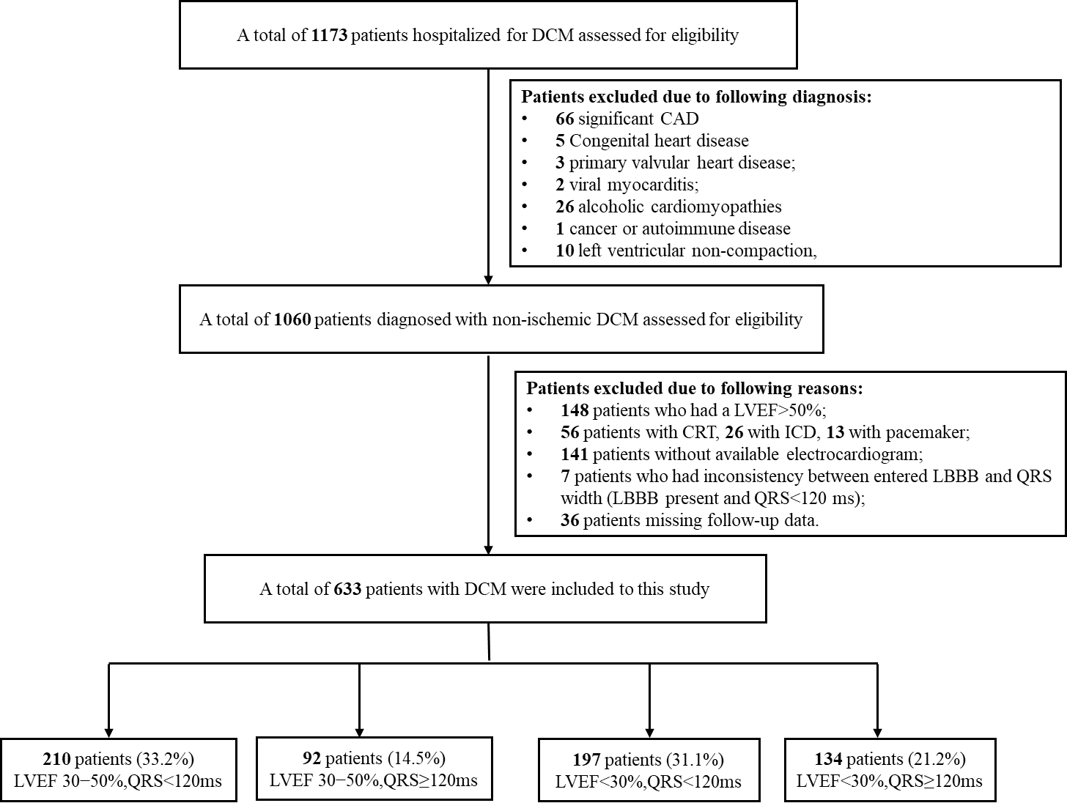
Supplementary Fig. 1. Flowchart of the study.
DCM: dilated cardiomyopathy; LVEF: left ventricular ejection fraction; CRT: cardiac resynchronization therapy; ICD: implantable cardioverter defibrillator; LBBB: left bundle branch block.
Supplementary Fig. 2. Restricted cubic splines of the relationship between QRS duration measured as a continuous variable and outcome.
The adjusted HR was calculated in multivariable COX regression model including age, gender, history of hypertension, history of atrial fibrillation, history of diabetes, NYHA class, hemoglobin, log-transformed creatine, log-transformed NT-Pro-BNP, therapy with ACEI/ARB and β-blocker.
Supplementary Fig. 3. Kaplan-Meier curves of the composite outcome in patients with LVEF 30~50% and QRSd ≥120ms, vs. those with LVEF <30% and QRSd <120ms, after propensity-score matching.
Propensity-score matching was conducted between patients with LVEF 30~50% and QRSd ≥120ms, vs. those with LVEF <30% and QRSd <120ms for age, gender, history of hypertension and left ventricular end-diastolic diameter (LVEF 30-50% and QRS >120ms vs. LVEF<30% and QRS≤120ms: HR 0.91, 95% CI 0.61-1.36, p=0.645).

