Supplementary material
Table 1 Characteristics of patients with non-ISR and ISR
Variables | non-ISR  (n=164) | ISR  (n=42) | P value
Age, year | 61.73±10.19 | 62.12±10.60 | 0.436
Male, n (%) | 40 (24.4) | 9 (21.4) | 0.688
BMI, kg/m² | 24.48±3.22 | 24.97±2.91 | 0.436
Obesity, n (%) | 16 (9.8) | 5 (11.9) | 0.681
Hypertension, n (%) | 105 (64.0) | 25 (59.5) | 0.590
Diabetes mellitus, n (%) | 87 (53.0) | 24 (57.1) | 0.635
Current smoking, n (%) | 46 (28.0) | 16 (38.1) | 0.205
TC, mmol/L | 4.27 [3.47,5.37] | 4.74 [3.59,5.85] | 0.155
TG, mmol/L | 1.54 [1.11,2.35] | 1.49 [1.17,2.20] | 0.946
HDL-C, mmol/L | 0.94±0.24 | 0.95±0.20 | 0.785
LDL-C, mmol/L | 2.81±1.09 | 3.14±1.09 | 0.089
eGFR, mL/min/1.73m² | 88.0 [72.8,95.6] | 83.9 [69.1,92.5] | 0.389
UA, umol/L | 395.5±117.9 | 403.1±99.7 | 0.718
HbA1c | 6.1 [5.6,6.8] | 6.0 [5.5,7.7] | 0.591
Hemoglobin, g/L | 135 [126,146] | 138 [131,146] | 0.314
Medications at discharge
Aspirin, n (%) | 162 (98.8) | 41 (97.6) | 1.000
Ticagrelor, n (%) | 55 (33.5) | 13 (31.0) | 0.751
Clopidogrel, n (%) | 108 (65.9) | 29 (69.0) | 0.696
Statin, n (%) | 163 (99.4) | 41 (97.6) | 0.871
β-block, n (%) | 100 (61.0) | 27 (64.3) | 0.694
ACEI/ARB, n (%) | 75 (45.7) | 24 (57.1) | 0.187
Angiography
Multivessel disease, n (%) | 126 (76.8) | 33 (78.6) | 0.810
LM disease, n (%) | 17 (10.4) | 3 (7.1) | 0.529
Intervention vessel
LM, n (%) | 5 (3.0) | 3 (7.1) | 0.437
LAD, n (%) | 93 (56.7) | 25 (59.5) | 0.742
LCX, n (%) | 54 (32.9) | 12 (28.6) | 0.589
RCA, n (%) | 61 (37.2) | 21 (50.0) | 0.130
Type of DES
Sirolimus stent, n (%) | 121 (73.8) | 36 (85.7) | 0.105
Everolimus stent, n (%) | 44 (26.8) | 6 (14.3) | 0.091
Multiple stents (n≥2), n(%) | 86 (52.4) | 30 (71.4) | 0.027  0.875
Minimal stent diameter, mm | 2.75 [2.50,3.00] | 2.75 [2.50,3.00]
Stent overlapping, n (%) | 11 (6.7) | 11 (26.2) | ＜0.001
Maximal expansion pressure | 16 [16,18] | 18 [16,18] | 0.021
Total stent length, mm/patients | 39 [28,65] | 58 [36,78] | 0.019
AHI, events/h | 11.09 [5.74,20.40] | 20.22[11.61,27.50] | 0.001
Minimal SaO₂ (%) | 85 [83,89] | 84 [80,88] | 0.107
Mean SaO₂ (%) | 94 [93,95] | 95 [92,96] | 0.609
Total percentage of time of SaO₂ <90% | 0.41 [0.01,2.22] | 0.69 [0.09,7.17] | 0.017
The data are reported as n (%) for categorical variables and as the mean±SD or median [IQR] for continuous variables. BMI: body mass index; TC: total cholesterol; TG: triglyceride; HDL-C: high-density lipoprotein cholesterol; LDL-C: low-density lipoprotein cholesterol; eGFR: estimated glomerular filtration rate; UA: uric acid; HbA1c: hemoglobin A1c; ACEI/ARB: angiotensin-converting enzyme inhibitors/angiotensin receptor blocker; LM: left main artery; LAD: left anterior descending artery; LCX: left circumflex artery; RCA: right coronary artery; ISR: in-stent restenosis; AHI: apnea-hypopnea index.

Table 2 Association of OSA and ISR in univariate logistic regression analysis
Variables | OR | 95%CI | P value
LDL-C | 1.293 | 0.959-1.743 | 0.092
Everolimus stent | 0.455 | 0.179-1.153 | 0.097
Multiple stents (n≥2) | 86 (52.4) | 30 (71.4) | ＜0.001
Stent overlapping | 4.935 | 1.966-12.392 | 0.001
Maximal expansion pressure | 1.132 | 0.992-1.290 | 0.065
Total stent length | 1.011 | 1.002-1.020 | 0.021
OSA | 3.712 | 1.774-7.770 | 0.001
AHI | 1.044 | 1.017-1.071 | 0.001
Minimal SaO₂ | 0.958 | 0.914-1.003 | 0.068
Total percentage of time of SaO₂ <90% | 1.084 | 1.021-1.150 | 0.008
LDL-C: low-density lipoprotein cholesterol; OSA: obstructive sleep apnea; AHI: apnea-hypopnea index.

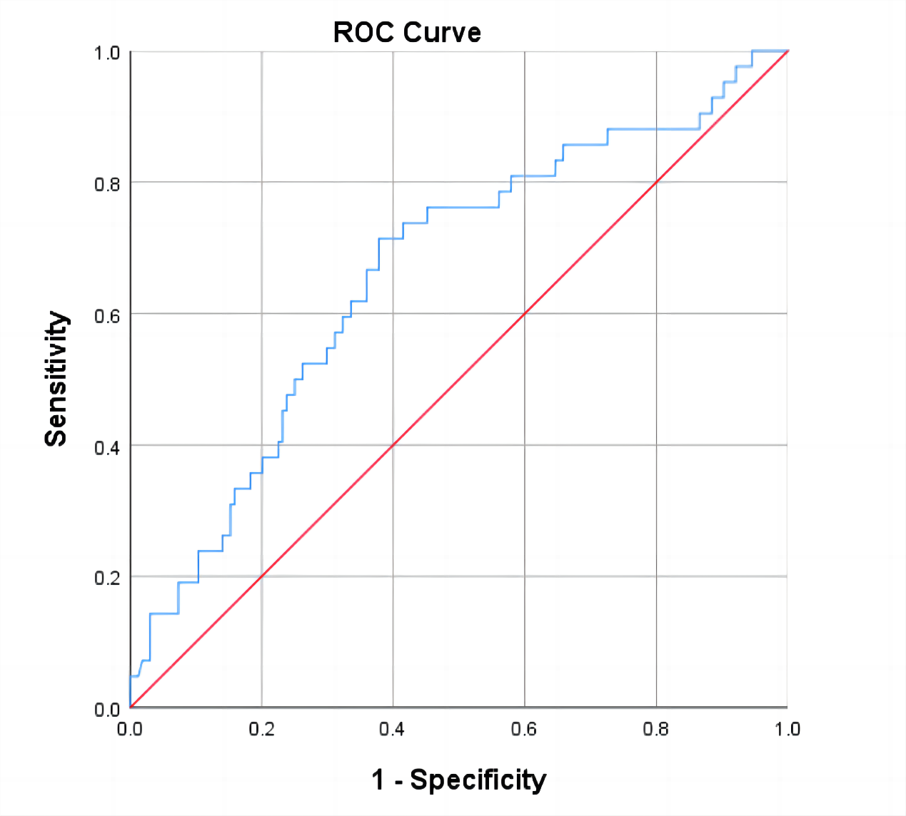
Figure 1 Receiver operating characteristic curve analysis of the AHI to predict DES-ISR

