Covariate processing
In NHANES, the data collection process consists of three main phases. The first phase involves household interviews where information on various factors such as age, gender, race, economic status, education level, diet, and health history are collected through questionnaires. The second phase takes place at a mobile screening center and focuses on collecting physical examination data, including measurements of height, weight, BMI, etc. The third phase involves telephone follow-up, primarily for dietary purposes. Body mass index (BMI) was calculated as weight in kilograms divided by the square of height in meters. The poverty impact ratio (PIR) represents the family income-to-poverty ratio. Smoking status included never smoker (≤100 cigarettes lifetime), former smoker (>100 cigarettes lifetime, currently quit), and current smoker. Alcohol consumption categories were non-drinkers, former drinkers, and drinkers. Physical activity, measured in metabolic equivalent of task (MET), indicated average weekly calories burned. Diabetes was defined by self-report, insulin use, fasting glucose>7mmol/L, or HbA1c≥6.5%. Hypertension included self-reported history, SBP≥140mmHg, or DBP≥90mmHg. History of CVD, heart failure, and stroke was self-reported. Impaired renal function was self-reported or eGFR >90ml/min/1.73m². The eGFR is calculated according to the classic MDRD formula, the formula being: eGFR = 170 × Scr ^ -0. 999 × Age ^ -0.176 × BUN ^ -0.170 × ALB ^ 0.318 × 0.762 (females) × l.180 (Afro-descendants). The use of statins, fibrate, and niacin was based on medication inventory.
The laboratory tests referenced in this article include the following key indicators: triglycerides, total cholesterol, high-density lipoprotein cholesterol (HDL-C), low-density lipoprotein cholesterol (LDL-C), plasma glucose, glycohemoglobin (HbA1c), creatinine, urea nitrogen, and albumin. The detailed methods and instruments used for these tests are summarized in the table below, showcasing the specific analytical techniques and equipment involved in measuring these clinical parameters to ensure accurate and standardized results.

Characteristic | Method | Equipment | Reagents | Website
TG | Cobas 6000 Chemistry Analyzer | Roche/Hitachi Cobas 6000 Analyzer | Cell Wash Solution II/Acid Wash, Cell Wash Solution I/NaOH-D, ECOTergent/Hitergent/Eco-D | extension://bfdogplmndidlpjfhoijckpakkdjkkil/pdf/viewer.html?file=https%3A%2F%2Fwwwn.cdc.gov%2Fnchs%2Fdata%2Fnhanes%2F2017-2018%2Flabmethods%2FTRIGLY-J-MET-508.pdf
TC | Roche Cobas 6000 | Roche/Hitachi Cobas 6000 Analyze | Cobas 6000 system reagents | extension://bfdogplmndidlpjfhoijckpakkdjkkil/pdf/viewer.html?file=https%3A%2F%2Fwwwn.cdc.gov%2Fnchs%2Fdata%2Fnhanes%2F2017-2018%2Flabmethods%2FTCHOL-J-MET-508.pdf
HDL-C | Cobas 6000 Chemistry Analyzer | Roche/Hitachi Cobas 6000 Analyzer | Cobas 6000 system reagents | extension://bfdogplmndidlpjfhoijckpakkdjkkil/pdf/viewer.html?file=https%3A%2F%2Fwwwn.cdc.gov%2Fnchs%2Fdata%2Fnhanes%2F2017-2018%2Flabmethods%2FHDL-J-MET-508.pdf
LDL-C | LDL-C is calculated from directly measured values of total cholesterol (LBXTC), triglycerides (LBXTR), and HDL-C (LBDHDD). |  |  | https://wwwn.cdc.gov/Nchs/Nhanes/2017-2018/TRIGLY_J.htm
plasma glucose | Roche/Hitachi Cobas C Chemistry Analyzer –  C311 | For cobas c 311 analyzers: GLUC3. | REF 04404483, CONTENT Glucose HK (GLUC3) | extension://bfdogplmndidlpjfhoijckpakkdjkkil/pdf/viewer.html?file=https%3A%2F%2Fwwwn.cdc.gov%2Fnchs%2Fdata%2Fnhanes%2F2017-2018%2Flabmethods%2FGLU-J-MET-508.pdf
HbA1c | Trinity Biotech Boronate Affinity HPLC | Trinity Biotech Premier Hb9210 Automated HPLC System | Trinity | extension://bfdogplmndidlpjfhoijckpakkdjkkil/pdf/viewer.html?file=https%3A%2F%2Fwwwn.cdc.gov%2Fnchs%2Fdata%2Fnhanes%2F2017-2018%2Flabmethods%2FGHB-J-Premier-508.pdf
Scr | Roche Cobas 6000 (c501 module) | Roche Cat. No. 03263991190 | CREP2 reagent kit (250 tests) | extension://bfdogplmndidlpjfhoijckpakkdjkkil/pdf/viewer.html?file=https%3A%2F%2Fwwwn.cdc.gov%2Fnchs%2Fdata%2Fnhanes%2F2017-2018%2Flabmethods%2FBIOPRO-J-MET-Creatinine-508.pdf
Bun | Roche Cobas 6000 (c501 module) | Roche Cat. No. 04460715190 | UREAL reagent kit (500 tests) | extension://bfdogplmndidlpjfhoijckpakkdjkkil/pdf/viewer.html?file=https%3A%2F%2Fwwwn.cdc.gov%2Fnchs%2Fdata%2Fnhanes%2F2017-2018%2Flabmethods%2FBIOPRO-J-MET-BUN-508.pdf
ALB | Roche Cobas 6000 (c501 module) | Roche product #05599261190 | ALBP reagent kit (225 tests) | extension://bfdogplmndidlpjfhoijckpakkdjkkil/pdf/viewer.html?file=https%3A%2F%2Fwwwn.cdc.gov%2Fnchs%2Fdata%2Fnhanes%2F2017-2018%2Flabmethods%2FBIOPRO-J-MET-Albumin-508.pdf

NCHS Ethics Review Board (ERB) Approval
The NHANES database has received NCHS ERB Approval, which is available on the official website at https://www.cdc.gov/nchs/nhanes/irba98.htm#print, and excerpted information is below:
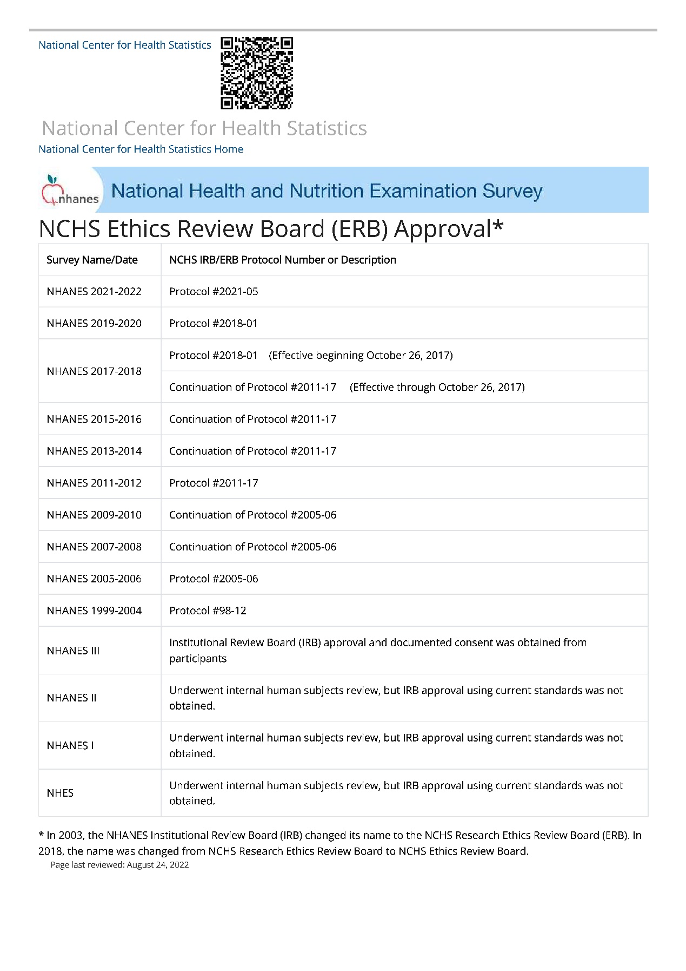

Supplementary Table 1 Comparison of baseline characteristics between CoQ10 users and non-users
Characteristic | Non-CoQ10 | Taking CoQ10 | P value
Individuals n (N) | 4164 (14,990,114) | 127 (592,567) | -
Age (years) | 62.00 (54.00, 70.00) | 65.41 (57.00, 71.00) | 0.075
Gender (female) | 1,972 (47%) | 66 (52%) | 0.2
Race |  |  | 0.003
Non-Hispanic White | 1,855 (45%) | 76 (60%)
Non-Hispanic Black | 934 (22%) | 20 (16%)
Mexican American | 602 (14%) | 9 (7.1%)
Other/multiracial | 405 (9.7%) | 17 (13%)
Other Hispanic | 368 (8.8%) | 5 (3.9%)
PIR | 3.04 (1.58, 5.00) | 4.30 (2.50, 5.00) | <0.001
Educational attainment |  |  | <0.001
Below high school | 695 (17%) | 5 (3.9%)
High school | 1,627 (39%) | 44 (35%)
Above high school | 1,840 (44%) | 78 (61%)
Hypertension | 3,156 (77%) | 92 (74%) | 0.9
Cardiovascular disease | 678 (16%) | 27 (21%) | >0.9
Heart failure | 464 (11%) | 7 (5.5%) | 0.3
Chronic bronchitis | 373 (9.0%) | 5 (4.0%) | 0.10
Liver condition | 215 (5.2%) | 5 (4.0%) | 0.077
Stroke | 458 (11%) | 5 (3.9%) | 0.2
A weak or failing kidney | 460 (12%) | 8 (6.5%) | 0.040
Smoking status |  |  | 0.3
Never smoker | 1,987 (48%) | 70 (55%)
Former smoker | 1,551 (37%) | 47 (37%)
Current smoker | 626 (15%) | 10 (7.9%)
Alcohol intake |  |  | 0.5
Non-drinker | 545 (19%) | 11 (13%)
Former drinker | 213 (7.4%) | 9 (11%)
Drinker | 2,124 (74%) | 65 (76%)
Physical activity | 77,112.52 (0.00, 280,357.43) | 101,353.37 (11,992.04, 369,214.35) | 0.10
BMI (kg/m²) | 29.79 (26.20, 34.50) | 29.32 (25.94, 35.22) | >0.9
Waist circumference (cm) | 105.20 (95.30, 116.00) | 103.60 (92.89, 114.68) | 0.5
TG (mmol/L) | 1.39 (0.97, 1.98) | 1.26 (0.89, 2.05) | 0.7
TC (mmol/L) | 4.55 (3.93, 5.22) | 4.65 (4.16, 5.28) | 0.062
LDL-C (mmol/L) | 2.48 (1.97, 3.00) | 2.53 (2.25, 2.96) | 0.2
HDL-C (mmol/L) | 1.32 (1.09, 1.58) | 1.34 (1.18, 1.71) | 0.052
eGFR (ml/min) | 173.02 (141.02, 203.48) | 166.65 (138.60, 190.90) | 0.2
Age when first taking statin | 57.00 (50.00, 66.00) | 59.00 (53.00, 66.00) | 0.12
Diabetes | 2,404 (58%) | 57 (45%) | 0.003
Glucose (mmol/L) | 5.91 (5.42, 6.75) | 6.05 (5.44, 6.37) | >0.9
HbA1c (%) | 5.80 (5.50, 6.30) | 5.70 (5.43, 5.90) | 0.032
Age when first diagnosed with diabetes | 50.00 (40.00, 59.00) | 55.01 (50.00, 60.00) | 0.010
New onset diabetes after statin use | 271 (6.5%) | 5 (3.9%) | 0.001
All-cause mortality | 1,066 (26%) | 23 (18%) | 0.3
Cardiovascular mortality | 337 (8.1%) | 5 (3.9%) | 0.2
Cancer-related mortality | 161 (3.9%) | 5 (3.9%) | >0.9
Diabetes-related mortality | 225 (5.4%) | 3 (2.4%) | 0.8
Survival length (months) | 87.00 (47.00, 135.00) | 80.40 (37.00, 144.98) | 0.5
BMI: body mass index, CI: Confidence Interval, CoQ10: coenzyme Q10, eGFR: estimated glomerular filtration rate, HbA1c: glycohemoglobin, HDL-C: high-density lipoprotein cholesterol, LDL-C: low-density lipoprotein cholesterol, OR: Odds Ratio, PIR: poverty income ratio, TC: total cholesterol, TG: triglycerides. n represents the number of participants in the study sample, while N represents the weighted number of participants based on NHANES sampling principles. Continuous variables are presented as median (Q25, Q75). Categorical variables are presented as numbers (percentages).
Supplementary Table 2 Univariate logistic regression results for factors associated with new-onset diabetes.
Characteristic | OR | 95% CI | P value
Age (years) | 1.019 | 1.006, 1.031 | 0.003
Gender (male) | 1.657 | 1.147, 2.394 | 0.007
Race
Mexican American | — | —
Other Hispanic | 1.899 | 0.837, 4.310 | 0.124
Non-Hispanic White | 2.033 | 1.199, 3.449 | 0.009
Non-Hispanic Black | 1.832 | 1.050, 3.196 | 0.033
Other/multiracial | 2.537 | 1.459, 4.412 | 0.001
PIR | 1.053 | 0.948, 1.170 | 0.331
Educational attainment
Below high school | — | —
High school | 1.150 | 0.730, 1.810 | 0.545
Above high school | 1.287 | 0.829, 1.998 | 0.259
Hypertension | 2.842 | 1.554, 5.197 | <0.001
Cardiovascular disease | 2.344 | 1.443, 3.809 | <0.001
Heart failure | 2.124 | 1.343, 3.361 | 0.001
Smoking status
Never smoker | — | —
Former smoker | 1.483 | 1.053, 2.088 | 0.024
Current smoker | 1.009 | 0.537, 1.894 | 0.978
Alcohol intake
Non-drinker | — | —
Former drinker | 2.972 | 1.398, 6.317 | 0.005
Drinker | 2.857 | 1.693, 4.824 | <0.001
Physical activity | 1.000 | 1.000, 1.000 | 0.156
BMI (kg/m2) | 1.019 | 0.995, 1.044 | 0.117
Waist circumference (cm) | 1.015 | 1.006, 1.025 | 0.002
SBP (mmHg) | 1.008 | 1.001, 1.014 | 0.022
DBP (mmHg) | 1.006 | 0.992, 1.020 | 0.402
Glucose (mmol/L) | 1.192 | 1.133, 1.254 | <0.001
HbA1c (%) | 1.413 | 1.291, 1.547 | <0.001
TG (mmol/L) | 1.054 | 0.985, 1.128 | 0.124
TC (mmol/L) | 0.621 | 0.502, 0.767 | <0.001
LDL-C (mmol/L) | 0.591 | 0.433, 0.807 | 0.001
HDL-C (mmol/L) | 0.179 | 0.084, 0.383 | <0.001
AST (U/L) | 1.005 | 0.997, 1.012 | 0.208
eGFR (ml/min) | 0.998 | 0.995, 1.001 | 0.207
Age when first taking statin | 0.971 | 0.959, 0.984 | <0.001
CoQ10 | 0.323 | 0.157, 0.668 | 0.003
CoQ10 daily dosage (mg) | 0.999 | 0.994, 1.004 | 0.72
CoQ10 daily dosage per kilogram of body weight (mg/kg) | 0.991 | 0.973, 1.010 | 0.341
CoQ10 daily dosage per body surface area (mg/m²) | 1.000 | 0.999, 1.000 | 0.456
AST: aspartate aminotransferase, BMI: body mass index, CI: Confidence Interval, CoQ10: coenzyme Q10, DBP: diastolic blood pressure, eGFR: estimated glomerular filtration rate, HbA1c: glycohemoglobin, HDL-C: high-density lipoprotein cholesterol, LDL-C: low-density lipoprotein cholesterol, OR: Odds Ratio, PIR: poverty income ratio, SBP: systolic blood pressure, TC: total cholesterol, TG: triglycerides. n represents the number of participants in the study sample, while N represents the weighted number of participants based on NHANES sampling principles. Continuous variables are presented as median (Q25, Q75). Categorical variables are presented as numbers (percentages).

Supplementary Table 3 Multifactor Logistics regression results for two sets of models for CoQ10.
 | Characteristic | OR | 95% CI | P value
Model 1 | CoQ10 | 0.344 | 0.160, 0.737 | 0.006
Model 1 | Age | 1.022 | 1.008, 1.037 | 0.002
Model 1 | Gender (male) | 1.662 | 1.148, 2.408 | 0.008
Model 1 | Race
Model 1 | Mexican American | — | —
Model 1 | Other Hispanic | 1.932 | 0.811, 4.605 | 0.136
Model 1 | Non-Hispanic White | 1.700 | 0.911, 3.173 | 0.095
Model 1 | Non-Hispanic Black | 1.828 | 0.968, 3.452 | 0.063
Model 1 | Other/multiracial | 1.959 | 0.961, 3.994 | 0.064
Model 1 | Educational attainment
Model 1 | Below high school | — | —
Model 1 | High school | 1.157 | 0.734, 1.824 | 0.528
Model 1 | Above high school | 1.065 | 0.626, 1.810 | 0.815
Model 1 | PIR | 1.060 | 0.935, 1.203 | 0.358
Model 2 | CoQ10 | 0.232 | 0.057, 0.942 | 0.041
Model 2 | Age | 1.141 | 1.106, 1.177 | <0.001
Model 2 | Gender (male) | 1.260 | 0.637, 2.492 | 0.503
Model 2 | Race
Model 2 | Mexican American | — | —
Model 2 | Other Hispanic | 1.715 | 0.458, 6.420 | 0.421
Model 2 | Non-Hispanic White | 0.877 | 0.393, 1.956 | 0.746
Model 2 | Non-Hispanic Black | 1.238 | 0.479, 3.201 | 0.657
Model 2 | Other/multiracial | 1.598 | 0.473, 5.395 | 0.447
Model 2 | Educational attainment
Model 2 | Below high school | — | —
Model 2 | High school | 2.592 | 1.084, 6.195 | 0.032
Model 2 | Above high school | 1.738 | 0.692, 4.363 | 0.237
Model 2 | PIR | 1.135 | 0.947, 1.361 | 0.168
Model 2 | Waist circumference | 1.017 | 0.999, 1.036 | 0.068
Model 2 | Hypertension | 2.293 | 0.804, 6.535 | 0.120
Model 2 | CVD | 1.309 | 0.487, 3.518 | 0.591
Model 2 | Heart Failure | 1.618 | 0.719, 3.642 | 0.243
Model 2 | LDL-C | 0.633 | 0.397, 1.011 | 0.055
Model 2 | Age when first taking statin | 0.861 | 0.834, 0.888 | <0.001
CI: Confidence Interval, CoQ10: coenzyme Q10, CVD: cardiovascular disease, LDL-C: low-density lipoprotein cholesterol, OR: Odds Ratio, PIR: poverty impact ratio.

Supplementary Table 4 Results of multicollinearity assessment for coq10 and nod logistic regression.
Characteristic | VIF value
CoQ10 | 1.356915
Age | 4.009753
Gender (Male) | 2.004245
Race
Other Hispanic | 2.354875
Non-Hispanic White | 4.555558
Non-Hispanic Black | 3.825725
Other/multiracial | 3.581602
Education attainment
High school | 3.674316
Above high school | 3.860086
PIR | 2.263565
Hypertension | 2.185125
CVD | 2.639633
Heart failure | 2.075325
Waist circumference | 3.592133
LDL-C | 2.969639
Age of first take statin | 4.210159
CI: Confidence Interval, CoQ10: coenzyme Q10, CVD: cardiovascular disease, LDL-C: low-density lipoprotein cholesterol, PIR: poverty impact ratio, VIF: Variance Inflation Factor.

Supplementary Table 5 Results of the interaction between coq10 and NOD correlation
Characteristic | OR | 95%CI lower | 95%CI upper | P value
CoQ10*Gender(male) | 1.782 | 0.112 | 28.238 | 0.683
CoQ10*CVD | 0.453 | 0.031 | 6.674 | 0.565
CoQ10*Waist circumference | 1.022 | 0.969 | 1.077 | 0.422
CoQ10*BMI | 1.099 | 0.907 | 1.332 | 0.336
CoQ10*Hypertension | 0.430 | 0.022 | 8.384 | 0.579
CoQ10*Heart failure | 0.000 | 0.000 | 0.000 | <0.001
CoQ10*LDL-C | 0.521 | 0.052 | 5.258 | 0.581
BMI: Body mass index, CI: Confidence Interval, CoQ10: coenzyme Q10, CVD: cardiovascular disease, LDL-C: low-density lipoprotein cholesterol, OR: Odds Ratio, PIR: poverty income ratio.

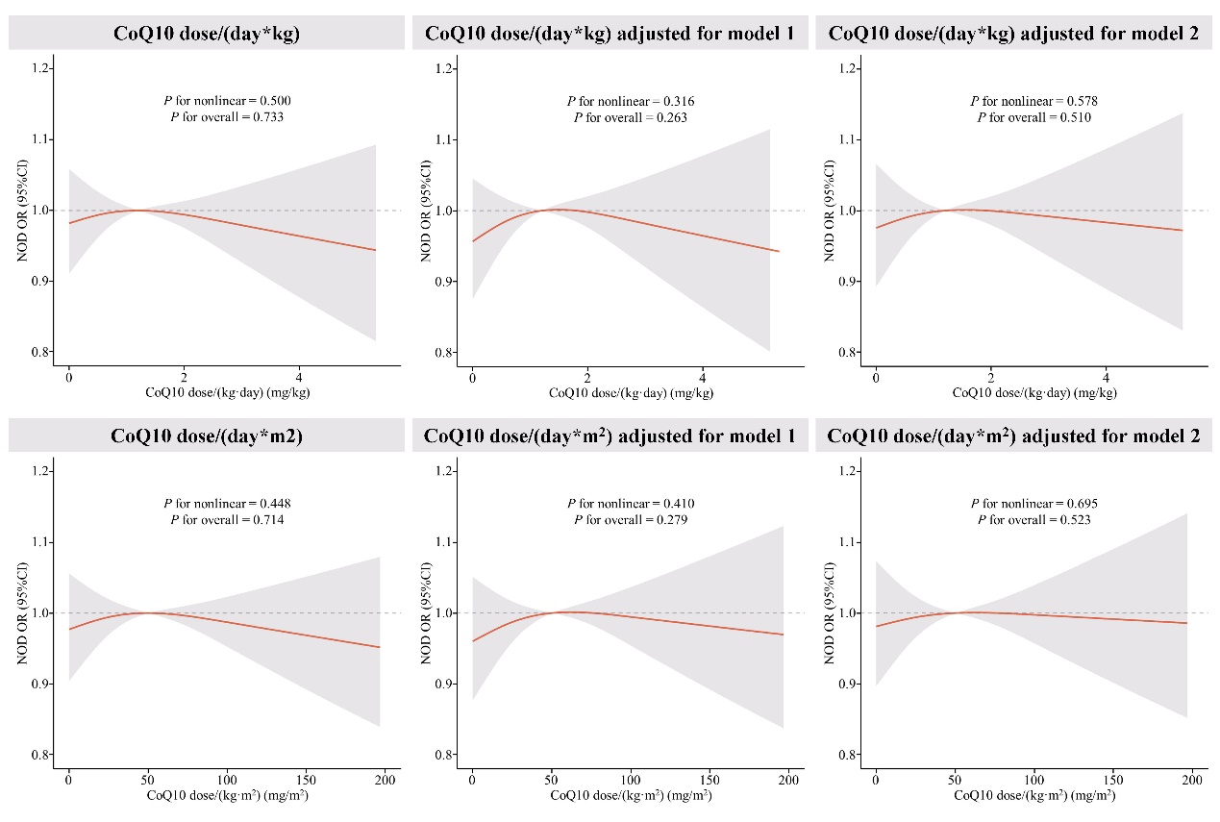Supplementary Fig. 1 RCS plot of the relationship between daily CoQ10 and new-onset diabetes per unit of body weight and per unit of body surface area.
Red lines represent odds ratios and shading indicates 95% confidence intervals. New onset diabetes was derived via logistics regression using RCS, following adjustments by model 1 and model 2. Model 1 adjusts for age, sex, race, PIR, and educational attainment. Model 2 further adjusts for hypertension, CVD, heart failure, waist circumference, LDL-C, and the age at which statin therapy was initiated.

