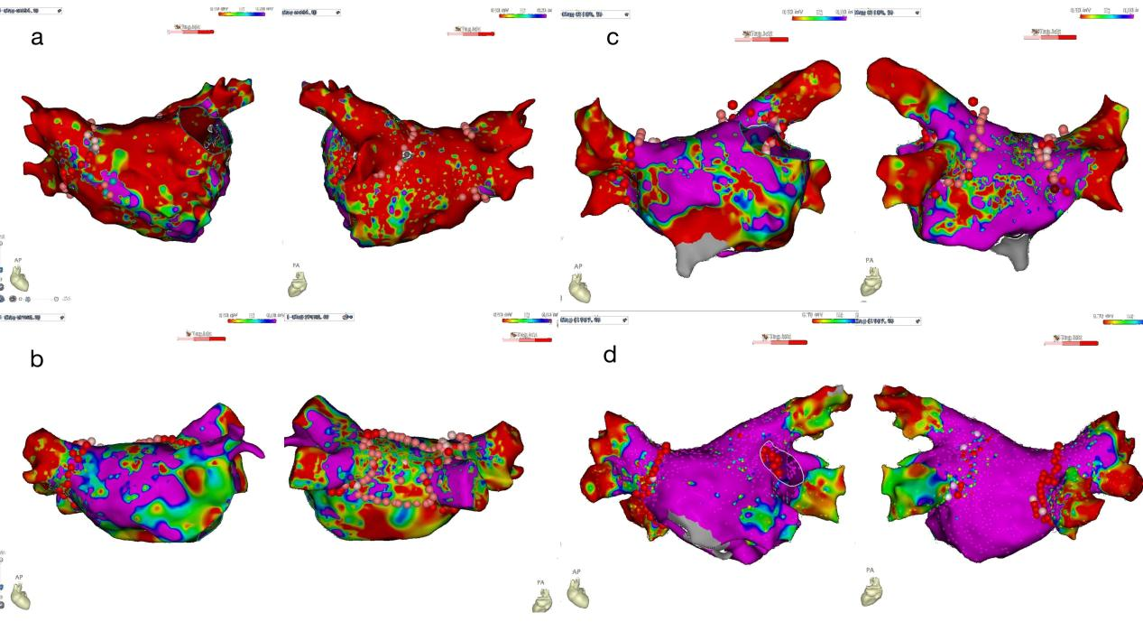
Supplementary Fig. 1. Extent of atrial fibrosis by voltage mapping. Voltage mapping of severe (a), moderate (b), mild (c), and normal (d) atrial fibrosis.

